IEEE P802.15
Wireless Personal Area Networks

Project | Dependability Interest Group
Title | Meeting Minutes for November 2019
Date Submitted | November 14th, 2019
Source | [Ryuji Kohno]  [YNU(Yokohama National University)/CWC-Nippon] | Voice: +81 90 3061 7978  +358 40 354 0034  E-mail: kohno@ynu.ac.jp  ryuji.kohno@ee.oulu.fi
Re: | Meeting Minutes
Abstract | IG-DEP activities as amendment of existing IEEE802.15.6 for WBAN or a new standard, conventional focused use cases, additional use cases, technical requirement, draft of PAR and CSD have been rereviewed. Cooperation with ETSI smart BAN and smart M2M projects has been discussed including commonality and difference although ETSI is directing smart implementation while IG-DEP is focusing on dependability for high QoS and QoL. According to request from BMI Center of NICT, IG-DEP restarts amendment of 15.6 standard for medical BAN applicable to 40 times more sensors and 5 times higher aggregate data rate for EEG or ECoG. Coexistence between 5G and UWB-BAN, and overall performance in case of overlaid multiple BANs have been discussed as resolve inter- and intra-system interference problems to guarantee enhanced dependability as an amendment of 15.6 MAC and PHY. By updating technical requirement for dependable BAN, focused use cases which have common requirement has been summarized.
Purpose | Minutes of Dependability Plenary sessions in Waikoloa, November 2019
Notice | This document has been prepared to assist the IEEE P802.15. It is offered as a basis for discussion and is not binding on the contributing individual(s) or organization(s). The material in this document is subject to change in form and content after further study. The contributor(s) reserve(s) the right to add, amend or withdraw material contained herein.
Release | The contributor acknowledges and accepts that this contribution becomes the property of IEEE and may be made publicly available by P802.15.

Monday, November 11th, 2019, PM1, 13:30-15:00
Room: Waikoloa 3 in Hilton Waikoloa, Big Island, Hawaii, USA

  - Meeting called to order 13:30
By Chair Ryuji Kohno (YNU / CWC UofOulu)

  - Roll Call
Notepad for Attendance circulated.

  - Opening Report
Chair presented Opening report doc.#19-0495-01
Chair showed IEEE Patent policy.
Chair issued Call for Potentially Essential Patents
No essential intellectual property in the scope of IG DEP was declared.
Chair presented agenda this week doc.#19-0496-01

  - Approval of previous meeting minutes
Upon no comments on the previous meeting minutes, doc #19-0431-00 was approved.

  - Review of ID DEP activities
- Overview of IG DEP activities for Cars and other IoT & M2M Use cases and Amendment of IEEE802.15.6 Wireless Medical doc.#15-18-0347-01
- Overview of IEEE802.15.6 for Wireless Medical BAN doc.#15-18-0384-00
- SmartBAN ETSI standard for smart body area networks doc.#15-19-0509-00
- Updated Technical Requirements for Focused Use Cases on WBAN for Human, Robotic and Car Bodies doc.#15-19-0157-03
- Requirement for Wireless Medical BAN to Apply for ECoG-based Brain-Machine Interface doc.#15-19-0419-03
- Brain-Machine Interface based on Electrocorticography using high speed UWB wireless body area network doc.#15-19-0421-02

  - Discussion
- Decision to focus on Amendment of IEEE802.15.6 Medical BAN
IG-DEP focuses on enhanced dependability in PHY as an amendment of existing standard IEEE802.15.6 for medical wireless BAN and MAC while covering non-medical use cases such as car, robotic, and UAV bodies.
IG-DEP focuses on enhanced dependability of wireless networks while ETSI SmartBAN does on smart or easy implementation. IG-DEP covers only PHY and MAC layers while smart BAN covers network layer, security, Quality-of-Service (QoS) and provision of generic applications and services. IG-DEP covers physical security and robustness against various types of interference and jamming. IG-DEP focuses on car and robotic bodies as well as human body as an extension of IEEE802.15.6 for wireless medical BAN.
So, IG-DEP focuses on amendment of IEEE802.15.6 to be dependable BAN in a sense of enhanced dependability of human, car, robotic bodies area networks(BAN’s) while smart BAN does on simplicity in implementation for only digital healthcare for human body and smart M2M does on more general use cases of M2M.

As amendment of IEEE802.15.6, MAC for multiple BANs coexistence can be guaranteed to satisfy permissible delay or back-off time and throughput of high QoS packets for all car, robotic and human BANs while maintaining overall average performance.

- Review of Last Keynote in WNG session in Ha Noi
Dr. Takafumi Sasaki(NICT)’s keynote in last WNG session doc.# 15-19-0421-02 has been reviewed. From an engineer point of view, technical requirement for WBAN to Apply for ECoG-based Brain-Machine Interface(BMI) has been discussed and his document has been revised once again doc.#15-19-0419-03
He explained BMI based on Electrocorticography needs higher speed UWB BAN.

  - Recess at 14:58.
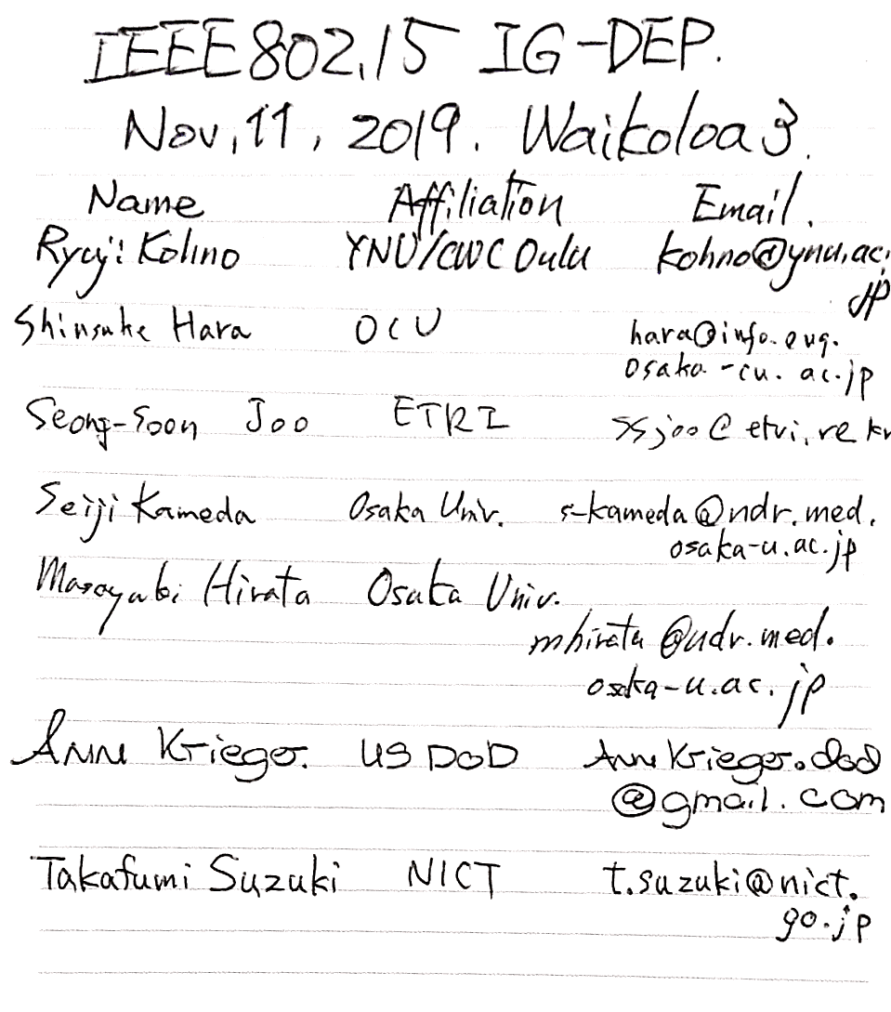
  - Attendees 7
Shinsuke Hara (OCU)
Seong-Soon Joo (ETRI)
Seiji Kameda (Osaka Univ.)
Masayuki Hirata (Osaka U.)
Ann Krieger (US DOD)
Takafumi Suzuki (NICT)
Ryuji Kohno (YNU/CWC
Uof Oulu)

Tuesday November 12th 2019, AM1, 8:00-10:00
Room; Waikoloa 2 in Hilton Waikoloa, Big Island, Hawaii, USA

  - Meeting called to order 8:01
By Chair Ryuji Kohno (YNU / CWC Uof Oulu)

  - Roll Call
Notepad for Attendance circulated.

  - Quick review of the last session
  - Review of existing WBAN standard IEEE802.15.6 and ESTI SmartBAN
・Doc.# 15-18-0384 Review of IEEE802.15.6 Wireless Medical BAN
was carefully review to find necessary change of all specification of IEEE802.15.6 such as necessary aggregate data rate, latency of packets, permissible delay, etc.
  - Preparation of Keynote Speech in WNG session on Wednesday
- Invited keynote speaker in WNG session on Wednesday Prof. Masayuki Hirata, MD, PhD (Osaka University, Medical School, Neuro Science) explained necessity for revision or amendment of existing standard of medical wireless BAN IEEE802.15.6 from a brain surgent point of view.
- Major application of ECoG-base BMI are detection of Parkinson disease, epilepsy swallowing disturbance, stroke etc. by analyzing ECoG data for Vagus nerve simulation etc.
- ECoG for neural activities has much more information than EEG and LFP while analysis of ECoG has a drawback of invasiveness.
- He summarized technical requirement such as applicable to 40 times more sensors and 5 times higher aggregate data rate for the 2nd Generation of ECoG in Brain Machine Interface(BMI) for Brain Networks and Communication.

  - Presentation
Before discussing update of technical requirement for a new focused application such as Brain-Machine-Interface(BMI), enable MAC and PHY technologies to ensure enhanced dependability have been presented as possible solution to ensure enhanced dependability.
- MAC Protocol with Interference Mitigation Using Negotiation among Coordinators in Multiple Wireless Body Area Networks(BAN’s) doc.#15-19-0503-00-0dep
- In multiple BANs overlaid environment, negotiation among coordinators can avoid unnecessary contention base delay for high priority QoS packets while scarifying performance of lower priority QoS packets. Some drawback of the previous proposed MAC could be resolved to improve worst and average throughput in high offered load or high packet traffic environment.

- Localization of implanted devices by combining TDOA, particle filter and map-mapping with intestine modeling doc.#15-19-0510-00-0dep
- According to trend of 5G, IoT/M2M, and increase of WBAN application beyond medical BAN, their overlapped coverage range of these networks will increase. UWB radio regulation in Japan was updated to promote its more applications. In order to solve such a problem, a new scheme of controlling transmission power of UWB-BANs has been proposed to avoid interference to 5G terminals overlapped in coverage range. Current standard IEEE802.15.6 for WBAN should be updated to apply this proposed scheme in physical layer to solve a coexistence problem between primary user 5G and secondary user UWB-BAN.

  - Recess at 9:54.

  - Attendees 8

Masayuki Hirata (Osaka U.)
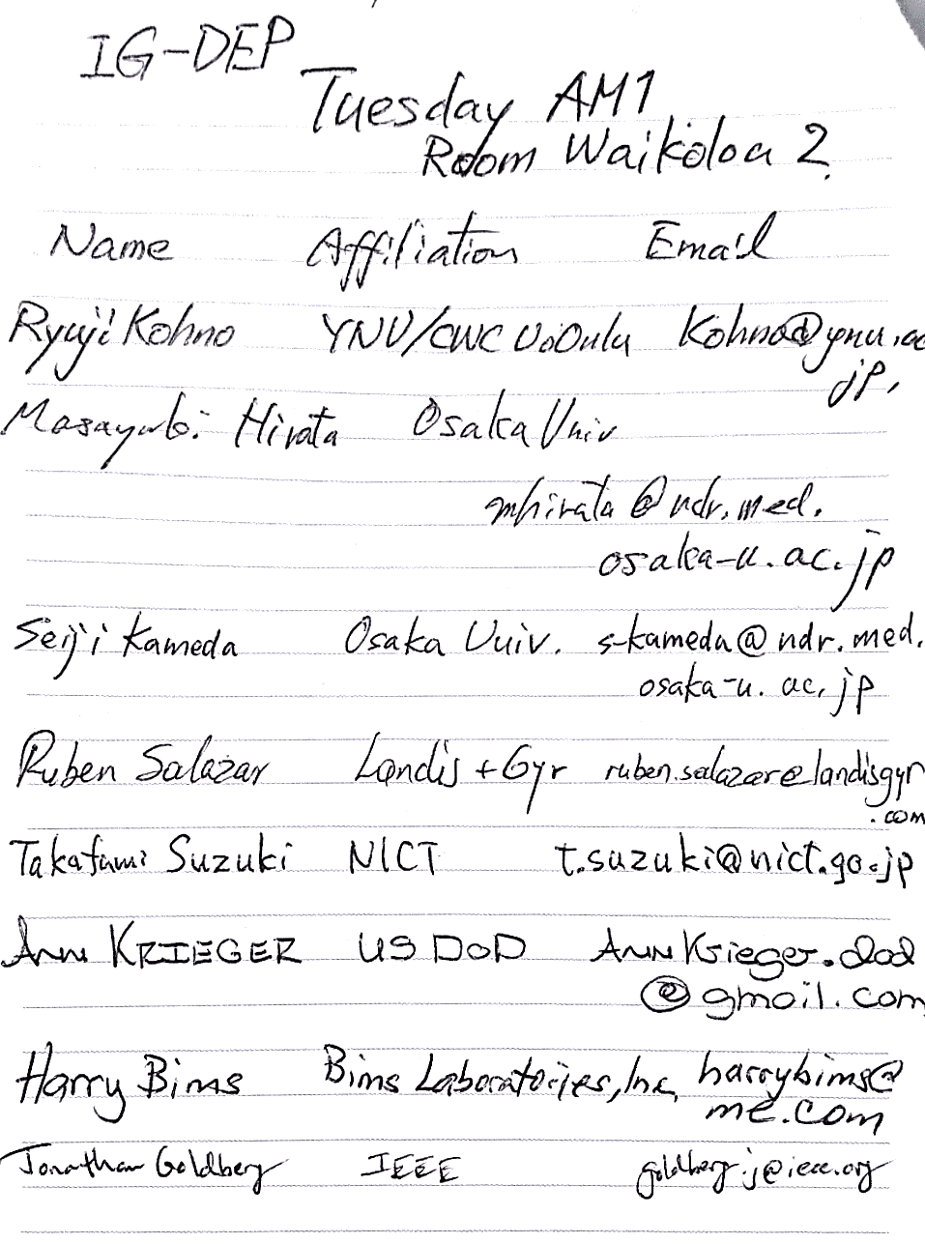
Seiji Kameda (Osaka Univ.)
Ruben Salazar (Landis Gyr)
Takafumi Suzuki(NICT)
Ann Krieger (US DOD)
Harry Bins (Bins Labocatories)
Jonathan Goldberg (IEEE)
Ryuji Kohno (YNU/CWC
Uof Oulu)

Wednesday November 13th 2019, AM2, 11:30-12:30
802.15 WNG Session
Room; King’s 3 in Hilton Waikoloa, Big Island, Hawaii, USA

IG-DEP invited Prof. Masayuki Hirata as a keynote speaker in WNG session.
He gave a talk on
“Higher speed wireless body area networks are required for implantable brain-machine interfaces” doc.#15-19-0545-00-0dep

Around 60 audience listened to his presentation.
Agenda was below.

■Fundamental basis of brain decoding: Brain functions are localized for ECoG-BMI system
■Brain signals used for BMIs
- fMRI NIRS EEG MEG ECoG LFP spike
■High frequency brain activity better reflects functional localization than low frequency activity
- High frequency brain activity (80-150Hz) offer highest decoding accuracy
■ECoG-based real time BMI system (wired)
■Trends in neurosurgical treatments using implantable devices
■Deep brain stimulation (DBS) for Parkinson disease
■Vagus nerve stimulation for intractable epilepsy
■Closed loop deep brain stimulation (DBS)
■Responsive neurostimulator (RNS) for intractable epilepsy
■Implantable brain machine interface (BMI)
■High frequency brain activity (80-150Hz) offer highest decoding accuracy
■No. of recording channels depends on inter-electrode spacing and recording areas to be covered.
■Requirement for data transfer speed of implantable BMI
- 1st generation:
- Sampling rate: 1000Hz
- Channel number: 100ch
- (Interelectrode spacing: 3mm, coverage 3cm2)
- Data transfer speed:14 bit x 1000 Hz x 100 ch = 1.6 Mbps
- Submission Slide 20 Masayuki Hirata(Osaka Univ.), Takafumi Suzuki(NICT)
- 2nd generation:
- Sampling rate: 1000Hz
- Channel number: 4000ch
- (Interelectrode spacing: 1mm, coverage 3cm2 X 4)
- Data transfer speed:14bit x 1000 Hz x 4000 ch = 64 Mbps
Wednesday November 13th 2019, PM1, 13:30-15:30
Room; Waikoloa 2 in Hilton Waikoloa, Big Island, Hawaii, USA

  - Meeting called to order at 13:31

  - Roll Call

3.3 Update of Technical Requirement
After brain surgent Prof. Masayuki Hirata’s keynote speech in WNG session, the following up discussion was done and the technical requirement was updated.

According to request of a group of Prof. Hirata and Dr. Suzuki, amendment of IEEE802.15.6 should include one of main use cases of 2nd Generation of ECoG for Brain-Machine-Interface(BMI).
Technical requirement has been updated for aggregate data rate, associate delay, delivery ratio requirement, disconnection ratio, coverage range, feedback loop response time, multiuser support, internetwork interference, channel model resilience etc.

- Updated Technical Requirements for Focused Use Cases on WBAN for Human, Robotic and Car Bodies doc.#15-19-0157-04-0dep

  - Discussion
- Technical requirement corresponding to a new application on ECoG vital sensing for BMI was shortly discussed in the table of doc.#15-19-0157-04-odep.
- IG-DEP has several supporters from industries and clinical party as well as car industries now of which representatives are attending in IG-DEP three sessions this week.
- IG-DEP has decided to move forward to be SG and TG in this week.
- Under email instruction of Dr. Bob Heile that we can put the case together at the Irvine meeting and maybe even avoid this step. If you can put together and circulate to this group, a draft scope and unique identity, we can get a head start on that.
- For coming a month, we will circulate our draft to 802.15 group. Them IG-DEP will hopefully move to SG/TG in next January.

  - Adjourn 15:28

  - Attendees 8

Toshimasa Matsuoka (SPChange)
Takafumi Suzuki(NICT)
Masayuki Hirata (Osaka Univ.)
Seiji Kameda (Osaka Univ.)
Seong-Soon Joo (ETRI)
Huan-Bang Li(NICT)
Harry Bins (Bins Labocatories)
Ryuji Kohno (YNU/CWC Uof Oulu)

