IEEE P802.15
Wireless Personal Area Networks

Project | Dependability Interest Group
Title | Meeting Minutes for September 2019
Date Submitted | September 19th, 2019
Source | [Ryuji Kohno]  [YNU(Yokohama National University)/CWC-Nippon] | Voice: +81 90 3061 7978  +358 40 354 0034  E-mail: kohno@ynu.ac.jp  ryuji.kohno@ee.oulu.fi
Re: | Meeting Minutes
Abstract | IG-DEP activities as amendment of existing IEEE802.15.6 for WBAN or a new standard, conventional focused use cases, additional use cases, technical requirement, draft of PAR and CSD have been rereviewed. Cooperation with ETSI smart BAN and smart M2M projects has been discussed including commonality and difference although ETSI is directing smart implementation while IG-DEP is focusing on dependability for high QoS and QoL. According to request from BMI Center of NICT, IG-DEP restarts amendment of 15.6 standard for medical BAN applicable to 40 times more sensors and 5 times higher aggregate data rate for EEG or ECoG. Coexistence between 5G and UWB-BAN, and overall performance in case of overlaid multiple BANs have been discussed as resolve inter- and intra-system interference problems to guarantee enhanced dependability as an amendment of 15.6 MAC and PHY. By updating technical requirement for dependable BAN, focused use cases which have common requirement has been summarized.
Purpose | Minutes of Dependability Interest Group sessions
Notice | This document has been prepared to assist the IEEE P802.15. It is offered as a basis for discussion and is not binding on the contributing individual(s) or organization(s). The material in this document is subject to change in form and content after further study. The contributor(s) reserve(s) the right to add, amend or withdraw material contained herein.
Release | The contributor acknowledges and accepts that this contribution becomes the property of IEEE and may be made publicly available by P802.15.

Monday, September 16th, 2019, PM1, 13:30-15:00
Room: Song Chay (Studio 2) in JW Marriott Hotel Ha Noi

  - Meeting called to order 13:31
By Chair Ryuji Kohno (YNU / CWC UofOulu)

  - Roll Call
Notepad for Attendance circulated.

  - Opening Report
Chair presented Opening report doc.#19-0401-00
Chair showed IEEE Patent policy.
Chair issued Call for Potentially Essential Patents
No essential intellectual property in the scope of IG DEP was declared.
Chair presented agenda this week doc.#19-0403-00

  - Approval of previous meeting minutes
Upon no comments on the previous meeting minutes, doc #19-0338-00 was approved.

  - Review of ID DEP activities
- Overview of IG DEP activities for Cars and other IoT & M2M Use cases and Amendment of IEEE802.15.6 Wireless Medical doc.#15-18-0347-00
- Overview of IEEE802.15.6 for Wireless Medical BAN doc.#15-18-0384-00
- Overview of ETSI Smart BAN Project Activities doc.#15-18-0308-03
- Updated Technical Requirements for Focused Use Cases on WBAN for Human, Robotic and Car Bodies 9oc.#15-19-0157-03

  - Discussion
IG-DEP focuses on enhanced dependability in PHY and MAC while smart BAN does on smart or smart implementation. IG-DEP covers only PHY and MAC layers while smart BAN covers network layer, security, Quality-of-Service (QoS) and provision of generic applications and services. IG-DEP covers UWB and narrowband solutions in PHY while smart BAN does only narrowband one. IG-DEP focuses on car and robotic bodies as well as human body as an extension of IEEE802.15.6 for wireless medical BAN while smart BAN does on only digital healthcare for human body and smart M2M does on more general use cases of M2M including car and machines.

As amendment of IEEE802.15.6, MAC for multiple BANs coexistence can be guaranteed to satisfy permissible delay or back-off time and throughput of high QoS packets for all car, robotic and human BANs while maintaining overall average performance.

  - Recess at 14:50.
  - Attendees 4
Takafumi Sasaki (NICT)
Tetsushi Ikegami(Meiji Univ.)
Huan-Bang Li(NICT
Ryuji Kohno (YNU/CWC Uof Oulu)

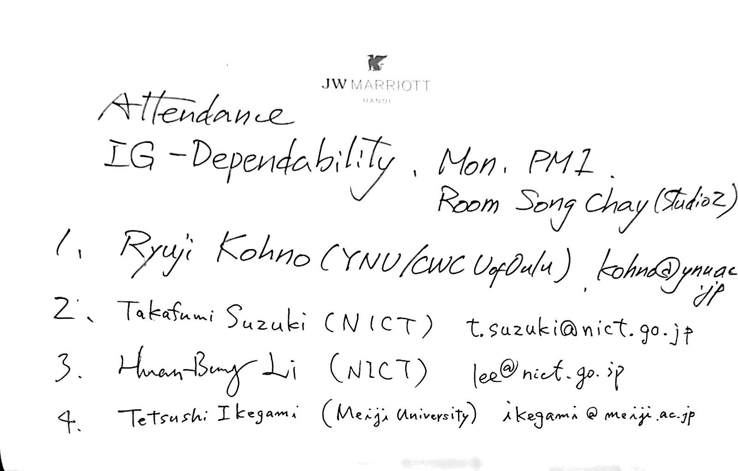

Tuesday September 17th 2019, PM2, 16:00-17:30
Room; Song Chay (Studio 2) in JW Marriott Hotel Ha Noi

  - Meeting called to order 16:01
By Chair Ryuji Kohno (YNU / CWC Uof Oulu)

  - Roll Call
Notepad for Attendance circulated.

  - Quick review of the last session
Invited keynote speaker in WNG session on Wednesday Dr. Takafumi Sasaki (NICT) explained necessity for revision or amendment of existing standard of medical wireless BAN IEEE802.15.6 applicable to 40 times more sensors and 5 times higher aggregate data rate for EEG or ECoG in Brain Machine Interface(BMI) for Brain Networks and Communication.

  - Presentation
Before discussing update of technical requirement for a new focused application such as Brain-Machine-Interface(BMI), enable MAC and PHY technologies to ensure enhanced dependability have been presented as possible solution to ensure enhanced dependability.

- Update MAC protocol with interference mitigation using negotiation among coordinators in multiple wireless body area networks doc.#15-19-0401-00-0dep
In multiple BANs overlaid environment, negotiation among coordinators can avoid unnecessary contention base delay for high priority QoS packets while scarifying performance of lower priority QoS packets. Some drawback of the previous proposed MAC could be resolved to improve worst and average throughput in high offered load or high packet traffic environment.

- Transmission power control using integrated terminal between 5G and UWB-BAN to maximize throughput of the BAN doc.#15-19-0327-00-0dep
According to trend of 5G, IoT/M2M, and increase of WBAN application beyond medical BAN, their overlapped coverage range of these networks will increase. UWB radio regulation in Japan was updated to promote its more applications. In order to solve such a problem, a new scheme of controlling transmission power of UWB-BANs has been proposed to avoid interference to 5G terminals overlapped in coverage range. Current standard IEEE802.15.6 for WBAN should be updated to apply this proposed scheme in physical layer to solve a coexistence problem between primary user 5G and secondary user UWB-BAN.

- Maximizing Power Supply Efficiency with Amplification in Relay Nodes for Multi-Hop Relay Wireless Power Transmission doc.#15-19-0418-00-0dep
Wireless network dependability should cover sustainable power supply. To keep supplying power, wireless power transmission (WPT) technology can be applied for a relatively longer distance about 10m in microwave band. This presentation introduces a new research result on multi-hop relay WPT scheme in which optimal number of hops and best manner of additional power supply in a relay node have been theoretically derived.

  - Discussion
Coexistence between 5G and UWB-BAN, and overall performance in case of overlaid multiple BANs have been discussed as resolve inter- and intra-system interference problems to guarantee enhanced dependability as an amendment of 15.6 MAC and PHY.
By updating technical requirement for dependable BAN, focused use cases which have common requirement has been summarized.
Wireless power transmission with multi-hop relay method is taken into account for continuous and dependable wireless networks with remote power suppy.

  - Recess at 17:49.

  - Attendees 4

Takafumi Suzuki(NICT)
Huan-Bang Li(NICT)
Tetsushi Ikegami(Meiji Univ.)
Ryuji Kohno (YNU/CWC Uof Oulu)

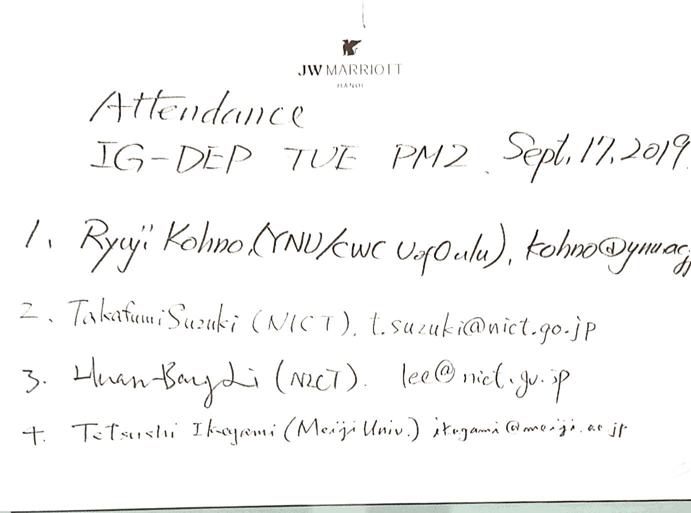

Wednesday September 17th 2019, AM2, 11:30-12:30
802.15 WNG Session
Room; Fansipan 2 (Salon B) in JW Marriott Hotel Ha Noi

IG-DEP invited Dr. Takafumi Suzuki as a keynote speaker in WNG session.
He gave a talk on
“Brain-Machine Interface based on Electrocorticography using high speed UWB wireless body area network.” doc.#15-19-0421-02-0dep

Around 50 audience listened to his presentation.
Agenda was below.

■ECoG-BMI system

■1st Genaration 128ch system： Clinical ECoG-BMI system
→ Clinical test in 2020

■2nd Generation 4096ch system
→ Next generation system
・Flexible electrode technology
・UWB wireless technology

■BMI (system evaluation)
・Real-time decoding
・Robotic arm control and cortical adaptation

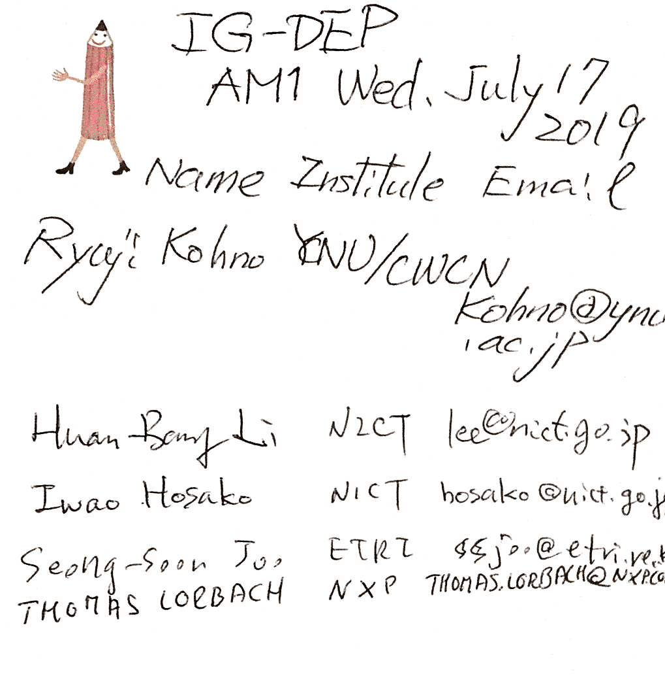
Wednesday September 17th 2019, PM1, 13:30-15:55
Room; Song Chay (Studio 2) in JW Marriott Hotel Ha Noi

  - Meeting called to order at 13:31

  - Roll Call

3.3 Update of Technical Requirement
After Dr. takafumi Suzuki’s keynote speech in WNG session, the following up discussion was done.
To include another use case of 2nd Generation of ECoEG for Brain-Machine-Interface(BMI), technical requirement has been updated to cover 4,096 units of ECoEG sensors with appropriate combination of no. of units x no. of sensors in a unit such as 64x64, 32x128, 16x256, 8x512, 4x1024 etc.
A draft of updating technical requirement for new focused applications was discussed.
- Updated Technical Requirements for Focused Use Cases on WBAN for Human, Robotic and Car Bodies doc.#15-19-0157-03-0dep

  - Discussion
Technical requirement corresponding to a new application on ECoG vital sensing for BMI was shortly discussed in the table of doc.#15-19-0157-03-odep. However, discussion was too short to complete update.
In next plenary session, Hawaii, clinical doctor and representative of BMI medical device company will come to give another presentation in WNG. Until the next plenary meeting, technical requirement table will be updated and completed in Hawaii.
IG-DEP will decide the next step to SG/TG in November or next January.

  - Adjourn 15:28

  - Attendees 4

Takafumi Suzuki(NICT)
Yeong Min Jang (Kookmin University)
Huan-Bang Li(NICT)
Ryuji Kohno (YNU/CWC Uof Oulu)

