IEEE P802.15
Wireless Personal Area Networks

Project | IEEE P802.15 Working Group for Wireless Personal Area Networks (WPANs)
Title | IEEE 802.15.4z PHY LRP – Comment resolution LB161
Date Submitted | 18-September-2019
Source | David Barras (3db-technologies)  Boris Danev (3db-technologies)  Peter Sauer (Microchip)
Re: | Letter Ballot comment resolution of draft Standard document P802.15.4z-D2
Abstract | This contribution proposes updated text for the baseline draft P802.15.4z-D2
Purpose | Provision of the text to facilitate its incorporation into the draft text of the IEEE 802.15.4z standard currently under development in TG4z.
Notice | This document does not represent the agreed views of the IEEE 802.15 Working Group. It represents only the views of the participants listed in the “Source(s)” field above. It is offered as a basis for discussion and is not binding on the contributing individual(s) or organization(s). The material in this document is subject to change in form and content after further study. The contributor(s) reserve(s) the right to add, amend or withdraw material contained herein.
Release
Patent Policy | The contributor is familiar with the IEEE-SA Patent Policy and Procedures:  <http://standards.ieee.org/guides/bylaws/sect6-7.html#6> and  <http://standards.ieee.org/guides/opman/sect6.html#6.3>.  Further information is located at <http://standards.ieee.org/board/pat/pat-material.html> and  <http://standards.ieee.org/board/pat>.

Comments Resolutions for the TG4z Recirculated Draft (P802.15.4z-D2.pdf, LB161)

r1-0876, r1-0877, r1-0879 Resolution:

1) update Table 59;
2) modify section titles and description on line 13, p. 153.

19.9 LRP UWB Return Time Transmit and Receive Timing Requirements

19.9.1 Receive-to-transmit turnaround Fixed reply time

The receive-to-transmit turnaround reply time for a device with phyFixedReplyTimeSupported attribute value of TRUE shall be the fixed reply time as specified in Table 59 selected by the phyLrpUwbFixedReplyTime attribute.

Table 59 – Fixed reply times for the LRP-ERDEV
Value of the phyLrpUwbFixedReplyTime  attribute | Selected fixed reply time  [μs]  [RSTU, number of base chip period]
FRT3 | 3
FRT7 | 7
FRT15 | 15
FRT31 | 31

Reminder: base chipping rate (RSTU) is defined in 6.9.1.2 of first draft version (P802.15.4z-D1.pdf)

Reminder: timing accuracy has been defined in section 19.7.2 of first draft version (P802.15.4z-D1.pdf):

19.7.2 Pulse timing

Insert the following new paragraph in clause 19.7.2 after the first paragraph:

For a LRP-SRDEV, the transmission time of any individual pulse shall not drift more than 2 ns from its nominal transmission time during 128 pulse periods transmitted at the lowest PRF of 1 MHz over the specified operating temperature range of the device.

3) Provide a picture that accurately describes timing for fixed reply time

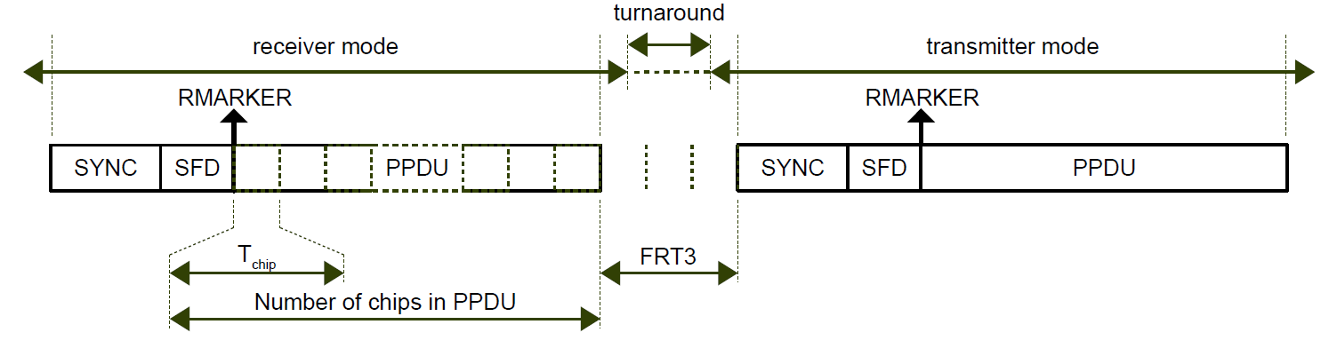

Figure XX – Fixed reply time as a function of FRTx parameter for LRP-ERDEV

Assuming perfectly synchronized transmitter and receiver, a fixed reply time of FRTx corresponds to a equivalent time of FRTx+1 between the active portion (pulses) of the last received chip and the first transmitted chip. In the exemple above, a fixed reply time value of FRT3 defines a pulse-to-pulse fixed reply time of 4 RSTU.

4) Rewrite 19.9.2 in a cleaner way as follows

19.9.2 Transmit-to-receive Turnaround times

The transmit-to-receive turnaround times for a device with phyFixedReplyTimeSupported attribute value of TRUE set to true shall be less than the fixed reply time as specified in Table 59 selected by the phyLrpUwbFixedReplyTime attribute.

When phyFixedReplyTimeSupported attribute is set to true, the turnaround time for a device to be configured from receiver to transmitter mode and from transmitter to receiver mode shall be less than the fixed reply time as specified in Table 59 selected by the phyLrpUwbFixedReplyTime attribute .

r1-0852 Resolution:
Modify lines 11 and 12, p. 142, as proposed below:

19.2.4.2 Dual-frequency and extended dual-frequency (without EPC)

The pulse is nominally sent in the center of the symbol chip period Tdsym T_{chip} as shown in Figure 19-1 for the base mode and Figure 19-2 for the extended mode,…

r1-0388, r1-0398, r1-0405, r1-0405, r1-0409, r1-423 Resolution:
1) Modify text in rectangle boxes of Figures 38, 39, 41, 42, 44

See contribution 15-19-0259-03-004z-lb-comment-resolution-clause-6.9.9

Add Text for Reference [B4] and Table 60 in 19.10

Table 60 – Distance commitment level definition for authenticated ranging

DistanceCommitmentLevel | T_{int,RF} aperture time | Maximum distance manipulation
DCL_1_4096 | RSTU/4096 | 0.075 m
DCL_1_2048 | RSTU/2048 | 0.15 m
DCL_1_1024 | RSTU/1024 | 0.29 m
DCL_1_512 | RSTU/512 | 0.59 m
DCL_1_256 | RSTU/256 | 1.17 m
DCL_1_128 | RSTU/128 | 2.34 m
DCL_1_64 | RSTU/64 | 4.7 m
DCL_DISABLED | N/A | N/A

Analysis and Implementation guidelines Distance Commitment are provided in Section 2 of “Authenticated Ranging of 802.15.4” [B24].

