IEEE P802.15
Wireless Personal Area Networks

Project | Dependability Interest Group
Title | Meeting Minutes for July 2019
Date Submitted | July 18th, 2019
Source | [Ryuji Kohno]  [YNU(Yokohama National University)/CWC-Nippon] | Voice: +81 90 3061 7978  +358 40 354 0034  E-mail: kohno@ynu.ac.jp  ryuji.kohno@ee.oulu.fi
Re: | Meeting Minutes
Abstract | IG-DEP activities as amendment of existing IEEE802.15.6 for WBAN or a new standard, conventional focused use cases, additional use cases, technical requirement, draft of PAR and CSD have been rereviewed. Cooperation with ETSI smart BAN and smart M2M projects has been discussed including commonality and difference although ETSI is directing smart implementation while IG-DEP is focusing on dependability for high QoS and QoL. According to request from BMI Center of NICT, IG-DEP restarts amendment of 15.6 standard for medical BAN applicable to 40 times more sensors and 5 times higher aggregate data rate for EEG or ECoG. Coexistence between 5G and UWB-BAN, and overall performance in case of overlaid multiple BANs have been discussed as resolve inter- and intra-system interference problems to guarantee enhanced dependability as an amendment of 15.6 MAC and PHY. By updating technical requirement for dependable BAN, focused use cases which have common requirement has been summarized.
Purpose | Minutes of Dependability Interest Group sessions
Notice | This document has been prepared to assist the IEEE P802.15. It is offered as a basis for discussion and is not binding on the contributing individual(s) or organization(s). The material in this document is subject to change in form and content after further study. The contributor(s) reserve(s) the right to add, amend or withdraw material contained herein.
Release | The contributor acknowledges and accepts that this contribution becomes the property of IEEE and may be made publicly available by P802.15.

Monday, July 15th, 2019, AM1, 8:00-10:00
Room: 0.15

  - Meeting called to order 10:31
By Chair Ryuji Kohno (YNU / CWC-Nippon)

  - Roll Call
Notepad for Attendance circulated.

  - Opening Report
Chair presented Opening report doc.#19-0282-00
Chair showed IEEE Patent policy.
Chair issued Call for Potentially Essential Patents
No essential intellectual property in the scope of IG DEP was declared.
Chair presented agenda this week doc.#19-0283-00

  - Approval of previous meeting minutes
Upon no comments on the previous meeting minutes, doc #19-0141-00 was approved.

  - Review of ID DEP activities
- Overview of IG DEP activities for Cars and other IoT & M2M Use cases and Amendment of IEEE802.15.6 Wireless Medical doc.#15-18-0347-00
- Overview of ETSI Smart BAN Project Activities doc.#15-18-0535-01
- Overview of IEEE802.15.6 for Wireless Medical BAN doc.#15-18-0384-00
- Updated Technical Requirements for Focused Use Cases on WBAN for Human, Robotic and Car Bodies 9oc.#15-19-0157-00

  - Discussion
Cooperation with ETSI smart BAN and smart M2M projects has been discussed including commonality and difference although ETSI is directing smart implementation while IG-DEP is focusing on dependability for high QoS and QoL.

Commonality and difference between IG-DEP and Smart BAN have been identified.
1. ETSI Smart BAN is focusing on (1) Easier implementation of more efficient MAC and PHY, yielding very low latency emergency messaging, very low energy consumption and rapid initial set up time and channel reassignment. (2) Extension to multiple BANs environment, (3) Extension from a star topology + one hop to a star + multiple hop relay, (4) Covering narrow band solution in PHY for BAN
2. IG-DEP focuses on enhanced dependability in PHY and MAC while smart BAN does on smart or smart implementation. IG-DEP covers only PHY and MAC layers while smart BAN covers network layer, security, Quality-of-Service (QoS) and provision of generic applications and services. IG-DEP covers UWB and narrowband solutions in PHY while smart BAN does only narrowband one. IG-DEP focuses on car and robotic bodies as well as human body as an extension of IEEE802.15.6 for wireless medical BAN while smart BAN does on only digital healthcare for human body and smart M2M does on more general use cases of M2M including car and machines.

As amendment of IEEE802.15.6, MAC for multiple BANs coexistence can be guaranteed to satisfy permissible delay or back-off time and throughput of high QoS packets for all car, robotic and human BANs while maintaining overall average performance.

  - Recess at 09:50.
  - Attendees 5
Iwao Hosaka (NICT)
Thomas Kürner (Technische Universität Braunschweig)
Bo Kun Juy (TUBS)
Seong-Soon Soo (ETRI)
Ryuji Kohno (YNU/CWC-Nippon)

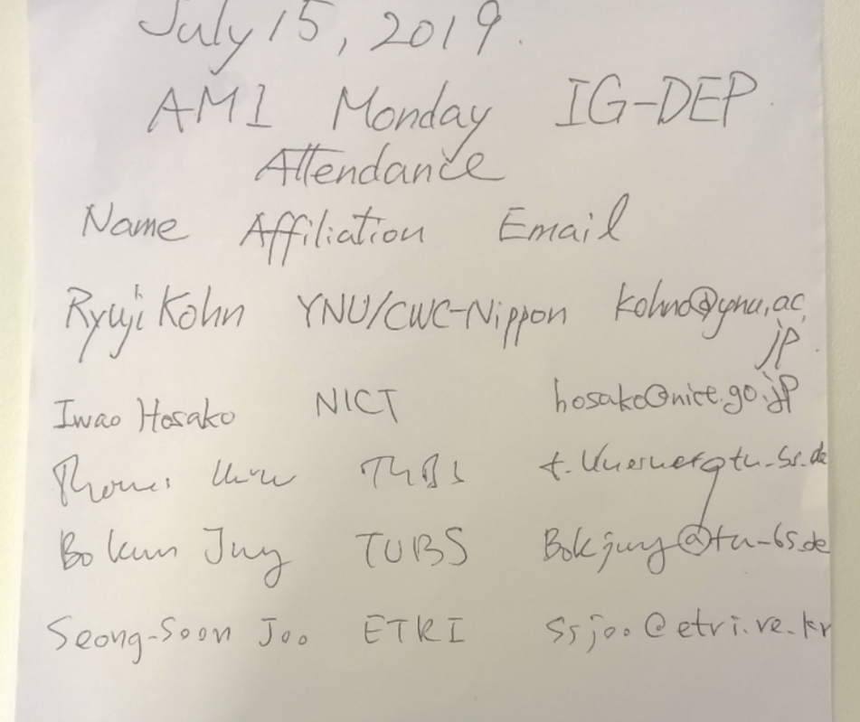

Wednesday 17 July 2019, AM1, 8:30-10:00
Room; 0.16

  - Meeting called to order 8:30
By Chair Ryuji Kohno (YNU / CWC-Nippon)

  - Roll Call
Notepad for Attendance circulated.

  - Quick review of the last session
New information about prospective supporter and sponsor for IG-DEP is announced. Center for Brain Networks and Communication Laboratory of NICT requests IG-DEP to revise IEEE802.15.6 standard for medical BAN applicable to 40 times more sensors and 5 times higher aggregate data rate for EEG or ECoG.

  - Presentation
Before discussing update of technical requirement for a new focused application such as Brain-Machine-Interface(BMI), enable MAC and PHY technologies to ensure enhanced dependability have been presented as possible solution to ensure enhanced dependability.

- Transmission power control using integrated terminal between 5G and UWB-BAN to maximize throughput of the BAN doc.#15-19-0327-00-0dep
According to trend of 5G, IoT/M2M, and increase of WBAN application beyond medical BAN, their overlapped coverage range of these networks will increase.
UWB radio regulation in Japan was updated to promote its more applications.
In order to solve such a problem, a new scheme of controlling transmission power of UWB-BANs has been proposed to avoid interference to 5G terminals overlapped in coverage range.
Current standard IEEE802.15.6 for WBAN should be updated to apply this proposed scheme in physical layer to solve a coexistence problem between primary user 5G and secondary user UWB-BAN.

- Dependable MAC protocol with interference mitigation using negotiation among coordinators in multiple wireless body area networks doc.#15-19-0291-00-0dep
In multiple BANs overlaid environment, negotiation among coordinators can avoid unnecessary contention base delay for high priority QoS packets while scarifying performance of lower priority QoS packets.

- Localization of Implanted Devices Combining TDOA, Particle Filter
and Map Mapping with WBAN doc.#15-18-0290-00-0dep
By modelling feedback decision rule of sensing vital signs such as glaucous level of blood and its corresponding feedback command such as insulin level to be injected, a pair of uplink packets from sensor nodes to coordinator and their corresponding downlink packets from coordinator to wearable actuator node can be assumed and used to design accessing time schedule for the pair.

  - Discussion
Coexistence between 5G and UWB-BAN, and overall performance in case of overlaid multiple BANs have been discussed as resolve inter- and intra-system interference problems to guarantee enhanced dependability as an amendment of 15.6 MAC and PHY.
By updating technical requirement for dependable BAN, focused use cases which have common requirement has been summarized.

  - Recess at 10:09.

  - Attendees 5

Huan-Bang Li(NICT)
Iwao Hosako(NICT)
Seong-Soon Joo(ETRI)
Thomas Kürner (Technische Universität Braunschweig)
Ryuji Kohno (YNU/CWC-Nippon)

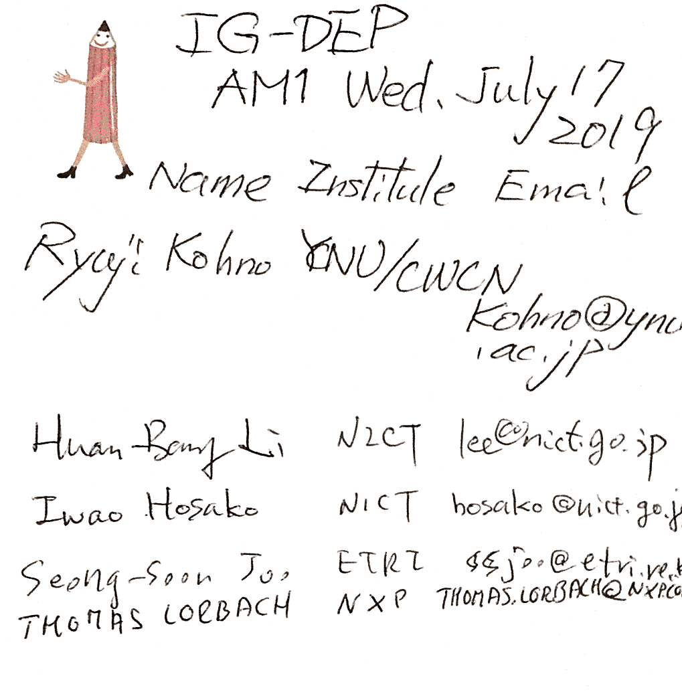

Wednesday 17 July 2019, PM1, 13:30-15:30
Room; 0.16

  - Meeting called to order at 13:33

  - Roll Call

3.3 Update of Technical Requirement
To include another use case of 2nd Generation of ECoEG for Brain-Machine-Interface(BMI), technical requirement has been updated to cover 4,096 units of ECoEG sensors with appropriate combination of no. of units x no. of sensors in a unit such as 64x64, 32x128, 16x256, 8x512, 4x1024 etc.
A draft of updating technical requirement for new focused applications was discussed.
- Updated Technical Requirements for Focused Use Cases on WBAN for Human, Robotic and Car Bodies doc.#15-19-0157-02-0dep

  - Discussion
Since technical requirement for new focused applications in the table of doc.#15-19-0157 has been discussed and updated to compare with the ready listed technical requirement for the focused automotive use cases. It has been mostly completed.
IG-DEP will decide the next step to SG/TG in September meeting, Vietnam.

  - Adjourn 15:28

  - Attendees 3

Seong-Soon Joo(ETRI)
Iwao Hosaka(NICT)
Ryuji Kohno (YNU/CWC-Nippon)
