IEEE P802.15
Wireless Personal Area Networks

Project | IEEE P802.15 Working Group for Wireless Personal Area Networks (WPANs)
Title | IEEE 802.15.4z PHY LRP - CRG
Date Submitted | 30-July-2019
Source | David Barras (3db-technologies)  Boris Danev (3db-technologies)  Peter Sauer (Microchip)
Re: | Letter Ballot comment resolution of draft Standard document P802.15.4z-D1
Abstract | This contribution proposes updated text for the baseline draft P802.15.4z-D1
Purpose | Provision of the text to facilitate its incorporation into the draft text of the IEEE 802.15.4z standard currently under development in TG4z.
Notice | This document does not represent the agreed views of the IEEE 802.15 Working Group. It represents only the views of the participants listed in the “Source(s)” field above. It is offered as a basis for discussion and is not binding on the contributing individual(s) or organization(s). The material in this document is subject to change in form and content after further study. The contributor(s) reserve(s) the right to add, amend or withdraw material contained herein.
Release
Patent Policy | The contributor is familiar with the IEEE-SA Patent Policy and Procedures:  <http://standards.ieee.org/guides/bylaws/sect6-7.html#6> and  <http://standards.ieee.org/guides/opman/sect6.html#6.3>.  Further information is located at <http://standards.ieee.org/board/pat/pat-material.html> and  <http://standards.ieee.org/board/pat>.

Editorial Comments (in complement to Excel file’s “Resolution Detail”)

i-0100:
Resolution: Replace the whole section 19.3.2.1 by the following one (including new Table 42)

19.3.2.1 Additional SFD for LRP-ERDEV

The SFD for the LRP-ERDEV UWB PHY can be of length 32, 64 or 128 pulse periods selected by the phyLrpUwbSfdSSelector PIB attribute from the sequences specified in Table 42. In all cases transmission order is b0 (leftmost and topmost bit in each line of Table 42) first in time. The length 128 SFD selected by phyLrpUwbSfdSSelector attribute value of 7 shall be the default for the LRP-ERDEV.

Table 42 - SFD sequences for the LRP-ERDEV

SFD length | phyLrpUwbSfdSSelector  PIB attribute value | Selected SFD sequence (b0 to b32/b64/b128)
32 | 0 | 1000 0100 1011 0011 1110 0011 0111 0100
 | 1 | 0001 1011 1100 0010 1011 1001 0110 1100
64 | 2 | 0001 0111 0010 1100 1000 0101 0111 1100  0011 1100 1110 1110 0010 1010 1100 0110
 | 3 | 0011 0101 1111 0011 0010 1011 0100 1111  1000 1100 1001 0111 0000 0000 1010 1110
 | 4 | 0111 0111 1101 1110 1101 0001 1010 1100  1011 0111 1001 0000 1001 0010 0000 1000
 | 5 | 1111 0011 1000 0101 0010 0100 0110 1010  1100 0001 1001 1111 1011 0111 0100 0100
 | 6 | 1011 0001 1010 1000 1101 1110 1000 1001  1111 1010 1001 1000 0010 0101 1110 0010
128 | 7 | 1000 0001 0001 0011 0001 0111 0101 1011  0000 0110 0110 1010 0111 0011 1101 1010  0001 0101 0111 1101 0010 1000 1101 1100  0111 1111 0000 1110 1111 0010 1100 1000
 | 8 | 1100 1110 0011 1010 0011 1010 0000 1011  0110 0010 0101 0000 1001 0100 1100 0001  0010 0101 0101 1110 1100 0001 0111 1110  1000 1001 1110 0001 0001 0011 1001 0001
 | 9 | 0101 1000 1001 0010 0000 1000 0001 0110  0001 0001 1101 1101 0000 1100 1101 0000  1101 0001 1000 1111 1011 1010 0000 1001  0111 1001 0100 1101 0101 1100 1011 1001

Technical Comments

i-0101 / i-523 / i-0524:
Resolution: Replace section 19.4.7 by the following sections

19.4.7 Short Ranging Frame for LRP-ERDEV

When the device is configured as an LRP-ERDEV, the PHR can be omitted as all the relevant information (encoding type, frame length, LEIP position and length) are defined through PIB or MCPS attributes. The PSDU portion of the message is sent directly after the SFD, saving time and power and potentially improving the link budget in energy limited systems. The PPDU format is built as shown in Figure 82.

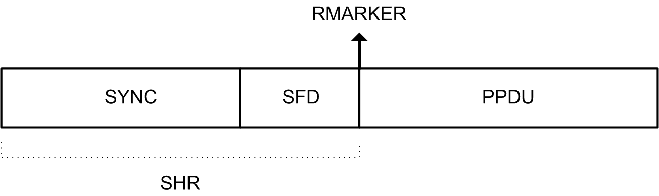

Figure 82—LRP-ERDEV PPDU short ranging frame

i-0157:
Resolution: Add the following cells into Table 11-2 “PHY PIB attributes”:

Attribute | Type | Range | Description
phyLrpUwbPrp | Integer | 0 to 7 | For LRP-ERDEV, this attribute specifies which pulse repetition period shall be used. The value corresponds to the factor k_{PRP} defined in Table 41.

i-1820 / i-1821 :
Resolution: Questions addressed in document 15-19-0261-04-004z

Add section “19.6 Distance Commitment on PSDU”
Resolution: This addresses comment from James Gilb during public discussion on Annex G (Monday, 15.07 PM1 session) to move Distance Commitment from Annex G to Clause 19.

19.6 Distance Commitment on PSDU

Distance commitment on data is a decoding method that only captures the energy during short active RF periods within each symbol of the PSDU. The position of short active period within a symbol duration is selected from information of the channel obtained during the preamble such that the earliest path(s) are captured. Figure 1 illustrates the distance commitment principle.

Figure 1 Distance commitment principle and RF integration window

Distance commitment assumes that channel state information (channel impulse response) is available after the SHR. The earliest path(s) are extracted from the channel state information available after the SHR is processed. This extraction is typically achieved by setting an appropriate threshold above the noise level at the receiver.

During reception of PSDU only the “earliest path(s)” of the received signal shall be used for symbol decoding. The aperture T_{int,RF} is the allowed window duration for collecting and integrating the incoming RF energy at the receiver. Distance commitment ensures that the symbols of the PSDU are decoded at the measured distance by the earliest detected path(s).

In Section 8.3 the MCPS-RANGING and MCPS-RANGING-REPLY DistanceCommitmentLevel defines the supported aperture T_{int,RF} to collect the earliest paths and integrate the corresponding RF energy for symbol decoding.

