IEEE P802.15
Wireless Specialty Networks
IEEE P802.15.13
Text proposal for clause 4
Date: 2019-07-15
Author:
Name | Affiliation | Address | Phone | Email
Kai Lennert Bober | Fraunhofer HHI |  |  | kai.lennert.bober@hhi.fraunhofer.de
Volker Jungnickel | Fraunhofer HHI

Abstract

This document contains proposed text for clause 4 of IEEE P802.15.13.

  - Introduction
Optical wireless communication (OWC) transmits data by intensity-modulating optical sources, such as light- emitting diodes (LEDs) and laser diodes (LDs), faster than the perception of the human eye. OWC merges lighting infrastructures and data communications in applications such as area lighting, signboards, streetlights, vehicles, and traffic signals. This standard describes the use of OWC for wireless specialty networks (WSN). Some of the characteristics found in this standard are as follows:
- Star topology supporting point-to-point, broadcast and MIMO operation
- 16-bit short or 48-bit extended addresses
- Scheduled or polled access, random initial access
- Acknowledgement protocol for transfer reliability
  - Components of IEEE 802.15.13 networks
An OWSN constitutes of standard-compliant devices. Devices carry a 48-bit MAC address for identification and flat addressing in the network. During association with the network, 16-bit short addresses are allocated to devices.

Devices constitute of a standards-compliant MAC implementation and make use of a compliant PHY defined in the standard. Not all devices are required to implement functionality to maintain an OWSN. Devices, which support that functionality, are also referred to as coordinator-capable devices or coordinators if they actively maintain an OWSN.

In each OWSN, a single coordinator-capable device assumes the role of the coordinator. The coordinator is responsible for starting, maintaining and finally stopping the OWSN. The coordinator is furthermore involved in all data transmissions in the OWSN.

Non-coordinator devices, subsequently also simply referred to as devices, implement less functionality than coordinators. Devices associate with an OWSN in order to gain layer 2 connectivity with the network.

Each OWSN has an identifier. This OWSN identifier allows communication between devices within a network using short addresses. The mechanism by which OWSN identifiers are chosen is outside the scope of this standard.
  - Network topologies
IEEE 802.15.13 OWSNs have a logical star topology. The protocol does not include fields to explicitly signal the type of topology. A single coordinator is involved in all data transmission between two devices or between external peers and the devices associated with the OWSN as illustrated in Figure 1. The coordinator offers the MAC service at its MCPS-SAP. Data transmissions between two devices of the same OWSN are forwarded by the coordinator.
802.15.13 networks that are not members of a coordinated topology operate independently from all other networks currently in operation. This is achieved by choosing an OWSN identifier that is not currently used by any other network within the coverage area. Once the OWSN identifier is chosen, the coordinator allows other devices to join its network. The higher layer is allowed to use the procedures described in clause 5 to form a star network.
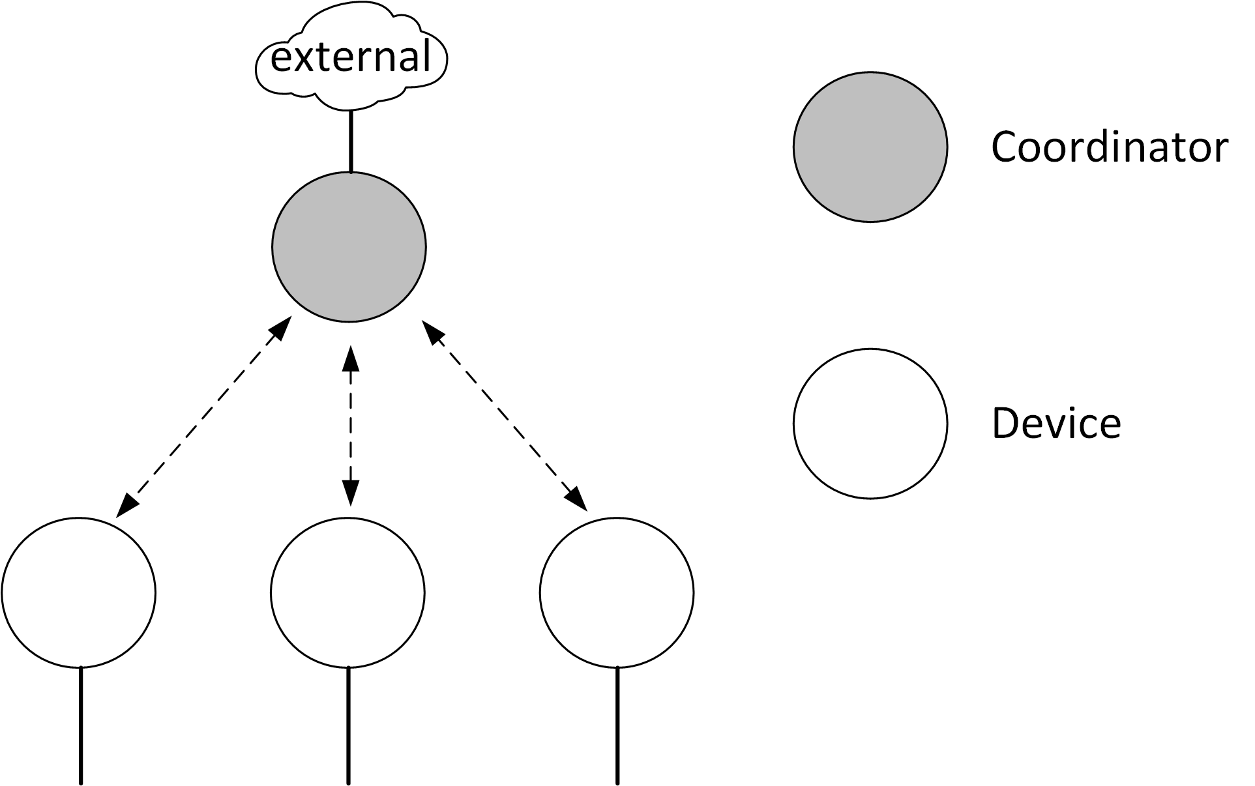
Figure 1: Basic star topology

Basic star topology
Depending on the application, the star topology is used to realize different physical topologies. The subsequent clauses list different special cases of star topologies to be realized.
    - Distributed MIMO star topology
To improve robustness of transmissions and enhance mobility support, the star topology may be realized supporting MIMO principles. In the MIMO star topology, the coordinator has multiple optical frontends (OFEs) for transmission and reception connected with its PHY. Over each OFE, the coordinator is able to transmit the same or different signals via multiple transmit and receive chains. Individual OFEs are transparent to the device. The device observes a single logical coordinator.

The realization of the distributed MIMO star topology is out of scope of this standard. For example, the OFEs may be distributed in space and connected to the single central coordinator instance via fronthaul technology, e.g. according to IEEE 802.1CM-2018. To regard for such possibilities, the standard defines means that are helpful for realization. These are, among others, the possibility to transmit multi-OFE pilot signals from each OFE at the physical layer and measure them at the PHY in the receiving device. The MAC supports MIMO transmissions through a channel access mechanism that is able to cope with fronthaul delays for individual OFEs. This includes scheduled medium access as well as the possibility for delayed acknowledgment.

The distributed MIMO star topology is illustrated in Figure 2.
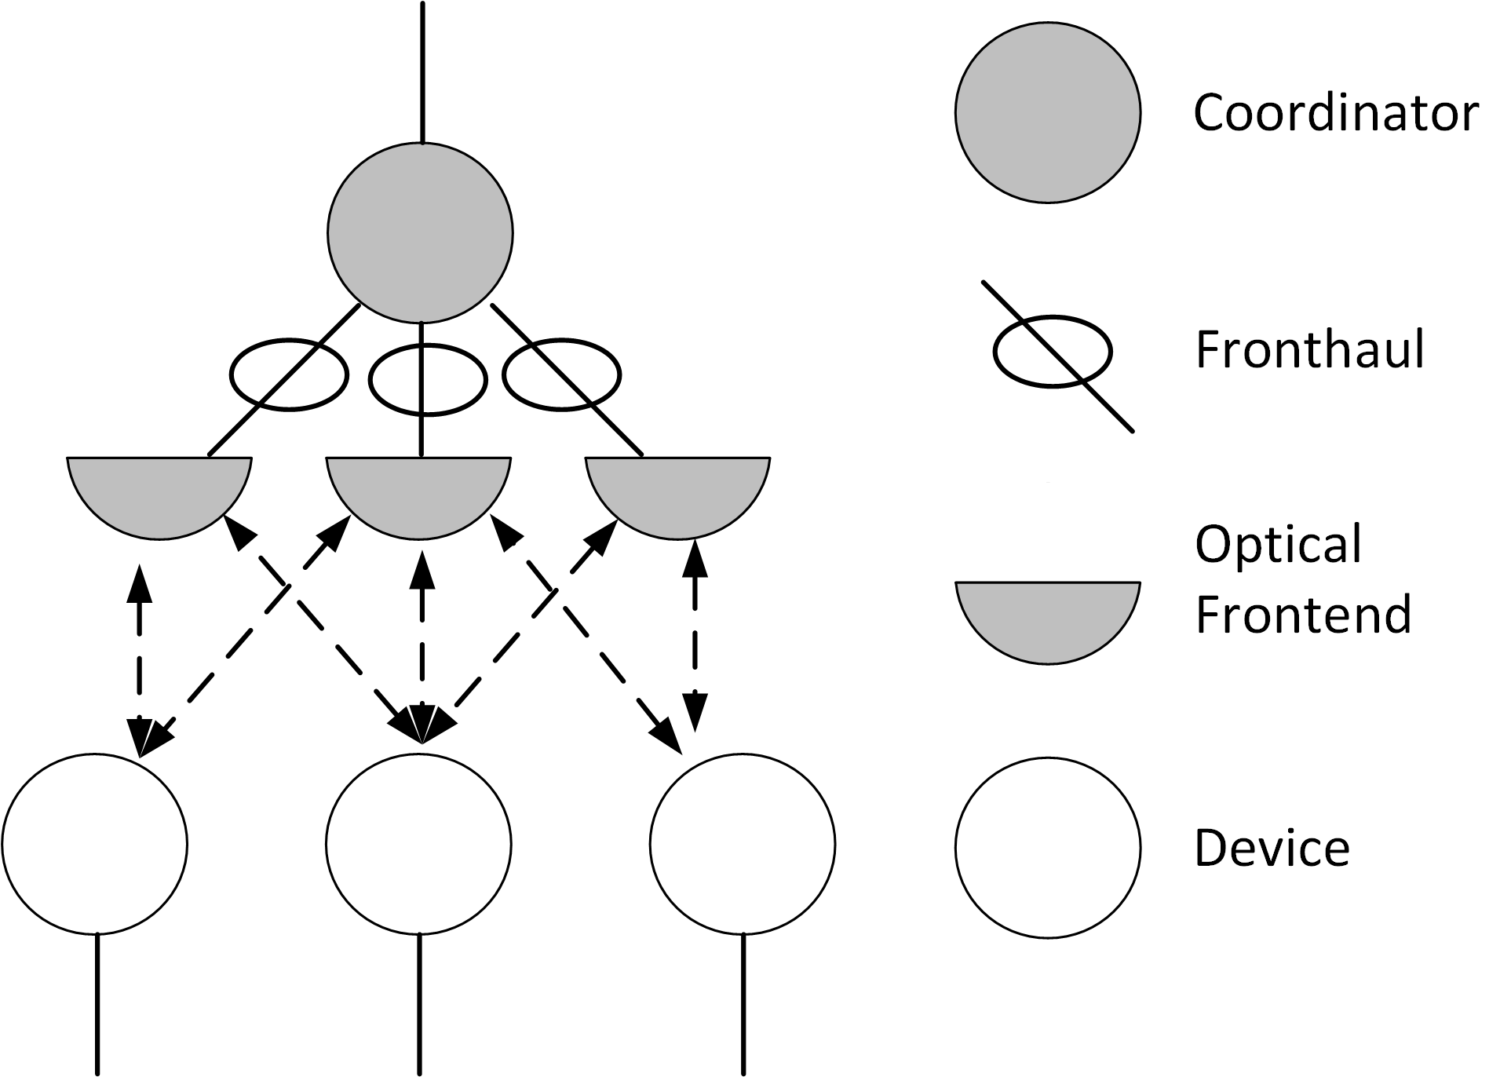
Figure 2: Distributed MIMO star topology

    - Broadcast topology
In the broadcast topology, the OWPAN comprises only the coordinator. The broadcast topology is depicted in Figure 3. The coordinator in broadcast mode transmits frames with the broadcast address as destination address which are received by all devices, even if not associated to any OWPAN.

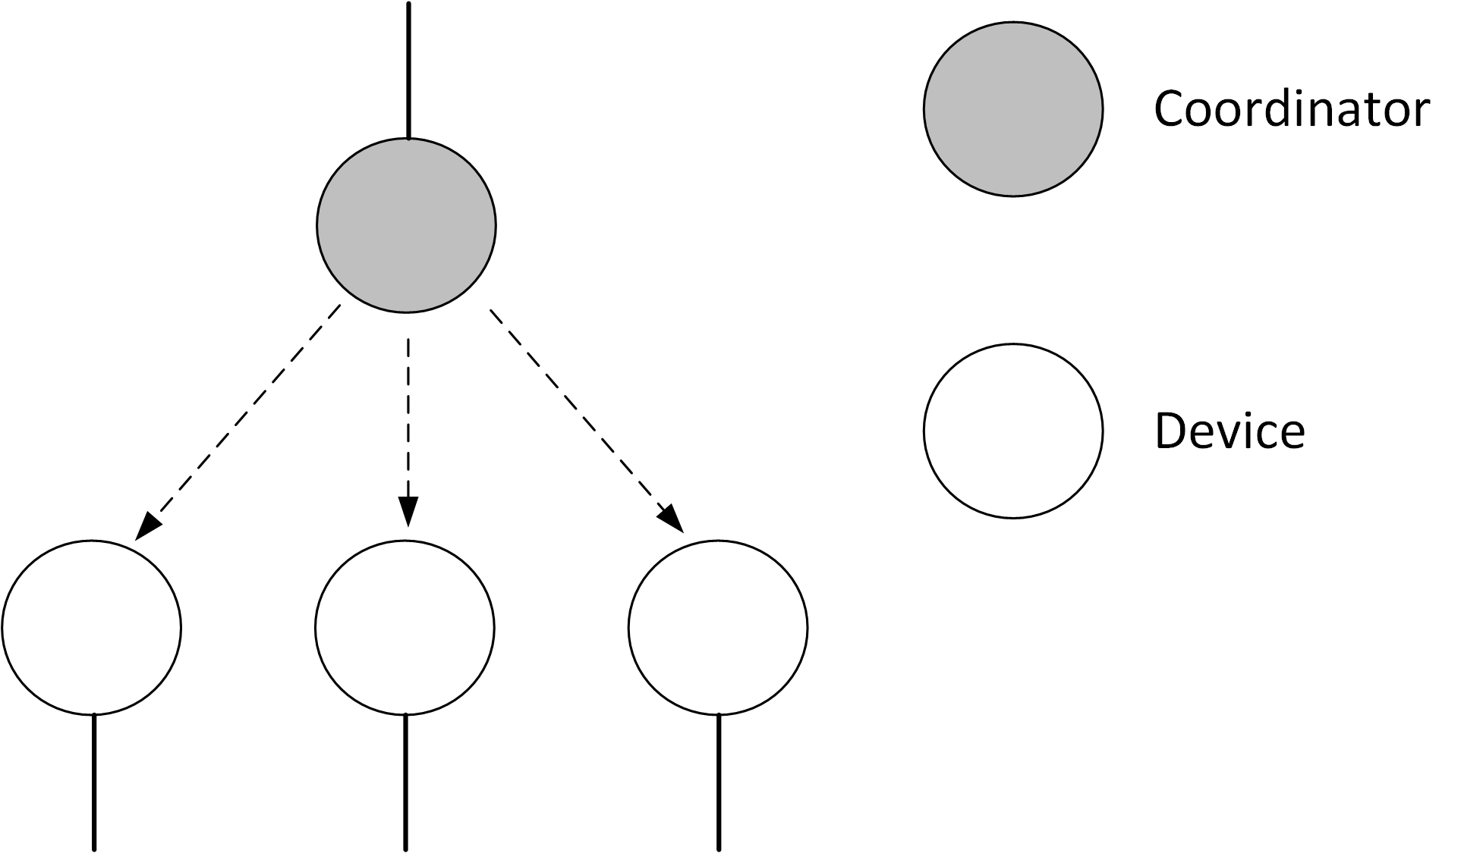
Figure 3: Broadcast topology

    - Coordinated star topology
Multiple coordinators deployed in the same area may be coordinated by a master coordinator. The corresponding topology is called coordinated star topology.

The functionality of the master coordinator is out of scope of the standard. Coordinators are connected with the master coordinator via the backhaul network. The master coordinator may be in charge of various kinds of coordination among the multiple OWSNs, e.g. handover, interference management, OWSN status monitoring, and more. For that purpose, coordinators may be synchronized, e.g. via the precision time protocol (PTP) v2 (IEEE Std 1588v2).

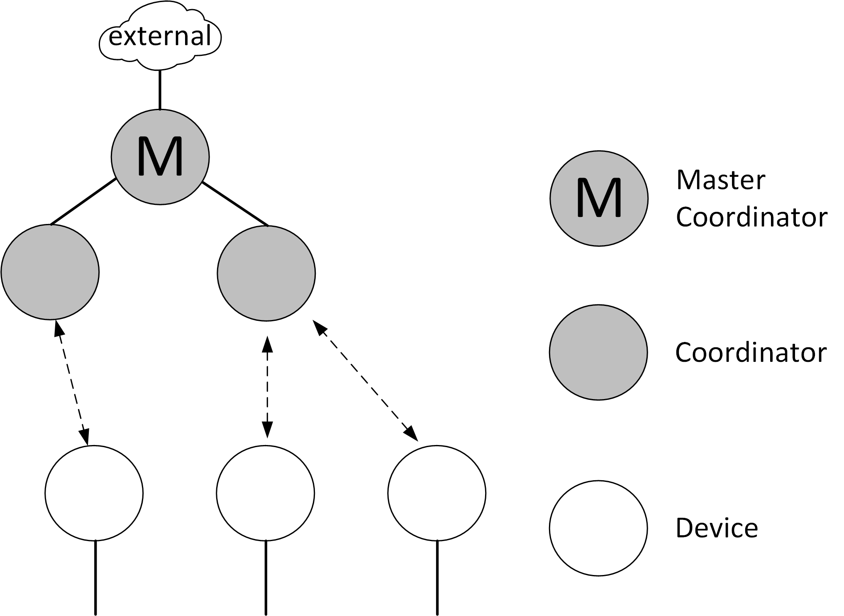
Figure 4: Coordinated star topology

As light is a highly local medium, a single area is typically not equipped with multiple uncoordinated infrastructures from different providers. Thus, it is assumed that neighboring IEEE 802.15.13 OWSNs will be deployed in a coordinated manner. If multiple OWSN infrastructures overlap in their coverage area, they should always be coordinated by a master coordinator, managing resource allocations between the corresponding coordinators.
    - Radio frequency hybrid topology
The hybrid topology involves an optional RF-based connection at each device. The realization of the hybrid topology is out of scope of the standard. It is expected that the coordination of the alternate OWC- and RF-based connections is performed above the 802.15.13 MAC, for example according to 802.1AX.
    - Peer-to-peer topology
In the peer-to-peer topology, two devices seek to perform layer 2 point-to-point communication with each other. In that case, one of the devices assumes the coordinator role, providing an OWSN to the other device. Therefore, the peer-to-peer topology is a special case of the star topology, involving a coordinator and a single non-coordinator device associated with the provided OWSN.
  - Relay functionality
With the relay functionality, an intermediate relay is used to assist a transmission via a direct optical wireless link. With the relay functionality, each relay supports different duplexing and relay modes. For full duplex (FD), the relay receives and transmits data simultaneously, while in half duplex (HD), the relay receives the data in one time slot and retransmits it in another transmission slot. The relay supports two modes; amplify-and-forward (AF), and decode-and-forward (DF).
- In AF mode, the RD receives the data from the coordinator, which are then retransmitted after amplification.
- In DF mode, the received data is decoded by the relay and then retransmitted to the destination device.
In case the device is disconnected from the coordinator, a relay search request is conducted, including the relay capabilities. The coordinator broadcasts a relay search request frame. Each relay replies back on the control channel with its own capabilities including duplexing and relaying modes. The coordinator selects the relay that provides the best connectivity to a device. The coordinator sets up a relay link between itself and the device through the selected relay. A connection remains active until the direct link between the coordinator and the device is reinitiated and the coordinator requires a termination of the link between the coordinator and the relay.
  - Coexistence
The directivity of light imposes difficulties on coexistence schemes that are based on energy detection. This is in contrast to RF-based communication technologies in the low GHz bands with their omnidirectional propagation characteristics. Through these omnidirectional characteristics, heterogeneous RF-technologies that feature not mutually decodable signals, can rely on refraining from transmissions after the channel is detected busy by exceeding a given signal energy threshold (CCA through energy detection).

Through the directivity, however, a device A is not always able to infer that a second device B’s transmission is currently received at device A’s prospective receiver C.

This standard restricts uncoordinated transmissions, i.e. random channel access, to the minimum required purposes such as association or reconnection. However, in case of alien technologies entering the coverage area of an IEEE 802.15.13 OWSN, the behavior is unspecified. Currently, there is no coexistence coordination among different OWC standards.

The IEEE 802.15.13 standard supports one PHY type also used by ITU-T recommendation G.9991 (G.vlc), which however uses a different MAC. Coexistence between both standards is possible through specific PHY frame types.
  - Architecture
The IEEE 802.15.13 architecture is defined in terms of a number of layers and sublayers in order to simplify the standard. Each layer is responsible for one part of the standard and offers services to the higher layers. The interface between the layers serve to define the logical links that are described in this standard.
An OWSN device comprises of a physical layer (PHY), which contains the optical wireless transceiver along with its low-level data, control and management mechanisms, and a medium access control (MAC) layer that provides access to the physical channel for all these types of transfers. Figure 5 shows these layers in a graphical representation, which are described in more detail in 4.6.1 and 4.6.2.
Each device involves a device management entity (DME), responsible for managing network functions. DME invokes MLME functionality through the MLME-SAP.
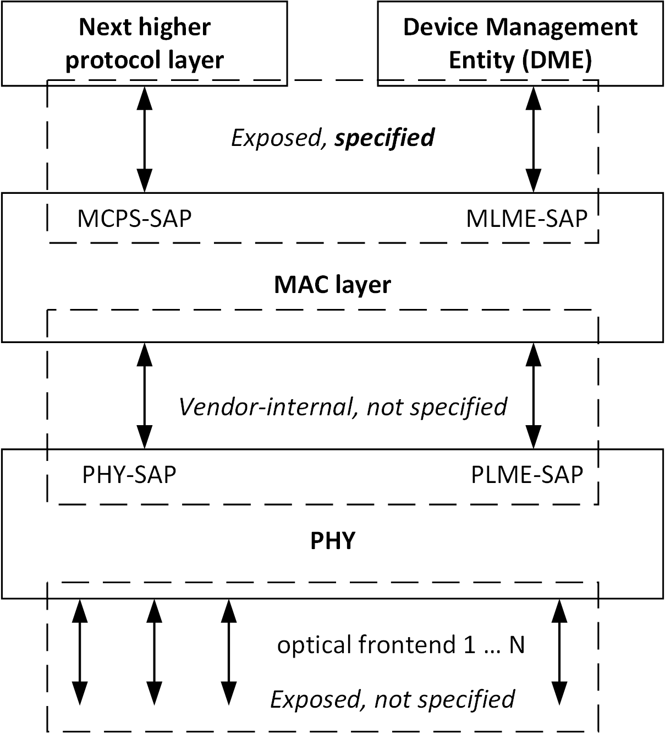
Figure 5: OWPAN device architecture
The higher layers consist of a network layer, which provides network configuration, manipulation, and message routing, and an application layer, which provides the intended function of the device. The definition of these upper layers is outside the scope of this standard.
    - PHY layer
The PHY layer supports multiple PHY types.
- Pulsed Modulation PHY (PM-PHY): This PHY type is intended for moderate data rate applications and enhanced energy efficiency. This mode uses 2-PAM modulation and 8B10B line coding or M-ary PAM in combination with HCM with data rates from 1 MB/s to several hundreds of Mb/s.
- Low bandwidth OFDM PHY (LB-PHY): This PHY type is intended for low rate applications with data rates in the tens of Mb/s using bit-interleaved coded OFDM modulation.
- High bandwidth OFDM PHY (HB-PHY): This PHY type is intended for high data rate applications with data rates from 10 Mb/s up to multiple Gb/s using OFDM modulation with adaptive bitloading.

      - PHY frame structure
The MAC protocol data unit (MPDU) at the output of the MAC sublayer passes through the PHY-SAP and becomes the PHY service data unit (PSDU) at the input of the PHY layer. Thereafter it is processed via the various PHY blocks such as channel coding, line coding and modulation.
The PSDU is prefixed with a synchronization header (SHR), containing the preamble sequence field; and a PHY header (PHR), which, among other things, contains the length of the PSDU in octets. The preamble sequence enables the receiver to achieve synchronization. The SHR, PHR, and PSDU together form the PHY frame or PHY layer data unit (PPDU).
For convenience, the PPDU frame structure is presented so that the left most field as written in this standard shall be transmitted or received first. The PPDU frame structure is illustrated in Figure 6.
Preamble | PHY header | HCS | Optional fields | PSDU
SHR | PHR |  |  | PHY payload
Figure 6 Format of the PPDU
      - PM-PHY introduction
The PM-PHY is intended for moderate data rates between 1 Mbit/s and several hundred Mbit/s, low power and low latency. It allows fast adaptation to the time-varying channel in mobile scenarios. The unique approach of the PM-PHY is to use a high optical clock rate (OCR) while keeping spectral efficiency low. This approach offers enhanced reach in applications where power efficiency is an issue, e.g. the Internet of Things (IoT). Binary (two-level) pulse-amplitude modulation (2-PAM) with 8B10B line coding and variable optical clock rate are used or multi-level M-ary PAM with Hadamard-Coded Modulation (HCM), both combined with Reed-Solomon (RS) forward error correction (FEC) to correct errors due to the noise, while clipping is avoided in the optical frontend. Moreover, the PM-PHY provides means to estimate the channel impulse response (CIR) of multiple LED lights simultaneously and thereby supports the use of advanced multiple-input multiple output (MIMO) schemes on the device side as well as at the coordinator. The PM-PHY enables multiple LEDs transmitting the same data to a device (spatial diversity) as well as spatially multiplexed transmissions. In addition, PM-PHY supports relaying functionality.
      - LB-PHY introduction
The LB-PHY is intended for low date rate applications with data rates in the tens of Mb/s using bit-interleaved OFDM modulation. It supports efficient utilization of the low-bandwidth resources (up to 32 MHz of single-sided bandwidth) of high-power LEDs as well as low-complexity, high energy efficiency and enhanced reliability. A DC-biased Optical OFDM (DCO-OFDM) is the default waveform. Furthermore, the enhanced unipolar OFDM (eU-OFDM) and reverse polarity optical OFDM (RPO-OFDM) waveforms are supported. For modulation of the LED, multiple optical clock rates (OCR) are used. LB-PHY supports the application of adaptive bitloading as well as multiple-input multiple-output (MIMO). In addition, the LB PHY supports relaying functionality.
      - HB-PHY introduction
The HB-PHY is intended for very high data rates between 10 Mbit/s and 10 Gbit/s and low latency. It allows fast adaptation to the time-varying channel in mobile scenarios. The unique approach of the HB-PHY is to combine a high optical clock rate with a high spectral efficiency. For modulation of the LED, multiple optical clock rates (OCR) are used. Direct-current (DC) biased orthogonal frequency multiplexing (OFDM) is used in combination with adaptive bitloading, applying quadrature amplitude modulation (QAM) with variable constellation orders on each subcarrier /subcarrier group. Low-density parity-check codes (LDPC) with variable code rates and different block sizes assist as a powerful forward error correction scheme correcting errors due to the noise and the clipping of the waveform in the optical frontend. Moreover, the HB-PHY provides means for the device to estimate the channel impulse response (CIR) of multiple LED lights simultaneously and thereby supports the use of advanced multiple-input multiple output (MIMO) schemes on the device side as well as at the coordinator. The HB-PHY enables multiple LEDs transmitting the same data to a device (spatial diversity) as well as spatially multiplexed transmissions. In addition, HB-PHY supports relaying functionality.
    - MAC sublayer
The MAC sublayer provides two services accessed through two service access points (SAPs). MAC data is accessed through the MAC common part sublayer SAP (MCPS-SAP) supporting the MAC service defined in IEEE Std 802.1AC. The MAC data service enables the transmission and reception of MPDUs across the PHY data service. The MAC management is accessed through the MAC sublayer management entity SAP (MLME-SAP).
The features of the MAC sublayer are association and disassociation, channel access, frame validation, and acknowledged frame delivery.
    - Dimming support
In this standard, dimming is considered independent of the communication functionality. The receiver is not required to know what dimming level is used while communication is ongoing.
      - Dimming Support Using Constant Bias Current
Dimming can be controlled via a bias current which is constant over time and orthogonal to the modulator output signal used for the data transmission (denoted as modulation signal).
The OWC system is responsible for the modulation while the lighting system provides a dimming level which is processed in a control unit being independent of the OWC system. The control unit can set both, the bias and the modulation index to achieve the required dimming level and to avoid clipping. Finally, the bias and the modulation are added, as shown in Figure 7.
In this way, the receiver does not need to know the dimming level for decoding the data from the compound signal received after the PD, and if needed, the transmitter is free to set the dimming level independent of the receiver. Accordingly, there is no need for signaling fields telling the receiver the dimming level used at the transmitter, or an accordingly used parameter setting of the modulation scheme.
Figure 7 Dimming control through modulation index and DC bias
    - Flicker mitigation support
In this standard, flickering is avoided by the principle of waveform design. Flickering is not perceivable by the human eye if average light output is constant and if the light is modulated at very high speed so that the average modulation current is zero, measured over millisecond time periods in which changes would be perceivable by the human eye. All PHY types are designed so that a constant bias is added in the optical frontend in order to obtain a constant average light output. Moreover, waveforms are designed so that they are modulated at OCR of at least 1 MHz with the intention to be DC-free and balanced around the bias, e.g. by using 8B10B line codes, M-ary PAM with HCM without the all-ones code or DCO-OFDM with zero amplitude of the DC subcarrier.
  - Functional overview
This clause provides a brief overview of the general functions of an OWSN MAC sublayer and includes information on the superframe structure, data transfer model, data frame structure, acknowledgments, and security. From a security perspective, IEEE 802.15.13 OWSN is slightly different from other wireless networks, due to directionality and visibility when using the visible optical spectrum. Because of directionality and visibility, if an unauthorized receiver is in the path of the communication signal, it can be recognized. Also, the signal will not travel across medium such as walls, unlike other radio frequency based wireless networks. However, security algorithms are still provided in the standard for features such as data confidentiality, authentication and replay protection.
    - Data transfer model
Two types of data transfer transactions exist:
- The data transfer to a coordinator in which a device transmits the data.
- The data transfer from a coordinator in which the device receives the data.
      - Data transfer to a coordinator
In a beacon-enabled OWSN, each device listens for the beacon before starting data transmission to a coordinator. When the beacon is found, the device synchronizes to the superframe structure. At the appropriate time, the device transmits its data frame to the coordinator. The coordinator is allowed to acknowledge the successful reception of the data by transmitting an optional acknowledgment frame.
When a device wishes to transfer data in a non-beacon-enabled OWSN, it waits for a polling frame from the coordinator and transmits its data frame. The coordinator is allowed to acknowledge the successful reception of the data by transmitting an optional acknowledgment frame.
      - Data transfer from a device to a coordinator with relaying
In a beacon-enabled OWPAN, each device listens for the beacon before transmitting its data frame. When the beacon is found, the device node synchronizes to the superframe structure. In half duplex (HD) relaying, relay node also listens for the beacon and synchronizes to the superframe structure. At the appropriate time, the device transmits its data frame, using slotted random access, to the coordinator and the relay node. Relay node buffers the received frames from the device and transmits them to the coordinator at its time. In full duplex (FD) relaying, the relay simultaneously receives and transmits the frames from the device to the coordinator. The coordinator is allowed to acknowledge the successful reception of the data by transmitting an optional acknowledgment frame that is to be received by both the relay node and the device.
In a non-beacon-enabled OWPAN, the device simply transmits its data frame, using unslotted random access, to the coordinator. The frame is also received by the relay node. In half duplex (HD) relaying, relay node buffers the received data frames from the device and transmits them to the coordinator using unslotted random access. In full duplex (FD) relaying, the relay simultaneously receives and transmits from the device to the coordinator. The coordinator acknowledges the successful reception of the data by transmitting an optional acknowledgment frame.
      - Data transfer from a coordinator to a device with relaying
In a beacon-enabled OWPAN, when the coordinator wishes to transfer data to a device, it indicates in the beacon that the data message is pending. The device periodically listens to the beacon and, if a message is pending, transmits a MAC command requesting the data, using slotted random access. In half duplex (HD) relaying, relay also receives the request from the device and is informed. The coordinator acknowledges the successful reception of the data request by transmitting an acknowledgment frame. The relay also receives the acknowledgment frame. The pending data frame is then sent using slotted random access. Relay node buffers the received frames from the coordinator and transmits them to the device at its time. In full duplex (FD) relaying, the relay simultaneously receives and transmits the frames from the coordinator to a device. The device is allowed to acknowledge the successful reception of the data by transmitting an optional acknowledgment frame. The transaction is now complete. Upon successful completion of the data transaction, the message is removed from the list of pending messages in the beacon.
When a coordinator wishes to transfer data to a device in a non beacon-enabled OWPAN, it stores the data and waits for the appropriate device to make contact and request the data. A device is allowed to make contact by transmitting a MAC command requesting the data, using unslotted random access, to its coordinator. In half duplex (HD) relaying, relay also receives the request from the device and is informed. The coordinator acknowledges the successful reception of the data request by transmitting an acknowledgment frame. If a data frame is pending, the coordinator transmits the data frame, using unslotted random access to the device. Relay node buffers the received frames from the coordinator and transmits them to the device at its time. If a data frame is not pending, the coordinator indicates this fact either in the acknowledgment frame following the data request or in a data frame with a zero-length payload. If requested, the device acknowledges the successful reception of the data frame by transmitting an acknowledgment frame. In full duplex (FD) relaying, the relay simultaneously receives and transmits the frames from the coordinator to a device.
    - Clock-rate selection
The standard supports multiple optical clock rates (OCRs) in order to accommodate a wide variety of optical sources and receivers. The standard also supports the use of asymmetric maximum clock rates between two devices since the transmitter and receiver in a device are independent and may support different OCRs. As an example, the coordinator may be able to use higher OCR than a mobile device. Coordinators are required to support all lower OCR besides their maximum supported OCR. In contrast, devices may be able to support only a single OCR or few selected OCRs. The optical clock rate for communication is established using the MAC and communicated to the device prior to the data transfer. The clock-rate-negotiation-and-selection procedure is described in section XXX.
    - Frame structure
The following frame structures have been designed to keep the complexity to a minimum while providing for error protection for transmission over a noisy channel.
- A data frame, used for all transfers of data.
- A management frame, used for handling for all OWPAN management transfer.
- A control frame, used to assist the delivery of data and management frames.

Each successive protocol layer adds to the structure with layer-specific headers and footers.
    - Improving probability of successful delivery
The IEEE 802.15.13 OWSN employs various mechanisms to improve the probability of successful data transmission. These mechanisms are deterministic access, frame acknowledgment, and data verification.
      - Channel access mechanism
The IEEE 802.15.13 OWSN uses different types of channel access mechanism, depending on the network configuration.
Beacon-enabled OWSNs use a beacon, a slotted random channel access mechanism in the contention access period (CAP) and a deterministic channel access mechanism in the contention-free period (CFP). Note that the CAP is only used for association purposes. Acknowledgment frames are always sent during the CFP.
Non-beacon-enabled OWSNs use unslotted channel access mechanism in general, starting with a control period normally followed by data period. Association is done during the control period. In the data period, the device is polled for transmission by the coordinator. Acknowledgment frames are sent in the next available frame for which a particular device has been polled.
      - Frame acknowledgment
A successful reception and validation of a data or MAC command frame can be optionally confirmed with an acknowledgment. If the receiving device is unable to handle the received data frame for any reason, the message is not acknowledged.
If the originator does not receive an acknowledgment after some period, it assumes that the transmission was unsuccessful. When the acknowledgment is not required, the originator assumes the transmission was successful.
      - Data verification
A cyclic redundancy check is included in the MAC frame and in the PHY header to verify the validity of the received data.
  - Concept of primitives
This subclause provides a brief overview of the concept of service primitives. The services of a layer are the capabilities it offers to the next higher layer or sublayer by building its functions on the services of the next lower layer. This concept is illustrated in Figure 8, showing the service hierarchy and the relationship of the two correspondent users and their associated layer (or sublayer) peer protocol entities.
Figure 8 Service primitives
The services are specified by describing the information flow between the user and the layer. This information flow is modeled by discrete, instantaneous events, which characterize the provision of a service. Each event consists of passing a service primitive from one layer to the other through a layer service access point (SAP) associated with a user. Service primitives convey the required information by providing a particular service. These service primitives are an abstraction because they specify only the provided service rather than the means by which it is provided. This definition is independent of any interface implementation.
Services are specified by describing the service primitives and parameters that characterize it. A service may have one or more related primitives that constitute the activity that is related to that particular service. Each service primitive may have zero or more parameters that convey the information required to provide the service.
A primitive can be one of the following four generic types:
- Request: The request primitive is used to request a service to be initiated.
- Confirm: The confirm primitive is used to convey the results of one or more associated previous service requests.
- Indication: The indication primitive is used to indicate the next higher layer of an internal event.
- Response: The response primitive is used to complete a procedure previously invoked by an indication primitive.
  - Conventions in this standard
This clause lists different conventions for the format, terminology and units within this standard.
    - Format conventions
Constants and attributes that are specified and maintained by the MAC sublayer are written in italics and without spaces. Constants have a general prefix of “a”, e.g., aMinFragmentSize. Variable attributes have a general prefix of “mac”, e.g., macOwpanId.

Names of frames, elements or fields are also written in italics. They are capitalized and might contain whitespaces, e.g., Association Request element.
    - Normative terminology
Requirements on conformant implementations of this standard are expressed using the following terminology:

- Shall is used for mandatory requirements
- May is used to describe optional functionality that the implementation is permitted to support
- Should is used for recommended implementation and configuration choices

