**IEEE P802.15**

**Wireless Personal Area Networks**

|  |  |
| --- | --- |
| Project | IEEE P802.15 Working Group for Wireless Personal Area Networks (WPANs) |
| Title | IEEE 802.15.4z HRP comment resolutions |
| Date Submitted | 06/17/2019 |
| Source | Zheda Li (Samsung), Ayman Naguib (Apple),  Aditya Vinod Padaki (Samsung), Mingyu Lee (Samsung), Seongah Jeong (Samsung), Kangjin Yoon (Samsung), Brima Ibrahim (NXP), Frank Leong (NXP) , Jack Lee (Samsung) |
| Re: |  |
| Abstract | This contribution proposes updated text for the baseline draft P802.15.4z-D1 |
| Purpose | Provision of the text to facilitate its incorporation into the draft text of the IEEE 802.15.4z standard currently under development in TG4z. |
| Notice | This document does not represent the agreed views of the IEEE 802.15 Working Group. It represents only the views of the participants listed in the “Source(s)” field above. It is offered as a basis for discussion and is not binding on the contributing individual(s) or organization(s). The material in this document is subject to change in form and content after further study. The contributor(s) reserve(s) the right to add, amend or withdraw material contained herein. |
| Release |  |
| Patent Policy | The contributor is familiar with the IEEE-SA Patent Policy and Procedures:  <http://standards.ieee.org/guides/bylaws/sect6-7.html#6> and  <http://standards.ieee.org/guides/opman/sect6.html#6.3>.  Further information is located at <http://standards.ieee.org/board/pat/pat-material.html> and  <http://standards.ieee.org/board/pat>. |

* **Page 19 Line 10 (6.9.8) ~ Page 30 Line 2 (6.9.8.3)**

i-0014, i-0041, i-0044, i-0045, i-0168, i-0182, i-0184, i-0185, i-186, i-189, i-190, i-0191, i-0192, i-0193, i-0194, i-0195, i-0196, i-0197, i-0216, i-0217, i-0219, i-267, i-0339, i-0351, i-0352, i-0353, i-0354, i-0355, i-0357, i-0358, i-0359, i-0360, i-0361, i-0362, i-0364, i-0365, i-0366, i-0367, i-0368, i-0369, i-0370, i-0371, i-0372, i-0373, i-0374, i-0375, i-0376, i-0377, i-0378, i-0392, i-0400, i-0404, i-0405, i-0406, i-0407, i-0408, i-0409, i-434, i-437, i-0442, i-0447, i-0448, i-0449, i-0450, i-0451, i-0453, i-0455, i-0456, i-0457, i-0458, i-0459, i-0461, i-0463, i-0464, i-0465, i-0466, i-0584, i-0586, i-0587, i-0588, i-0757, i-0758, i-0759, i-0760, i-0761, i-0764, i-0765, i-0766, i-0767, i-0768, i-0771, i-0772, i-0773, i-0774, i-0775, i-0776, i-0777, i-0778, i-0779, i-0780, i-0782, i-0783, i-0784, i-0785, i-0786, i-0787, i-0789, i-0790, i-0791, i-0792, i-0796, i-0797, i-0798, i-0799, i-0800, i-0801, i-0802, i-0803, i-0804, i-0805, i-0806, i-0807, i-0808, i-0809, i-0810, i-0811, i-0812, i-8013, i-0814, i-0813, i-0815, i-0816, i-0817, i-0818, i-0819, i-0820, i-0821, i-0822, i-0823, i-0824, i-0825, i-0826, i-0827, i-0828, i-0829, i-0830, i-0831, i-0832, i-0833, i-0834, i-0835, i-0836, i-1196, i-1394, i-1395, i-1396, i-1397, i-1401, i-1402, i-1403, i-1404, i-1405, i-1408, i-1409, i-1410, i-1411, i-1412, i-1413, i-1414, i-1415, i-1416, i-1417, i-1422, i-1423, i-1424, i-1426, i-1427, i-1428, i-1429, i-1433, i-1434, i-1435, i-1436, i-1437, i-1438, i-1439, i-1440, i-1441, i-1442, i-1443, i-1444, i-1445, i-1446, i-1447, i-1448, i-1449, i-1450, i-1451, i-1452, i-1453, i-1454, i-1455, i-1456, i-1457, i-1458, i-1459, i-1460, i-1461, i-1462, i-1463, i-1464, i-1465, i-1466, i-1467, i-1468, i-1469, i-1470, i-1471, i-1472, i-1473, i-1833, i-1856, i-1969, i-1970, i-1971, i-1972, i-1973, i-2014, i-2015, i-2064, i-2065, i-2066, i-2098, i-2099, i-2148, i-2149, i-2185, i-2121, i-2122, i-2221, i-2242, i-2262, i-2263, i-2309, i-2310, i-2329, i-2330, i-2331, i-2356, i-2429, i-2430, i-2448, i-2449, i-2472, i-2492, i-2529, i-2530, i-2551, i-2561, i-2562, i-2563, i-2569, i-2594, i-2612, i-2620, i-2621, i-2622, i-2623, i-2624, i-2625, i-2626, i-2633, i-2635, i-2636, i-2637, i-2642, i-2643, i-2644, i-2649, i-2652, i-2653, i-2657, i-2658, i-2659, i-2662, i-2663, i-2671, i-2673, i-2674, i-2688, i-2689, i-2690,

* + 1. Multi-node ranging

A Ranging Control Message (RCM) is a frame conveying the Advanced Ranging Control IE (ARC IE) as specified in 7.4.4.38. The RCM can be used to convey ranging parameters to control and configure aspects of the ranging procedure(s) such as the time-slot structure shown in Figure 12, the ranging methods specified in 6.9.5, and the STS packet configuration as specified in 16.2.

The following nomenclature is used for ERDEVs:

* Controller: An ERDEV that controls the ranging and defines the ranging parameters by sending the RCM.
* Controlee: An ERDEV that utilizes the ranging parameters received from the controller in the RCM.
* Initiator: An ERDEV that following the RCM initiates a ranging exchange by sending the first RFRAME, i.e., ranging initiation message. A controller or a controllee can be an initiator.
* Responder: An ERDEV that responds to the ranging initiation message received from the initiator.

These terms are illustrated in Figure 11.



Figure 11—Ranging Controller, Controlee, Initiator and Responder

The next higher layer of the controller is responsible for determining the ranging parameters and the role of the participating ERDEVs as either initiators or responders.

Multi-node ranging is a ranging procedure in which one or more initiators perform ranging with multiple responders. There are two types of multi-node ranging, as indicated by the Schedule Mode field of the ARC IE (see subclause 7.4.4.38). The first type is time-scheduled ranging in which the controller knows the identities of all controlees, and specifies the precise schedule of ranging transmissions. The second type is contention-based ranging in which the controller may not know the number or identities of the controlees, and hence the ERDEVs contend with each other.

For time-scheduled ranging, the controller selects the ranging devices participating in the ranging, their roles as either initiator or responder, and their assigned time slots these devices will utilize by specifying the Ranging Device Management IE (RDM IE) (7.4.4.X1). The roles of the participating devices and their transmission schedule may be set by the higher layers. In this case, the RCM will not include the RDM IE.

For contention-based ranging, the controller can include Ranging Contention Maximum Attempts IE (RCMA IE) (7.4.4.43), and Ranging Contention Phase Structure IE (RCPS IE) (7.4.4.42) in the RCM in addition to the ARC IE (7.4.4.38). If the controller knows the identities of the controlees, the RDM IE can be used for contention-based ranging to determine ranging roles.

A data frame can be used to convey the non-receipt of messages during a ranging procedure. This procedure can be used whenever ERDEVs are scheduled to send messages bearing payload to the controller. As depicted in Figure X0, RCM is transmitted successfully. However, Responder-1 does not receive the expected Ranging Initiation Message from the ranging initiator/controller. Rather than remaining idle in its assigned time slot for ranging response, Responder-1 can send a response message with Ranging Message Non-Receipt IE (RMNR IE) (7.4.4.57) in to indicate the failure of the Ranging Initiation Message, and implicitly confirm the successful exchange of RCM. For the Responder-2, once the controller receives its ranging response message, the controller also knows that RCM has been received by Responder-2.



**Figure X0. Ranging message non-receipt** **exchange for one initiator and multiple responders: controller is a ranging initiator**

* + - 1. Ranging block and round structure

A Ranging Block is a time period for ranging. Each Ranging Block consists of an integer quantity of multiple Ranging Rounds, where a Ranging Round is period of sufficient duration to complete one entire range-measurement cycle involving the set of ERDEVs participating in the ranging exchange Each Ranging Round is further subdivided into an integer number of Ranging Slots where a Ranging Slot is a time period of sufficient duration for the transmission of at least one RFRAME. Figure 12 shows the Ranging Block Structure, with the Ranging Block divided into N Ranging Rounds, each consisting of M Ranging Slots. The duration of rounds/slots of a ranging block may vary for different rounds. This can be configured by different RCMs.



Figure 12—Illustration of Ranging Block, Ranging Round and Ranging Slot

The time unit used in specifying the duration of Ranging Block, Ranging Round, and Ranging Slot is the RSTU as specified in 6.9.1.2.

The following nomenclature is used for messages:

* Ranging Control Message (RCM): A message transmitted by a controller at the Slot 0 of a Ranging Round to configure ranging parameters.
* Ranging Control Update Message (RCUM): A message transmitted by the controller at the last slot of ranging round(s) configured by the RCM to update ranging parameters for the next ranging round(s). RCUM includes IEs utilized by RCM in the Ranging Round.
* Ranging Interval Update Message (RIUM): A message transmitted by the controller between Ranging Blocks to update the intervals and also to help the synchronization between the participating ERDEVs.

The following nomenclature is used to describe the functionalities of different exchanges in a Ranging Round:

* Ranging Control Phase (RCP): A phase in which the controller sends RCM.
* Ranging Initiation Phase (RIP): A phase in which the initiator(s) sends ranging initiation message to the responder(s).
* Ranging Response Phase (RRP): A phase in which the responder(s) send their response messages to the initiator.
* Ranging Final Phase (RFP): A phase in which the initiator sends ranging final message to the responder(s). This phase is only used for DS-TWR.
* Ranging Phase (RP): A phase which should comprise RIP, RRP, and/or RFP.
* Measurement Report Phase (MRP): A phase in which participating ERDEVs exchange ranging measurements and related service information, whenever such measurements and service information cannot be embedded in RFRAMEs.
* Ranging Control Update Phase (RCUP): A phase in which the controller sends RCUM. If present, this phase shall be at the last slot of ranging round(s) configured by the RCM.
* Ranging Interval Update Phase (RIUP): A phase in which the controller sends RIUM.

In a Ranging Round, SS-TWR or DS-TWR can be used for ranging and localization as described in 6.9.8.4 to 6.9.8.8, or one way ranging (OWR) may be used as described in Applications of IEEE Std 802.15.4 [B3]. As shown in Figure 13, each Ranging Round may be comprised of an RCP, an RP, and an MRP, where each of these phases may consist of multiple slots. In practice, it may be possible to merge some phases. For example, RCP and RIP may be merged into a single phase when the controller and the initiator are the same device. The MRP may be used to convey ranging-related service information via dedicated IEs.



Figure 13—An example of phases in a ranging round

When the Schedule Mode field in the ARC IE is zero, it indicates that contention-based ranging is used. The first slot index and the last slot index for ranging phase and/or measurement report phase are specified in the RCPS IE described in 7.4.4.42. The RCPS IE provides the slot indices for different phases in a Ranging Round. Without specifying phases for different ranging roles via RCPS IE, ERDEVs can also contend for all remaining slots of a Ranging Round configured by the RCM. If the Schedule Mode field in the ARC IE is set to one, it indicates that time-scheduled ranging is used. In this case, the slot allocation for the ERDEVs is specified either using the RDM IE (7.4.4.X1), or it can be specified by an out-of-band mechanism.

In Figure 14, the message ordering diagrams for different example cases of ranging procedures are presented. In each case, the RCM should be set to indicate the type of ranging that is used.



Figure 14—Example timing diagrams for seven different multi-device ranging use cases

For ranging with HRP UWB PHY, SP3 format packets (with no PHR or data payload) described in 16.2, may be used. An example for phases of SP3 ranging round is shown in Figure 15. In addition to the RCP and the RP, the controller may request certain information, (e.g., AOA, reply time, or round trip time measurements) from the controlees participating in the ranging exchange. The controller may send its request either in-band as part of the RCM, (e.g., using SP3 Ranging Request Reports (SRRR) IE (7.4.4.55)) or this may be coordinated through an out-of-band mechanism.



Figure 15—SP3 Ranging Round Structure

Only time-scheduled ranging shall be used for SP3 ranging in order to differentiate messages from different devices. However, he scheduling can be static or dynamic via the RDM IE (7.4.4.X1).

SP3 ranging may be performed without a measurement report phase in the ranging round (e.g., an ERDEV can use AOA from multiple ERDEVs to determine ranging).

One-to-many multi-node ranging with fixed reply times can be supported in the block structure as shown in the example in Figure X4. All UWB packets from the controller and the initiator will follow the slot structure. However, the responders will respond after fixed reply times FRT1, FRT2, …, FRTN. The fixed reply time FRTj is measured from the RMARKER of the ranging initiation message P1 to the RMARKER of the response message Rj Furthermore, we assume that:

1. FRT1>= 16*RSTU
2. FRTi > FRTj for i > j
3. The duration between the start of any two consecutive transmissions minus the packet length is greater than or equal to 16*RSTU
4. (FRTN + Packet_Length) < N*(Ranging Slot Duration)

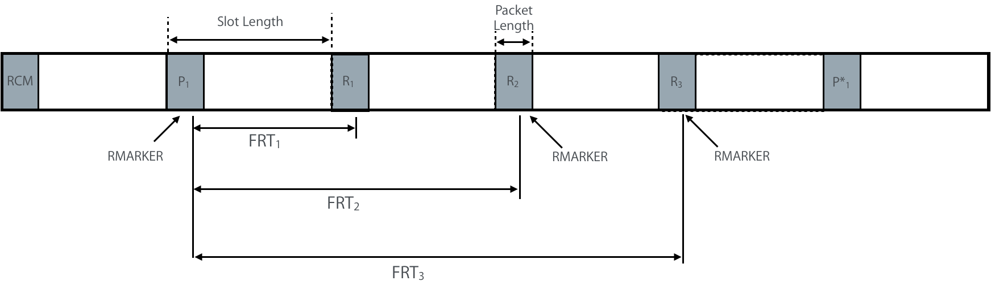

**Figure X4—Example Ranging Block Structure with Fixed Reply Time**

Fixed reply time cannot be used if the scheduling mode of the responses is contention-based.

* + - 1. Ranging modes

In this section, two modes for ranging resource management are introduced: Interval-based mode and Block-based mode. The key difference between the Block-based mode and the Interval-based mode is that the time between successive ranging rounds in the Block-based mode is constant (i.e., using a time structure with uniform sampling) while in the Interval-based mode the time between successive ranging rounds can be varied. The controller selects the mode and the corresponding time structure. This selection may be achieved by an out-of-band mechanism or in-band using the Time Structure Indicator field in the ARC IE (7.4.4.38).

* + - * 1. Interval-based mode

The Interval-based mode utilizes the three intervals: block interval, round interval, and RIUM interval. Settings of these intervals are specified in the RIU IE described in 7.4.4.39.

The following nomenclature is used in this mode:

* Ranging Round Set: A set of ranging round(s) covered by a specific RCM in a ranging block
* Block Interval: Time remaining until the start time of the next ranging block relative to the start time of the current message.
* Round Interval: Time remaining until the start time of the ranging round set relative to the start time of the ranging block.
* RIUM interval: Time remaining until the start time of the next RIUM relative to the start time of the current message.

In the first ranging round of a ranging round set, an RCM with the ARC IE (7.4.4.38) configures ranging parameters of the ranging round set. The number of ranging rounds in a ranging round set is specified by the RCM Validity Rounds field of the ARC IE (7.4.4.38). Ranging block can consist of multiple ranging round sets, while each ranging round set can be configured by its RCM at the beginning of the first ranging round.

The controller transmits interval information to controlee(s) using RIU IE (7.4.4.39). The RIU IE can be included in the RCM, RCUM, and RIUM. Upon reception of the RIU IE (7.4.4.39), each controlee knows the start time of next scheduled ranging round set. The controller can adjust block interval and round interval as a strategy to help reduce interference. The criteria and mechanism for adjusting block interval and round interval are out of scope of the standard.

A controlee can request a change to the current ranging configuration by sending a change request with Ranging Change Request IE (RCR IE), as defined in 7.4.4.45, to the controller. The RCR IE can be transmitted along with various IEs to indicate the preferred parameter settings of a controlee, such as ARC IE (7.4.4.38), RIU IE, Ranging Channel and Preamble Code Selection (RCPCS) IE, and Ranging STS Key and IV (RSKI) IE. The controller can receive the change request with the preferred ranging parameters in the ARC IE and the preferred intervals in RIU IE from the controlee. After receiving the change request, the controller should decide whether to accept the change request or not. The controller can transmit RCUM including IEs with updated ranging parameters. For example, RCUM can include RIU IE (7.4.4.39) with updated intervals, which specify the start time of the next ranging block and the ranging round set with updated ranging parameters in the subsequent ranging rounds.

The controller can transmit multiple RIUMs between ranging blocks as shown in Figure 16, each of which contains an RIU IE to indicate block interval and next round interval. The Remaining Number of RIUMs field in RIU IE decreases until it becomes zero. If Remaining Number of RIUMs field is zero, it means that no more RIUMs are expected until the next ranging block.



Figure 16—Time diagram for an example of Interval-based mode with one ranging round per ranging block

Figure 16 shows a time diagram example of Interval-based mode with one ranging round per ranging block. In Ranging Round 1 of the first ranging block, the controller transmits an RCM which includes ARC IE (7.4.4.38) and RIU IE (7.4.4.39). The ARC IE is supplied to the next higher layer of the controlee to set its ranging parameters. Since the RCM covers one ranging round, the RCM Validity Rounds field in ARC IE of the RCM is one. Intervals are specified by corresponding fields in the RIU IE. Since the start time of the ranging block and the start time of the RCM are the same, the round interval for Ranging Round 1 of the second ranging block is zero. The Next Round Interval field in RIU IE is zero to specify the round interval for Ranging Round 1 of the second ranging block. The controller can transmit RIUMs between ranging blocks. Block Interval field, RIUM Interval field, and Remaining Number of RIUM field are updated in every RIUM.



Figure 17—Time diagram for an example of Interval-based mode with two ranging rounds per ranging block

Figure 17 shows a time diagram for an example of Interval-based mode with two ranging rounds per ranging block. The first ranging block has two ranging rounds. In Ranging Round 1 of the first ranging block, the controller transmits an RCM which includes ARC IE (7.4.4.38) and RIU IE for Ranging Rounds 1 and 2. Upon reception of the RCM, controlees acquire ranging parameters specified in the ARC IE. Since the RCM covers two ranging rounds, the RCM Validity Rounds field in the ARC IE of the RCM is two. Intervals are specified by the corresponding fields in the RIU IE. Since the start times of subsequent ranging block and the RCM are the same, the round interval for the ranging round set of the second ranging block is zero. The Next Round Interval field in RIU IE is zero to specify the round interval for the ranging round set of the second ranging block. The controller can transmit RIUMs between ranging blocks. Block Interval field, RIUM Interval field, and Remaining Number of RIUM field are updated in every RIUM. The second ranging block has two ranging rounds for the same set of ERDEVs in the first ranging block.



Figure 18—Time diagram for an example of Interval-based mode

Figure 18 shows a time diagram for an example of Interval-based mode. The first ranging block has three ranging rounds. In the Ranging Round 1 of the first ranging block, the controller transmits an RCM which includes the ARC IE (7.4.4.38) and the RIU IE. Upon reception of the RCM, the controlees acquire ranging parameters specified in the ARC IE. The RCM Validity Rounds field in the ARC IE of the first RCM is one, which indicates that the first RCM covers one ranging round, i.e., Ranging Round 1. Intervals are specified by corresponding fields in the RIU IE. Since start times of the next ranging block and the next RCM for Ranging Round 1 are the same, the round interval for Ranging Round 1 of the second ranging block is zero. Each RIUM for Ranging Round 1 is transmitted with the RIU IE, which specifies the intervals for Ranging Round 1 of the second ranging block. Since the second RCM covers two ranging rounds, i.e., Ranging Rounds 2 and 3, the RCM Validity Rounds field in the ARC IE of the second RCM is two.

For different ranging round sets in a ranging block, the controller should have the same setting for the Ranging Block Duration field in the ARC IEs conveyed by different RCMs, while other ranging parameters and participated ERDEVs can be different. For example, the ranging round sets with different ranging parameters can support different sets of ERDEVs with different capabilities, or the same set of ERDEVs for different applications.

If a controlee fails to receive an RCM and the controlee has no information for intervals, the controlee can keep listening to the channel for receiving the RCM.

If a controlee fails to receive RCM, RCUM, or RIUM with updated value of intervals and has information for the previous intervals updated by the previous RCM, the controlee will continue using the previous intervals. One of these two possibilities will occur:

* The updated time for the next RCM is prior to the previously scheduled time. As the controller will use the updated time for the next RCM and it will not receive ranging initiation message or ranging response message from the controlee, the controller shall resume using the previously scheduled time for the next RCM.
* The updated time for the next RCM is after the previously scheduled time and the controlee continues with the previous previously scheduled time. In this case, the controlee will not receive the RCM, it will continue listening to the channel for the RCM sent by the controller at the updated time for the next RCM.

RCM Timing Window (RTW) operation is optionally configured by the RIU IE as described in 7.4.4.39. Specifically, a controller can send the RCM at random timing within a time window, namely RTW, centered at its originally scheduled time. The size of RTW in the unit of RSTU can remain constant or vary for subsequent ranging round sets. The RCM shall be transmitted within the RTW. In order to participate in the exchange, a controlee has to enable its receiver during the RTW in order to receive the RCM

The controller and the controlee may change the size of the RTW by using the RTW Initial Size field or RTW Multiplier field of the RIU IE (7.4.4.39). The duration of the RTW should not overlap with the last ranging round set. If the RTW is configured by the RIU IE for the subsequent ranging round, the controller randomly chooses the transmission timing of the next RCM within the RTW. The controlee waits during the RTW to receive the RCM.



**Figure 19-Timing diagram for an example of RCM transmission without RTW**

Figure 19 shows a timing diagram for an example of the RCM transmission without the RTW. The RCMs are transmitted at the exact start time of ranging round without the RTW. Since the RCM of Ranging Round N+1 failed, the RCM of Ranging Round N+2 is transmitted at the start time of ranging round which is specified in the RCM of Ranging Round N.



**Figure 20- Timing diagram for an example of RCM transmission with RTW**

Figure 20 shows a timing diagram for an example of the RCM transmission with the RTW. RCMs are transmitted at random time within the RTW. Since the RCM of Ranging Round N+1 failed, the RCM of Ranging Round N+2 is transmitted within the RTW which is centered on the scheduled time configured by the RCM of Ranging Round N. The size of the RTW is calculated by using the RTW Initial Size field and the RTW Multiplier field of the RIU IE in the RCM of Ranging Round N.

* + - * 1. Block-based modes

The Block-based mode uses a structured timeline where the ranging block structure, as defined in 6.9.8.1, is periodic by default. Figure X1 shows an example timing diagram for the Block-based mode. The ranging block structure can be setup by specifying the Ranging Block Duration, the Ranging Round Duration, and the Ranging Slot Duration fields in the ARC IE (7.4.4.38).

The number of ranging rounds in a ranging block is derived by:



The number of ranging slots in a ranging round is then given by:



These fields completely define the ranging block structure. An ERDEV that receives an RCM successfully may set the initial ranging block structure and the associated timeline for ranging using the values of those ARC IE fields. Alternatively, the ranging block structure may be setup and/or fixed by the next higher layer.

The ranging block structure can be repeatedly transmitted in every RCM by the controller. If the block structure needs to be changed or updated (i.e., to a new ranging block duration, ranging round duration, and/or ranging slot duration), the controller may send a Ranging Block Update (RBU) IE (7.4.4.41) with the new configuration. In addition to the new configuration, the RBU IE should include a field for the number of remaining ranging blocks with the current configuration before switching to the new configuration. Alternatively, the block structure update signaled to the participating ERDEVs via the next higher layer.

For a given block configuration, each ranging block will be assigned an index relative to the first block in that configuration (block number 0). Each ranging round in any ranging block will have an index relative to the first ranging round in the current ranging block. For example, if the ranging block has *M* ranging rounds, the first ranging round in the block will have index 0 and the last ranging round in the block will have index *M* -1. Similarly, each ranging slot in a ranging round will have an index relative to the first ranging slot in the ranging round. For example, in a ranging round with *K* ranging slots, the first ranging slot in the round will have index 0 and the last ranging slot in the round will have index *K*-1. A new ranging session will start by transmitting the first RCM in Ranging Slot 0 of Ranging Round 0 in Ranging Block 0.

The controller can decide to start the transmission with a transmission offset within each slot, which is indicated by the Transmission Offset field of Ranging Round IE (RR IE), as defined in 7.4.4.40. The transmission offset is expressed as a multiple of RSTU. All packet transmissions within the same ranging round should be transmitted with the same transmission offset. The next higher layer of controller is responsible for choosing the transmission offset and communicating it to all other devices in the RR IE. Controller may change the transmission offset of each ranging round, as a strategy to help reduce interference. Controlees should send at the specified offset in their slots, otherwise the packets may be missed by receiving devices expecting the transmission at that offset.

In the first ranging round of a ranging session, a UWB packet is transmitted at the beginning of the ranging slot. However, in subsequent ranging rounds, the controller can decide to start the transmission within each slot at a transmission offset which is indicated by the Transmission Offset field of Ranging Round IE (RR IE), as defined in 7.4.4.40. This offset can be less than the Ranging Slot Duration minus the UWB packet duration. Figure X2 shows an example of ranging rounds with different Transmission Offsets.

The transmission offset is expressed as a multiple of RSTU. All packet transmissions within the same ranging round should be transmitted with the same transmission offset. The next higher layer of controller is responsible for choosing the transmission offset and communicating it to all other devices in the RR IE. Controller may change the transmission offset of each ranging round, as a strategy to help reduce interference. Controlees should send at the specified offset in their slots, otherwise the packets may be missed by receiving devices expecting the transmission at that offset.

Additionally, participating ERDEVs may continue to use the same ranging round in the next ranging block (i.e., if they are using Ranging Round *m* in Ranging Block *n,* they will also use Ranging Round *m* in Ranging Block *n*+1). Alternatively, the controller may also decide to “hop” to a different relative ranging round in the next ranging block (i.e., if participating ERDEVs are using Ranging Round *m* in Ranging Block *n,* they will use Ranging Round *k* in Ranging Block *n*+1). Figure X3 shows an illustration for the concept of transmission offset and round hopping. The criteria for using a different transmission offset and/or hopping to a different relative ranging round is out of scope of the standard and is assumed to be a next higher layer function/protocol. However, it is assumed that as part of such function/protocol, the devices participating in the ranging exchange have either (a) pre-negotiated a hopping sequence that it is known to all devices, or (b) have exchanged all the information necessary such that each device can generate the hopping sequence so that they know which ranging round in each ranging block is to be used if hopping is triggered. If the block structure is updated (by sending an RBU IE or by a next higher layer protocol), the participating ERDEVs can set Transmission Offset to zero and reset the block, round, and slot indices at the beginning of the new block structure.

In the allocated ranging round of a ranging block, the controller configures the ranging round by sending the RCM with the ARC IE and the RR IE (as defined in 7.4.4.40). The RR IE includes the following fields: current Ranging Block Index, current Ranging Round Index, Transmission Offset of the current Ranging Round, and Hopping Mode of the current round. By default, the controller selects the hopping mode and transmission offset to be used in the ranging round of the next ranging block. If the last scheduled message in the current ranging round in block *i* is a message sent by the controller to the controlees, then the controller will send the RR IE in this last message of the current ranging round to signal to the participating ERDEVs whether to hop to a different round and/or use a different transmission offset in the ranging round of the next ranging block *i*+1. If the last scheduled message in the current ranging round is not from the controller, then the Controller will send a second RR IE in the RCM of the ranging round in block *i*+1 to signal to the participating ERDEVs whether to hop to a different round and/or use a different transmission offset in the ranging round of ranging block *i*+2. Note that in this last case, the RCM in the *i*+1 block will include two instances of the RR IE. The first one is applicable to ranging in the *i*+1 block while the second instance is applicable to ranging in the *i*+2 block. The contents of the RR IE in this case will be Ranging Block Index and Ranging Round Index of the current ranging block, the Hopping Mode and the Transmission Offset for the ranging round of the next ranging block. A Controlee that receives the RR IE shall follow the controller instruction and, in the subsequent ranging block, uses a new transmission offset (as specified in the RR IE) and switches to a new ranging round (as determined by the ranging block index, ranging round index, and hoping mode specified in the RR IE and the hopping sequence). If the controlee does not receive the RR IE(either in the final message of the exchange or in the RCM), e.g. due to interference event, the controlee can turn on hopping in the next ranging block and move to a new ranging round (as determined by the new hopping mode, next ranging block index, and hopping sequence) with a zero transmission offset.  An ERDEV that misses the ARC IE but correctly receive the RR IE in the last message in the current round can use the content of the RR IE to resynchronize itself and be able to receive the RCM and ARC IE in the next ranging block if the block structure is unchanged. The block structure configured by the ARC IE and RR IE sent in the RCM and the RR IE and RBU IE sent either in the in the last message or in the RCM, allow the participating ERDEVs to maintain the block structure while being idle with its receiver turned between transmit and receive slots to save energy.

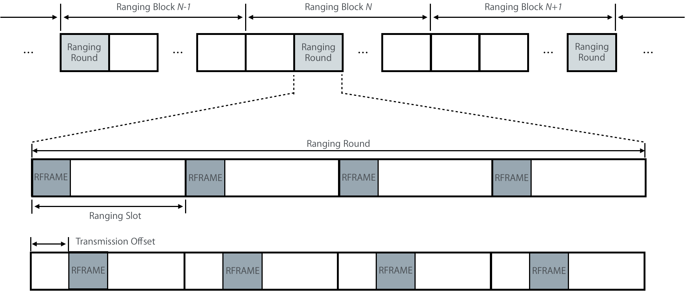

**Figure X1—Time diagram for an example of block-based mode**

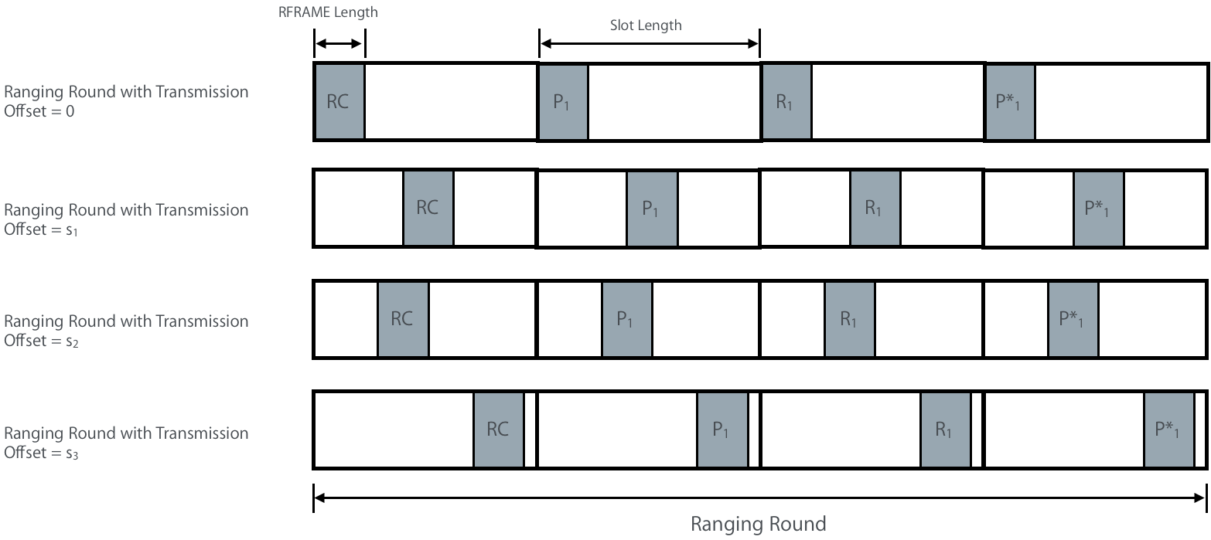

**Figure X2—Ranging Rounds with Different Transmission Offsets**

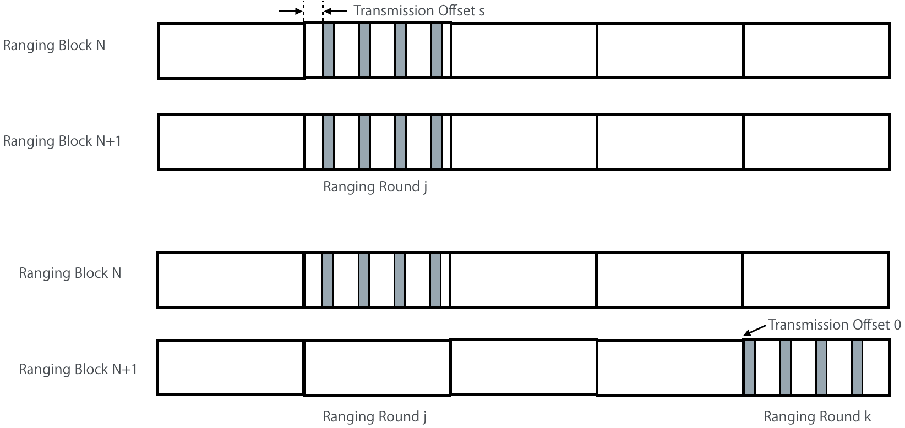

**Figure X3: Illustration of Transmission Offset and Round Hopping**

* **Page 63 Line 23 [7.4.4.40]**

**i-0265, i-0356, i-1015, i-1031, i-1032, i-1652, i-1668, i-1669, i-2161, i-2248, i-2552**

*Definition of the RR IE is incomplete. Replace the whole section with the following:*

* + - 1. Ranging Round IE

The Ranging Round IE (RR IE) may be included in the RCM, or in the final RFRAME, or in the final data message of a ranging message sequence. Its role is to specify scheduling of the ranging round.

The content field the RR IE shall be formatted as shown in Figure .

|  |  |  |  |
| --- | --- | --- | --- |
| **Octets : 2** | **Bits: 1** | **15** | **Octets: 2** |
| Ranging Block Index | Hopping Mode | Round Index | Transmission Offset |

**Figure 48—Ranging Round IE Content field format**

The Ranging Block Index field specifies the index of the ranging block with a range of 0 to 65535.

The Hopping Mode field specifies the hop mode for the ranging block, where 0 = No Hopping, and 1 = Hopping.

The Round Index field specifies the ranging round index for the ranging block with a range of 0 to 32767.

The Transmission Offset field specifies the value of transmission offset of the ranging round in the block. The time unit of Transmission Offset is the RSTU. This offset shall be at most the Ranging Slot Duration minus the packet duration.

When the time structure, as selected by the Time Structure Indicator field of the ARC IE (7.4.4.38), is Block-based mode, then all the fields shown in Figure 48 shall be included in the RR IE.

Note that for the Block-based mode, when the RR IE is included in the RCM, the configurations it conveys relate to the current ranging round in the current ranging block. However, when it is sent at the end of the ranging round in the final RFRAME or the final data message, the configurations it conveys relate to the next ranging round.

* **Page 64 Section 7.4.4.41. Definition of the RBU IE is incomplete. Replace the whole section with the following:**

**i-0187, i-0188, i-0496**, **i-1033, i-1034, i-1035, i-1036, i-1037, i-1670, i-1671, i-1672, i-1673, i-1674,** i-**1857, i-2414, i-2436, i-2456, i-2516, i-2536**, **i-2787**

* + - 1. Ranging Block Update IE

The Ranging Block Update IE (RBU IE) is included in the final Ranging frame or final data frame of ranging message sequence. The content field of the RBU IE shall be formatted as shown in Figure 50.

|  |  |  |  |
| --- | --- | --- | --- |
| Octet: 1 | Octet: 3 | 1/0 | 2/0 |
| Relative Block Index | Updated Block Duration | Updated Ranging Round Duration | Updated Slot Duration |

**Figure 50: Ranging Block Update IE Content Field Format**

The Relative Block Index indicates the number of ranging blocks with the current block structure before switching to the new block structure.

The Updated Block Duration field is an unsigned integer used to set the new ranging block duration and is expressed in multiple of RSTUs.

The Updated Ranging Round Duration field is an unsigned integer used to specify the value of the ranging round duration in the new block structure as an integer multiple of ranging slot duration.

The Updated Ranging Slot Duration field is an unsigned integer used to specify the value of the ranging slot duration in the new block structure and is expressed in multiple of RSTU.

Note that the RBU IE can be used to update the block duration only, in which case the Updated Ranging Round Duration and Updated Ranging Slot Duration fields will not be present.

* **Page 53 Line 11**

i-0392, i-0393, i-0432

*Add the following row to Table 7-16*

|  |  |  |  |  |  |  |  |  |  |  |
| --- | --- | --- | --- | --- | --- | --- | --- | --- | --- | --- |
| **Sub-ID Value** | **Name** | **E-B.** | **E-ACK** | **Data** | **MP** | **MAC cmd** | **Format Sub Clause** | **Use Description** | **Used By** | **Created By** |
| <ANA> | Ranging Message Non-Receipt IE |  |  | X |  |  | 7.4.4.X | 6.9.8 | UL | UL |

*Add the following sub-clause to 7.4.4*

**7.4.4.X Ranging Message Non-Receipt IE**

The Ranging Message Non-Receipt IE (RMNR IE) is used to convey non-receipt of a ranging message. This IE is formatted without any content field. An example procedure of using this IE is described in 6.9.8.























* **Page 65 Line 22, Page 66 Line 5**

i-0272, i-0332, i-1047, i-1058, i-1060, i-1421, i-1684, i-1695, i-1697, i-1987, i-2013, i-2163, i-2599, i-2879

*To enhance flexibility of adjusting IV, use 4 bits for IVC field, which correspond to presence indicators of IV potions, i.e., bits [0:31], [32:63], [64:95], and [96:127], respectively. The updated figure 54 can be found below:*

|  |  |  |  |  |  |  |  |  |  |  |  |  |
| --- | --- | --- | --- | --- | --- | --- | --- | --- | --- | --- | --- | --- |
| Bits: 1 | 1 | 1 | 1 | 1 | 2 | 1 | Octets: 0/4 | 0/4 | 0/4 | 0/4 | 0/16 | 0/4/8/16 |
| IVCP | IVLP | IVMP | IVHP | SKP | ICP | CP | IV Counter | IV Low | IV Mid | IV High | STS Key | Integrity Code |

**Figure 54-Ranging STS Key IE Content field format**

*Replace paragraph between line 23 and line 25 on page 65 by following:*

The fields of IVCP, IVLP, IVMP, and IVHP respectively indicate the presence of fields, including IV Counter, IV Low, IV Mid, and IV High. If the value of the IVCP/IVLP/IVMP/IVHP field is one, the IV Counter/IV Low/IV Mid/IV high is present, otherwise it is not.

*Replace paragraph between line 5 and line 6 on page 66 by following:*

If present, the fields of IV Counter, IV Low, IV Mid, and IV High are used to update corresponding portions of IV. Specifically, the IV counter field is used to update bits [0:31] of IV; the IV Low field is used to update bits [32:63] of IV; the IV Mid field is used to update bits [64:95] of IV; and the IV High field is used to update bits [96:127].

*Add after line 14 on page 66 the following:*

It is assumed that the RSKI IE is sent encrypted, except in applications that require it to be sent (broadcast) in plaintext.

* **Page 54 Table 7-16, Page 61 Line 1, Page 71 Line 10 (Revise [7.4.4.38] ARC IE & Merge [7.4.4.51] RIRL IE and [7.4.4.52] RS IE)**

i-0053, i-0054, i-0055, i-0198, i-0199, i-0256, i-0257, i-0258, i-0259, i-0260, i-0287, i-0329, i-0333, i-0334, i-0340, i-0341, i-0388, i-0414, i-0489, i-0490, i-0491, i-0492, i-0493, i-0494, i-0495, i-0500, i-0503, i-0991, i-0994, i-1002, i-1003, i-1004, i-1005, i-1006, i-1007, i-1008, i-1009, i-1010, i-1011, i-1012, i-1020, i-1021, i-1022, i-1023, i-1101, i-1398, i-1628, i-1631, i-1639, i-1640, i-1641, i-1642, i-1643, i-1644, i-1645, i-1646, i-1647, i-1648, i-1649, i-1657, i-1658, i-1659, i-1660, i-1738, i-1980, i-1981, i-1982, i-1983, i-1986, i-2046, i-2074, i-2104, i-2105, i-2107, i-2108, i-2129, i-2130, i-2157, i-2158, i-2160, i-2189, i-2190, i-2192, i-2193, i-2194, i-2226, i-2285, i-2286, i-2289, i-2572, i-2597, i-2779, i-2839, i-2840, i-2841, i-2842, i-2843, , i-0168, i-1436, i-1437, i-2551, i-2562, i-2620, i-2621, i-0501, i-0502, i-1096, i-1733, i-2165, i-1097, i-1734, i-2797, i-1110, i-1747, i-2028, i-2537

# 7.4.4.38 Advanced Ranging Control IE

*Change the row of ARC IE in Table 7-16 on page 54*

|  |  |  |  |  |  |  |  |  |  |  |
| --- | --- | --- | --- | --- | --- | --- | --- | --- | --- | --- |
| **Sub-ID**  **value** | **Name** | **Enhanced Beacon** | **Enhanced ACK** | **Data** | **Multipurpose** | **MAC Command** | **Format subclause** | **Use description** | **Used by** | **Created by** |
| <ANA> | Advanced Ranging Control IE |  |  | X |  |  | 7.4.4.38 | 6.9.8 | UL | UL |

*Add the following sentence before “The content field of the ARC IE….” at line 29, on page 60:*

The ARC IE can also be used by the controlee, along with the RCR IE (7.4.4.45), to send preferred ranging parameters to the controller.

*Replace Figure 47 on page 61 by the following one:*

|  |  |  |  |  |  |  |  |  |  |  |
| --- | --- | --- | --- | --- | --- | --- | --- | --- | --- | --- |
| **Bits :2** | **2** | **2** | **1** | **1** | **1** | **6** | **1** | **Octets: 0/3** | **0/1** | **0/2** |
| Multi-node Mode | Ranging Round Usage | STS Packet Config | Schedule Mode | Deferred Mode | Time Structure Indicator | RCM Validity Rounds | MMRCR | Ranging Block Duration | Ranging Round Duration | Ranging Slot Duration |

**Figure 47 –Advanced Ranging Control IE content field format**

.

*Replace Table 14 on page 61 by the following one:*

**Table 14 –Values of the Multi-node Mode field in the ARC IE**

|  |  |
| --- | --- |
| Multi-node Mode field value | Meaning |
| 0 | Single device to single device (unicast) |
| 1 | Multi-node one-to-many |
| 2 | Multi-node many-to-many |
| 3 | Reserved |

*Replace texts line 7-8, and Table 15 on page 61 by the following:*

The Ranging Round Usage field specifies the usage of the ranging round(s) that follow the ARC IE. The Ranging Round Usage field shall have one of values as defined in Table 15.

**Table 15 –Values of the Ranging Round Usage field in the ARC IE**

|  |  |
| --- | --- |
| Ranging Round Usage field value | Meaning |
| 0 | One way ranging (OWR) |
| 1 | Single-sided two-way ranging (SS-TWR) |
| 2 | Double-sided two-way ranging (DS-TWR) |
| 3 | Ranging ancillary information exchange |

*Replace texts from line 3-9, and Table 17 on page 62*

The Schedule Mode field specifies whether the scheduling-based ranging or contention-based ranging is performed in the following ranging rounds as per Table 17.

**Table 17 –Values of the Schedule Mode field in the ARC IE**

|  |  |
| --- | --- |
| Schedule Mode field value | Selected ranging schedule mode and behavior |
| 0 | Contention-based ranging is used for the following ranging rounds, and the RDM IE (7.4.4.X1) and the RCPS IE (7.4.4.42) can be employed to control participation. |
| 1 | Scheduling-based ranging is used for the following ranging rounds, and the RDM IE (7.4.4.X1) can be employed to control participation and time-slot allocation. |

The Deferred Mode field specifies whether the deferred data frame is required or not for the measurement report. If the field value is one, it indicates that deferred data frame(s) after the ranging cycle will be used to report certain information. If the field value is zero, it indicates that certain requested information can be embedded in the RFRAME, e.g., RRTI IE (7.4.4.32).

*Replace texts on page 63 between line 1 and line 8 by the following texts:*

The RCM Validity Rounds field is an unsigned integer that specifies the number of consecutive ranging rounds controlled by the RCM. Note that this value cannot be larger than the number of remaining ranging rounds in the current block.

The Multiple Message Receipt Confirmation Request (MMRCR) field indicates whether multiple message receipt confirmation is requested or not: if the MMRCR field value is one, it is requested, otherwise it is not.

The Ranging Block Duration field is an unsigned integer that specifies the duration of a Ranging Block in the unit of RSTU as defined in 6.9.1.2.

The Ranging Round Duration field is an unsigned integer that specifies the duration of the Ranging Round in the unit of Ranging Slot duration.

The Ranging Slot Duration field is an unsigned integer that specifies the duration of a Ranging Slot in the unit of RSTU.

One or more fields of duration, i.e., Ranging Block Duration, Ranging Round Duration, and Ranging Block Duration, may not be present in the ARC IE of the current RCM, if ranging block structure follows the same specified duration as before. But other fields, e.g., Schedule Mode, STS Packet Config, can still be used to update corresponding ranging parameters. The presence of last three fields in the ARC IE can be determined by its content length. When the length of content fields is 2-octet, the last three fields are not present. When the length of content fields is 5-octet, the Ranging Block Duration field is present. When the length of content fields is 6-octet, Ranging Block Duration and Ranging Round Duration fields are present. When the length of content fields is 8-octet, the last three fields in the ARC IE are present.



*Merge [7.4.4.51] RIRL IE and [7.4.4.52] RS IE into a single IE, namely Ranging Device Management IE (RDM IE). Remove Sub-clause [7.4.4.51] and [7.4.4.52], and assign a sub-clause to RDM IE.*

**7.4.4.X1 Ranging Device Management IE**

The Ranging Device Management IE (RDM IE) is used by the controller to control devices participating in a Ranging Round if the controller knows the device identities. The content field of the RDM IE shall be formatted as shown in the Figure Y1.

|  |  |  |
| --- | --- | --- |
| **Bits: 1** | **7** | **Variable** |
| SIP | RDM Table Length | RDM Table |

**Figure Y1 –Ranging Device Management IE content field format**

The RDM Table field contains row elements formatted as per Figure Y2.

|  |  |  |
| --- | --- | --- |
| **Bits: 1** | **7** | **Octets: 2/8** |
| Ranging Role | Slot Index/Reserved | Address |











**Figure Y2 –RDM Table row element format**

The Slot Index Present (SIP) field as shown in Figure Y1 indicates whether Bit: 1-7 of the first octet in each RDM Table row element is used as slot index or reserved: if the SIP field value is one, these 7 bits are used as the slot index, otherwise they are reserved. When the SIP field value is zero, the RDM IE is used to assign ranging role, i.e., initiator or responder, of controlees for the contention-based ranging. When the SPI field value is one, the RDM IE is used to allocate time slots, and specify ranging roles of controlees for the scheduling-based ranging.

The RDM Table Length field indicates the number of row elements in the RDM Table. If the SIP field value is one, the RDM Table Length field value equals the number of assigned time slots. If the SIP field value is zero, the RDM Table Length field value equals the number of participated ERDEVs.

Each row element of RDM Table contains the address and ranging role of a particular ERDEV. The Ranging Role field specifies whether the selected device is to be an initiator or a responder. When the Ranging Role field has a value of 0, the selected device is a responder. When the Ranging Role field has a value of 1, the selected device is an Initiator.

The Slot Index field is used if the SIP field value is one, which indicates the time slot assigned to the ERDEV.

The address field shall contain a short address when the DstAddrMode of the MCPS-DATA.request is SHORT, and an extended address otherwise.

* **Page 63 Line 9 [7.4.4.39] RIU IE**

i-0261, i-0262, i-0327, i-0330, i-0391, i-0415, i-1013, i-1016, i-1017, i-1018, i-1650, i-1653, i-1654, i-1655, i-2227, i-2247, i-2272, i-2287, i-2290, i-0381

*Replace Figure 48 by following:*

|  |  |  |  |  |  |  |  |  |  |  |  |  |
| --- | --- | --- | --- | --- | --- | --- | --- | --- | --- | --- | --- | --- |
| Bits :1 | 1 | 1 | 1 | 1 | 3 | Octets: 4 | 0/2 | 0/2 | 0/1 | 0/1 | 0/2 | 0/2 |
| NRIP | RIU  MP | RTWMP | RTW ISP | CRSIP | Reserved | Block Interval | Next  Round Interval | RIUM Interval | Remaining Number  of RIUMs | RTW Multiplier | RTW Initial  Size | Current Round Set Index |

**Figure 48-Ranging Interval Update IE Content field format**

*Add the follow texts before line 13:*

The NRIP field indicates the presence of Next Round Interval field as follows: an NRIP field value of 0 means that the Next Round Interval field is not present; while the NRIP field value of 1 means that the Next Round Interval field is present. If the Next Round Interval is 0, the Next Round Interval field can be omitted with the NRIP field value of 0.

The RIUMP field indicates the presences of RIUM Interval field and Remaining Number of RIUMs field as follows: The RIUMP field value of 0 means that neither the RIUM Interval field or Remaining Number of RIUMs field are present; while the RIUMP field value of 1 means that the RIUM Interval field and the Remaining Number of RIUMs field are both present.

The RTWMP field indicates the presence of the RTW Multiplier field as follows: RTWMP field value of 0 means that the RTW Multiplier field is not present; while the RTWMP field value of 1 means that the RTW Multiplier field is present.

The RTWISP field indicates the presence of the RTW Initial Size field as follows: RTWISP field value of 0 means that the RTW Initial Size field is not present; while the RTWISP field value of 1 means that the RTW Initial Size field is present.

The CRSIP field indicates the presence of the Current Round Set Index field as follows: CRSIP field value of means that the Current Round Set Index is not present; while the CRSIP field value of 1 means that the Current Round Set Index is present.

*Replace paragraph between line 13 and line 19 by following:*

The Block Interval field specifies the time remaining until the start time of the next Ranging Block relative to the start time of the current frame. The Block Interval field is in the unit of RSTU as defined in 6.9.1.2.

The Next Round Interval field if present, as determined by the NRIP field, specifies the time remaining until the start time of the next Ranging Round relative to the start time of the next ranging block. The Next Round Interval field is in the unit of RSTU as defined in 6.9.1.2.

The RIUM Interval field if present, as determined by the RIUIP field, specifies the time remaining until the start time of the next RIU message relative to the start time of the current frame. The RIUM Interval field is in the unit of RSTU as defined in 6.9.1.2.

*Add the follow texts before line 22:*

The RTW Multiplier field specifies the exponential multiplier of RTW Initial Size to calculate the size of RTW, i.e., RTW Initial Size*2^(RTW Multiplier). The RTW Initial Size field specifies the initial size of RTW in the unit of RSTU as defined in 6.9.1.2.

RCM Timing Window (RTW) operation is enabled if RTWISP or both RTWISP and RTWMP in the RIU IE is 1. If both RTWMP and RTWISP are 0, a controller sends the RCM with Block Interval field and/or Next Round Interval field in the RIU IE without RTW. If RTWISP is 1 and RTWMP is 0, a controller sends the RCM at random timing within RTW. The size of RTW is fixed with RTW Initial Size. If both RTWMP and RTWISP are 1, a controller sends the RCM at random timing within RTW.

The Current Round Set Index field specifies the ranging round set index for the ranging block with a range of 0 to 65535.



* **Page 64 Line 24 [7.4.4.42 RCPS IE]**

i-1102, i-1739, i-2799

*The Slot Index should be 7-bit for consistency. Replace the Figure 52 on the page 65 by the following one:*

|  |  |  |
| --- | --- | --- |
| **Bits:2** | **7** | **7** |
| Phase Indicator | Slot Index to Start | Slot Index to End |

**Figure 52-Ranging Interval Update IE Content field format**

*Replace texts line 6-8 on page 65 by the following:*

The Phase Indicator field selects whether the phase being described is used for ranging transmissions or measurement reports. The values are specified in the Table YY.

**Table YY –Values of the Phase Indicator field in the RCPS IE**

|  |  |
| --- | --- |
| Phase Indicator field value | Meaning |
| 0 | This phase is used by the initiators to contend for ranging transmissions |
| 1 | This phase is used by the responders to contend for ranging transmissions |
| 2 | This phase is used by participated RDEVs to contend for measurement report |
| 3 | Reserved |

* **Page 66, 7.4.4.45, Line 24 [RCR IE]**

i-1062, i-1699, i-2519, i-0335

*Add the follow texts to the end of line 24, on page 66:*

The change request of certain information is reflected in the next scheduled time to exchange the updated parameters in a message sent by controller to controlee(s).

* **Page 73, 7.4.4.55, Line 13 [Include TOF request in SRRR IE]**

i-0338

*To include the request of time-of-flight (ToF), use a reserved bit of SRRR IE. The updated Figure 67 can be found below:*

|  |  |  |  |  |  |  |  |  |
| --- | --- | --- | --- | --- | --- | --- | --- | --- |
| Bits: 1 | 1 | 1 | 1 | 1 | 1 | 2 | Octets: 0/2/8 | 0/2/8 |
| RAP | PAP | RAOA | RRT | RRTM | RTOF | Reserved | Requestor Address | Provider Address |

**Figure 67— SP3 Ranging Request Reports IE content field format**

*Add the follow texts after line 23:*

The RTOF field indicates that a report of time-of-flight (ToF) is required when the RTOF field is 1, and not required when the RTOF field is 0.

* **Page 75 Line 19 [7.4.4.57 RPCS IE]**

i-0331, i-0567, i-1121, i-1122, i-1127, i-1130, i-1758, i-1759, i-1764, i-1767, i-2134, i-2168, i-2460, i-2480, i-0506, i-0507, i-0508

**Page 6 Line 7, Page 18 Line 25, Page 7 Line 19, Page 53 Line 11, Page 75 Line 19, Page 80 Line 3**

i-1419, i-1420, i-2011, i-2012

*The following texts and figures are considered to be included for the feature of channel selection, which is proposed in the original contribution: 15-19-0034-02-004z-ieee-802-15-4z-mac*

# MAC functional description

# 6.9.2 Set-up activities before a ranging exchange

*Change the following sentences between line 7 and line 13 on page 6: “Furthermore, if the optional dynamic preamble selection (DPS) capability is to be used, there shall have been some sort of coordination of preambles prior to the two-way ranging exchange. The RPCS IE, as specified in 7.4.4.57, may be used for this purpose” by:*

Furthermore, if the optional dynamic preamble selection (DPS) and dynamic channel selection (DCS) capability are to be used, there shall have been some sort of coordination of preambles and channels prior to the ranging exchange. The Ranging Channel and Preamble Code Selection IE (RCPCS IE) IE, as specified in 7.4.4.57, may be used for this purpose.

# 6.9.7.8 Other procedures for coordinating RDEV and ERDEV

*Change the following sentences between line 25 and line 27 on page 18: “Similarly when using DPS as described in 6.9.4, the RDEVs need to coordinate the preamble codes they are going to employ and again the secure private data communication capability of this standard may be used to transfer the DSP selection between devices using the RPCS IE (7.4.4.57)” by:*

Similarly, when using DPS and DCS as described in 6.9.4 and 6.9.5, the RDEVs need to coordinate the preamble codes and UWB sub-band they are going to employ and again the secure private data communication capability of this standard may be used to transfer the DPS and DCS between devices using the RCPCS IE (7.4.4.57).

*Include the following subsection after 6.9.4, and increment the numbering of all the subsequent subsections and figures as required*

# 6.9.5 Managing DCS

# Figure 6-49 shows a suggested message sequence chart to configure a selected UWB channel. Messages are the suggestions showing how the communications capability of the RDEV can be used to accomplish the DCS.

# 

**Figure 6-49 – A message sequence chart to configure a selected channel**

# The originator may transmit the RCPCS IE (7.4.4.57) to exchange the sub-band selection for the coordination of ranging channel. The coordination of ranging channel is needed only when using the optional DCS capability of the PHY. For the multi-node ranging scheme (6.9.8), controller shall be the originator to initiate DCS, and RCPCS IE can be inserted in the ranging control message (RCM).

# In the coordination process of a ranging channel, the next higher layer in each participating devices shall set a Channel Configuration Interval (CCI) timer. Once this timer has elapsed, the selected channel is configured. The setting of CCI is determined by the originator next higher layer, which may be exchanged via RCPCS IE. CCI has to be long enough for PHY to configure a channel switch. The bottom interactions between next higher layer and MAC illustrate the use of the MLME-SET.request, as described in 8.2.6.3, and the MLME-SET.confirm, as described in 8.2.6.4, which adjust phyCurrentChannel /phyCurrentPage (Table 11-2), and report the status of parameter setting.

# Upon the assertion of the MLME-SET.confirm primitives, as illustrated in Figure 6-49, PHYs of both sides will use selected channel, where future Ranging Round(s) will be operated on. After a certain period of time, if the originator intends to switch to another available channel or back to a previous one, it can reiterate procedures illustrated in Figure 6-49. The DCS provides more flexibility to manage multi-node ranging, and can also help to alleviate interference.

*Change the row of Ranging Preamble Code Selection IE in Table 7-16*

|  |  |  |  |  |  |  |  |  |  |  |
| --- | --- | --- | --- | --- | --- | --- | --- | --- | --- | --- |
| **Sub-ID**  **value** | **Name** | **Enhanced Beacon** | **Enhanced ACK** | **Data** | **Multipurpose** | **MAC Command** | **Format subclause** | **Use description** | **Used by** | **Created by** |
| <ANA> | Ranging Channel and Preamble Code Selection IE |  |  |  |  |  | 7.4.4.57 | 6.9.5  6.9.7.8 | UL | UL |

*Change the following subsection*

**7.4.4.57** **Ranging Channel and Preamble Code Selection IE**

The Ranging Channel and Preamble Code Selection IE (RCPCS IE) is provided as a mechanism to signal the choice of UWB channel for DCS as described in 6.9.5, and/or preamble code for DPS as described in 6.9.4. The content format of the RCPCS IE shall be formatted as shown in Figure 71.

|  |  |  |  |  |  |  |  |
| --- | --- | --- | --- | --- | --- | --- | --- |
| Bits: 1 | 1 | 2 | 4 | Octets: 0/4 | 0/1 | 0/1 | 0/2 |
| CCIP | PSP | Reserved | Channel Number | CCI | TX Preamble Code | RX Preamble Code | PSR |

**Figure 71 – Ranging Channel and Preamble Code Selection IE content field format**

The field of CCI Present (CCIP) indicates the presence of CCI field. If its value is 1, CCI field is present. Otherwise, it does not exist, and the setting of CCI is specified by the next higher layer.

The field of preamble selection presence (PSP) indicates the presence of last three fields for DPS. If its value is 1, the last three fields are present. Otherwise, they are not present.

The Channel Number field specifies the UWB channel number, i.e., 0~15, corresponding to field values 0000~1111. For LRP UWB PHY, the valid range is 0~2 as described in 10.1.2.7, while it is 0~15 for HRP UWB PHY as described in 10.1.2.4. The selection of channel number by upper layer shall depend on the device capability and regional-based regulation.

The 4-octet CCI field specifies the timer duration between the exchange of this IE and configuration of selected channel, which is in the unit of RSTU (6.9.1.2).

The TX Preamble Code field shall be set to the DPS preamble code that the IE sender will use for transmission. The RX Preamble Code field shall be DPS preamble code that the IE sender will use for reception. Both these preamble codes shall be selected from Table 16-6, both from Table 16-7, or both from Table 28. The PSR field shall be set to the number of preamble symbol repetitions to transmit for the SYNC of each RFRAME of the ranging exchange, if PSR is 0 the length of the SYNC is not changed, otherwise the PSR shall be one of the valid SYNC lengths, as specified in 16.2.5.1.

* **Page 19 Line 1 [6.9.7.9 Secure Service IE]**

**i-1389, i-2010, i-0146, i-2876, i-0293, i-1119, i-1756, i-2294, i-1124, i-1761, i-2340, i-0071, i-1123, i-1760, i-2800, rg-0004, rg-0010**

*Replace the sub clause 6.9.7.9 with the following*

**6.9.7.9 Ranging Enhanced Service Transactions**

The enhanced ranging capabilities of the ERDEV can be used to protect by using ranging to check that the distance between the communicating devices is as expected. In such secure service transaction scenarios, the higher layer is often interfacing between the radio and a secure element used in validating the transaction.  The Secure Service IE (7.4.4.56) is provided as a means to transfer information relevant to the Secure Element between the ERDEVs in conjunction with range measurements. When a Secure Service IE is received in an RFRAME, the MAC delivers it to the higher layer with an associated ranging measurement, which the higher layer can use to limit access based on range. The Secure Service IE contains fields to identify and distinguish transactions, and fields to carry information about the MAC payload that can be used by the higher layer to route the payload to different device components. If the transaction takes place using multiple frames, all frames that transport data belonging to the particular transaction should include the Secure Service IE with the same USS ID value.

*Revise the Table 22 in the IE description of sub clause 7.4.4.56*

**Table 22 – Payload Type field values**

|  |  |
| --- | --- |
| **Field value** | **Meaning** |
| 0 | Application specific payload |
| 1 | MAC Payload field contains an APDU as defined by ISO/IEC 7816-4 [B##]. |
| 2 | MAC Payload field contains a Mifare Classic® command or response. |
| 3 | MAC Payload field contains a Mifare Desfire® command or response. |
| 4 | MAC Payload field contains an Information field as defined by JIS X 6319-4 [B#]. |
| All other values | Reserved |











* **i- 0340 [Ranging Ancillary Information]**

*Add following lines to Section 6.9.8.1, page 23 after line 7*

A block may have one or more ranging rounds during which ranging ancillary information can be exchanged between initiators and responders. For ranging ancillary information exchange, following terminology is used:

Initiator: a Ranging device that initiates a ranging exchange by sending the first message of the exchange or the device that sends ranging ancillary information

Responder: a Ranging device that receives ranging ancillary information and/or responds to the message received from the initiator

Ranging Round Usage field of ARC IE (7.4.4.38) shall be used to indicate that the ranging round(s) following this RCM is used for ranging ancillary information exchange. The information exchange can be scheduled or contention based. A given data may be divided into multiple fragments and transmitted over multiple ranging in a ranging round. In such a case RAICT IE (7.4.4.XX) shall be used by the initiator to convey the number of ranging message frames remaining to complete the transmission. If the initiator is not the controller, the RAICT IE can be used along with RCR IE (7.4.4.45) to request the number of slots to be scheduled. This information may also be exchanged via upper layer.

A receiver or responder may use a Multiple Message Receipt Confirmation (MMRC) to confirm the receipt of multiple messages originating from the same initiator or to confirm the receipt of multiple messages originating from multiple initiators (or transmitters). The MMRC IE may be used by the responder (or recipient of multiple messages) to acknowledge the multiple messages. The Multiple Message Receipt Confirmation Request (MMRCR) field of the ARC IE shall be used to indicate MMAR.

Figure XW illustrates an example message sequence chart for MMRC with MMRCR from controller in the RCM. Devices A1 to AN each send multiple messages to devices B1 to BM, where the Message $i_{A_{j}}$ is the th message transmitted from Aj for j in $1$ to $N$ . Upon the completion of onward messages from devices A1 to AN, devices B1 to BM confirm the receipt of all the messages to different initiators through by sending MMRC via multicast or multi-node messages using the Ranging Multiple Message Receipt Confirmation IE (RMMRC IE). The messages and the MMRC slots may be scheduled or may be contention based or may be a combination of both.

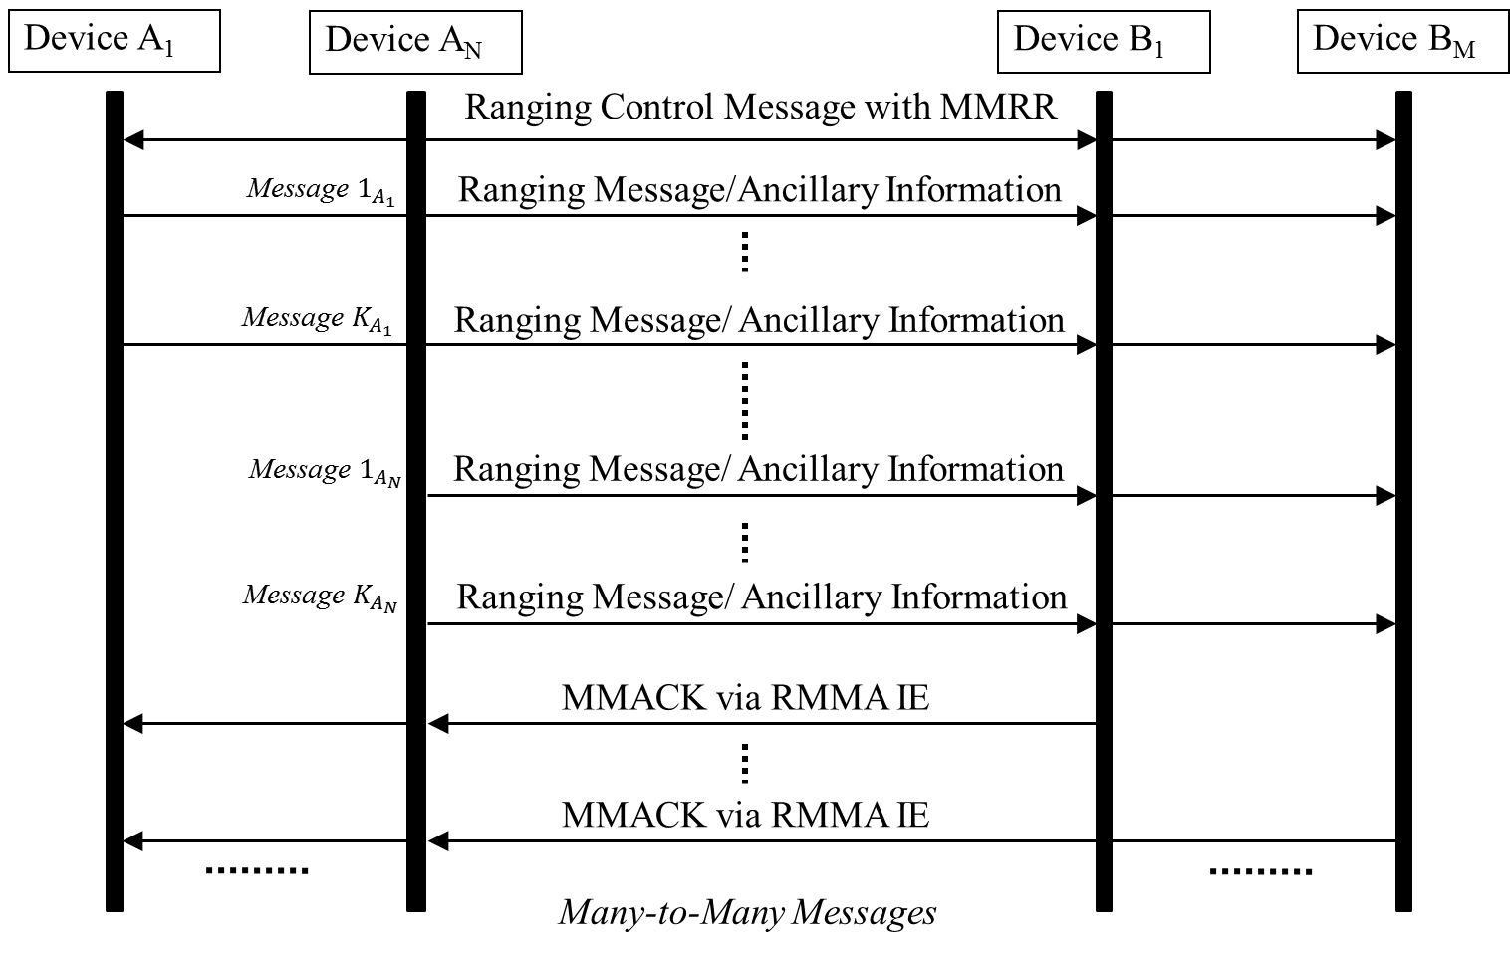

**Figure XW. Illustrative message sequence chart multiple message acknowledgement for multiple many-to-many messages**

*Add a new IE description 7.4.4.XX*

**17.4.4.XX Ranging Ancillary Information Message Counter and Type IE**

The Ranging Ancillary Information Message Counter and Type IE (RAICT IE) is used during ranging ancillary information exchange (in payload). This IE is formatted as shown in Figure XX.

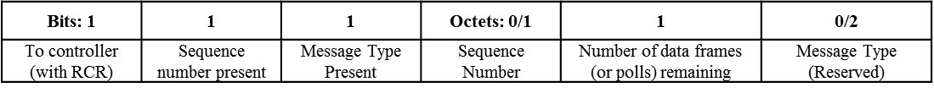

**Figure XX—** **Ranging Ancillary Information Message Counter and Type IE Content field format**

initiator uses this IE in two ways:

1. To convey the sequence number of the current data frame, the number of ranging ancillary data frames remaining to complete this message and the message type to the responder
2. Used along with RCR IE to request the controller to schedule the number of slots as specified in number of data frames (or polls) remaining

To controller (with RCR) bit is set to 1 to use RADCT IE to request the slots from controller. Otherwise it is set to 0.

Sequence number present field is set to 1 if Sequence number of present, else it is set to 0.

Message Type Present field is set to 1 if Message Type is being conveyed.

Sequence number field conveys the MAC frame sequence number.

Number of data frames field remaining conveys to the responder the number of ranging ancillary data frames remaining to complete the present message/data.

Message Type field is a reserved field of 2 octets which can be used to convey the type of message (e.g., authentication info).

*Add a new IE description 7.4.4.XX*

**17.4.4.XX Ranging Multiple Message Receipt Confirmation IE**

Messages from one or more initiators may be acknowledged with MMRC using Ranging Multiple Message Receipt Confirmation (RMMRC IE) with initiator addresses and MMRC bitmap string to acknowledge all the messages from that initiator (or transmitter). The IE shall contain a table to acknowledge multiple initiators in a single message. The content field of the IE may be formatted as illustrated in Figure XY.

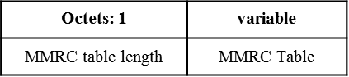

**Figure XY. Ranging Multiple Message Receipt Confirmation IE content field**

Each row of the MMRC table is formatted as illustrated in Figure XZ.

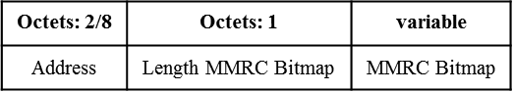

**Figure XZ. Format of each row of MMRC table**























Confirmation for the receipt of each message in the MMRC is done through a binary bitmap string. Each bit in the bitmap string sequentially maps to the number of slots prior to the slot in which MMRC is sent. The length of this acknowledgement bitmap is equal to the number of slots in the ranging round preceding the MMRC transmission. Each bit confirms the receipt of a message in the slot. The bit is set to 1 to confirm successful reception, otherwise it is set to 0 to convey that the message was not received or not addressed to the MMRC sender in that slot. The confirmation for the receipt of a message in the first slot shall be conveyed using the least significant bit (LSB) of the MMRC bitmap string and sequentially the following bits shall represent the confirmation for the receipt of messages in the subsequent slots with the MSB representing the confirmation receipt for the final slot.