**IEEE P802.15**

**Wireless Personal Area Networks**

|  |  |
| --- | --- |
| Project | IEEE P802.15 Working Group for Wireless Personal Area Networks (WPANs) |
| Title | IEEE 802.15.4z HRP comment resolutions |
| Date Submitted | 06/17/2019 |
| Source | Zheda Li (Samsung), Ayman Naguib (Apple),  Aditya Vinod Padaki (Samsung), Mingyu Lee (Samsung), Seongah Jeong (Samsung), Kangjin Yoon (Samsung), Brima Ibrahim (NXP), Frank Leong (NXP) , Jack Lee (Samsung) |
| Re: |  |
| Abstract | This contribution proposes updated text for the baseline draft P802.15.4z-D1 |
| Purpose | Provision of the text to facilitate its incorporation into the draft text of the IEEE 802.15.4z standard currently under development in TG4z. |
| Notice | This document does not represent the agreed views of the IEEE 802.15 Working Group. It represents only the views of the participants listed in the “Source(s)” field above. It is offered as a basis for discussion and is not binding on the contributing individual(s) or organization(s). The material in this document is subject to change in form and content after further study. The contributor(s) reserve(s) the right to add, amend or withdraw material contained herein. |
| Release |  |
| Patent Policy | The contributor is familiar with the IEEE-SA Patent Policy and Procedures:  <http://standards.ieee.org/guides/bylaws/sect6-7.html#6> and  <http://standards.ieee.org/guides/opman/sect6.html#6.3>.  Further information is located at <http://standards.ieee.org/board/pat/pat-material.html> and  <http://standards.ieee.org/board/pat>. |

* **Page 19 Line 10 (6.9.8) ~ Page 30 Line 2 (6.9.8.3)**

i-0014, i-0041, i-0044, i-0045, i-0168, i-0182, i-0184, i-0185, i-0191, i-0193, i-0194, i-0195, i-0196, i-0197, i-0216, i-0217, i-0219, i-0351, i-0352, i-0353, i-0354, i-0355, i-0357, i-0358, i-0359, i-0360, i-0361, i-0362, i-0364, i-0365, i-0366, i-0367, i-0368, i-0369, i-0370, i-0371, i-0372, i-0373, i-0374, i-0375, i-0376, i-0377, i-0378, i-0392, i-0400, i-0404, i-0405, i-0406, i-0407, i-0408, i-0409, i-0442, i-0447, i-0448, i-0449, i-0450, i-0451, i-0453, i-0455, i-0457, i-0458, i-0459, i-0461, i-0463, i-0464, i-0465, i-0466, i-0584, i-0586, i-0587, i-0588, i-0774, i-0775, i-0802, i-0810, i-0811, i-0812, i-8013, i-0814, i-0816, i-0817, i-0818, i-0819, i-0822, i-0824, i-0825, i-0826, i-0827, i-0828, i-0829, i-0830, i-0831, i-0832, i-0833, i-0834, i-0835, i-0836, i-1196, i-1394, i-1395, i-1396, i-1397, i-1411, i-1412, i-1436, i-1437, i-1439, i-1455, i-1456, i-1462, i-1463, i-1464, i-1465, i-1466, i-1467, i-1468, i-1469, i-1470, i-1471, i-1472, i-1473, i-1856, i-1969, i-1970, i-1971, i-1972, i-1973, i-2014, i-2015, i-2065, i-2066, i-2098, i-2099, i-2148, i-2149, i-2185, i-2121, i-2122, i-2221, i-2242, i-2263, i-2309, i-2310, i-2329, i-2330, i-2429, i-2430, i-2448, i-2449, i-2472, i-2492, i-2529, i-2530, i-2551, i-2561, i-2562, i-2569, i-2594, i-2612, i-2620, i-2621, i-2622, i-2623, i-2624, i-2626, i-2633, i-2635, i-2636, i-2637, i-2642, i-2643, i-2644, i-2649, i-2652, i-2653, i-2657, i-2658, i-2659, i-2671, i-2673, i-2674, i-2688, i-2689,

* + 1. Multi-node ranging

A Ranging Control Message (RCM), which is a frame conveying the Advanced Ranging Control IE (ARC IE), specified in 7.4.4.38, can be used to set the ranging parameters controlling the ranging procedure(s). The RCM can configure aspects of the ranging procedure(s) such as the time-slot structure shown in Figure 12, ranging methods (6.9.5), and STS packet configuration (16.2).

The following nomenclature is used for ERDEVs:

* Controller: An ERDEV that defines and controls the ranging parameters by sending RCM.
* Controlee: An ERDEV that utilizes the ranging parameters received from the Controller in the RCM.
* Initiator: An ERDEV that following the RCM initiates a ranging exchange by sending the first RFRAME, i.e., ranging initiation message.
* Responder: An ERDEV that responds to the ranging initiation message received from the initiator.

These terms are illustrated in Figure 11.



Figure 11—Ranging Controller, Controlee, Initiator and Responder

The Controlee(s) should be managed by a Controller. The Next higher layer of the Controller is responsible for determining the ranging parameters and device type of the ERDEVs (i.e., Initiator or Responder).

Multi-node ranging is a ranging procedure in which one or more Initiators perform ranging with multiple responders. There are two types of multi-node ranging. The first type is time-scheduled ranging in which the Controller knows the identities of all Controlees, and schedules ranging transmissions. The second type is contention-based ranging in which the Controller may not know the number or identities of the Controlees, and hence ERDEVs contend with each other. The Controller selects the type by setting the Schedule Mode field of the ARC IE (7.4.4.38).

A message sequence chart for multi-node ranging configuration is illustrated in Figure 12.



Figure 12—Message sequence chart for multi-node ranging configuration

The next higher layer of the Controller initiates MCPS-DATA.request by setting MultiRangingEnable to either SCHEDULE or CONTENTION (8.3.1), thus instructing the MAC sublayer to include an ARC IE in the transmitted data frame, which is then an RCM broadcast to controlees. The parameters included in the ARC IE are via MAC PIB attributes in Table 8-95. Then, MCPS-DATA.confirm reports the Status of sending the RCM to the next higher layer of the Controller (8.3.2), while MCPS-DATA.indication conveys the ARC IE, and other IEs from the Controller’s next higher layer, to the next higher layer of the Controlee(s) (8.3.3).

For time-scheduled ranging, the Controller selects the ranging devices participating in the ranging, their roles (i.e., whether the device is an Initiator or a Responder), and the time slots these devices will utilize by specifying the Ranging Device Management IE (RDM IE) (7.4.4.X1). The roles of the participating devices and their transmission schedule may be fixed and/or set by the higher layers. In this case, the RCM will not include the RDM IE.

For contention-based ranging, the Controller can include Ranging Contention Maximum Attempts IE (RCMA IE) (7.4.4.43), and Ranging Contention Phase Structure IE (RCPS IE) (7.4.4.42) from its next higher layer in the RCM. If the Controller knows the identities of the Controlees, the RDM IE can be used for contention-based ranging to determine device types.

The usage of multi-node ranging specific PIB attributes (Table 8-95) to create the ARC IE and/or RDM IE by the MAC sublayer is elaborated as following:

If *macRangingConfigIndicator* is TRUE, the ARC IE shall convey the fields of Ranging Block Duration, Ranging Round Duration, and Ranging Slot Duration, which have the same setting as *macRangingBlocDura*, *macRangingRoundDura*, and *maxRangingSlotDura*, respectively.

If macRangingConfigIndicator is FALSE, the fields of Ranging Block Duration, Ranging Round Duration, and Ranging Slot Duration shall not be present in the ARC IE. The ranging block and round structure, as described in 6.9.8.1, follows the same configuration of the recently exchanged RCM(s) or it has been exchanged via the out-of-band mechanism.

The fields of Multi-node Mode, Ranging Round Usage, STS Packet Config, Schedule Mode, Deferred Mode, Time Structure Indicator, RCM Validity Rounds, and MMRCR in the ARC IE, shall be consistent with the setting of *macMultiRangingMode*, *macRangingRoundUsage*, *macMultiRangingSpConfig*, *MultiRangingEnable*, *macMultiRangingDefer*, *macTimeStructure*, *RoundNumber*, and *macMmrcrEnable*.

If *macDevicePresence* is TRUE, the Controller knows the identities of participated RDEVs, whose addresses are listed in the *macUWBrngAddressList*. The RDM IE shall be created by the MAC sublayer, along with the ARC IE, in one of the following two cases.

* When *MultiRangingEnable* is SCHEDULE, and *macDeviceControl* is TRUE, the MAC sublayer of the Controller will create the RDM IE, along with the ARC IE, to fulfill the ranging scheduling. The fields of device type in the RDM IE shall be determined by the *macUWBrngInitiatorList*, while the assignment of time slot is determined by the *macUWBrngScheduleAssign*.
* When *MultiRangingEnable* is CONTENTION, and *macDeviceControl* is TRUE, the MAC sublayer of the Controller will create the RDM IE, along with the ARC IE, to control the device type. The fields of device type in the RDM IE shall be determined by the *macUWBrngInitiatorList*.

If the device mangament has been performed via the out-of-band mechanism, *macDeviceControl* is set to be FALSE for the scheduling-based (or contention-based) ranging by the next higher layer of the Controller. The MAC sublayer of the Controller will not create the RDM IE.

If *macDevicePresence* is FALSE, the Controller does not know the identities of participated RDEVs. The MultiRangingEnable of MCPS-DATA.request to initiatlize the RCM should be CONTENTION. Meanwhile, *macDeviceControl* is set to be FALSE by the next higher layer of the Controller, since the Controller has no information about the participated RDEVs.

A negative acknowledgement can be used to convey the non-receipt of messages during a ranging procedure. This procedure can be used whenever ERDEVs are scheduled to send messages bearing payload to the Controller. As depicted in the Figure X0, RCM is transmitted successfully. However, Responder-1 does not receive the expected Ranging Initiation Message from the Ranging Initiator/Controller. Rather than remaining idle in its assigned time slot for ranging response, Responder-1 can send a negative-acknowledgement using Ranging Negative Acknowledgement (RNA) IE (7.4.4.57) in the response message to indicate the failure of the Ranging Initiation Message, and implicitly confirm the successful exchange of RCM. For the Responder-2, once the controller receives its ranging response message, the Controller also knows that RCM has been received by Responder-2.



**Figure X0. Negative-acknowledgement exchange for one Initiator and multiple Responders: Controller is a ranging initiator**

* + - 1. Ranging block and round structure

The Ranging Block is a time period for ranging. Each Ranging Block consists of an integer multiple of Ranging Rounds, where a Ranging Round is period of sufficient duration to complete one entire range-measurement cycle involving the set of ERDEVs participating in the ranging exchange. Each Ranging Round is further subdivided into an integer number of Ranging Slots, where a Ranging Slot is a time period of sufficient duration for the transmission of at least one RFRAME. Figure 12 shows the Ranging Block Structure, with the Ranging Block divided into N Ranging Rounds, each consisting of M Ranging Slots. Durations of round/slot for different rounds in a ranging block may be different, which can be configured by different RCMs.



Figure 12—Illustration of Ranging Block, Ranging Round and Ranging Slot

The time unit used in specifying the duration of Ranging Block, Ranging Round, and Ranging Slot is the RSTU as specified in 6.9.1.2.

The following nomenclature is used for messages:

* Ranging Control Message (RCM): A message transmitted by the Controller at the beginning of Ranging Round(s) to configure ranging parameters.
* Ranging Control Update Message (RCUM): A message transmitted by the Controller at the end of Ranging Round(s) to update ranging parameters configured by RCM in the Ranging Round. RCUM includes IEs utilized by RCM in the Ranging Round.
* Ranging Interval Update Message (RIUM): A message transmitted by the Controller between Ranging Blocks to update the intervals and also to help the synchronization between the participating ERDEVs.

The following nomenclature is used to describe the functionalities of different exchanges in a Ranging Round:

* Ranging Control Phase (RCP): A phase in which the controller sends RCM.
* Ranging Initiation Phase (RIP): A phase in which the Initiator sends ranging initiation message to the Responder(s).
* Ranging Response Phase (RRP): A phase in which the Responder(s) send their response messages to the initiator.
* Ranging Final Phase (RFP): A phase in which the Initiator send ranging final message to the Responder(s). This phase is only used for DS-TWR.
* Ranging Phase (RP): A phase which should comprise RIP, RRP, and/or RFP.
* Measurement Report Phase (MRP): A phase in which participating ERDEVs exchange ranging measurements and related service information, whenever such measurements and service information cannot be embedded in RFRAMEs.
* Ranging Control Update Phase (RCUP): A phase in which the controller sends RCUM. If present, this phase shall be at the end of Ranging Round(s).
* Ranging Interval Update Phase (RIUP): A phase in which the controller sends RIUM.

In a Ranging Round, SS-TWR or DS-TWR can be used for ranging and localization as described in 6.9.8.4 to 6.9.8.8, or one way ranging (OWR) may be used as described in Applications of IEEE Std 802.15.4 [B3]. As shown in Figure 13, each Ranging Round may be comprised of an RCP, an RP, and an MRP. In practice, it may be possible to merge some phases. For example, RCP and RIP may be merged into a single phase when the Controller and the Initiator are the same device. The MRP may be used to convey ranging-related service information via dedicated IEs. For example, ERDEV supports the transfer of sensitive information pertaining to a higher layer in conjunction with ranging. In such secure transaction scenarios, the next higher layer can interface between the radio and a secure element used in validating the transaction via Secure Service IE (SS IE) as described in 7.4.4.56.



Figure 13—Phases of a Ranging Round

When the Schedule Mode field in the ARC IE is zero, contention-based ranging is enabled. The first slot index and the last slot index for each phase are specified in the RCPS IE described in 7.4.4.42. The RCPS IE provides the slot indices for different phases in a Ranging Round. Without specifying phases for different device types via RCPS IE, ERDEVs can also contend for all remaining slots of a Ranging Round configured by the RCM. If the Schedule Mode field in the ARC IE is one, the time-scheduled ranging is enabled. In this case, the slot allocation for the ERDEVs is specified either using the RDM IE (7.4.4.X1), or it can be specified by the next higher layer.

In Figure 14, the timing diagrams for different example cases of ranging procedures are presented. In each case, the RCM determines the type of ranging that is used.



Figure 14—Example timing diagrams for seven different multi-device ranging use cases

RFRAMES without PHR and payload may be used for ranging with HRP UWB PHY. These RFRAMES are SP3 format packets as shown in 16.2. The round structure of SP3 ranging is shown in Figure 15. In addition to the RCP and the RP, the Controller may request certain information, (e.g., AOA, reply time, or round trip time measurements) from the Controlees participating in the ranging exchange. The Controller may send its request either in-band as part of the RCM, (e.g., using SP3 Ranging Request Reports (SRRR) IE (7.4.4.55)) or this may be coordinated through an out-of-band mechanism.



Figure 15—SP3 Ranging Round Structure

SP3 RFRAMEs do not contain payload exchanges. Therefore, only time-scheduled ranging shall be used for SP3 RFRAME ranging in order to differentiate messages from different devices. However, the scheduling can be static or dynamic via the RDM IE (7.4.4.X1).

There can be SP3 ranging use cases without measurement report in the round structure. For example, an ERDEV may estimate the AOA of another ERDEV by using received SP3 RFRAME, without sending measurement report to the remote device afterwards.

For an LRP-ERDEV, the payload only mode (see 19.4.7) may be used, in which case the time structure of the Ranging Round can be similar to that shown Figure 15 for HRP-ERDEV SP3 ranging.

The ERDEVs can decide to start the transmission with a transmission offset within each slot by using the Transmission Offset field of Ranging Round (RR) IE (7.4.4.40). The transmission offset is expressed as a multiple of RSTU. All packet transmissions within the same Ranging Round can be transmitted with the same transmission offset. By adjusting the Transmission Offset, ERDEVs can avoid collisions and mitigate interference. Only the Controller is responsible for changing the Transmission Offset.

One-to-many multi-node ranging with fixed reply times can be supported in the block structure as shown in the example in Figure X4. All UWB packets from the Controller and the Initiator will follow the slot structure. However, the Responders will respond after reply fixed times FRT1, FRT2, …, FRTN. The fixed reply time FRTj is measured from the RMARKER of the ranging initiation message P1 to the RMARKER of the response message Rj Furthermore, we assume that:

1. FRT1>= 16*RSTU
2. FRTi > FRTj for i > j
3. The duration between the start of any two consecutive transmissions minus the packet length is greater than or equal to 16*RSTU
4. (FRTN + Packet_Length) < N*(Ranging Slot Duration)

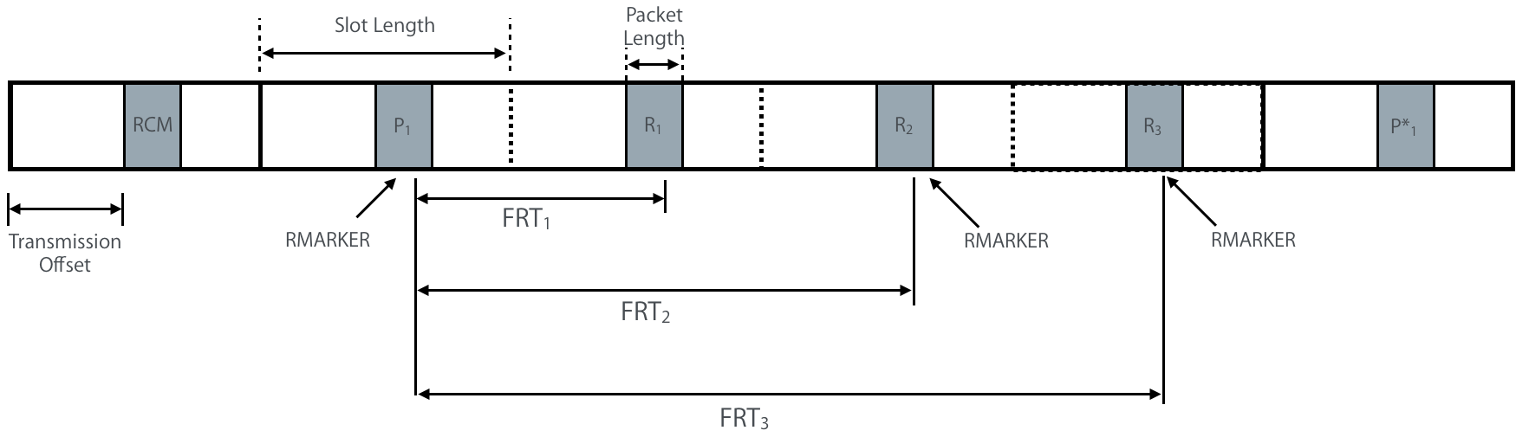

**Figure X4—Example Ranging Block Structure with Fixed Reply Time**

Fixed reply time cannot be used if the scheduling mode of the responses is contention based.

* + - 1. Ranging modes

In this section, two modes for ranging resource management are introduced: Interval-based mode and Block-based mode. The key difference between the Block-based mode and the Interval-based mode is that the time between successive Ranging Rounds in the Block-based mode is constant (i.e., using a time structure with uniform sampling) while in the Interval-based mode the time between successive Ranging Round can be varied. The Controller selects the mode and the corresponding time structure. This selection may be achieved by an out-of-band mechanism or in-band using the Time Structure Indicator field in the ARC IE (7.4.4.38).

* + - * 1. Interval-based mode

The Interval-based mode utilizes the three intervals: Block Interval, Round Interval, and RIUM interval. Settings of these intervals are specified in the RIU IE described in 7.4.4.39.

The following nomenclature is used in this mode:

* Block Interval: Time remaining until the start time of the next Ranging Block relative to the start time of the current message.
* Round Interval: Time remaining until the start time of the next RCM relative to the start time of the current message.
* RIUM interval: Time remaining until the start time of the next RIUM relative to the start time of the current message.
* Ranging Round Set: A set of Ranging Round(s) covered by a specific RCM in a Ranging Block

In the first Ranging Round of a Ranging Round Set, an RCM with the ARC IE (7.4.4.38) configures ranging parameters of the Ranging Round Set. The number of ranging rounds in a Ranging Round Set is specified by the RCM Validity Rounds field of the ARC IE (7.4.4.38). Ranging Block can consist of multiple Ranging Round Sets, while each Ranging Round Set can be configured by its RCM at the beginning of the first Ranging Round.

The Controller transmits interval information to Controlee(s) using RIU IE (7.4.4.39). The RIU IE can be included in the RCM, RCUM, and RIUM. Upon reception of the RIU IE (7.4.4.39), each Controlee knows the start time of next scheduled Ranging Round Set. The Controller can adjust Block Interval, Round Interval, and Transmission Offset to avoid collisions. The criteria and mechanism for adjusting Block Interval, Round Interval, and Transmission Offset are out of scope of the standard.

The Controlee can change current ranging configuration and/or Intervals by sending a change request with Ranging Change Request (RCR) IE (7.4.4.45) to the Controller. The RCR IE can be transmitted along with various IEs to indicate the preferred parameter settings of a controlee, such as ARC IE (7.4.4.38), RIU IE, Ranging Channel and Preamble Code Selection (RCPCS) IE, and Ranging STS Key and IV (RSKI) IE. The Controller can receive the change request with the preferred ranging parameters in the ARC IE and the preferred intervals in RIU IE from the Controlee. After receiving the change request, the Controller should decide whether to accept the change request or not. The Controller can transmit RCUM including IEs with updated ranging parameters. For example, RCUM can include RIU IE (7.4.4.39) with updated Intervals, which specify the start time of the next RCM with updated ranging parameters in the subsequent ranging rounds.

The Controller can transmit multiple RIUMs between Ranging Blocks as shown in Figure 16, each of which contains the RIU IE to indicate Block Interval and Round Interval. The Remaining Number of RIUMs field in RIU IE decreases until it becomes zero. If Remaining Number of RIUMs field is zero, it means that no more RIUMs are expected until the next RCM.



Figure 16—Time diagram for an example of Interval-based mode with one Ranging Round per Ranging Block

Figure 16 shows a time diagram for an example of Interval-based mode with one Ranging Round per Ranging Block. In Ranging Round 1 of the first Ranging Block, the Controller transmits an RCM which includes ARC IE (7.4.4.38) and RIU IE (7.4.4.39). Controlees should set their ranging parameters based on the field values supplied by the ARC IE. Since the RCM covers one Ranging Round, the RCM Validity Rounds field in ARC IE of the RCM is one. Intervals are specified by corresponding fields in the RIU IE. Since the start time of the ranging block and the start time of the RCM are the same, the Block Interval and the Round Interval for Ranging Round 1 are the same. Controller can transmit RIUMs between Ranging Blocks. Block Interval field, Round Interval field, RIUM Interval field, and Remaining Number of RIUM field are updated in every RIUM.



Figure 17—Time diagram for an example of Interval-based mode with two Ranging Rounds per Ranging Block

Figure 17 shows a time diagram for an example of Interval-based mode with two Ranging Rounds per Ranging Block. The first Ranging Block has two Ranging Rounds. In Ranging Round 1 of the first Ranging Block, the Controller transmits an RCM which includes ARC IE (7.4.4.38) and RIU IE for Ranging Rounds 1 and 2. Upon reception of the RCM, Controlees acquire ranging parameters specified in the ARC IE. Since the RCM covers two Ranging Rounds, the RCM Validity Rounds field in the ARC IE of the RCM is two. Intervals are specified by the corresponding fields in the RIU IE. Since the start times of subsequent ranging block and the RCM are the same, the Block Interval and the Round Interval are the same. The Controller can transmit RIUMs between ranging blocks. Block Interval field, Round Interval field, RIUM Interval field, and Remaining Number of RIUM field are updated in every RIUM. The second ranging block has two ranging rounds for the same set of ERDEVs in the first ranging block.



Figure 18—Time diagram for an example of Interval-based mode

Figure 18 shows a time diagram for an example of Interval-based mode. The first Ranging Block has three ranging rounds. In the Ranging Round 1 of the first ranging block, the Controller transmits an RCM which includes the ARC IE (7.4.4.38) and the RIU IE. Upon reception of the RCM, the Controlees acquire ranging parameters specified in the ARC IE. Since the first RCM covers one ranging round, i.e., Ranging Round 1, the RCM Validity Rounds field in the ARC IE of the first RCM is one. Intervals are specified by corresponding fields in the RIU IE. Since start times of the next ranging block and the next RCM for Ranging Round 1 are the same, the Block Interval and the Round Interval for Ranging Round 1 are the same. Each RIUM for Ranging Round 1 is transmitted with the RIU IE, which specifies the Block/Round Interval of Ranging Round 1 of the second Ranging Block. Since the second RCM covers two Ranging Rounds, i.e., Ranging Round 2 and 3, the RCM Validity Rounds field in the ARC IE of the second RCM is two. Since start times of the next ranging block and the next RCM for Ranging Round 2 and 3 are different, the Block Interval and the Round Interval for Ranging Round 2 and 3 are different.

For different Ranging Round Sets in a Ranging Block, the Controller should have the same setting for the Ranging Block Duration field in the ARC IEs conveyed by different RCMs, while other ranging parameters and participated ERDEVs can be different. For example, Ranging Round Sets with different ranging parameters can support different sets of ERDEVs with different capabilities, or the same set of ERDEVs for different applications.

If a Controlee fails to receive an RCM and the Controlee has no information for intervals, the Controlee can keep listening to the channel for receiving the RCM.

If a Controlee fails to receive RCM, RCUM, or RIUM with updated value of intervals and has information for the previous intervals updated by the previous RCM, the Controlee will continue using the previous Round Interval. One of these two possibilities will occur:

* The updated Round Interval is shorter than the previous Round Interval. As the Controller will use the updated Round Interval and it will not receive ranging initiation message or ranging response message from the Controlee, the Controller shall resume using the previous Round Interval.
* The updated Round Interval is longer than the previous Round Interval and the Controlee continues with the previous Round Interval. In this case, the Controlee will not receive the RCM, it will continue listening to the channel and will receive the RCM sent by the controller at the updated Round Interval.

RCM Timing Window (RTW) operation is optionally configured by the RIU IE as described in 7.4.4.39. Specifically, a Controller can send the RCM at random timing within a time window, namely RTW, centered at its originally scheduled time. The size of RTW in the unit of RSTU can remain constant or vary for subsequent Ranging Round Sets. The RCM shall be transmitted within the RTW. In order to participate in the exchange, Controlees have to awake during the RTW in order to receive the RCM

The Controller and the Controlee may change the size of the RTW by using the RTW Initial Size field or RTW Multiplier field of the RIU IE (7.4.4.39). The duration of the RTW should not overlap with the last Ranging Round Set. If the RTW is configured by the RIU IE for the subsequent ranging round, the Controller randomly chooses the transmission timing of the next RCM within the RTW. The Controlee waits during the RTW to receive the RCM.

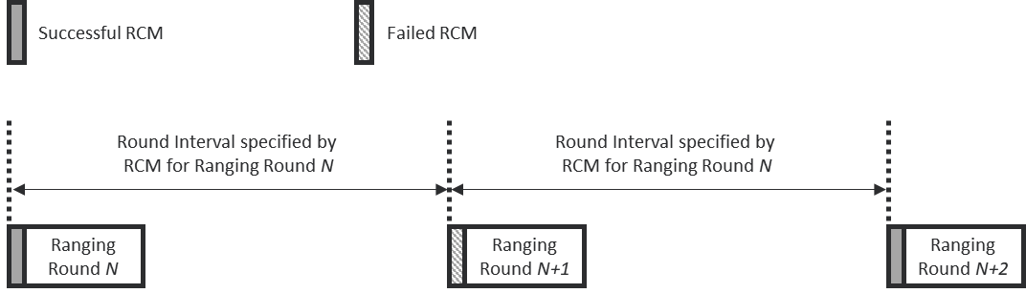

**Figure 19-Timing diagram for an example of RCM transmission without RTW**

Figure 19 shows a timing diagram for an example of the RCM transmission without the RTW. The RCMs are transmitted at the exact timing of Round Interval without the RTW. Since the RCM of Ranging Round N+1 failed, the RCM of Ranging Round N+2 is transmitted at Round Interval which is specified in the RCM of Ranging Round N.

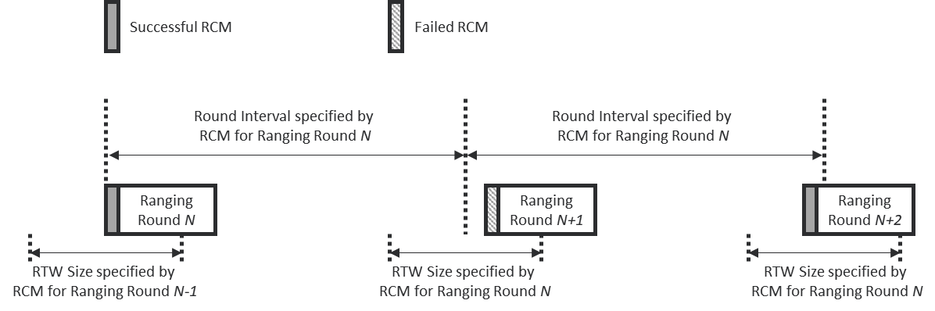

**Figure 20- Timing diagram for an example of RCM transmission with RTW**

Figure 20 shows a timing diagram for an example of the RCM transmission with the RTW. RCMs are transmitted at random time within the RTW. Since the RCM of Ranging Round N+1 failed, the RCM of Ranging Round N+2 is transmitted within the RTW which is centered on the Round Interval configured by the RCM of Ranging Round N. The size of the RTW is calculated by the RTW Initial Size and the RTW Multiplier in the RCM of Ranging Round N.

* + - * 1. Block-based modes

The Block-based mode uses a structured timeline where the ranging block structure, as defined in 6.9.8.1, is periodic by default. Figure X1 shows an example timing diagram for the Block-based mode. The ranging block structure can be setup by specifying the Ranging Block Duration, the Ranging Round Duration, and the Ranging Slot Duration fields in the ARC IE (7.4.4.38).

The number of ranging rounds in a ranging block is derived by:



The number of ranging slots in a ranging round is then given by:



These fields completely define the ranging block structure. An ERDEV that receives an RCM successfully may set the initial ranging block structure and the associated timeline for ranging using the values of those ARC IE fields. Alternatively, the ranging block structure may be setup and/or fixed by the next higher layer.

The ranging block structure can be repeatedly transmitted in every RCM by the Controller. If the block structure needs to be changed or updated (i.e., to a new Ranging Block Duration, Ranging Round Duration, and/or Ranging Slot Duration), the Controller may send a Ranging Block Update (RBU) IE (7.4.4.41) with the new configuration. In addition to the new configuration, the RBU IE should include a field for the number of ranging blocks with the current configuration before switching to the new configuration. Alternatively, the block structure update can be performed using the next higher layer.

For a given block configuration, each ranging block will have an index relative to the first block in that configuration. Each ranging round in any ranging block will have an index relative to the first ranging round in the current ranging block. For example, if the ranging block has *M* ranging rounds, the first ranging round in the block will have index 0 and the last ranging round in the block will have index *M* -1. Similarly, each ranging slot in a ranging round will have an index relative to the first ranging slot in the ranging round. For example, in a ranging round with *K* ranging slots, the first ranging slot in the round will have index 0 and the last ranging slot in the round will have index *K*-1. A new ranging session will start by transmitting the first RCM in Ranging Slot 0 of Ranging Round 0 in Ranging Block 0.

By default, an RFRAME is transmitted at the beginning of the ranging slot. However, the time at which the Controller starts the transmission can be offset by a duration that is less than the Ranging Slot Duration minus the RFRAME duration. Figure X2 shows an example of ranging rounds with different Transmission Offsets. Additionally, participating ERDEVs may continue to use the same relative ranging round in the next ranging block (i.e., if they are using Ranging Round *m* in Ranging Block *n,* they will also use Ranging Round *m* in Ranging Block *n*+1). However, the Controller may also decide to “hop” to a different relative ranging round in the next ranging block (i.e., if participating ERDEVs are using Ranging Round *m* in Ranging Block *n,* they will use Ranging Round *k* in Ranging Block *n*+1). Figure X3 shows an illustration for the concept of transmission offset and round hopping. The criteria for using a different transmission offset and/or hopping to a different relative ranging round is out of scope of the standard and is assumed to be a next higher layer function/protocol. However, it is assumed that as part of such function/protocol, the devices participating in the ranging exchange have either (a) pre-negotiated a hopping sequence that it is known to all devices, or (b) have exchanged all the information necessary such that each device can generate the hopping sequence so that they know which ranging round in each ranging block is to be used if hopping is triggered. If the block structure is updated (by sending an RBU IE or by a next higher layer protocol), the participating ERDEVs will set Transmission Offset to zero and reset the block, round, and slot indices at the beginning of the new block structure.

In the allocated ranging round of a ranging block, the Controller configures the ranging round by sending the RCM with the ARC IE and the Ranging Round (RR) IE (7.4.4.40) or via the next higher layer. The RR IE includes the following fields: current Ranging Block Index, current Ranging Round Index, Transmission Offset of the current Ranging Round, and Hopping Mode of the current round. By default, the Controller selects the hopping mode and transmission offset to be used in the ranging round of the next ranging block. The Controller sends the RR IE in the last message of the current ranging round to signal to the participating ERDEVs whether to hop to a different round and/or use a different transmission offset in the ranging round of the next ranging block. The contents of the RR IE in this case will be Ranging Block Index and Ranging Round Index of the current ranging block, the Hopping Mode and the Transmission Offset for the ranging round of the next ranging block. A Controlee that receives the RR IE in the final data message of the ranging exchange shall follow the Controller instruction and, in the next ranging block, uses a new transmission offset (as specified in the RR IE) and switches to a new ranging round (as determined by the ranging block index, ranging round index, and hoping mode specified in the RR IE and the hopping sequence). If the Controlee does not receive that final message of the exchange, e.g. due to interference event, the Controller shall turn on hopping in the next ranging block and move to a new ranging round (as determined by the new hopping modem, next ranging block index, and hopping sequence) with a zero transmission offset.  An ERDEV that misses the ARC IE but correctly receive the RR IE in the last message in the current round can use the content of the RR IE to resynchronize itself and be able to receive the RCM and ARC IE in the next ranging block if the block structure is unchanged, otherwise it is ignored. The block structure configured by the ARC IE and RR IE sent in the RCM and the RR IE and RBU IE sent in the last message in each ranging round, allow the participating ERDEVs to maintain the block structure and still be able to sleep between transmit and receive slots to save energy.

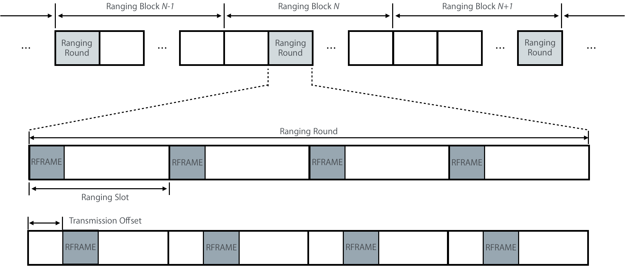

**Figure X1—Time diagram for an example of block-based mode**

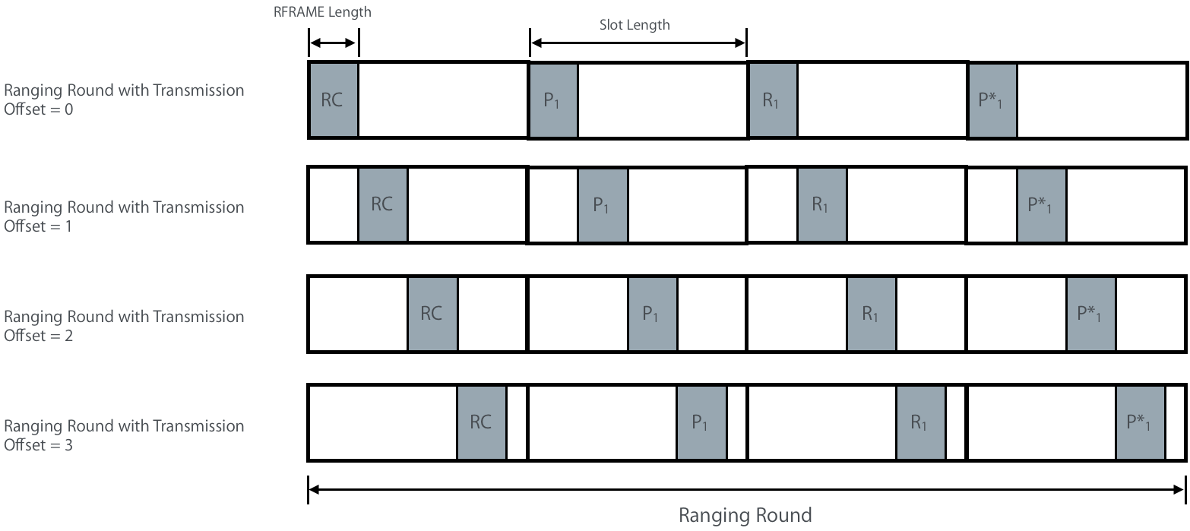

**Figure X2—Ranging Rounds with Different Transmission Offsets**

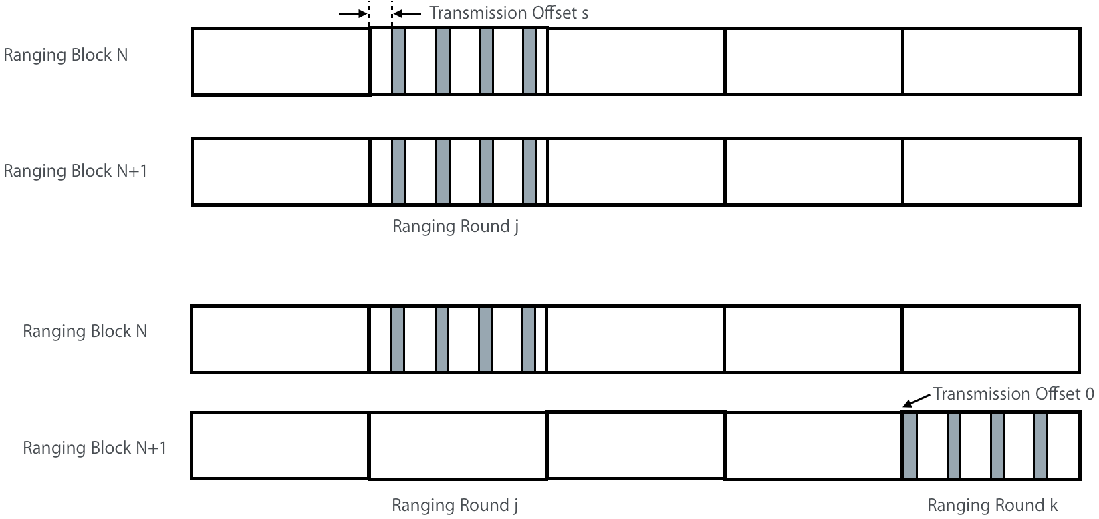

**Figure X3: Illustration of Transmission Offset and Round Hopping**

* **Page 63 Line 23 [7.4.4.40]**

**i-0356**

*Definition of the RR IE is incomplete. Replace the whole section with the following:*

* + - 1. Ranging Round IE

The Ranging Round IE (RR IE) may be included in the RCM, or in the final RFRAME, or in the final data message of a ranging message sequence. Its role is to specify scheduling of the ranging round.

The content field the RR IE shall be formatted as shown in Figure .

|  |  |  |  |
| --- | --- | --- | --- |
| **Octets : 0/2** | **0/1** | **0/2** | **2** |
| Ranging Block Index | Hopping Mode | Round Index | Transmission Offset |

**Figure 48—Ranging Round IE Content field format**

The Ranging Block Index field specifies the index of the ranging block with a range of 0 to 65535.

The Hopping Mode field specifies the hop mode for the ranging block, where 0 = No Hopping, and 1 = Hopping.

The Round Index field specifies the ranging round index for the ranging block with a range of 0 to 65535.

The Transmission Offset field specifies the value of transmission offset of the ranging round in the block. The time unit of Transmission Offset is the RSTU. This offset shall be at most the Ranging Slot Duration minus the packet duration.

When the time structure, as selected by the Time Structure Indicator field of the ARC IE (7.4.4.38), is Block-based mode, then all the fields shown in Figure 48 shall be included in the RR IE. However, when the time structure is Interval-based mode, the RR IE only contains the Transmission Offset field.

Note that for the Block-based mode, when the RR IE is included in the RCM, the configurations it conveys relate to the current ranging round in the current ranging block. However, when it is sent at the end of the ranging round in the final RFRAME or the final data message, the configurations it conveys relate to the next ranging round.

* **Page 64 Section 7.4.4.41. Definition of the RBU IE is incomplete. Replace the whole section with the following:**

**i-0496**, i-**1857, i-2414**

* + - 1. Ranging Block Update IE

The Ranging Block Update IE (RBU IE) is included in the final Ranging frame or final data frame of ranging message sequence. The content field of the RBU IE shall be formatted as shown in Figure 50.

|  |  |  |  |
| --- | --- | --- | --- |
| Octet: 1 | Octet: 3 | 1/0 | 2/0 |
| Relative Block Index | Updated Block Duration | Updated Ranging Round Duration | Updated Slot Duration |

**Figure 50: Ranging Block Update IE Content Field Format**

The Relative Block Index indicates the number of ranging blocks with the current block structure before switching to the new block structure.

The Updated Block Duration field is an unsigned integer used to set the new ranging block duration and is expressed in multiple of RSTUs.

The Updated Ranging Round Duration field is an unsigned integer used to specify the value of the ranging round duration in the new block structure as an integer multiple of ranging slot duration.

The Updated Ranging Slot Duration field is an unsigned integer used to specify the value of the ranging slot duration in the new block structure and is expressed in multiple of RSTU.

Note that the RBU IE can be used to update the block duration only, in which case the Updated Ranging Round Duration and Updated Ranging Slot Duration fields will not be present.

* **Page 53 Line 11**

i-0392, i-0393, i-0432

*Add the following row to Table 7-16*

|  |  |  |  |  |  |  |  |  |  |  |
| --- | --- | --- | --- | --- | --- | --- | --- | --- | --- | --- |
| **Sub-ID Value** | **Name** | **E-B.** | **E-ACK** | **Data** | **MP** | **MAC cmd** | **Format Sub Clause** | **Use Description** | **Used By** | **Created By** |
| <ANA> | Ranging Negative Acknowledgement IE |  |  | X |  |  | 7.4.4.X | 6.9.8 | UL | UL |

*Add the following sub-clause to 7.4.4*

**7.4.4.X Ranging Negative Acknowledgment IE**

The Ranging Negative Acknowledgement IE (RNA IE) is used to convey non-receipt of a ranging message. This IE is formatted without any content field. An example procedure of using this IE is described in Section 6.9.8.























* **Page 65 Line 22, Page 66 Line 5**

i-1421, i-2013, i-2879, i-1047

*To enhance flexibility of adjusting IV, use 4 bits for IVC field, which correspond to presence indicators of IV potions, i.e., bits [0:31], [32:63], [64:95], and [96:127], respectively. The updated figure 54 can be found below:*

|  |  |  |  |  |  |  |
| --- | --- | --- | --- | --- | --- | --- |
| Bits: 4 | 1 | 2 | 1 | Octets: 4/8/12/16 | 0/16 | 0/4/8/16 |
| IVC | SKP | ICP | CP | STS IV Counter | STS Key | Integrity Code |

**Figure 54-Ranging STS Key IE Content field format**

*Replace paragraph between line 23 and line 25 on page 65 by following:*

The IVC field indicates the content of the STS IV Counter field as follows: if the value of i-th bit in IVC is 1, updated bits [32(i-1):32i-1] of the IV are included, otherwise they are not.

*Replace paragraph between line 5 and line 6 on page 66 by following:*

The STS IV Counter field contains a string intended to set full or portion of the IV. The size of this field equals number of ones in the IVC multiplying by four. The string is formed by concatenation of multiple 4-octet strings, each of which is used to update corresponding portion of IV indicated by IVC. For example, if IVC field value is “1001”, size of STS IV Counter field is 8 octets, where first 4-octet is used to update bits [0:31] of IV, and later 4-octet is used to update bits

[96:127] of IV.

*Add after line 14 on page 66 the following:*

It is assumed that the RSKI IE is sent encrypted, except in applications that require it to be sent (broadcast) in plaintext.

* **Page 54 Table 7-16, Page 61 Line 1, Page 71 Line 10 (Revise [7.4.4.38] ARC IE & Merge [7.4.4.51] RIRL IE and [7.4.4.52] RS IE)**

i-0053, i-0054, i-0055, i-0198, i-0199, i-0256, i-0257, i-0258, i-0259, i-0260, i-0329, i-0333, i-0334, i-0340, i-0341, i-0388, i-0414, i-0489, i-0490, i-0491, i-0492, i-0493, i-0494, i-0495, i-0991, i-0994, i-1002, i-1003, i-1004, i-1005, i-1006, i-1007, i-1008, i-1009, i-1010, i-1011, i-1012, i-1020, i-1021, i-1022, i-1023, i-1628, i-1631, i-1639, i-1640, i-1641, i-1642, i-1643, i-1644, i-1645, i-1646, i-1647, i-1648, i-1649, i-1657, i-1658, i-1659, i-1660, i-1980, i-1981, i-1982, i-1983, i-1986, i-2046, i-2074, i-2104, i-2105, i-2107, i-2108, i-2129, i-2130, i-2157, i-2158, i-2160, i-2189, i-2190, i-2192, i-2193, i-2194, i-2226, i-2285, i-2286, i-2289, i-2572, i-2597, i-2779, i-2839, i-2840, i-2841, i-2842, i-2843, , i-0168, i-1436, i-1437, i-2551, i-2562, i-2620, i-2621

# 7.4.4.38 Advanced Ranging Control IE

*Change the row of ARC IE in Table 7-16 on page 54*

|  |  |  |  |  |  |  |  |  |  |  |
| --- | --- | --- | --- | --- | --- | --- | --- | --- | --- | --- |
| **Sub-ID**  **value** | **Name** | **Enhanced Beacon** | **Enhanced ACK** | **Data** | **Multipurpose** | **MAC Command** | **Format subclause** | **Use description** | **Used by** | **Created by** |
| <ANA> | Advanced Ranging Control IE |  |  | X |  |  | 7.4.4.38 | 6.9.8 | UL, MAC | UL, MAC |

*Replace Figure 47 on page 61 by the following one:*

|  |  |  |  |  |  |  |  |  |  |  |
| --- | --- | --- | --- | --- | --- | --- | --- | --- | --- | --- |
| **Bits :2** | **2** | **2** | **1** | **1** | **1** | **6** | **1** | **Octets: 0/3** | **0/1** | **0/2** |
| Multi-node Mode | Ranging Round Usage | STS Packet Config | Schedule Mode | Deferred Mode | Time Structure Indicator | RCM Validity Rounds | MMRCR | Ranging Block Duration | Ranging Round Duration | Ranging Slot Duration |

**Figure 47 –Advanced Ranging Control IE content field format**

.

*Replace Table 14 on page 61 by the following one:*

**Table 14 –Values of the Multi-node Mode field in the ARC IE**

|  |  |
| --- | --- |
| Multi-node Mode field value | Meaning |
| 0 | Single device to single device (unicast) |
| 1 | Multi-node one-to-many |
| 2 | Multi-node many-to-many |
| 3 | Reserved |

*Replace texts line 7-8, and Table 15 on page 61 by the following:*

The Ranging Round Usage field specifies the usage of the ranging round(s) that follow the ARC IE. The Ranging Round Usage field shall have one of values as defined in Table 15.

**Table 15 –Values of the Ranging Round Usage field in the ARC IE**

|  |  |
| --- | --- |
| Ranging Round Usage field value | Meaning |
| 0 | One way ranging (OWR) |
| 1 | Single-sided two-way ranging (SS-TWR) |
| 2 | Double-sided two-way ranging (DS-TWR) |
| 3 | Ranging ancillary information exchange (in payload) |

*Replace texts from line 3-5, and Table 17 on page 62*

The Schedule Mode field specifies whether the scheduling-based ranging or contention-based ranging is performed in the following ranging rounds as per Table 17.

**Table 17 –Values of the Schedule Mode field in the ARC IE**

|  |  |
| --- | --- |
| Schedule Mode field value | Selected ranging schedule mode and behavior |
| 0 | Contention-based ranging is used for the following ranging rounds, and the RDM IE (7.4.4.X1) and the RCPS IE (7.4.4.42) can be employed to control participation. |
| 1 | Scheduling-based ranging is used for the following ranging rounds, and the RDM IE (7.4.4.X1) can be employed to control participation and time-slot allocation. |

*Replace texts on page 63 between line 1 and line 8 by the following texts:*

The RCM Validity Rounds field specifies the number of consecutive ranging rounds controlled by the RCM. Note that this value cannot be larger than the number of remaining ranging rounds in the current block.

The Multiple Message Receipt Confirmation Request (MMRCR) field indicates whether multiple message receipt confirmation is requested or not: if the MMRCR field value is one, it is requested, otherwise it is not.

The Ranging Block Duration field is an unsigned integer that specifies the duration of a Ranging Block in the unit of RSTU as defined in 6.9.1.2. The Ranging Round Duration is an unsigned integer that specifies the duration of the Ranging Round in the unit of Ranging Slot duration. The Ranging Slot Duration field is an unsigned integer that specifies the duration of a Ranging Slot in the unit of RSTU.

One or more fields of duration, i.e., Ranging Block Duration, Ranging Round Duration, and Ranging Block Duration, may not be present in the ARC IE of the current RCM, if ranging block structure follows the same specified duration as before. But other fields, e.g., Schedule Mode, STS Packet Config, can still be used to update corresponding ranging parameters. The presence of last three fields in the ARC IE can be determined by its content length. When the length of content fields is 2-octet, the last three fields are not present. When the length of content fields is 5-octet, the Ranging Block Duration field is present. When the length of content fields is 6-octet, Ranging Block Duration and Ranging Round Duration fields are present. When the length of content fields is 8-octet, the last three fields in the ARC IE are present.



*Merge [7.4.4.51] RIRL IE and [7.4.4.52] RS IE into a single IE, namely Ranging Device Management IE (RDM IE). Remove Sub-clause [7.4.4.51] and [7.4.4.52], and assign a sub-clause to RDM IE.*

**7.4.4.X1 Ranging Device Management IE**

The Ranging Device Management IE (RDM IE) is used by the Controller to control devices participating in a Ranging Round if the Controller knows the device identities. The content field of the RDM IE shall be formatted as shown in the Figure Y1.

|  |  |  |
| --- | --- | --- |
| **Bits: 1** | **7** | **Variable** |
| SIP | RDM Table Length | RDM Table |

**Figure Y1 –Ranging Device Management IE content field format**

The RDM Table field contains row elements formatted as per Figure Y2.

|  |  |  |
| --- | --- | --- |
| **Bits: 1** | **7** | **Octets: 2/8** |
| Device Type | Slot Index/Reserved | Address |











**Figure Y2 –RDM Table row element format**

The Slot Index Present (SIP) field as shown in Figure Y1 indicates whether Bit: 1-7 of the first octet in each RDM Table row element is used as slot index or reserved: if the SIP field value is one, these 7 bits are used as the slot index, otherwise they are reserved. When the SIP field value is zero, the RDM IE is used to assign device type, i.e., Initiator or Responder, of Controlees for the contention-based ranging. When the SPI field value is one, the RDM IE is used to allocate time slots, and specify device types of Controlees for the scheduling-based ranging.

The RDM Table Length field indicates the number of row elements in the RDM Table. If the SIP field value is one, the RDM Table Length field value equals the number of assigned time slots. If the SIP field value is zero, the RDM Table Length field value equals the number of participated ERDEVs.

Each row element of RDM Table contains the address and device type of a particular ERDEV. The Slot Index is used if the SIP field value is one, which indicates the time slot assigned to the ERDEV. The address field shall contain a short address when the DstAddrMode of the MCPS-DATA.request is SHORT, and an extended address otherwise.

* **Page 63 Line 9 [7.4.4.39] RIU IE**

i-0261, i-0262, i-0327, i-0330, i-0391, i-0415, i-1013, i-1016, i-1017, i-1018, i-1650, i-1653, i-1654, i-1655, i-2227, i-2247, i-2272, i-2287, i-2290, i-0381

*Replace Figure 48 by following:*

|  |  |  |  |  |  |  |  |  |  |  |
| --- | --- | --- | --- | --- | --- | --- | --- | --- | --- | --- |
| Bits :1 | 1 | 1 | 1 | 4 | Octets: 4 | 0/4 | 0/2 | 0/1 | 0/1 | 0/2 |
| RIP | RIUP | RTWMP | RTWISP | Reserved | Block Interval | Round Interval | RIUM Interval | Remaining Number of RIUMs | RTW Multiplier | RTW Initial Size |

**Figure 48-Ranging Interval Update IE Content field format**

*Add the follow texts before line 13:*

The RIP field indicates the presence of Round Interval field as follows: an RIP field value of 0 means that the Round Interval field is not present; while the RIP field value of 1 means that Round Interval field is present. If a Ranging Block consists of one Ranging Round, Round Interval is the same as Block Interval and Round Interval field can be omitted with an RIP field value of 0.

The RIUP field indicates the presences of RIUM Interval field and Remaining Number of RIUMs field as follows: The RIUP field value of 0 means that the RIUM Interval field and Remaining Number of RIUMs field are not present; while the RIUP field value of 1 means that the RIUM Interval field and the Remaining Number of RIUMs field are present.

The RTWMP field indicates the presence of the RTW Multiplier field as follows: RTWMP field value of 0 means that the RTW Multiplier field is not present; while an RTWMP field value of 1 means that the RTW Multiplier field is present.

The RTWISP field indicates the presence of the RTW Initial Size field as follows: RTWISP field value of 0 means that the RTW Initial Size field is not present; while an RTWISP field value of 1 means that the RTW Initial Size field is present.

*Replace paragraph between line 15 and line 19 by following:*

The Round Interval field if present, as determined by the RIP field, specifies the time remaining until the start time of the next RCM relative to the start time of the current frame. The Round Interval field is in RSTU time units as define in 6.9.1.2.

The RIUM Interval field if present, as determined by the RIUIP field, specifies the time remaining until the start time of the next RIU message relative to the start time of the current frame. The RIUM Interval field is in RSTU time units as define in 6.9.1.2.

*Add the follow texts before line 22:*

The RTW Multiplier field specifies the exponential multiplier of RTW Initial Size to calculate the size of RTW, i.e., RTW Initial Size*2^(RTW Multiplier). The RTW Initial Size field specifies the initial size of RTW in RSTU time units as define in 6.9.1.2.

RCM Timing Window (RTW) operation is enabled if RTWISP or both RTWISP and RTWMP in the RIU IE is 1. If both RTWMP and RTWISP are 0, a Controller sends the RCM with Block Interval and/or Round Interval in the RIU IE without RTW. If RTWISP is 1 and RTWMP is 0, a Controller sends the RCM at random timing within RTW. The size of RTW is fixed with RTW Initial Size. If both RTWMP and RTWISP are 1, a Controller sends the RCM at random timing within RTW. The size of RTW can be calculated by RTW Initial Size and RTW Multiplier.

* **Page 64 Line 24 [7.4.4.42 RPCS IE]**

i-1102

*The Slot Index should be 7-bit for consistency. Replace the Figure 52 on the page 65 by the following one:*

|  |  |  |
| --- | --- | --- |
| **Bits:2** | **7** | **7** |
| Phase Indicator | Slot Index to Start | Slot Index to End |

**Figure 52-Ranging Interval Update IE Content field format**

*Replace texts line 6-8 on page 65 by the following:*

The Phase Indicator field selects whether the phase being described is used for ranging initiator or responder to contend. The control values are specified

* **Page 73, 7.4.4.55, Line 13 [Include TOF request in SRRR IE]**

i-0338

*To include the request of time-of-flight (ToF), use a reserved bit of SRRR IE. The updated Figure 67 can be found below:*

|  |  |  |  |  |  |  |  |  |
| --- | --- | --- | --- | --- | --- | --- | --- | --- |
| Bits: 1 | 1 | 1 | 1 | 1 | 1 | 2 | Octets: 0/2/8 | 0/2/8 |
| RAP | PAP | RAOA | RRT | RRTM | RTOF | Reserved | Requestor Address | Provider Address |

**Figure 67— SP3 Ranging Request Reports IE content field format**

*Add the follow texts after line 23:*

The RTOF field indicates that a report of time-of-flight (ToF) is required when the RTOF field is 1, and not required when the RTOF field is 0.

* **Page 75 Line 19 [7.4.4.57 RPCS IE]**

i-0331, i-0567, i-1121, i-1122, i-1127, i-1130, i-1758, i-1759, i-1764, i-1767, i-2134, i-2168, i-2460, i-2480, i-0506, i-0507, i-0508

**Page 6 Line 7, Page 18 Line 25, Page 7 Line 19, Page 53 Line 11, Page 75 Line 19, Page 80 Line 3**

i-1419, i-1420, i-2011, i-2012

*The following texts and figures are considered to be included for the feature of channel selection, which is proposed in the original contribution: 15-19-0034-02-004z-ieee-802-15-4z-mac*

# MAC functional description

# 6.9.2 Set-up activities before a ranging exchange

*Change the following sentences between line 7 and line 13 on page 6: “Furthermore, if the optional dynamic preamble selection (DPS) capability is to be used, there shall have been some sort of coordination of preambles prior to the two-way ranging exchange. The RPCS IE, as specified in 7.4.4.57, may be used for this purpose” by:*

Furthermore, if the optional dynamic preamble selection (DPS) and dynamic channel selection (DCS) capability are to be used, there shall have been some sort of coordination of preambles and channels prior to the ranging exchange. The RCPCS IE, as specified in 7.4.4.57, may be used for this purpose.

# 6.9.7.8 Other procedures for coordinating RDEV and ERDEV

*Change the following sentences between line 25 and line 27 on page 18: “Similarly when using DPS as described in 6.9.4, the RDEVs need to coordinate the preamble codes they are going to employ and again the secure private data communication capability of this standard may be used to transfer the DSP selection between devices using the RPCS IE (7.4.4.57)” by:*

Similarly when using DPS and DCS as described in 6.9.4 and 6.9.5, the RDEVs need to coordinate the preamble codes and UWB sub-band they are going to employ and again the secure private data communication capability of this standard may be used to transfer the DPS and DCS between devices using the RCPCS IE (7.4.4.57).

*Include the following subsection after 6.9.4, and increment the numbering of all the subsequent subsections and figures as required*

# 6.9.5 Managing DCS

# Figure 6-49 shows a suggested message sequence chart to configure a selected UWB channel. Messages are the suggestions showing how the communications capability of the RDEV can be used to accomplish the DCS.

# 

**Figure 6-49 – A message sequence chart to configure a selected channel**

# The originator may transmit the RCPCS IE (7.4.4.57) to exchange the sub-band selection for the coordination of ranging channel. The coordination of ranging channel is needed only when using the optional DCS capability of the PHY. For the multi-node ranging scheme (6.9.8), controller shall be the originator to initiate DCS, and RCPCS IE can be inserted in the ranging control message (RCM).

# In the coordination process of a ranging channel, the next higher layer in each participating devices shall set a Channel Configuration Interval (CCI) timer. Once this timer has elapsed, the selected channel is configured. The setting of CCI is determined by the originator next higher layer, which may be exchanged via RCPCS IE. CCI has to be long enough for PHY to configure a channel switch. The bottom interactions between next higher layer and MAC illustrate the use of the MLME-DCS.request, as described in 8.2.27.1, and the MLME-DCS.confirm, as described in 8.2.27.2. Use of these primitives is unique to the optional DCS.

# Upon the assertion of the MLME-DCS.confirm primitives, as illustrated in Figure 6-49, PHYs of both sides have switched to a selected channel, where future Ranging Round(s) will be operated on. After a certain period of time, if the originator intends to switch to another available channel or back to a previous one, it can reiterate procedures illustrated in Figure 6-49, where an MLME-DCS.request primitive with requested ChannelNumber will be initiated. DCS provides more flexibility to manage multi-node ranging, and can also help to avoid collisions.

*Change the row of Ranging Preamble Code Selection IE in Table 7-16*

|  |  |  |  |  |  |  |  |  |  |  |
| --- | --- | --- | --- | --- | --- | --- | --- | --- | --- | --- |
| **Sub-ID**  **value** | **Name** | **Enhanced Beacon** | **Enhanced ACK** | **Data** | **Multipurpose** | **MAC Command** | **Format subclause** | **Use description** | **Used by** | **Created by** |
| <ANA> | Ranging Channel and Preamble Code Selection IE |  |  |  |  |  | 7.4.4.57 | 6.9.5  6.9.7.8 | UL | UL |

*Change the following subsection*

**7.4.4.57** **Ranging Channel and Preamble Code Selection IE**

The Ranging Channel and Preamble Code Selection IE (RCPCS IE) is provided as a mechanism to signal the choice of UWB channel for DCS as described in 6.9.5, and/or preamble code for DPS as described in 6.9.4. The content format of the RCPCS IE shall be formatted as shown in Figure 71.

|  |  |  |  |  |  |  |  |
| --- | --- | --- | --- | --- | --- | --- | --- |
| Bits: 1 | 1 | 2 | 4 | Octets: 0/4 | 0/1 | 0/1 | 0/2 |
| CCIP | PSP | Reserved | Channel Number | CCI | TX Preamble Code | RX Preamble Code | PSR |

**Figure 71 – Ranging Channel and Preamble Code Selection IE content field format**

The field of CCI Present (CCIP) indicates the presence of CCI field. If its value is 1, CCI field is present. Otherwise, it does not exist, and the setting of CCI is specified by the next higher layer.

The field of preamble selection presence (PSP) indicates the presence of last three fields for DPS. If its value is 1, the last three fields are present. Otherwise, they are not present.

The Channel Number field specifies the UWB channel number, i.e., 0~15, corresponding to field values 0000~1111. For LRP UWB PHY, the valid range is 0~2 as described in 10.1.2.7, while it is 0~15 for HRP UWB PHY as described in 10.1.2.4. The selection of channel number by upper layer shall depend on the device capability and regional-based regulation.

The 4-octet CCI field specifies the timer duration between the exchange of this IE and configuration of selected channel, which is in the unit of RSTU (6.9.1.2).

The TX Preamble Code field shall be set to the DPS preamble code that the IE sender will use for transmission. The RX Preamble Code field shall be DPS preamble code that the IE sender will use for reception. Both these preamble codes shall be selected from Table 16-6, both from Table 16-7, or both from Table 28. The PSR field shall be set to the number of preamble symbol repetitions to transmit for the SYNC of each RFRAME of the ranging exchange, if PSR is 0 the length of the SYNC is not changed, otherwise the PSR shall be one of the valid SYNC lengths, as specified in 16.2.5.1.

*Include the following subsection after 8.2.26*

**8.2.27 Primitives for specifying ranging channel**

These primitives are used by a device to enable DCS as well as to configure the selected ranging channel for future Ranging Round(s).

**8.2.27.1 MLME-DCS.request**

Within CCI (6.9.5), the next higher layer of originator initiates MLME-DCS.request to request PHY utilize the given channel until the next MLME-DCS.request for channel reconfiguration.

The semantics of this primitive are as follows:

|  |  |  |
| --- | --- | --- |
| MLME-DCS.request | ( |  |
|  | ChannelNumber |  |
|  | ) |  |

The primitive parameters are defined in Table 8-74.

**Table 8-74. MLME-DCS.request parameter**

|  |  |  |  |
| --- | --- | --- | --- |
| Name | Type | Valid range | Description |
| ChannelNumber | Integer | 0~15 | Ranging channel number |

The selected ChannelNumber, which may be exchanged via RCPCS IE, is used as defined in [XYZ] and must reflect the regional-based regulation and device capability. After configuration of the selected ranging channel, MLME responses with a MLME-DCS.confirm primitive with appropriate Status parameter.

**8.2.27.2 MLME-DCS.confirm**

The MLME-DCS.confirm primitive reports the results of the attempt to enable the DCS. The semantics of this primitive are as follows:

|  |  |  |
| --- | --- | --- |
| MLME-DCS.confirm | ( |  |
|  | Status |  |
|  | ) |  |

The primitive parameter is defined in Table 8-75.

**Table 8-75. MLME-DCS.confirm parameter**

|  |  |  |  |
| --- | --- | --- | --- |
| Name | Type | Valid range | Description |
| Status | Enumeration | SUCCESS, DCS_NOT_SUPPORTED | The result of the request to enable the selected channel. |

The MLME-DCS.confirm primitive is generated by the MLME and issued to its next higher layer in response to an MLME-DCS.request primitive.

If ChannelNumber in the MLME-DCS.request is not supported, the Status of DCS_NOT_SUPPORTED is returned. If the request to enable the selected ranging channel was successful, the MLME issue the MLME-DCS.confirm primitive with a Status of SUCCESS.

* **Page 86 Line 14 [Multi-node ranging Primitive&PIB]**

i-0328

**7.4.4 Nested IE**

**8.3.1 MCPS-DATA.request**

*Include the following semantic in the primitive MCPS-DATA.request on page 80*

|  |  |  |
| --- | --- | --- |
| MCPS-DATA.request | ( |  |
|  | MultiRangingEnable |  |
|  | ) |  |

*Add the following new row in Table 8-75 on page 81*

**Table 8-75. MCPS-DATA.request parameter**

|  |  |  |  |
| --- | --- | --- | --- |
| Name | Type | Valid range | Description |
| MultiRangingEnable | Enumeration | SCHEDULE,  CONTENTION | A value of SCHEDULE indicates that time-scheduled multi-node ranging is to be used in the ranging round. A value of CONTENTION indicates that contention-based multi-node ranging is to be used in the ranging round. |

*Insert the following paragraph at the end of 8.3.1 on page 82:*

If MultiRangingEnable is SCHEDULE, multi-node time-scheduled ranging is enabled to be configured by the MAC sublayer of Controller. According to MAC PIB attributes in Table 8-95, the MAC sublayer generates the ARC IE and inserts it into the RCM prior to sending it. As described in 6.9.8, if *macDeviceControl* in Table 8-95 is TRUE, the MAC sublayer generates the RDM IE along with the ARC IE.

If MultiRangingEnable is Contention, multi-node contention-based ranging is enabled to be configured by the MAC sublayer of Controller. According MAC PIB in Table 8-95, the MAC sublayer generates the ARC IE and inserts it into the RCM prior to sending it. As described in 6.9.8, if *macDeviceControl* in Table 8-95 is TRUE, the MAC sublayer generates the RDM IE along with the ARC IE to assign device types of participated RDEVs.

If the multi-node time-scheduled ranging is successfully configured, an MCPS_Data.confirm with status of SUCCESS is generated. If the resulting frame exceeds *aMaxPhyPacketSize* MAC sublayer shall discard the frame and generate the MCPS_Data.confrim with a status of FRAME_TOO_LONG.

*Include the following subclause in 8.4.2, and increment numbering of subsequent tables:*

**8.4.2.9 Multi-node Ranging Specific MAC PIB attributes**

The attributes contained in the MAC PIB for multi-node ranging configuration are presented in Table 8-95.

**Table 8-95. Multi-node Ranging Specific MAC PIB attributes**

|  |  |  |  |  |
| --- | --- | --- | --- | --- |
| Attribute | Type | Range | Description | Default |
| *macMultiRangingSupport* | Boolean | TRUE, FALSE | Read only value indicating whether the device is able to configure multi-node ranging by the MAC sublayer. | Implementation dependent |
| *macDevicePresence* | Boolean | TRUE, FALSE | If TRUE, ranging controller knows the identities controlees, FALSE otherwise. This parameter is valid only when *macMultiRangingSupport* is set to be TRUE. | FALSE |
| *macUWBrngAddressList* | IEEE address | List of addresses | The address list of participated RDEVs. This parameter contains address list only when *macDevicePresence* is TRUE. | NULL |
| *MultiRangingEnable* | Enumeration | SCHEDULE,  CONTENTION, NONE | A value of SCHEDULE indicates that time-scheduled multi-node ranging is to be configured, which can only be used if *macDevicePresence* is TRUE. A value of CONTENTION indicates that contention-based multi-node ranging is to be used. The default setting of this parameter is NONE, which disables the ranging configuration and control via the MAC sublayer. This parameter is valid only when *macMultiRangingSupport* is set to be TRUE. | NONE |
| *macRangingConfigIndicator* | Boolean | TRUE, FALSE | If TRUE, MAC sublayer forms the ARC IE (7.4.4.38) with the fields of Ranging Block Duration, Ranging Round Duration, and Ranging Slot Duration, otherwise these fields are not present. This parameter is valid only when *MultiRangingEnable* is SCHEDULE or CONTENTION. | FALSE |
| *macRangingBlockDura* | Integer | 0x00-0xffffff | Specifies the Ranging Block duration in the unit of RSTU (6.9.1.2), which corresponds to the field value of Ranging Block Duration in the ARC IE (7.4.4.38). The default value is 0, which indicates that the multi-node ranging is disabled. | 0 |
| *macRangingSlotDura* | Integer | 0x00-0xff | Specifies the Ranging Slot duration in the unit of RSTU (6.9.1.2), which corresponds to the field value of Ranging Slot Duration in the ARC IE (7.4.4.38). The default value is 0, which indicates that the multi-node ranging is disabled. | 0 |
| *macRangingRoundDura* | Integer | 0 to 255 | Specifies the Ranging Round duration in the unit of *macRangingSlotDura,* which corresponds to the field value of Ranging Round Duration in ARC IE (7.4.4.38). The default value is 0, which indicates that the multi-node ranging is disabled. | 0 |
| *macDeviceControl* | Boolean | TRUE, FALSE | Only when *MultiRangingEnable* is CONTENTION (or SCHEDULE), and MAC sublayer is used to assign device types (or time slots), this parameter is set to be TRUE. Otherwise it is FALSE. | FALSE |
| *macMultiRangingMode* | Integer | 0-2 | Indicates the multi-node ranging mode: value of 0 indicates one initiator-to-one Responder, value of 1 indicates one initiator-to-multiple Responders, and value of 2 indicates many initiators-to-many Responders (M2M). | Implementation dependent |
| *macRangingRoundUsage* | Integer | 0-3 | Indicates the usage of a ranging round: if value is 0, ranging round is used for one-way ranging (OWR); if value is 1, ranging round is used for single-sided two-way ranging (SS-TWR); if value is 2, ranging round is used for double-sided two-way ranging (DS-TWR); if value is 3, ranging round is used for ranging ancillary information exchange. | Implementation dependent |
| *macMultiRangingSpConfig* | Integer | 0-3 | Indicates the STS packet configuration of ranging transmission, see Table 27. | Implementation dependent |
| *macMultiRangingDefer* | Boolean | TRUE, FALSE | If TRUE, the deferred mode of ranging is enabled. Ranging IEs related to reply time, AOA report are exchanged in the data frame(s) of measurement report phase (6.9.8.1). If FALSE, the deferred mode of ranging is disabled, and ranging IEs related to reply time, AOA report are inserted in the RFRAME. | Implementation dependent |
| *macTimeStructure* | Integer | 0,1 | Indicates the time structure mode of multi-node ranging: value of 0 denotes the interval-based structure (6.9.8.2.1), and value of 1 denotes the block-based structure (6.9.8.2.2). | Implementation dependent |
| *RoundNumber* | Integer | 0-63 | Number of consecutive ranging rounds controlled by the RCM per ranging configuration. The default value is 0, which indicates that the multi-node ranging is disabled. | 0 |
| *macMmrcrEnable* | Boolean | TRUE, FALSE | Only when multiple message receipt confirmation is requested in the ranging round, this parameter is set to be TRUE. Otherwise it is FALSE. | FALSE |
| *macUWBrngInitiatorList* | List of enumerations | INITIATOR,  RESPONDER,  NONE | The list of enumerations to indicate the role of ranging devices. If INITIATOR, the ranging device is an initiator. If RESPONDER, the ranging device is a Responder. The order of the list follows the same as that of macUWBrngAddressList. This parameter can be present only when macUWBrngAddressList is not NULL. The default setting of this parameter is NONE. | NONE |
| *macUWBrngScheduleAssign* | IEEE address | List of addresses | The attribute is present when *MultiRangingEnable* is SCHEDULE and  *macDeviceControl* is TRUE. The length of the list equals *macRangingRoundDura*. Each element of the address list represents an RDEV scheduled on a time slot of a Ranging Round. | — |























* **i-1140, i-1143, i-1777, i-1780, i-2078, i-2079, i-0340 [Primitives for RX-ENABLE]**

*Modify Section 8.2.10.2*

**8.2.10 Primitives for specifying the receiver enable time**

These primitives are used to enable or disable a device’s receiver at a given time.

**8.2.10.2 MLME-RANGING-ROUND-RX-ENABLE.request**

The next higher layer can request that the receiver is either enabled for a finite period of time or disabled multiple times in a ranging round through a single primitive request using MLME-RANGING-ROUND-RX-ENABLE.request.

The semantics of this primitive are as follows:

MLME-RANGING-ROUND-RX-ENABLE.request (

DeferPermit,

RxOnTimes,

RxOnDurations,

RangingRxControl

)

The primitive parameters are defined in Table 8-TX.

cf

**Table 8-TX—MLME-RX-ENABLE.request parameters**

|  |  |  |  |
| --- | --- | --- | --- |
| **Name** | **Type** | **Valid Range** | **Description** |
| DeferPermit | Boolean | TRUE, FALSE | TRUE if the requested operation can be deferred until the next ranging round if the requested time has already passed. FALSE if the requested operation is only to be attempted in the current ranging round. |
| RxOnTimes | List of Integers | 0x000000–0xffffff | The number of RSTUs measured from the start of the first RSTU of the first slot of the ranging round before the receiver is to be enabled or disabled. This is a 24-bit value, and the precision of this value shall be a minimum of 20 bits, with the lowest 4 bits being the least significant. |
| RxOnDurations | List of Integers | 0x000000–0xffffff | The number of RSTUs for which the receiver is to be enabled. If this parameter is equal to 0x000000, the receiver is to be disabled. |
| RangingRxControl | Enumeration | RANGING_OFF,  RANGING_ON | Configure the transceiver to Rx with ranging for a  value of RANGING_ON or to not enable ranging for RANGING_OFF. |

The MLME-RANGING-ROUND-RX-ENABLE.request primitive is generated by the next higher layer and issued to the MLME to enable the receiver for fixed durations, at times relative to the start of the current or next ranging round. This primitive may also be generated to cancel a previously generated request to enable the receiver. The receiver is enabled based on the times in the unit of RSTU specified by the list of integers in RxOnTimes and disabled after the corresponding duration chronologically specified by the list of integers in RxOnDurations. The length of the list of integers specified in RxOnTimes and RxOnDurations shall be the same.

.

The MLME will treat the request to enable or disable the receiver as secondary to other responsibilities of the device (e.g., GTSs, coordinator beacon tracking, or beacon transmissions). When the primitive is issued to enable the receiver, the device will enable its receiver until either the device has a conflicting responsibility or the time specified by RxOnDuration has expired. In the case of a conflicting responsibility, the device will interrupt the receive operation. After the completion of the interrupting operation, the RxOnDuration will be checked to determine whether the time has expired. If so, the operation is complete. If not, the receiver is re-enabled until either the device has another conflicting responsibility or the time specified by RxOnDuration has expired. When the primitive is issued to disable the receiver, the device will disable its receiver unless the device has a conflicting responsibility.

Before attempting to enable the receiver, the MLME first determines whether each of the corresponding (RxOnTimes + RxOnDurations) is less than the number of RSTUs spanning the ranging round duration, as defined by the previous ranging control message. If those of the corresponding (RxOnTimes + RxOnDurations) is not less than the ranging round duration, the MLME issues the MLME-RXENABLE.confirm primitive with a Status of ON_TIME_TOO_LONG.

The MLME then determines whether the receiver can be enabled in the current ranging round. If the current time measured from the start of the ranging round is less than each of the (RxOnTimes), the MLME attempts to enable the receiver in the current ranging round. If the current time measured from the start of the ranging round is greater than or equal to one or more of the (RxOnTimes) and DeferPermit is equal to TRUE, the MLME defers until the next ranging round and attempts to enable the receiver in that ranging round. Otherwise, if the MLME cannot enable the receiver in the current ranging round and is not permitted to defer the receive enable operation until the next ranging round, the MLME issues the MLME-RX-ENABLE.confirm primitive with a Status of PAST_TIME.

If the RxOnDuration parameter is equal to zero, the MLME requests that the PHY disable its receiver.

*Change Section number 8.2.10.2 to 8.2.10.3*

*Add Section 8.2.10.4*

**8.2.10.4 MLME-RANGING-ROUND-RX-ENABLE.confirm**

The MLME-RANGING-ROUND-RX-ENABLE.confirm primitive reports the results of the attempt to enable or disable the receiver.

The semantics of this primitive are as follows:

MLME-RANGING-ROUND-RX-ENABLE.confirm (

Status

)

The primitive parameters are defined in Table 8-TY.

The MLME- RANGING-ROUND-RX-ENABLE.confirm primitive is generated by the MLME and issued to its next higher layer in response to an MLME-RANGING-ROUND-RX-ENABLE.request primitive. This primitive returns a Status of either SUCCESS, if the request to enable or disable the receiver was successful, or the appropriate error code, for each of the enable and disable request in MLME-RANGING-ROUND-RX-ENABLE.request. The Status values are fully described in 8.2.10.2.

**Table 8-TY—MLME-RANGING-ROUND-RX-ENABLE.confirm parameter**

|  |  |  |  |
| --- | --- | --- | --- |
| **Name** | **Type** | **Valid Range** | **Description** |
| Status | List of Enumeration | SUCCESS, PAST_TIME,  ON_TIME_TOO_LONG,  INVALID_PARAMETER,  RANGING_NOT_SUPPORTED | The result of the request to enable or disable the  receiver. |

**8.2.10.X MLME-RANGING-ROUND-START.request**

The next higher layer uses the MLME-RANGING-ROUND-START.request to request to start the MAC timing for the new ranging round. Since the time structure of ranging round is managed by the next higher layer, this primitive enables the indication and alignment of MAC timing structure.

The semantics of the primitive

MLME-RANGING-ROUND-START.request (

RangingRoundStart

)

MLME-RANGING-ROUND-START.request is generated by the next higher layer and issued to the MLME at the exact instant of the start of the ranging round to indicate the start of the ranging round and align the MAC timing structure. All the MAC timing counters and durations such as MLME-RANGING-ROUND-RX-ENABLE.request primitive are with respect to the timing of MLME-RANGING-ROUND-START.request primitive.

**Table 8-TY—MLME-RANGING-ROUND-RX-START.request parameter**

|  |  |  |  |
| --- | --- | --- | --- |
| **Name** | **Type** | **Valid Range** | **Description** |
| RangingRoundStart | Constant | TRUE | MAC starts the new ranging round timing from the RSTU starting immediately after the reception of this primitive |

Example message charts for MLME-RANGING-ROUND-START.request, MLME-RANGING-ROUND-RX-ENABLE.request and MLME-RANGING-ROUND-RX-ENABLE.confirm for controller and controlee are shown in figures FX and FY respectively. MLME-RANGING-ROUND-START.request is sent by the next higher layer at the beginning of the ranging round for both controller and controlee. For the controller, the MLME-RANGING-ROUND-RX-ENABLE.request is sent to the MAC by the next higher layer after the controller’s next higher layer has set the configurations for the ranging round including the schedule for the ranging round. This can be either after the next higher layer conveys the RCM to the MAC (as shown in left side of Figure FX) or may be before the controller conveys the RCM to the MAC (as shown in right side of Figure FX), either of which is decided by implementation choice. For the controlee, the MLME-RANGING-ROUND-RX-ENABLE.request is sent to the MAC by the next higher layer after the RCM and the schedule information (ARC IE and RDM IE) are received as shown in Figure FY.

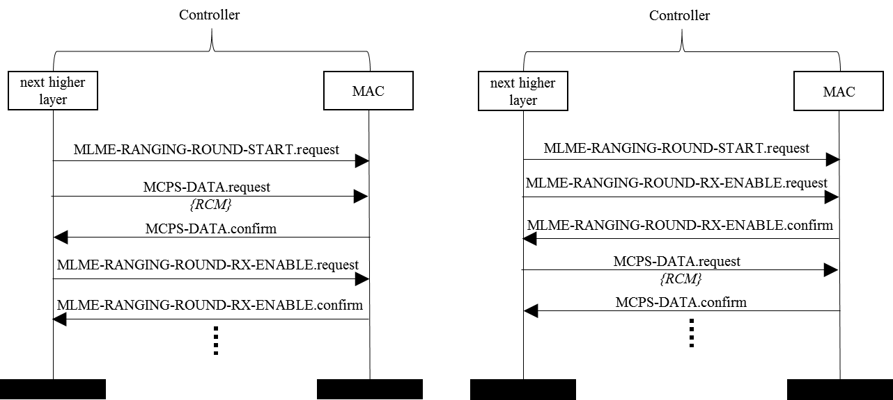

**Figure FX—** **MLME-RANGING-ROUND-RX-ENABLE.request and MLME-RANGING-ROUND-RX-ENABLE.confirm Message Sequence Charts for controller**

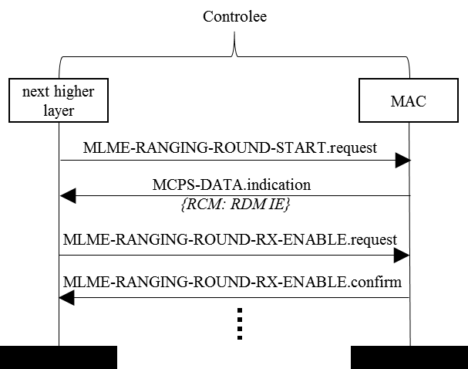

**Figure FY—** **MLME-RANGING-ROUND-RX-ENABLE.request and MLME-RANGING-ROUND-RX-ENABLE.confirm Message Sequence Charts for controlee**

* **i- 0340 [Ranging Ancillary Information]**

*Add following lines to Section 6.9.8.1, page 23 after line 7*

A block may have one or more ranging rounds during which ranging ancillary information can be exchanged between initiators and responders. For ranging ancillary information exchange, following terminology is used:

Initiator: a Ranging device that initiates a ranging exchange by sending the first message of the exchange or the device that sends ranging ancillary information

Responder: a Ranging device that receives ranging ancillary information and/or responds to the message received from the initiator

Ranging Round Usage field of ARC IE (7.4.4.38) shall be used to indicate that the ranging round(s) following this RCM is used for ranging ancillary information exchange. The information exchange can be scheduled or contention based. A given data may be divided into multiple fragments and transmitted over multiple messages in a ranging round. In such a case RAICT IE (7.4.4.XX) shall be used by the initiator to convey the number of messages remaining to complete the transmission of ranging ancillary information. If the initiator is not the controller, the RAICT IE can be used along with RCR IE (7.4.4.45) to request the number of slots to be scheduled. This information may also be exchanged via upper layer.

A receiver or responder may use a Multiple Message Receipt Confirmation (MMRC) to confirm the receipt of multiple messages originating from the same initiator or to confirm the receipt of multiple messages originating from multiple initiators (or transmitters). The MMRC IE may be used by the responder (or recipient of multiple messages) to acknowledge the multiple messages. The Multiple Message Receipt Confirmation Request (MMRCR) field of the ARC IE shall be used to indicate MMRCR.

Figure XW illustrates an example message sequence chart for MMRC with MMRCR from controller in the RCM. Devices A1 to AN each send multiple messages to devices B1 to BM, where the Message $i_{A_{j}}$ is the th message transmitted from Aj for j in $1$ to $N$ . Upon the completion of onward messages from devices A1 to AN, devices B1 to BM confirm the receipt of all the messages to different initiators through by sending MMRC via multicast or multi-node messages using the Ranging Multiple Message Receipt Confirmation IE (RMMRC IE). The messages and the MMRC slots may be scheduled or may be contention based or may be a combination of both.

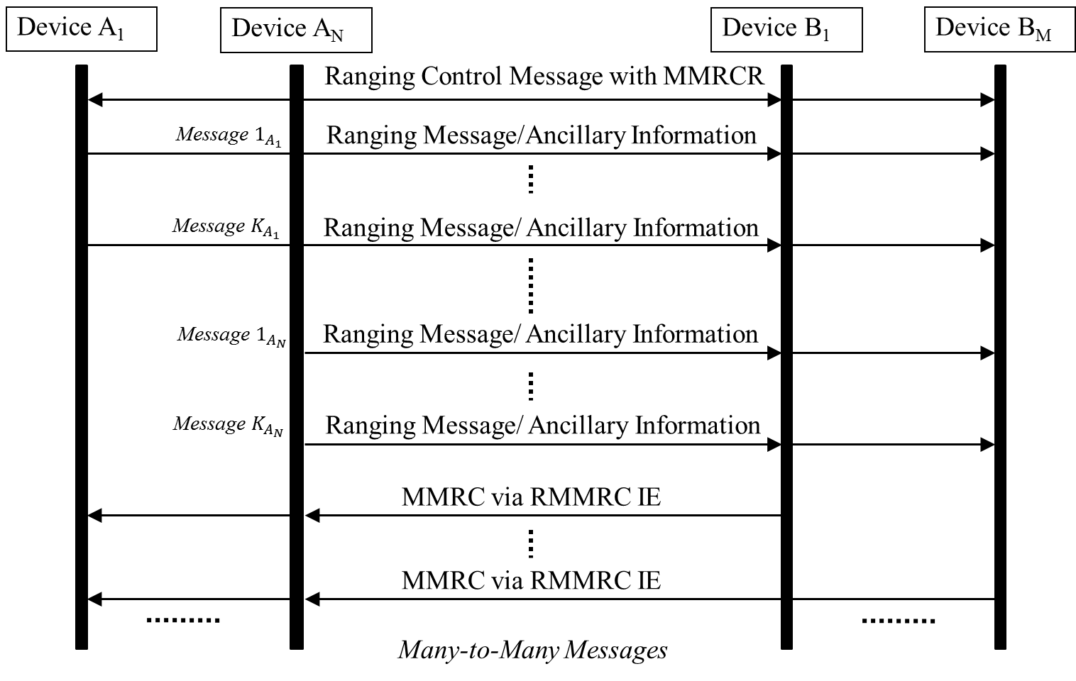

**Figure XW. Illustrative message sequence chart multiple message acknowledgement for multiple many-to-many messages**

*Add a new IE description 7.4.4.XX*

**17.4.4.XX Ranging Ancillary Information Message Counter and Type IE**

The Ranging Ancillary Information Message Counter and Type IE (RAICT IE) is used during ranging ancillary information exchange (in payload). This IE is formatted as shown in Figure XX.

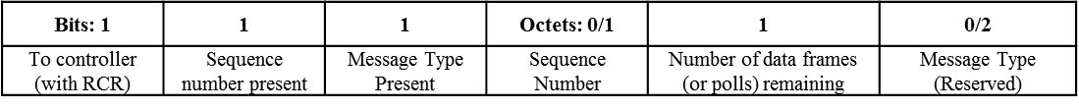

**Figure XX—** **Ranging Ancillary Information Message Counter and Type IE Content field format**

Initiator uses this IE in two ways:

1. To convey the sequence number of the current data frame, the number of ranging ancillary data frames remaining to complete this information, and the message type to the responder
2. Used along with RCR IE to request the controller to schedule the number of slots as specified in number of data frames remaining

To controller (with RCR) bit is set to 1 to use RADCT IE to request the slots from controller. Otherwise it is set to 0.

Sequence number present field is set to 1 if Sequence number of present, otherwise it is set to 0.

Message Type Present field is set to 1 if Message Type is being conveyed.

Sequence number is a field that conveys the MAC frame sequence number.

Number of data frames field remaining conveys to the responder the number of ranging ancillary data frames remaining to complete the present message/data.

Message Type field is a reserved field of 2 octets which can be sued to convey the type of message (e.g., authentication info).

*Add a new IE description 7.4.4.XX*

**17.4.4.XX Ranging Multiple Message Receipt Confirmation IE**

Messages from one or more initiators may be acknowledged with MMRC using Ranging Multiple Message Receipt Conformation (RMMRC IE) with initiator addresses and MMRC bitmap string to acknowledge all the messages from that initiator (or transmitter). The IE shall contain a table to acknowledge multiple initiators in a single message. The content field of the IE may be formatted as illustrated in Figure XY.

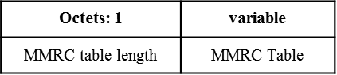

**Figure XY. Ranging Multiple Message Receipt Confirmation IE content field**

Each row of the MMRC table is formatted as illustrated in Figure XZ.

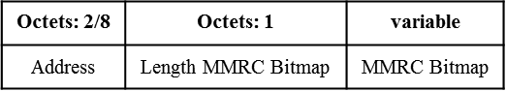

**Figure XZ. Format of each row of MMRC table**

* Confirmation for the receipt of each message in the MMRC is done through a binary bitmap string. Each bit in the bitmap string sequentially maps to the number of slots prior to the slot in which MMRC is sent. The length of this acknowledgement bitmap is equal to the number of slots in the ranging round preceding the MMRC transmission. Each bit confirms the receipt of a message in the slot. The bit is set to 1 to confirm successful reception, otherwise it is set to 0 to convey that the message was not received or if the message was not addressed to the MMRC sender in that slot. The confirmation for the receipt of a message in the first slot shall be conveyed using the least significant bit (LSB) of the MMRC bitmap string and sequentially the following bits shall represent the confirmation for the receipt of messages in the subsequent slots with the most significant bit (MSB) representing the confirmation for the receipt of the message in the final slot.