IEEE P802.15
Wireless Personal Area Networks

Project | IEEE P802.15 Working Group for Wireless Personal Area Networks (WPANs)
Title | IEEE 802.15.4z MAC
Date Submitted
Source | Ayman Naguib (Apple)
Re: | Letter Ballot Comments with Figures and Tables – P802.15.4z-D1
Abstract | This contribution proposes updated text for the baseline draft P802.15.4z-D1
Purpose | Provision of the text to facilitate its incorporation into the draft text of the IEEE 802.15.4z standard currently under development in TG4z.
Notice | This document does not represent the agreed views of the IEEE 802.15 Working Group. It represents only the views of the participants listed in the “Source(s)” field above. It is offered as a basis for discussion and is not binding on the contributing individual(s) or organization(s). The material in this document is subject to change in form and content after further study. The contributor(s) reserve(s) the right to add, amend or withdraw material contained herein.
Release
Patent Policy | The contributor is familiar with the IEEE-SA Patent Policy and Procedures:  <http://standards.ieee.org/guides/bylaws/sect6-7.html#6> and  <http://standards.ieee.org/guides/opman/sect6.html#6.3>.  Further information is located at <http://standards.ieee.org/board/pat/pat-material.html> and  <http://standards.ieee.org/board/pat>.

Editorial Comments
- Page 4 line 23 change “ … and its Ack frame response …” to “…. and its Ack response frame …”
- Page 15 line 6 add “on” before “the fixed reply time.”
- Page 20 lines 22-23. Change the end of line 22 and line 23 to read as follows “ Figure 12 shows the Ranging Block Structure. In this figure, the Ranging Block is divided into N Ranging Rounds, each consisting of M Ranging Slots.”
- Page 20 Line 29: Change MinimumBlockLength to MinimumBlock.Duration. This should be a global fix (i.e. applied to rest of the document)

- Page 27 line 9. Replace “RCM fields” with “ARC IE fields”

- Page 27 line 13,14. Replace “Ranging Round Start IE” with “Ranging Round IE”

- Page 27 line 23, 25. Replace “Next Ranging Round IE” with “Ranging Round IE”

- Page 29 line 25: Replace “…Slot Offset …” with “slot offset”

- Page 29 line 32: Replace “Next Ranging Round IE” with “Ranging Round IE (RR IE)”

- Page 29 line 37: Replace “Next Ranging Round IE” with “Ranging Round IE (RR IE)”

- Page 29 line 20: Replace “Ranging_Round_Hopping_Sequence” with “Round_HoppingSequence”
- Page 30 line 2: Replace HoppingSequence(N+1) with Round_HoppingSequence(N+1).

- Page 71 line 14. Replace “RIRL IE” with “RS IE”.

Technical Comments

- Page 4 Line 16, 17 “ … to cross correlate ..”. text implies a specific receiver implementation. Change to: “ … generate the sequence used to estimate the CIR from which to …”

- Page 5 Table 1: Do we need an RTSU definition for TVWS PHY? (section 6.9.1.1 defines ranging counter time units for TV WSPHY)

- Page 11 Line 41: Text states that "The use and support of any of these ranging procedure and associated IEs is optional". This is vague. Is this applicable to section 6.9.7 only or is it applicable for other ranging procedures as well, e.g. section 6.9.8 "Time Scheduled and Multi-mode Raging"

Change sentence to The use and support of any of the ranging procedures and associated IEs described in 6.9.7. is optional. Perhaps should add something similar in 6.9.8 (see next comment)

- Page 19 lines 11-14: The word "Central" pretty much makes everything in this section as mandatory while out of band signaling can certainly be used for control.

Replace text with " The techniques and procedures decribed below support time-scheduled and contention-based ranging among multiple participating RDEVs. Ranging Control Messages RCM , which are frames conveying the Advanced Control IE (ARC IE) specified in 7.4.4.38, may optionally be used to control these procedure.

- Page 19 line 16 replace “knows the identity” with “knows the number and identity”

- Page 20 line 5 The text states that RS IE is used by the controller to select the roles of the participating devices and the time slots when the perform the ranging exchanges. However, the current definition of the RS IE in 7.4.4.52 only allows for explicit scheduling and role specification of the participating devices. In certain applications, the responding devices scheduling is/can be implicit (for example based on a fixed order) and the roles are fixed. This can be addressed by not sending the RS IE at all. In this case, the controller is also the initiator and other participating devices are responders that will send their ranging messages in a predetermined order.

To support this:

- Page 20 line 16 - add the following text at the end of line 16:
“If the Controller is the only initiator and the order in which the responding devices transmit the messages is implicit (i.e. if it has been fixed by the upper layers via the setting the parameter macExplicitSch in the MLME-SCH.request), the Controller should not transmit the RS IE in the RCM.”

- Page 62 line 6 - Change the text in the second raw of Table 17 .
“ Time-scheduled-based ranging is used for the following ranging rounds. If the parameter macExplicitSch is set (via MLME-SCH.request) to TRUE, then the RS IE (7.4.4.52) is transmitted in the RCM. Otherwise (i.e macExplicitSch is set to FALSE ) the RS IE is not transmitted.”

- Page 71 line 11 – Change “ … is used in Scheduled-based mode ranging …” to “… is used in Scheduled-based mode ranging when appropriate …”

- Page 80 Line 4 Add the following section to define MLME-SCH.request

Section 8.2.26.3 MLME-SCH.request
The MLME-SCH.request primitive allows the next higher layer to set the scheduling mode to either explicit or implicit scheduling. The semantics of this primitive are:
MLME-SCH.request (
macExplicitSch
)
The primitive parameter is defined in Table 27

macExplicitSch | Boolean | TRUE  FALSE | When set, the scheduling is explicit and RS IE is sent in the RCM

- Page 20 Line 29. Add the following text at the end of line 29
The MinimumBlockDuration shall have a tolerance of +/-100x10⁻⁶.

- Page 21 line 11. Add the following text at the end of line 11: “ Again, it may be possible for one or more of these phases to be contained in a single MAC frame”

- Page 27 lines 28-33 The text describes how the block structure is updated. There are two issues with the current text. First some of the parameters listed are redundant. Specifically, given the new Ranging block length, we only need to specify the new Ranging Round Length or the Number of Ranging Round not both. Second issue with the text is that it is inconsistent with the Ranging Block Update (RBU) IE in 7.4.4.41. The definition of the RBU IE only allows for a new block length and a new Round length.

Replace text on lines 28-33 with the following text: “Block structure can be repeatedly transmitted in every RCM by the Controller. If the block structure needs to be changed or updated (i.e. to a new Ranging Block Length, Number of Ranging Rounds, and Number of Slots per round), this change may occur using an out-of-band channel or through an upper-layer protocol. Additionally, this change may also occur in-band by sending a Ranging Block Update IE. The Ranging Block Update IE fields will include the fields necessary to establish the new block and timeline structure. It will also include the future block index where the new block structure shall be used. Note also that if the block structure is updated, then the Round_HoppingSequence (6.9.8.3) must also be updated to reflect the new block structure. If the block structure is updated via sending RBU IE, then at the receiver, the updated block structure is reported visa the MCPS-Data.indication primitive.”

- Page 64 Figure 50 Replace Figure 50 with the following Figure

Octet: 2 | 1 | 1 | 1
Updated Block Multiplier | Updated Number of Ranging Rounds per Block | Updated Number of Slots Per Round | Relative Block Index

- Page 64 line 19 Replace line 19 with the following text
Updated Number of Ranging Rounds per Block is used to specify the value of the Updated Number of Ranging Rounds in the new block structure. If that value is set to 0, this will indicate that the Number of Ranging Rounds is unchanged from before. Similarly, Updated Number of Slots per Round is used to specify the value of the Updated Number of Slots per Round. If that value is set to 0, this will indicate that the Number of Slots per Round is unchanged from before.

- Page 85 line 10: Add the following parameters to the MCPS-DATA.indication

UpdatedBlockMul
UpdatedNoRRounds
UpdatedNoSlotPRd
RltvBlckIndex

- Page 86 Table 8-77 Add the following rows to the MCPS-DAT.indication table

Name | Type | Valid Range | Description
UpdatedBlockMul | Unsigned Integer | 0x0001 – 0xFFFF | Updated Block Multiplier for the new block structure
UpdatedNoRRounds | Unsigned Integer | 0x00 – 0xFF | Updated number of rounds per block in the new block structure. If value is set to 0, then the number of rounds per block in the new block structure is the same as before
UpdatedNoSlotPRd | Unsigned Integer | 0x00 – 0xFF | Updated number of slots per round in the new block structure. If value is set to 0, then the number of slots per round in the new block structure is the same as before
RltvBlckIndex | Unsigned Integer | 0x01-0xFF | Relative block index where the new block structure is applicable

- Pag 28 Lines 7,8 and Page 29 lines 1-6 Replace the text with the following text:

One-to-many multi-node ranging with fixed reply times can be supported in the block structure as shown in the example in Figure 20 below. All UWB packets from the controller and the initiator (i.e. RCM, P1, and P*1) follow the slot structure. However the responding nodes will respond after reply times FRT₁, FRT₂, …, FRT_{N}. Furthermore we assume that:

- FRT₁ > D, minimum reply time
- FRT_{i} > FRT_{j} for i > j
- | FRT_{i+1} - FRT_{i} - Packet_Length|>= D
- (FRT_{N} + Packet_Length)< N*Slot_Duration

The value of the minimum reply time D must be set such that no two responses overlap. D can be any of the possible values for phyFixedReplyTime (4,8,16, or 32 microsecnds). Fixed reply time cannot be used if the scheduling mode of the responses is contention based. The fixed reply times can be set either through the upper layer or by using Ranging Fixed Reply Time IE (RFRT IE).

- Page 29 Figure 21: Replace Figure with the following one

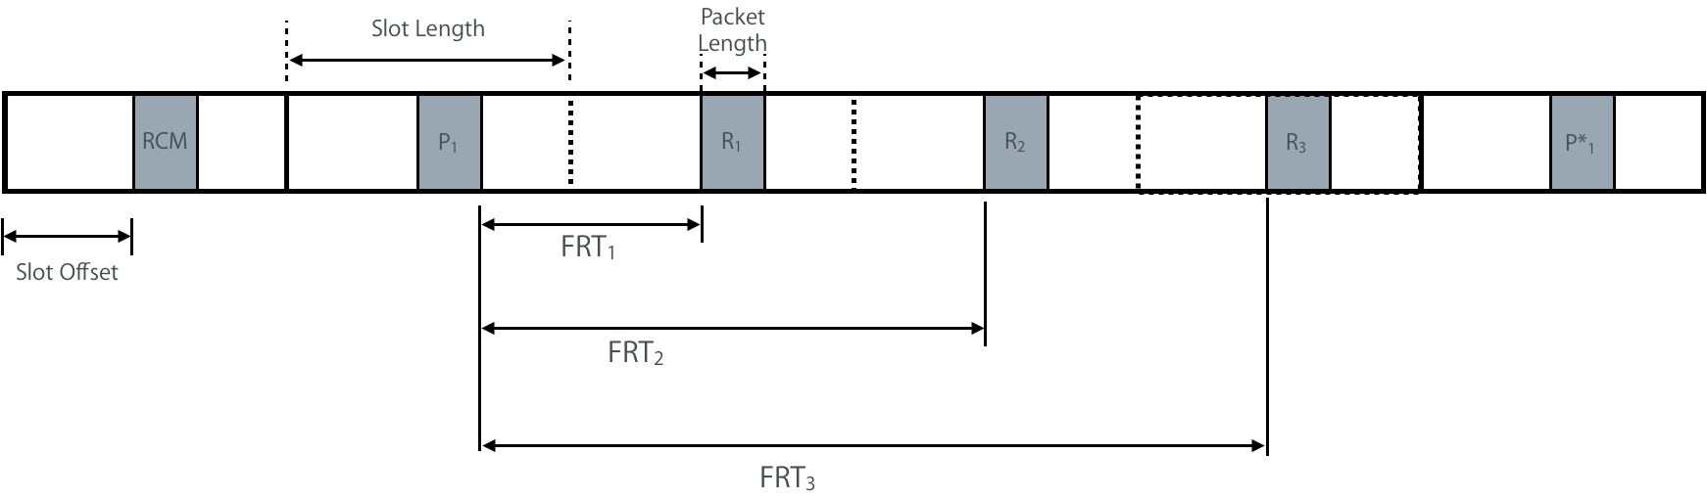

- Page 29 Line 21-24: Remove the text
“Only one device among the ranging devices shall be responsible for triggering the hopping mode and/or changing the slot offset. That device must be either a controller or an initiator, i.e. a controlee that is not an initiator shall not be responsible for triggering hopping mode and/or changing the slot offset.”

Add the following text after line 27
“Only one device among the ranging devices shall be responsible for sending a Ranging Round IE (RR IE) to change the hopping mode and/or change the slot offset . That device must be either a controller or an initiator, i.e. a controlee that is not an initiator cannot send a RR IE to trigger hopping mode and/or change the slot offset.”

- Page 29 line 27: Text states that hopping is signaled in a RR IE in an RCM. That is incorrect. It is sent in the last message in the ranging exchange.
Replace “…. in an RCM.” with “by sending a Ranging Round IE (RR IE) in the final ranging frame of the final data message of the ranging round.”

- Page 29 Line 27: Add The following Figure after line 27

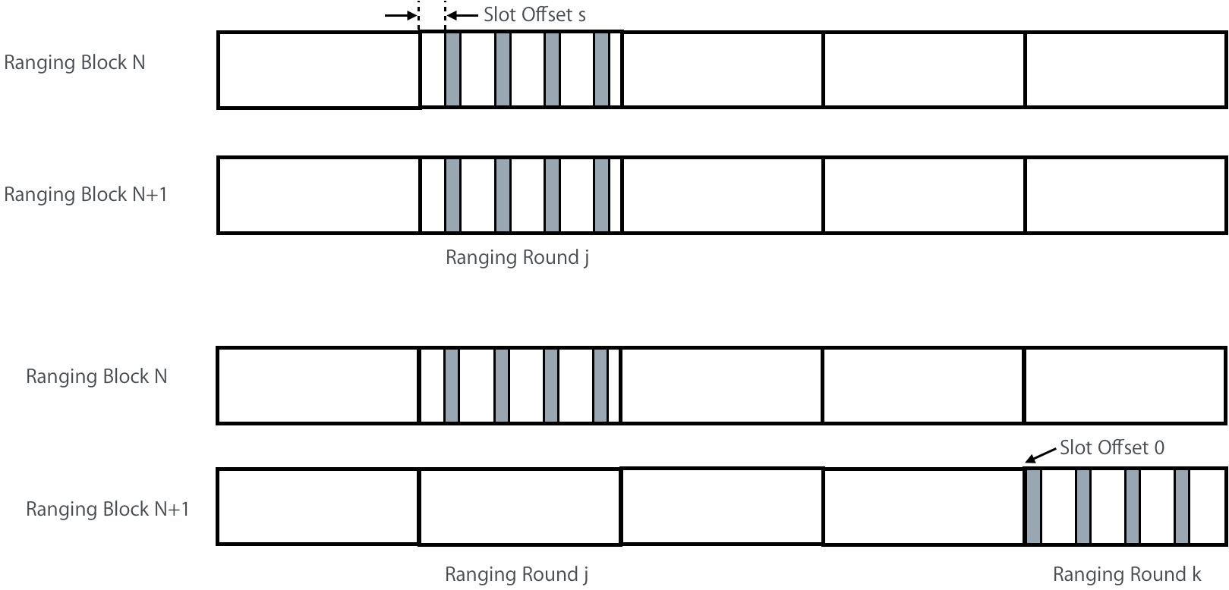

- Page 29 Section 6.9.8.3: Information needed to support triggering the hopping are missing. The information needed will depend on whether the hopping is triggered by the MAC or by the upper layers.
- If hopping is triggered by the MAC, then Round_HoppingSequence has to be defined as a MAC PIPP
- If hopping is triggered by upper layer, then we need to define the following supporting parameters in the MCPS-Data.request (Page 80 line 31)

NxtHoppingMode
NxtSlotIdx

Name | Type | Valid Range | Description
NxtHoppingMode | Boolean | TRUE, FALSE | This parameter sets the hopping mode that is signaled in Ranging Round IE transmitted in the last message of the ranging round. When hopping mode is on, this parameter is set to TRUE
NxtSlotIdx | Unsigned integer | 0x0000 – 0xFFFF | Slot index in the next ranging slot signaled in the Ranging Round IE transmitted in the last message in the ranging round

The upper layer at the initiator will use these parameters to signal the hopping mode in the MCPS-Data.request before the final message in the ranging exchange is sent. The message sequence charts need to be updated accordingly.

At the responding devices, we need to define an MLME so that next higher layer can trigger hopping and instruct the MAC to use a specific round in the next ranging block. This is needed so that responding device can resynchronize with the initiator in the case of an error event where the responding device does not receive the final message with the Ranging Round IE carrying the information about the ranging round in the next ranging block. Add the following section on Page 80 Line 4

Section 8.2.26.4 MLME-HOP.request
The MLME-HOP.request primitive allows the next higher layer to set the hopping mode and round index in the next ranging block to either explicit or implicit scheduling. The semantics of this primitive are:
MLME-HOP.request (
NxtHoppingMode
NxtSlotIdx
)
The primitive parameter is defined in Table 27

Name | Type | Valid Range | Description
NxtHoppingMode | Boolean | TRUE, FALSE | This parameter sets the hopping mode that is signaled in Ranging Round IE transmitted in the last message of the ranging round. When hopping mode is on, this parameter is set to TRUE
NxtSlotIdx | Unsigned integer | 0x0000 – 0xFFFF | Slot index in the next ranging slot signaled in the Ranging Round IE transmitted in the last message in the ranging round

- Page 30 Line 2: Add the following text at the end of line 2:
In case of an error event that will cause the ranging devices to be out of sync (for example due to the loss of the last UWB message in which the RR IE carrying the ranging information in the next ranging block N+1), the ranging devices will experience a ranging failure in ranging block N+1 and will restore sync in ranging block N+2 using the Round_HoppingSequence.

- Page 61 Figure 47:
Change “Block Length Multiplier” to “Block Duration Multiplier”
Change “Ranging Round Length” to “Ranging Round Duration”
Change Ranging Slot Length” to “Ranging Slot Duration”
These fixes should applied globally to the rest of the document

- Page 61 Figure 47: I would suggest replacing the Ranging Round Duration/length and Ranging Slot Duration/Length to Number of Ranging Rounds and Number of Ranging Slots. (Ranging Round Duration = Block Duration Multiplier X Minimum Block Duration / Number of Ranging Rounds). All the block structure timings are defined by the Minimum Block Duration and hence we need to specify only one tolerance value for the MAC timing
- Page 77 line 3: Content of the IE is undefined and is not used anywhere in the text. Remove IE
- Page 77 line 6: Content of the IE is undefined and is not used anywhere in the text. Remove IE
- Page 77 line 9: Content of the IE is undefined. Seems to be defined by 7.4.4.58. Remove IE

