IEEE P802.15
Wireless Personal Area Networks

Project | IEEE P802.15 Working Group for Wireless Personal Area Networks (WPANs)
Title | Proposed new Table D.5 for LRP UWB
Date Submitted | [March 14, 2019]
Source | H.-B. Li (NICT, Japan), David Barras (3db Access, Switzerland), K. Takizawa (NICT, Japan), F. Kojima (NICT, Japan), Boris Danev (3db Access, Switzerland), H. Nishikawa (GIT Japan Inc.), Bernd Baer (Marquardt, Germany), Peter Sauer (Microchip Technology, Germany). | E-Mail:[lee (at) nict.go.jp
Re: | [If this is a proposed revision, cite the original document.]  [This is a proposal for updating Table D.5 in the draft of 15.4z to reflect all channelization for LRP UWB]  [Note: Contributions that are not responsive to this section of the template, and contributions which do not address the topic under which they are submitted, may be refused or consigned to the “General Contributions” area.]
Abstract | [Contribute a proposal to the enhanced impulse radio group 15.4z]
Purpose | [Proposed new Table D.5 for LRP UWB]
Notice | This document has been prepared to assist the IEEE P802.15. It is offered as a basis for discussion and is not binding on the contributing individual(s) or organization(s). The material in this document is subject to change in form and content after further study. The contributor(s) reserve(s) the right to add, amend or withdraw material contained herein.
Release | The contributor acknowledges and accepts that this contribution becomes the property of IEEE and may be made publicly available by P802.15.

Proposed changes are shown in blue.

Table D.5 in IEEE 802.15.4-2015 is given as follows

Table D.5—LRP UWB channels
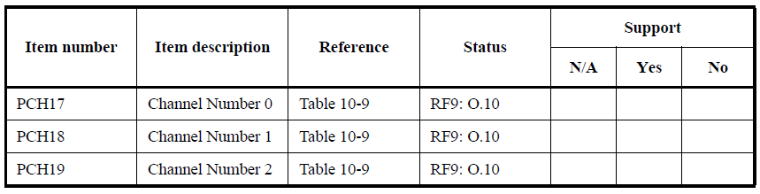

This table needs to be updated to reflect the added channel numbers as agreed within TG4z. Also, the above table includes incorrect references that need to be modified. The new Table D.5 is as follows.

Table D.5—LRP UWB channels
Item number | Item description | Reference | Status | Support
 |  |  |  | N/A | Yes | No
PCH17 | Channel number 0 | Table 19-9 | RF9: O.10
PCH18 | Channel number 1 | Table 19-9 | RF9: O.10
PCH19 | Channel number 2 | Table 19-9 | RF9: O.10
PCH20 | Channel number 3 | Table 19-9 | RF9: O.10
PCH21 | Channel number 4 | Table 29 | RF9: O.10
PCH22 | Channel number 5 | Table 29 | RF9: O.10
PCH23 | Channel number 6 | Table 29 | RF9: O.10
PCH24 | Channel number 7 | Table 29 | RF9: O.10
PCH25 | Channel number 8 | Table 29 | RF9: O.10
PCH26 | Channel number 9 | Table 29 | RF9: O.10

