IEEE P802.15
Wireless Personal Area Networks

Project | Dependability Interest Group
Title | Meeting Minutes for March 2019
Date Submitted | March 15th, 2019
Source | [Ryuji Kohno]  [YNU(Yokohama National University)/CWC-Nippon] | Voice: +81 90 3061 7978  +358 40 354 0034  E-mail: kohno@ynu.ac.jp  ryuji.kohno@ee.oulu.fi
Re: | Meeting Minutes
Abstract | Considering cooperation with ETSI smart BAN and smart M2M, IG-Dependability has decided to concentrate into amendment of IEEE802.15.6 for wireless medical BAN to cover internal car network for IoT/M2M car BAN as well as BAN for human and robotic bodies. Mainly enhanced dependability of MAC layer of IEEE802.15.6 has been discussed for some critical use cases such as multiple BANs coexistence environment. Interference mitigation in PHY layer in cases of multiple BANs and multiple UWB radios such as 15.4a, 4f, 4z and others have been discussed.  For newly focused applications, technical requirement has been updated comparing with current existing standard of WBAN IEEE802.15.6.
Purpose | Minutes of Dependability Interest Group sessions
Notice | This document has been prepared to assist the IEEE P802.15. It is offered as a basis for discussion and is not binding on the contributing individual(s) or organization(s). The material in this document is subject to change in form and content after further study. The contributor(s) reserve(s) the right to add, amend or withdraw material contained herein.
Release | The contributor acknowledges and accepts that this contribution becomes the property of IEEE and may be made publicly available by P802.15.

Tuesday, March 13th, 2019, AM2, 10:30-12:30
Room: Dover

  - Meeting called to order 10:31
By Chair Ryuji Kohno (YNU / CWC-Nippon)

  - Roll Call
Notepad for Attendance circulated.

  - Opening Report
Chair presented Opening report doc.#19-0115-r1
Chair showed IEEE Patent policy.
Chair issued Call for Potentially Essential Patents
No essential intellectual property in the scope of IG DEP was declared.
Chair presented agenda this week doc.#19-0114-r1

  - Approval of previous meeting minutes
Upon no comments on the previous meeting minutes, doc #18-0595-00 was approved.

  - Review of ID DEP activities
- Overview of IG DEP activities for Cars and other IoT & M2M Use cases and Amendment of IEEE802.15.6 Wireless Medical doc.#15-18-0347-00
- Overview of ETSI Smart BAN Project Activities doc.#15-18-0535-01
- Overview of IEEE802.15.6 for Wireless Medical BAN doc.#15-18-0384-00

  - Discussion
Corresponding to request from chair Dr. John Faserote, smart BAN TC of European standard body ETSI, IG-DEP chair Kohno started to discuss on commonality and difference between smart BAN and IG-DEP.

< Commonality between IG-DEP and Smart BAN >
- Easier implementation of more efficient MAC and PHY, yielding very low latency emergency messaging, very low energy consumption and rapid initial set up time and channel reassignment.
- Extension to multiple BANs environment
- Extension from a star topology + one hop to a star + multiple hop relay
- Covering narrow band solution in PHY for BAN
< Difference between IG-DEP and Smart BAN >
- IG-DEP focuses on enhanced dependability in PHY and MAC while smart BAN does on smart or smart implementation
- IG-DEP covers only PHY and MAC layers while smart BAN covers network layer, security, Quality-of-Service (QoS) and provision of generic applications and services.
- IG-DEP covers UWB and narrowband solutions in PHY while smart BAN does only narrowband one.
- IG-DEP focuses on car and robotic bodies as well as human body as an extension of IEEE802.15.6 for wireless medical BAN while smart BAN does on only digital healthcare for human body and smart M2M does on more general use cases of M2M including car and machines.

Possible collaboration with ETSI TC smart BAN has been discussed to design appropriate MAC and PHY for the common targets to keep interoperability for instance, common permissible packet and bit error rates, feedback controlling loop delay, and so on.

  - Recess at 12.29.
  - Attendees 6
Iwao Hosaka (NICT)
Demir Rakanovic (U-BLOX)
Shinsuke Hara (OCU)
Seong-Soon Soo (ETRI)
Huan-bang Li (NICT)
Ryuji Kohno (YNU/CWC-Nippon)

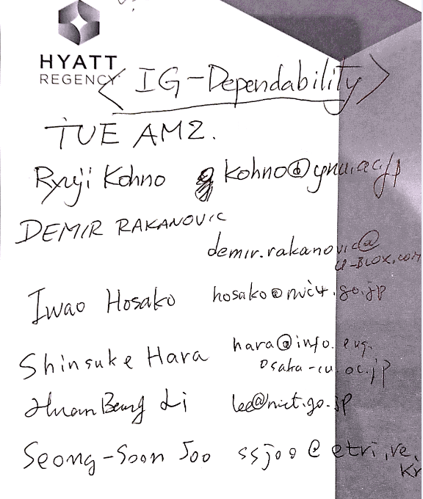

Wednesday 14 March 2019, AM1, 8:30-10:00
Room; Dover

  - Meeting called to order 8:11
By Chair Ryuji Kohno (YNU / CWC-Nippon)

  - Roll Call
Notepad for Attendance circulated.

  - Quick review of the last session

  - Review
Overview of Updated Radio Regulation for UWB in Japanese doc.#15-18-0546-01
To reconsider UWB PHY of IEEE802.15.6 corresponding to update of Japanese radio regulation for UWB last November, Chair Kohno explained its detail because he is a committee member of Japanese regulator MIC radio regulation. In UWB regulation he has played a role of chair. Key change is that although Japanese UWB regulation has not allowed outdoor uses in all UWB microwave high and low bands, only channel 9 of high band has be available in outdoor uses.

  - Presentation
Before discussing update of technical requirement for newly focused applications, we listen to presentation of enable MAC and PHY technologies to ensure enhanced dependability as possible solution.
- MAC protocol with interference mitigation using negotiation among coordinators in multiple wireless body area networks doc.#15-19-0119-00-0dep
In multiple BANs overlaid environment, negotiation among coordinators can avoid unnecessary contention base delay for high priority QoS packets while scarifying performance of lower priority QoS packets.

- A dependable MAC protocol matched to bi-directional transmission in WBAN
doc.#15-18-0115-01-0dep
By modelling feedback decision rule of sensing vital signs such as glaucous level of blood and its corresponding feedback command such as insulin level to be injected, a pair of uplink packets from sensor nodes to coordinator and their corresponding downlink packets from coordinator to wearable actuator node can be assumed and used to design accessing time schedule for the pair.
- Space-time domain interference mitigation using based on OMF and TDL-AA for dependable UWB-BANs doc.# 15-18-0352-00-0dep
In PHY layer, space-time signal processing using tapped delay line (TDL) type of array antenna with orthogonal matched digital filter (OMF) can be applied for interference mitigation of overlaid multiple BANs environment.

- Learning and Recognition with Neural Network of Heart Beats Sensed by WBAN for Patient Stress Estimate for Rehabilitation
doc.#15-19-01240-00-0dep
As one of applications of WBAN in conjunction with current popular machine learning as an initial acquisition of teacher signals has been presented.

  - Discussion
Since Kohno gave a talk on “Update of Japanese UWB Radio Regulation,” doc.#18-15-0546-02-0dep in AM1 session of 802.15.4z EIR (extended impulse radio UWB), several members of 15.4z attended in IG-DEP session.
- A killer application of 15.4z such as keyless entry for a car may have common PHY with a main application of IG DEP such as internal car network or CAR BAN. If a common or over-compatible MAC protocol is designed for amendment of BAN 15.6 and 15.4z, it may be a dependable MAC for resolving a coexistence problem among different UWB 802.15 standards because one of core PHY technologies in IG-DEP is assumed UWB impulse radio as well as 4z.
- Approach of 15.4z such as amendment of 15.4 MAC and two PHYs such as HDR and LDR(1Mbps) could be simpler than approach of IG-DEP to make a new standard. So, IG-DEP has decided to be amendment of 15.6.

  - Recess at 12.31.

  - Attendees 3
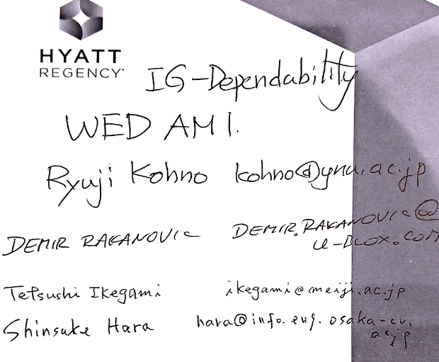
Tetsushi Ikegami(Meiji University)
Demir Rakanovic(U-Blox)
Ryuji Kohno(YNU/CWC-Nippon)

Wednesday 14 March 2019, PM1, 13:30-15:30
Room; Dover

  - Meeting called to order at 13:33

  - Roll Call

3.3 Update of Technical Requirement
IG-DEP has selected only car, robotic and human BANs by pushing down inter vehicle and vehicle to roadside networks as secondary use case. However, feedback sensing and controlling networks for factory manufacturing line and remote controlling UAV such as drones can be involved as BAN for sequential robotic body in manufacturing line and vehicle body BAN.

A draft of updating technical requirement for new focused applications was discussed.
- Updated Technical Requirements for Focused Use Cases on WBAN for Human, Robotic and Car Bodies doc.#15-19-0157-00-0dep
Automotive network standards CAN and LIN must be fully supported as a context of
Structure of packets.

  - Discussion
Since technical requirement for new focused applications in the table of doc.#15-19-0157 has been discussed and updated to compare with the ready listed technical requirement for the focused automotive use cases. It has been mostly completed.
Due to absence of both chair and secretary in May meeting, IG-DEP will decide the next step to SG/TG in July meeting, Vienna.
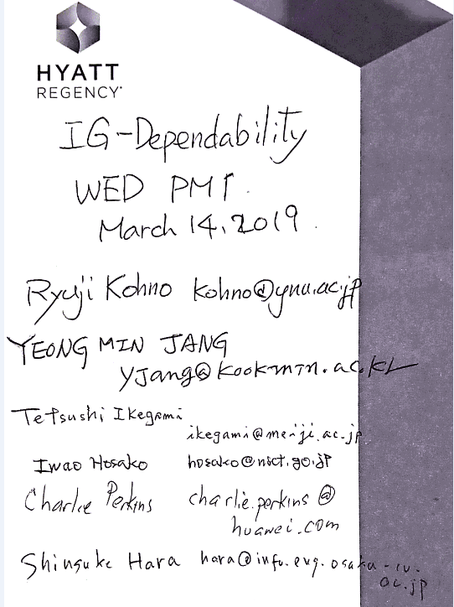
  - Adjourn 15:28

  - Attendees 6

Iwao Hosaka(NICT)
Yeong Min Jang (Kookmin Univ.)
Tetsushi Ikegami (Meiji Univ.)
Charlie Perkins(HUAWEI)
Shinsuke Hara (OCU)
Ryuji Kohno (YNU/CWC-Nippon)

