IEEE P802.15
Wireless Specialty Networks
IEEE P802.15.13
Further text for TG13
Date: 2019-02-15
Author:
Name | Affiliation | Address | Phone | Email
Kai Lennert Bober | Fraunhofer HHI |  |  | kai.lennert.bober@hhi.fraunhofer.de

Abstract

This document contains proposed text for IEEE P802.15.13.

Hints & legend
Text marked in green refers to other documents
Text marked in yellow depends on further decisions or indicates missing content

Overview

Scope

Purpose

Normative References

Definitions, acronyms, and abbreviations

Definitions

Acronyms and abbreviations

General description

Introduction

Components of IEEE 802.15.13 Networks

Network Topologies

Coexistence

Due to the physical properties of light, the number of observed different OWPANs within a given space is likely to be limited. Signals from remotely deployed OWPANs, e.g. in different rooms, usually do not have implications on the local signal processing.

Furthermore, it is assumed that IEEE 802.15.13 OWPANs will be deployed in a coordinated manner. Thus, a room is typically not equipped with multiple uncoordinated infrastructures from different providers. If multiple OWPAN infrastructures overlap in their coverage area, they should always be coordinated by a master coordinator, managing resource allocations between the corresponding coordinators. The details of coordination are out of scope of this standard.

The high directivity of light imposes difficulties on coexistence schemes that are based on energy detection. This is in contrast to RF-based communication technologies with omnidirectional propagation characteristics. Through these omnidirectional characteristics, heterogeneous technologies that feature not mutually decodable signals, can rely on refraining from transmissions after the channel is detected busy by exceeding a given signal energy threshold (CCA through energy detection).

This standard restricts uncoordinated transmissions, i.e. random channel access, to the minimum required purposes such as association or reconnection. However, in case of alien technologies entering the coverage area of an IEEE 802.15.13 OWPAN, the behavior is unspecified. Currently, there is no coexistence coordination among different OWC standards.

Architecture

Similar to other IEEE 802 standards, the architecture of this standard is defined by a number of layers in order to group related functionality and simplify the standard. Each layer is responsible for a subset of the functionality included in the standard and offers services to the next higher layer.

Each layer includes interfaces that serve the exchange with other layers. More specifically, a lower layer provides its service to the next higher layer. The term used for the corresponding interfaces in this standard is service access point (SAP).

This standard specifies only exposed interfaces, which are likely to connect entities provided by different vendors. Currently, this are the MCPS-SAP and the MLME-SAP, as depicted in Figure 4-1. Other interfaces are assumed to be vendor-internal or do not require detailed specification.

Different functionalities of a layer are accessible through so-called primitives that make up a given SAP. The concept of primitives is further described in clause 4.6.

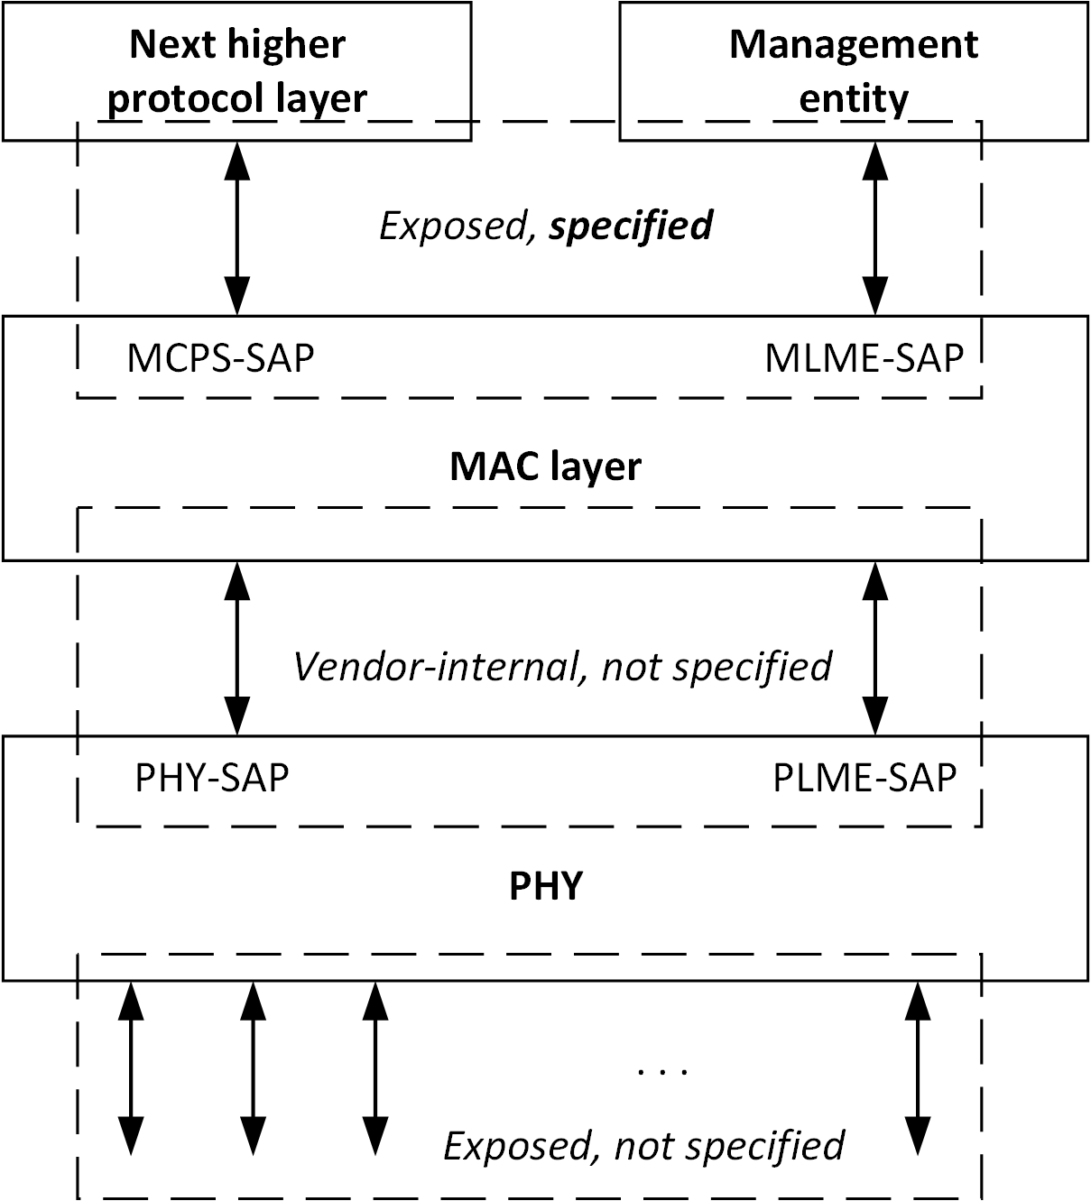
Figure 4-1: Architecture and interfaces of the IEEE 802.15.13 standard

Concept of primitives

The services of a layer are the capabilities it offers to the user in the next higher layer or sublayer by building its functions on the services of the next lower layer. This concept is illustrated in Figure 4-2, showing the relationship of the service user and the service provider (next lower layer).

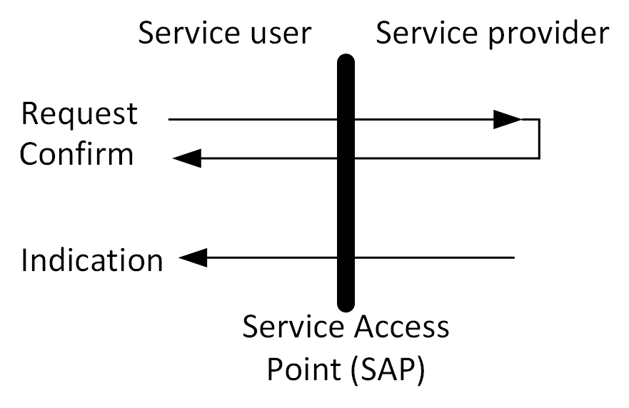
Figure 4-2: Request, confirm and indication primitives of a SAP
The services are specified by describing the information flow between the user and the layer. This information flow is modeled by discrete, instantaneous events, which characterize the provision of a service. Each event consists of passing a service primitive from one layer to the other through a layer SAP associated with a user. Service primitives convey the required information by providing a particular service. These service primitives are an abstraction because they specify only the provided service rather than the means by which it is provided. This definition is independent of any other interface implementation.

Functional Overview

Conventions in this standard

This clause lists different conventions for the format, terminology and units within this standard.

Format conventions

Field- and element names are underlined. Attributes and capabilities are written in italics.

Normative terminology

Requirements on conformant implementations of this standard are expressed using the following terminology:

- Shall is used for mandatory requirements
- May is used to describe optional functionality that the implementation is permitted to support
- Should is used for recommended implementation and configuration choices

Power levels

Optical wireless communication utilizes intensity modulated light and direct detection at the receiver. Hence, electrical signal levels, as measured at the receiving DSP, do not relate to the received optical power level in the same way for all devices. Rather, the relationship between received optical power and received electrical power depends on implementation details of a given device.

To compare signal levels, one must thus refer to the optical power and not the electrical power. When signal levels are specified in this standard, these are optical powers. This is the case for emitted signal levels and received signal levels.

MAC functional description

This clause specifies the MAC sublayer of this standard. The MAC sublayer functionality makes use of the physical layer and is responsible for the following tasks:

- Performing channel access and transmission in correspondence with the OWPAN’s configuration
- Starting and maintaining an OWPAN if the device is a coordinator
- Associating / disassociating with / from an existing OWPAN
- Fragmenting and aggregating MSDUs
- Providing a reliable link between two peer MAC entities

The MAC frame formats supporting the function of the MAC are specified in clause 6. Services, MAC attributes and device capabilities are specified in clause 7. The support for security is specified in clause 8.

Introduction and overview

This clause specifies the majority of MAC functionality. It covers procedures for frame transmission, as initiated through the MCPS-DATA.request primitive until the start of PSDU processing through the PHY. Similarly, procedures for frame reception, starting after the successful reception of a PSDU to the triggering of a MCPS-DATA.indication primitive are described.

An OWPAN can operate in beacon-enabled or non-beaconed enabled mode. Depending on which mode is used applied by the coordinator, channel access is performed in different ways.

The transmit process

A device prepares MPDUs for transmission in accordance with the maximum duration, as dictated through the applied channel access mode, for transmission. The details of obtaining a transmission opportunity depend on the channel access mechanism applied in the associated OWPAN (see clauses 5.2. and 5.3).

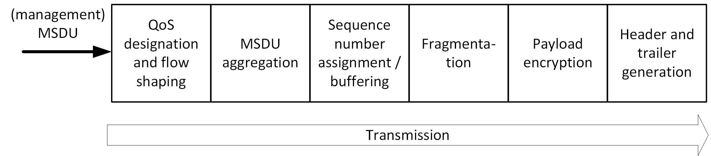
Figure 5-1: The MAC frame (MPDU) transmit process

The receive process

The reception process starts when the MAC receives an incoming MPDU from the PHY.

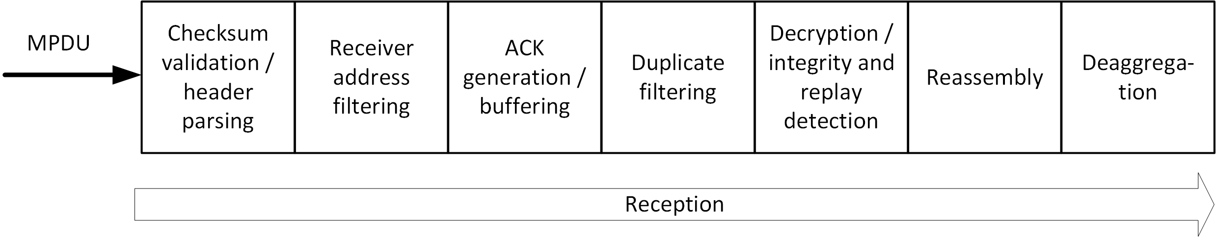
Figure 5-2: The MAC frame (MPDU) receive process

Beacon-enabled channel access

[see document 15-18-0616-03-0013]

Non-beacon-enabled channel access

[see document 15-18-0488-01-0013]

OWPAN management

This clause describes the scanning for existing OWPANs, starting of new OWPANs as well as the association and disassociation of devices with / from and existing OWPANs.

Scanning for OWPANs

A scan procedure is performed by a device to detect any OWPANs that are operating in its vicinity. In light communication, a single frequency range in the baseband is utilized for all transmissions. Hence, scanning for existing OWPANs reduces to the scanning of a single frequency channel. However, that channel may host multiple OWPANs, maintained by different coordinators in a coordinated topology.

IEEE 802.15.13 devices shall support passive scanning for OWPANs. During a passive scan, the device listens for incoming frames but also non-decodable signals whose received power exceeds a given threshold.

The scan is started upon request by the higher layer management entity through the MLME-SCAN.request primitive. A device instructed to scan for OWPANs shall listen for received beacon or RA frames during the scan period. For every successfully decoded beacon or RA frame during the scan period, the device shall add the corresponding OWPAN ID and OWPAN name to the scan result list. It shall furthermore add the received electrical SNR to the result list. During a scan, the MAC sublayer shall discard all other frames received over the PHY data service.

If a device detects at least one non-decodable signal that has a received power of more than macEdScanThreshold during the scan time, the device shall add an entry with OWPAN ID = 0xFFFF, OWPAN name = “Unknown” and the received power level of the strongest received signal to the scan result list.

The results of the scan shall be returned via the MLME-SCAN.confirm primitive.

Scan over backhaul?

Starting and maintaining an OWPAN

The process of starting a new OWPAN is initiated after a coordinator-capable device was instructed to do so through the MLME-START.request primitive of the MLME-SAP. This subclause describes the steps involved in starting and maintaining the OWPAN.

If the prospective coordinator maintained an OWPAN before, the higher layers shall stop the OWPAN prior to starting a new OWPAN in order to reset all MAC state and disassociated potentially associated devices.

The higher layers shall issue a scan immediately before attempting to start a new OWPAN. The higher layers shall only issue the MLME-START.request primitive, if the corresponding scan reported an empty result list.

The next higher layer management entity of the prospective coordinator shall select an OWPAN ID and OWPAN name. If the coordinator implements the capShortAddressing capability, it shall adopt the selected OWPAN ID as its short address. The higher layer management entity shall provide the selected OWPAN ID, OWPAN name and its short address as a parameter of the MLME-START.request.

NOTE - The OWPAN ID may be retrieved from a master coordinator. Two neighboring OWPANs shall not use the same OWPAN ID. Two OWPANs may use the same OWPAN name.

On receipt of the MLME-START.request, the MLME of the prospective coordinator shall prepare operation as a coordinator and subsequently start transmitting frames in accordance with the configured channel access mode.

Stopping an OWPAN

To stop an existing OWPAN, the higher layer management entity of a coordinator shall issue the MLME-STOP.request through the MLME-SAP. Upon reception of the primitive, the MAC shall disassociate all associated devices with the reason code XXX. Successively, it shall purge all state that was introduced during the up time of the OWPAN.

Association with an existing OWPAN

A device may be instructed to attempt association with an existing OWPAN by the higher layer management entity through the MLME-ASSOCIATE.request primitive. Before starting the association procedure, a device shall reset all state, including queues and variables, of its MAC layer. The association procedure involves two steps:

- Request association with the goal to obtain (temporary) channel access
- Request Authentication if required by the OWPAN

The device shall prepare a management frame, containing the Association Request element. The Association Request element shall contain necessary information as detailed in clause 6.6.1.3. The requesting device shall then transmit the management in frame in correspondence with the channel access rules for association. These differ depending on the applied channel access mode in the OWPAN as detailed in clauses 5.2 and 5.3 respectively.

After successful reception of an Association Response element, the device shall perform Authentication with the OWPAN coordinator if necessary.

A sequence chart of a successful association procedure is depicted in Figure 5-3.

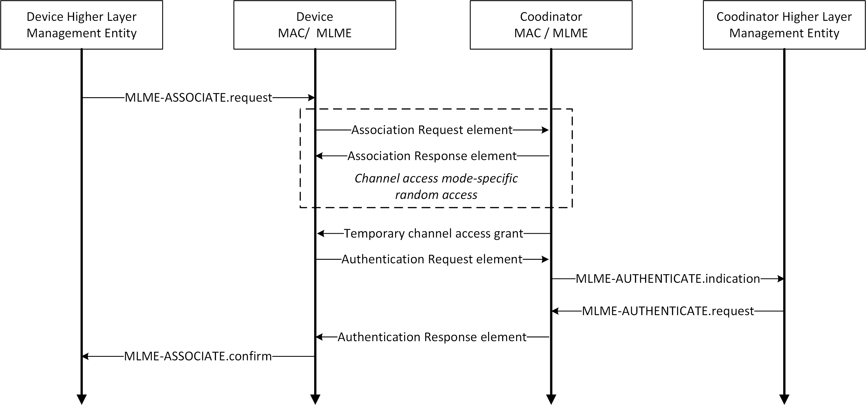

Figure 5-3: Association procedure message exchange

During the association procedure, each device advertises its capabilities to the coordinator. The coordinator vice versa indicates its supported capabilities to the device. Functions that are supported by both the coordinator and the device may be used during the associated time.

Disassociation from an OWPAN

The disassociation of a single device from an OWPAN can may be initiated by either the coordinator of the OWPAN or the affected device itself.

To disassociate a device from the OWPAN, the coordinator shall transmit a management frame, containing the Disassociation Notification element, to the device to be disassociated. If the coordinator does not receive a corresponding acknowledgment frame, it shall regard the device as disassociated after it did not receive further frames from the device for timeout of XXX.

A device that wants to disassociate from the OWPAN shall transmit a management frame containing the Disassociation Notification element to the coordinator of the OWPAN. It shall only consider to be disassociated after if received an acknowledgment for the transmitted management frame.

Fragmentation and reassembly

Fragmentation may be performed at the transmitting device on each MSDU. All fragments shall contain an even number of octets, except the last fragment, which may contain an odd number of octets. Once the MSDU is fragmented and a transmission attempted, it shall not be fragmented again. The smallest size of a fragment, excluding the last fragment, shall be at least aMinFragmentSize.

A device indicates its maximum fragment size for reception in the Maximum Fragment Size field in the capabilities field, as described in 5.4, that it sends to the coordinator when the device associates with the OWPAN. All fragments but the last fragment shall be sent with the Last Fragment field of the data MPDU set to 0. The last fragment shall have the Last Fragment field set to 1. Each subsequent fragment shall be sent with the Fragment Number field incremented. However, the Fragment Number field shall not be incremented when a fragment is retransmitted.

All fragments of the same MSDU shall have the same sequence number. Defragmentation of an MSDU is the reassembly of the received fragments into the complete MSDU. The MSDU shall be completely reassembled in the correct order before delivering it to the upper layer.

The receiving device may discard the fragments of an MSDU if it is not completely received within a timeout determined by the receiving device. The destination device may also discard the oldest incomplete MSDU if otherwise a buffer overflow would occur. Fragments shall be transmitted in order of their fragment numbers. If the no-ACK policy is used, the destination device shall discard an MSDU immediately if a fragment is missing. A device shall support concurrent reception of fragments of at least three MSDUs.

PM-PHY

[see document 15-18-0003-07-0013]

LB-PHY

[see document 15-18-0267-05-0013]

HB-PHY

[see document 15-18-0273-02-0013]

