IEEE 802.15
Wireless Specialty Networks
IEEE P802.15.13
Text proposal for beacon enabled medium access
Date: 2018-01-14
Author:
Name | Affiliation | Address | Phone | Email
Kai Lennert Bober | Fraunhofer HHI |  |  | kai.lennert.bober@hhi.fraunhofer.de
Volker Jungnickel | Fraunhofer HHI |  |  | volker.jungnickel@hhi.fraunhofer.de
Xu Wang | VLNComm Inc |  |  | wang@vlncomm.com
Abstract

This document contains proposed text for the medium access in the beacon-enabled mode. The content is subject to further changes.

Overview

Normative references

Definitions, acronyms, and abbreviations

General description

MAC functional description

Introduction and overview

Beacon-enabled channel access

If an OWPAN runs in beacon-enabled channel access mode, channel time is subdivided into subsequent superframes. Each superframe is composed of three major parts: a beacon transmission, an optional contention access period (CAP), and the contention free period (CFP).

Transmission of the beacon by the OWPAN coordinator is described in 5.2.2.

In the CAP, devices may access the channel randomly by means of slotted ALOHA. Random channel access in the CAP is only allowed for specific procedures and frame types as specified in 5.2.3.

All other frame transmissions happen in the CFP (see 5.2.4). The CFP consists of reserved resources, called GTSs, which are assigned to each device for a given superframe. The coordinator coordinates and announces GTS allocations as described in 5.2.5.

Superframe structure

A superframe consists in total of aNumSuperframeSlots superframe slots. aNumSuperframeSlots is a variable determined by the OWPAN coordinator and announced to the devices in the beacon frame. The maximum number of superframe slots within a superframe is 65535 (see 7.1). Each superframe slot has a duration of aSuperframeSlotDuration. Hence, the number of superframe slots and their respective duration determine the duration of each superframe.

The MAC protocol makes use of integer numbers of superframe slots to specify durations within the superframe. That can be duration of the CAP, CAP slots, GTS and other sub-parts of the superframe.

Each OWPAN coordinator defines the superframe structure for its coordinated OWPAN. Consecutive superframes of an OWPAN do not necessarily have to be adjacent but may have channel time between them that is not used by the OWPAN.

In the coordinated topology, the master coordinator determines when the superframe of each OWPAN starts and how long it is. The details of the coordinated topology are outside the scope of this standard.

Of the aNumSuperframeSlots superframe slots in a superframe, three consecutive slot groups are used for the beacon transmission, the CAP and CFP respectively as shown in Fig 5-1. The number of superframe slots reserved for the beacon transmission depends on the length of the beacon frame. The length of the CAP is determined by the OWPAN coordinator and may change from superframe to superframe. The remaining slots in the superframe are used for the CFP and can be used for frame transmissions between the devices and the coordinator.

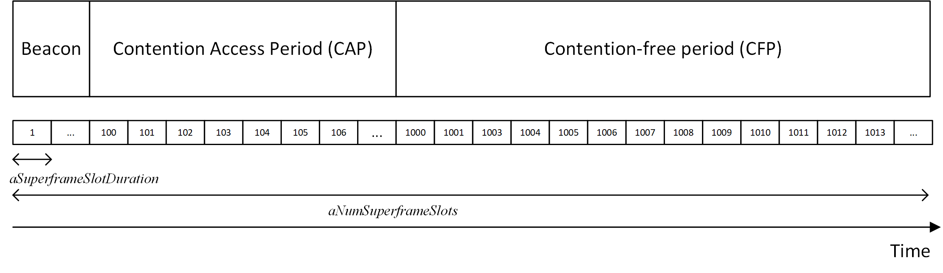
Figure 5-1: Superframe structure including exemplary number of superframe slots

Beacon transmission

In the beacon-enabled mode, each coordinator shall transmit a beacon at the beginning of the OWPAN’s superframe. Devices synchronize their clocks to the received beacon frame as described in 5.2.6. When multiple optical frontends are used, the beacon frame shall be transmitted over all optical frontends simultaneously.

Medium access in the CAP

The CAP shall only be used for frame transmissions in the

- Association procedure (see 5.2.3.1)
- Resource request procedure (see 5.2.3.2)

The CAP shall start with the superframe slot following the beacon and complete before the beginning of the CFP on a superframe slot boundary. The length of the CAP is advertised in the beacon frame (see 6.4.2.3).

Both CAP and CFP periods may shrink or grow dynamically on a superframe-by-superframe basis in order to allow more random access transmissions in the CAP or more scheduled ones in the CFP.

The superframe slots in the CAP are grouped in so-called CAP slots, which comprise aCapSlotsLength superframe slots. aCapSlotsLength is advertised in the beacon frame (see clause 5.2.3.4).

The slotted Aloha scheme is used for contention-based access in the CAP. Transmissions must start at the beginning of a CAP slot, counting from the first superframe slot within the CAP. A device willing to transmit shall choose a CAP slot uniform randomly from all available CAP slots within the CAP. Random number generators of all devices must be statistically uncorrelated.

If a device detects that a CAP transmission was not successful, e.g. by the fact that the expected response is never received, the device shall wait for a certain number of CAP slots until it retries the slotted ALOHA transmission.
How to detect unsuccessful CAP transmission depends on the specific procedure. Details are given in the respective clauses 5.2.3.1 and 5.2.3.2.

The number of CAP slots to wait before reattempting CAP transmission is drawn from a uniform distribution [1, CW], where CW is equal to aInitialCW after the first assumed collision and shall be doubled after each detected unsuccessful slotted Aloha transmission. However, CW must not exceed aMaximumCapBackoff. The number of CAP slots to wait may extend over the CAPs of multiple superframes.

Association procedure in the CAP

As a device does not have GTS assigned prior to association, the association request frame must be transmitted in the CAP. Hence, the requesting device begins the CAP transmission procedure after preparing the association request management frame.

A flow chart of the association request procedure is given in figure 5-figx.

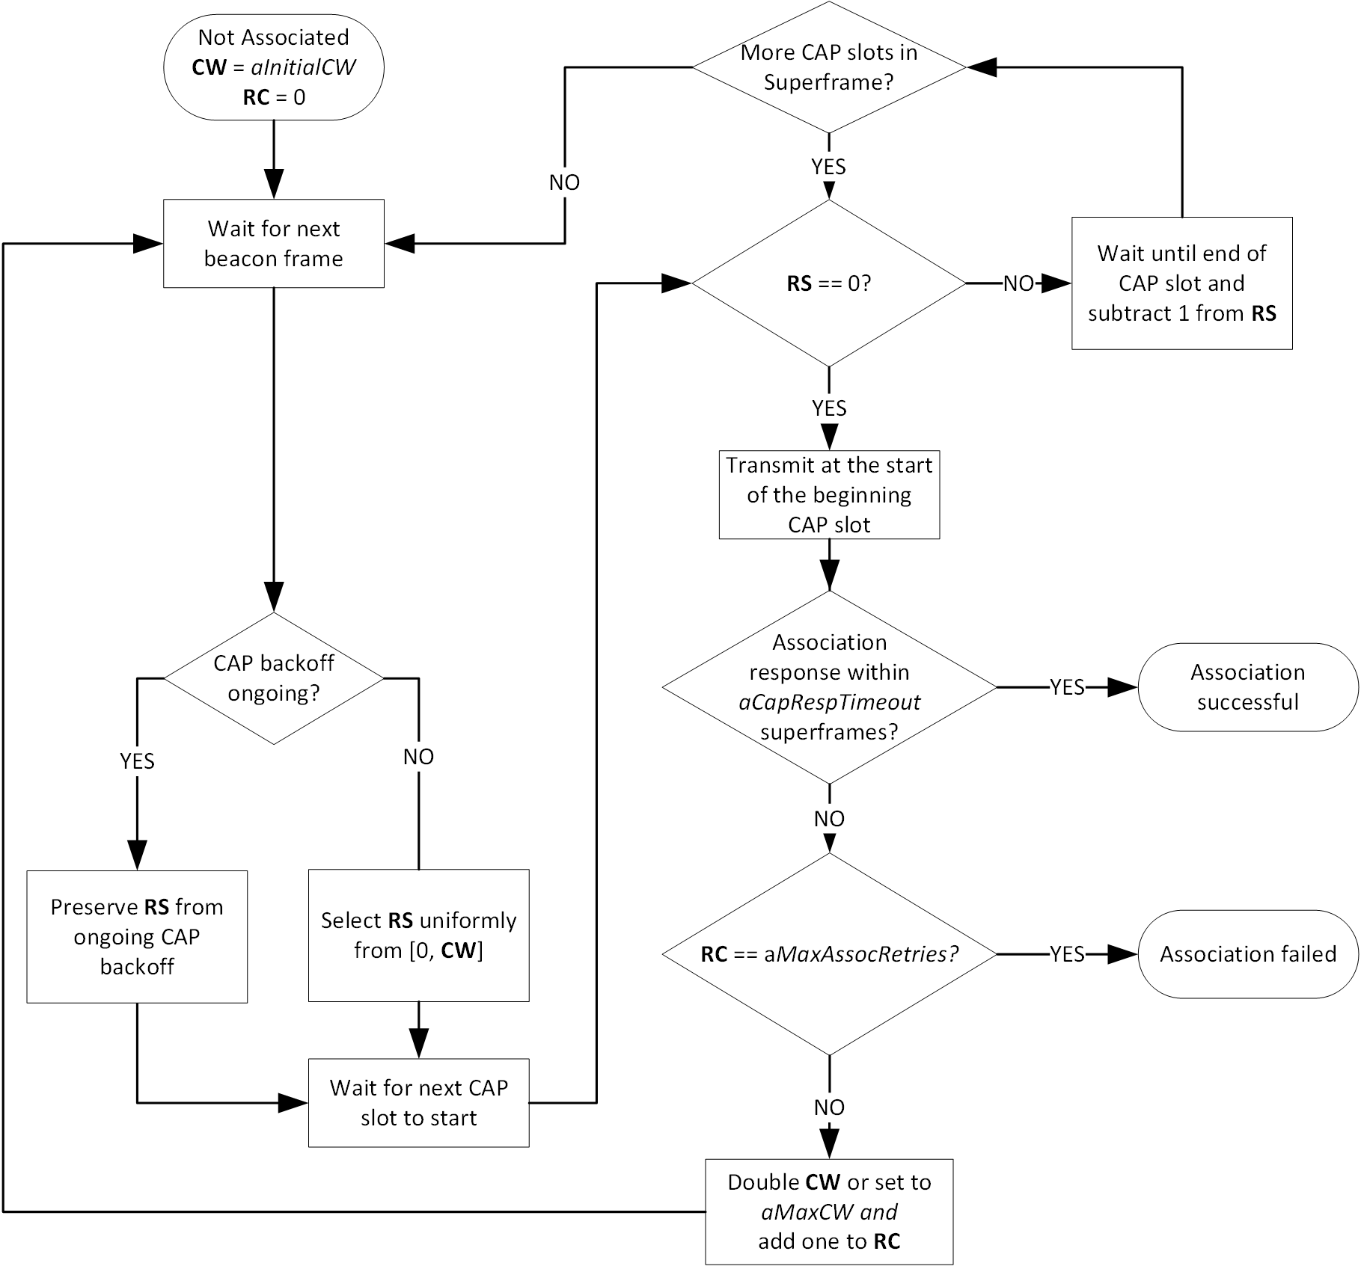
Figure 5-2: Flow chart of an association request in the CAP

Resource request procedure in the CAP

When a device does not have any or sufficient GTS time for its transmissions, it may perform the resource request procedure. For example, this may be the case after the device’s connectivity was interrupted and the coordinator stopped allocating GTSs.

In that case, the device may transmit a feedback control frame in the CAP to signal the requirement for (additional) GTS time to the coordinator.

The procedure for a GTS request in the CAP is similar to the association procedure. The corresponding flow chart is depicted in figure 5-figx.

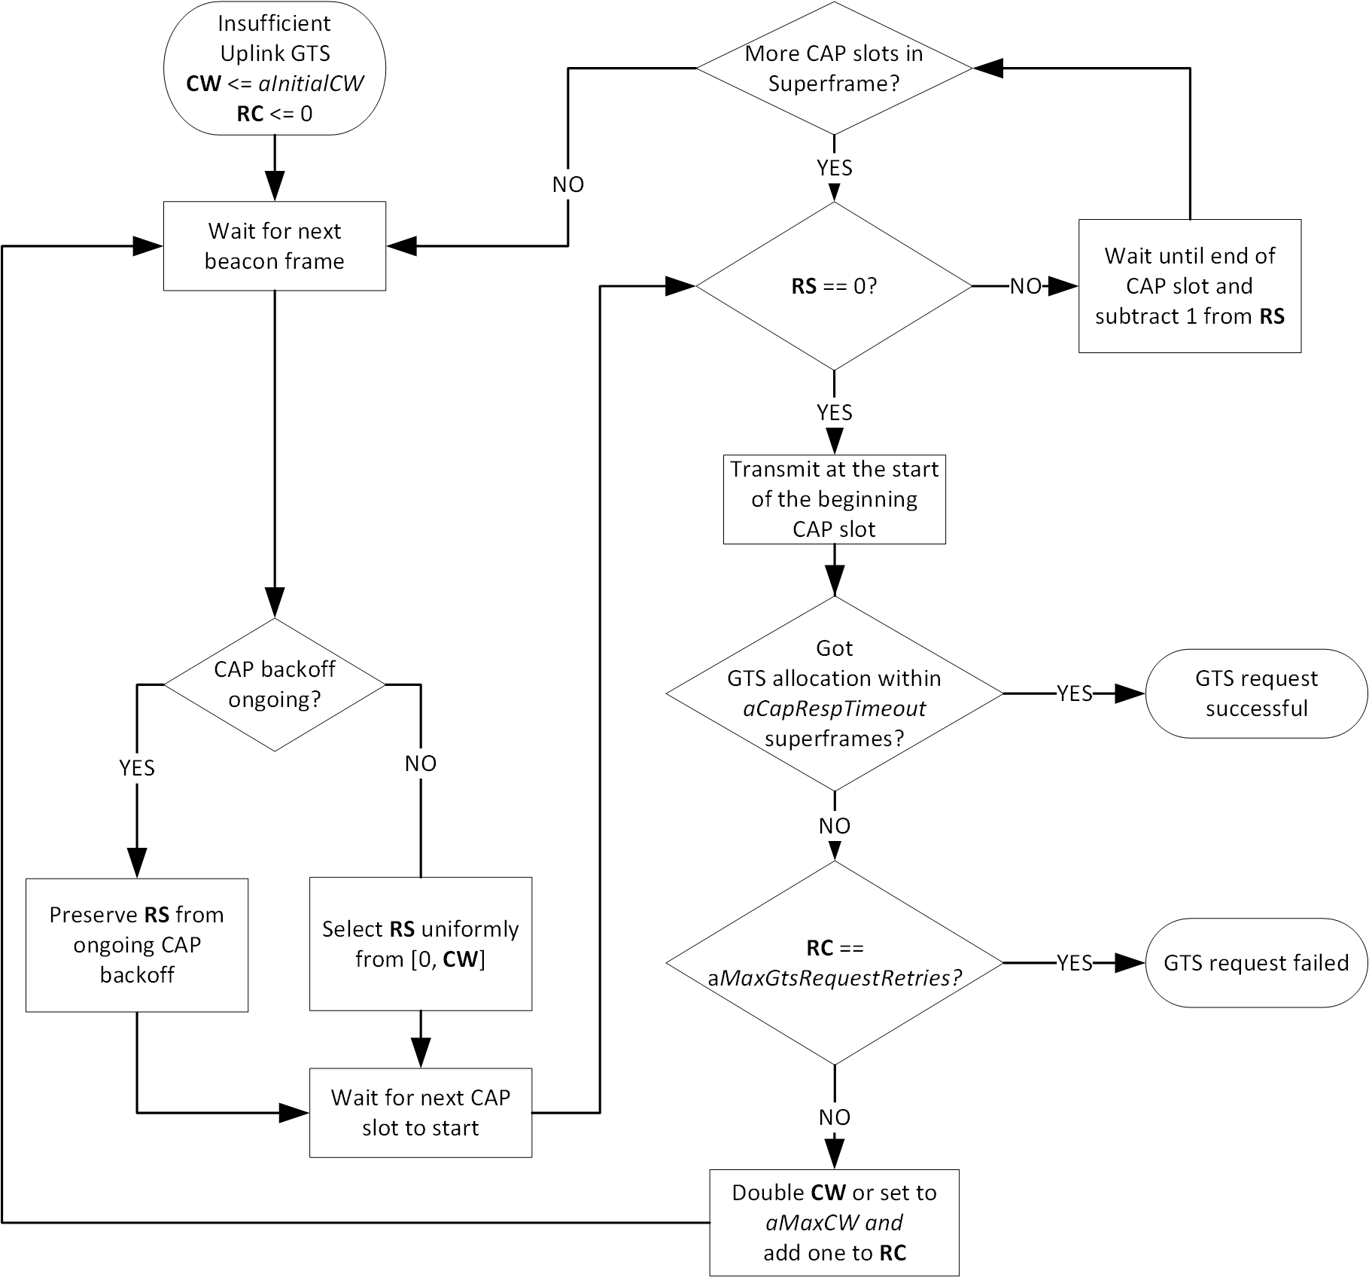
Figure 5-3: Flow chart of a GTS request in the CAP

Medium access in the CFP

Channel access in the CFP is based on a dynamic TDMA principle. Superframe slots can be reserved on a per-device basis in order to allow contention-free medium access. A group of adjacent superframe slots that is reserved for a specific device is called guaranteed time slot (GTS). The first superframe slot and a duration, given in an integer number of superframe slots, define the position of a GTS in the superframe as described in clause 6.x.x.x. GTS shall only reside within the CFP.

The coordinator controls all GTS allocations as described in 5.2.5. GTS assignments are communicated from the coordinator to the devices via control frames.

A device shall keep a list of all its upcoming GTS that it received. A device shall only transmit in GTS that were assigned to it. A device that is given a GTS can expect that it is able to perform collision-free transmisison while the GTS is lasting.

A device with a GTS may or may not make use of all the allocated time duration within the GTS. The selection of a MPDU for transmission is determined locally by the device depending on the number of pending frames in its queue and the value of their user priority fields and potentially other criteria.

A device shall ensure that its transmissions adhere to the rules for inter-frame spaces, as described in 5.2.7. That is especially, that all transmissions within a GTS end at least a SIFS before the end of the last superframe of the GTS.

The coordinator may perform transmissions to a device at any point in the CFP. Hence, all devices must listen for receptions during the whole CFP. Vice versa, the coordinator must be listening to the channel for receptions during each GTS.

GTS allocation

Only the OWPAN coordinator is entitled to allocate GTSs. Any allocated GTSs shall be located within the CFP.

Devices aid the coordinator in the GTS allocation process through providing information about their queue states and making flow reservations

If the coordinator supervises multiple spatially distributed optical frontends, it may allocate the same superframe slots in different GTS for multiple spatially distant devices in order to facilitate spatial reuse of resources throughout the OWPAN’s coverage area. However, the coordinator must ensure that transmissions from and to devices that share the same superframe slots do not interfere.

Devices aid the coordinator to avoid interference in the GTS allocation process through providing information about the signal strengths by which they receive the nearest optical frontends.

The coordinator may move dynamic GTSs within the superframe on a superframe-by-superframe basis. This allows the coordinator the flexibility to rearrange GTS assignments, optimize the utilization of resources and prevent collisions of GTSs if visibility and signal strength varies among optical frontends and devices due to mobility.

GTS allocations shall be advertised from the coordinator to the corresponding devices via control frames including the.

Synchronization

All devices, whether they are associated with a beacon-enabled OWPAN or attempting association, shall be synchronized to the coordinator’s clock before they start transmission or reception. The beacon sent at the beginning of every superframe contains the information necessary to time-synchronize the devices in the beacon-enabled OWPAN. Refer to clause 6.4.2.3 for the definition of the timing parameters sent in each beacon.

Each device in the OWPAN, including the coordinator, shall begin counting the first superframe slot at the beginning of the PHY preamble of the beacon, as shown in Figure 5-2. All superframe slots and hence timings within the superframe are thus relative to the start of the beacon preamble.

Figure 5-4: Timing relative to the beacon frame reception at every device

A compliant device implementation shall maintain the accuracy of the local time to be at least as accurate as aClockAccuracy.

Interframe spaces

The only IFS defined by this standard is the Short Interframe Space (SIFS). The SIFS is required to ensure sufficient turnaround time between transmissions. Hence, a transmitter has to ensure that its transmissions end at least a SIFS before the end of the GTS.

Guard time

In a TDMA system, guard times are required to keep transmissions in adjacent GTS from colliding when local clocks of devices are imperfectly synchronized, e.g. through drift caused by frequency inaccuracies of device-local clocks. A GTS is defined by the start time and the duration, as specified in the GTS element (see clause 6.4.2.5). Guard time is the time between the end of one GTS and the start of the next GTS.

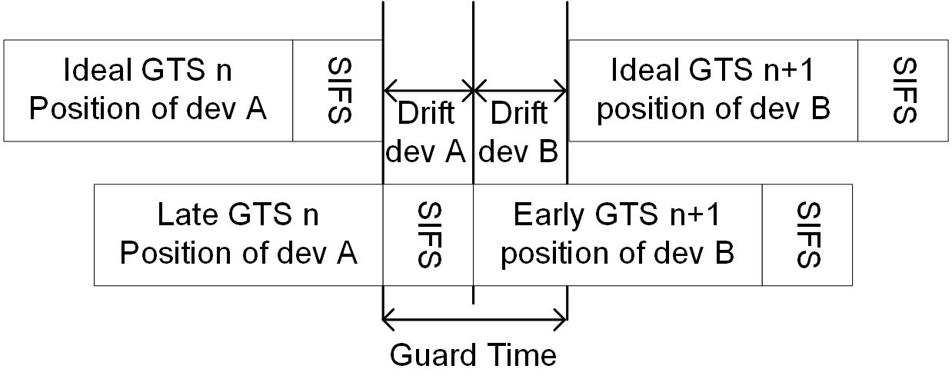
Figure 5-5: Application of the guard time and SIFS between GTS of adjacent GTSs

Figure 5-3 is an illustration of the allocation of the guard time such that consecutive transmissions are always separated by at least a SIFS if the owners of adjacent GTS have drift towards the other GTSs. The coordinator shall allocate sufficient guard time between GTSs to ensure that transmissions in adjacent GTSs do not overlap.

The required guard time depends on the maximum drift between a device’s local time and the ideal time. This drift is a function of the time elapsed since a synchronizing reference event and the precision of local oscillators in optical frontends and devices defining the local sampling clock. In an IEEE 802.15.13 OWPAN, the synchronizing event is the start of the preamble of a beacon. The maximum drift, MaxDrift, can be calculated as follows:

MaxDrift = Clock accuracy / superframe duration

Clock accuracy is out of scope for this specification but defined depending on the application.

The coordinator shall ensure that a guard time of at least 2 x MaxDrift lies between two subsequent GTS that are not orthogonal in space.

Non-beacon-enabled channel access

…

MAC frame formats

MAC services

Security

PHY layer specification

PHY service specifications

PM-PHY

LB-PHY

HB-PHY

