IEEE 802.15  
Wireless Specialty Networks

|  |  |  |  |  |
| --- | --- | --- | --- | --- |
| IEEE P802.15.13  Text proposal for beacon enabled medium access | | | | |
| Date: 2018-12-12 | | | | |
| Author: | | | | |
| Name | Affiliation | Address | Phone | Email |
| Kai Lennert Bober | Fraunhofer HHI |  |  | kai.lennert.bober@hhi.fraunhofer.de |
| Volker Jungnickel | Fraunhofer HHI |  |  | volker.jungnickel@hhi.fraunhofer.de |
| Xu Wang | VLNComm Inc |  |  | wang@vlncomm.com |

Abstract

# This document contains proposed text for the medium access in the beacon-enabled mode. The content is subject to further changes.

# Overview

# Normative References

# Definitions, acronyms, and abbreviations

# General description

# MAC functional description

## Introduction and overview

## Beacon-enabled channel access

If an OWPAN runs in beacon-enabled channel access mode, channel time is subdivided into subsequent superframes. Each superframe is composed of three major parts: the beacon period (BP), an optional contention access period (CAP), and the contention free period (CFP) as shown in Figure 5-1. In the BP, each coordinator transmits a beacon frame in its associated beacon slot (see 5.2.2). Transmission of the beacon may be performed simultaneously via multiple distributed optical frontends. In the CAP, devices may access the channel randomly by means of slotted ALOHA (see 5.2.3). Dedicated resources, called GTSs, are assigned to each device in the CFP. All regular transmissions take place in these GTS (see 5.2.4). The coordinator controls GTS allocations as described in 5.2.5.

Coordinators that run a beacon-enabled OWPAN shall set the beaconed bit of the frame control field

### Superframe structure

A superframe consists in total of *aNumSuperframeSlots* superframe slots. Each superframe slot has a duration of *aSuperframeSlotDuration*. Hence, the number of superframe slots and their respective duration determine the duration of each superframe. Of the *aNumSuperframeSlots* superframe slots in a superframe, three consecutive slot groups form the BP, the CAP and CFP respectively, as shown in Fig 5-1.

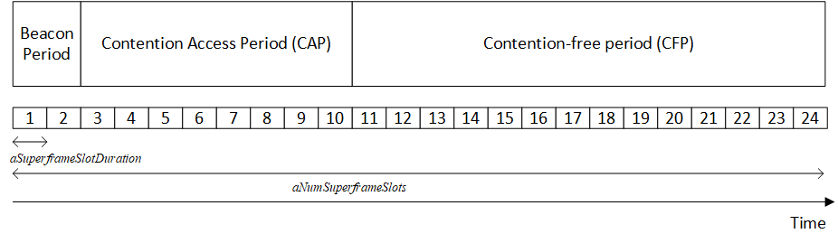*Fig 5-1: Superframe structure consisting of BP, CAP, CFP*

The MAC protocol makes use of integer numbers of superframe slots to specify durations within the superframe. This may be periods, resource reservations (GTS) and other portions of the superframe. The maximum number of superframe slots within a superframe is 65535 (see 7.1).

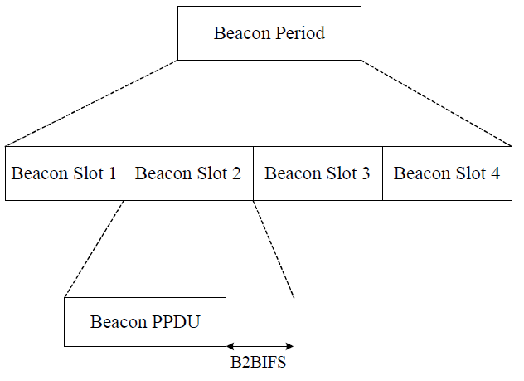

Figure 5-2: Exemplary BP structure

### Beacon Transmission

The BP allows the coordinated transmission of beacons from multiple neighboring coordinators. The BP shall start at slot 0 of a superframe and end before the beginning of the CAP on a superframe slot boundary. The BP is further divided into multiple beacon slots as shown in Figure 5-2. The duration of each beacon slot is equal to the sum of the duration of a beacon physical layer data unit (PPDU) and the subsequent beacon-to-beacon inter-frame spacing. By default the BP shall contain only one beacon slot. Only in the coordinated topology, the BP shall consist of one to a maximum of a*MaxBeaconSlots* beacon slots as shown in Figure 13.

In the beacon-enabled mode, each coordinator shall transmit a beacon in its assigned beacon slot. In the coordinated topology, each beacon shall advertise the first slot of the beacon transmission as well as the last slots of the BP. The implementation details of OWPAN coordination are out of scope of this standard.

### Medium access in the CAP

The CAP shall start immediately following the BP and complete before the beginning of the CFP on a superframe slot boundary. The length of the CAP is advertised in the beacon frame (see 6.4.2.3). In the coordinated topology, the CAP starts at the superframe slot advertised in the CAP start field within the beacon frame (see 6.4.2.3).

Both CAP and CFP periods may shrink or grow dynamically on a superframe-by-superframe basis in order to allow more random access transmissions in the CAP or more scheduled ones in the CFP.

This standard is designed for time-critical industrial applications. Accordingly, devices shall only perform random access if they do not have channel resources assigned in the CFP. This may be the case during association or after connectivity between the device and its coordinator was interrupted.

The slotted Aloha scheme is used for contention-based access in the CAP. Transmissions must start at the beginning of a CAP slot, i.e. a superframe slot within the CAP that is a multiple of *aCapSlotsLength,* counting from the first superframe slot within the CAP. *aCapSlotsLength* is advertised in the beacon frame (see clause 5.2.3.4)*.* A device willing to transmit shall choose a CAP slot uniform randomly from all available CAP slots within the CAP. Random number generators of all devices must be statistically uncorrelated.

If a device detects a collision, e.g. by the fact that the expected response is never received, the device shall wait for a certain number of CAP slots until it retries the slotted ALOHA transmission. The number of CAP slots to wait is drawn from a uniform distribution [1, CW], where CW is equal to *aInitialCapBackoff* after the first assumed collision and shall be doubled after each detected unsuccessful slotted Aloha transmission. However, CW must not exceed *aMaximumCapBackoff.* The number of CAP slots to wait may extend over the CAPs of multiple superframes.

### Medium access in the CFP

Channel access in the CFP is based on a dynamic TDMA principle. Superframe slots can be reserved on a per-device basis in order to allow contention-free medium access. A group of adjacent superframe slots that is reserved for a specific device is called guaranteed time slot (GTS). The first superframe slot and a duration, given in an integer number of superframe slots, define a GTS as described in clause 6.x.x.x. The coordinator controls all GTS allocations as described in 5.2.5. GTS assignments are communicated from the coordinator to the devices via control frames. These control frames are transmitted as part of the CFP.

A device shall keep a list of its assigned GTSs for the next superframes. A device shall only transmit in GTS that were assigned to it. All transmissions shall finish at least SIFS before the end of the GTS. A device that is given a GTS can expect that no other devices will compete for the channel during the indicated duration of the GTS. A device with a GTS may or may not make use of all the allocated time duration within the GTS. The selection of a MPDU for transmission is determined locally by the device depending on the number of pending frames in its queue and the value of their User Priority fields. Each device must ensure that it stops transmitting at least one SIFS before the nominal end of the GTS.

### GTS allocation

Only the OWPAN coordinator is entitled to allocate GTSs. Any allocated GTSs shall be located within the CFP.

Devices aid the coordinator in the GTS allocation process through providing information about their queue states and making flow reservations

If the coordinator supervises multiple spatially distributed optical frontends, it may allocate the same superframe slots to GTSs for multiple spatially distant devices in order to facilitate spatial reuse of resources throughout the OWPAN’s coverage area. However, the coordinator must ensure that transmissions from and to devices that share the same superframe slots do not interfere.

Devices aid the coordinator to avoid interference in the GTS allocation process through providing information about the signal strengths by which they receive the nearest optical frontends.

The coordinator may move dynamic GTSs within the superframe on a superframe-by-superframe basis. This allows the coordinator the flexibility to rearrange GTS assignments, optimize the utilization of resources and prevent collisions of GTSs if visibility and signal strength varies among optical frontends and devices due to mobility.

### Synchronization

All devices, whether they are associated with a beacon-enabled OWPAN or attempting association, shall be synchronized to the coordinator’s clock before they start transmission or reception. The beacon sent at the beginning of every superframe contains the information necessary to time-synchronize the devices in the beacon-enabled OWPAN. Refer to clause 6.4.2.3 for the definition of the timing parameters sent in each beacon.

Each device in the OWPAN, including the coordinator, shall begin counting the first superframe slot at the beginning of the PHY preamble of the beacon, as shown in Figure 5-2. All superframe slots and hence timings within the superframe are thus relative to the start of the beacon preamble.



*Fig 5-2: timing relative to the beacon frame reception at every DEV*

A compliant device implementation shall maintain the accuracy of the local time to be at least as accurate as *aClockAccuracy*.

### Guard time

In a TDMA system, guard times are required to keep transmissions in adjacent GTS from colliding when local clocks of devices are imperfectly synchronized, e.g. through drift caused by sampling frequency offsets. A GTS is defined by the start time and the duration, as specified in the GTS element (see clause 6.4.2.5). Guard time is the time between the end of one GTS and the start of the next GTS.

Figure 5-3 is an illustration of the allocation of the guard time such that consecutive transmissions are always separated by at least a SIFS if the owners of adjacent GTS have drift towards the other GTSs. The coordinator shall allocate sufficient guard time between GTSs to ensure that transmissions in adjacent GTSs do not overlap.

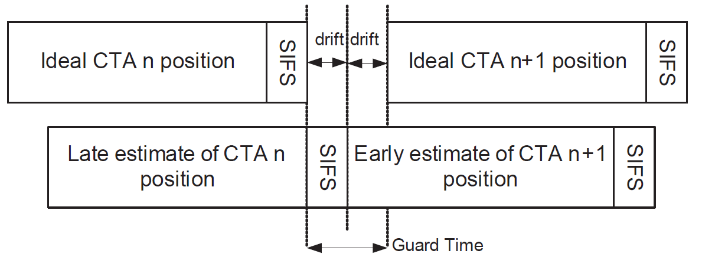

*Fig 5-3: Application of the guard time and SIFS between adjacent GTSs*

The required guard time depends on the maximum drift between a device’s local time and the ideal time. This drift is a function of the time elapsed since a synchronizing reference event and the precision of local oscillators in optical frontends and devices defining the local sampling clock. In an IEEE 802.15.13 OWPAN, the synchronizing event is the start of the preamble of a beacon. The maximum drift, MaxDrift, can be calculated as follows:

MaxDrift = Clock accuracy / superframe duration

Clock accuracy is out of scope for this specification but defined depending on the application.

### Interframe spaces

Interframe spaces (IFS) aid the temporal separation of frame transmissions. Multiple types of IFS are defined for different purposes:

1. SIFS
2. …

T.B.D.

A SIFS time is required to ensure sufficient turnaround time between transmissions. Including SIFS as part of GTS and allocating guard time between GTS ensures that transmissions are spaced by at least a SIFS.

## Non-beacon-enabled channel access

## …

# MAC frame formats

# MAC services

# Security

# PHY layer specification

# PHY service specifications

# PM-PHY

# LB-PHY

# HB-PHY