IEEE P802.15
Wireless Personal Area Networks

Project | Dependability Interest Group
Title | Meeting Minutes for November 2018
Date Submitted | November 15th, 2018
Source | [Ryuji Kohno]  [YNU(Yokohama National University)/CWC-Nippon] | Voice: +81 90 3061 7978  +358 40 354 0034  E-mail: kohno@ynu.ac.jp  ryuji.kohno@oulu.fi
Re: | Meeting Minutes
Abstract | Cooperation with ETSI smartBAN and smartM2M has been discussed as well as IEICE TC RCC and MICT. Focused use cases for automotive industry and additional medical BAN use cases have been discussed by updating technical requirement which is common and different among these use cases.
Purpose | Minutes of Dependability Interest Group sessions
Notice | This document has been prepared to assist the IEEE P802.15. It is offered as a basis for discussion and is not binding on the contributing individual(s) or organization(s). The material in this document is subject to change in form and content after further study. The contributor(s) reserve(s) the right to add, amend or withdraw material contained herein.
Release | The contributor acknowledges and accepts that this contribution becomes the property of IEEE and may be made publicly available by P802.15.

Monday, November 12th, 2018, PM2, 16:00-18:00
Room: Apartment 8

  - Meeting called to order 16:01
By Chair Ryuji Kohno (YNU / CWC-Nippon)

  - Roll Call
Notepad for Attendance circulated.

  - Opening Report
Chair presented Opening report Doc #18-0526-r1
Chair showed IEEE Patent policy.
Chair issued Call for Potentially Essential Patents
No essential intellectual property in the scope of IG DEP was declared.
Chair presented agenda this week

  - Approval of previous meeting minutes
Upon no comments on the previous meeting minutes, doc #18-0380-01 was approved.

  - Review of ID DEP activities
- Overview of IG DEP activities for Cars and other IoT & M2M Use cases and Amendment of IEEE802.15.6 Wireless Medical doc #15-18-0347-00
- Overview of ETSI Smart BAN Project Activities doc.#15-18-0535-01
  - Discussion
Corresponding to request from chair Dr. John Faserote, smartBAN TC of European standard body ETSI when Kohno joined in smartBAN TC meeting in Oulu, Finland while international conference BodyNets2018 wad held. Commonality and difference between smartBAN and IG-DEP have been discussed in order to make sure if IG-DEP can collaborate with ETSI smartBAN or not.
TC smartBAN covers:
- communication and the associated physical layer (PHY) and the Medium access control (MAC) layer
- network layer, security, Quality-of-Service (QoS) and provision of generic applications and services,
- a star network around a “smart” hub such as a handset or a watch, with the option for a multi-hop relay.
TC smartBAN is going to address to
- Targets a more efficient MAC and PHY, yielding very low latency emergency messaging, very low energy consumption and rapid initial set up time and channel reassignment.
- Provides additional semantic and data analytic enablers (e.g. semantic discovery, reasoning / rules) and automatic node discovery such as semantic discovery of nodes or composition.
- Provides added robustness via forward error correction
- Supports operation across heterogeneous networks with enhanced interoperability / connectivity options, including data, network and semantic interoperability.

Possible collaboration with ETSI TC smartBAN has been discussed to design appropriate MAC and PHY for the common targets, permissible packet and bit error rates, feedback controlling loop delay, and so on.

  - Recess at 17.55.
  - Attendees 6
Iwao Hosaka(NICT)
Tetsushi Ikegami(Meiji University)
Shinsuke Hara(OCU)
Thomas Kurner(TU Braunschweig)
Huanbang Li(NICT)
Ryuji Kohno(YNU/CWC-Nippon)

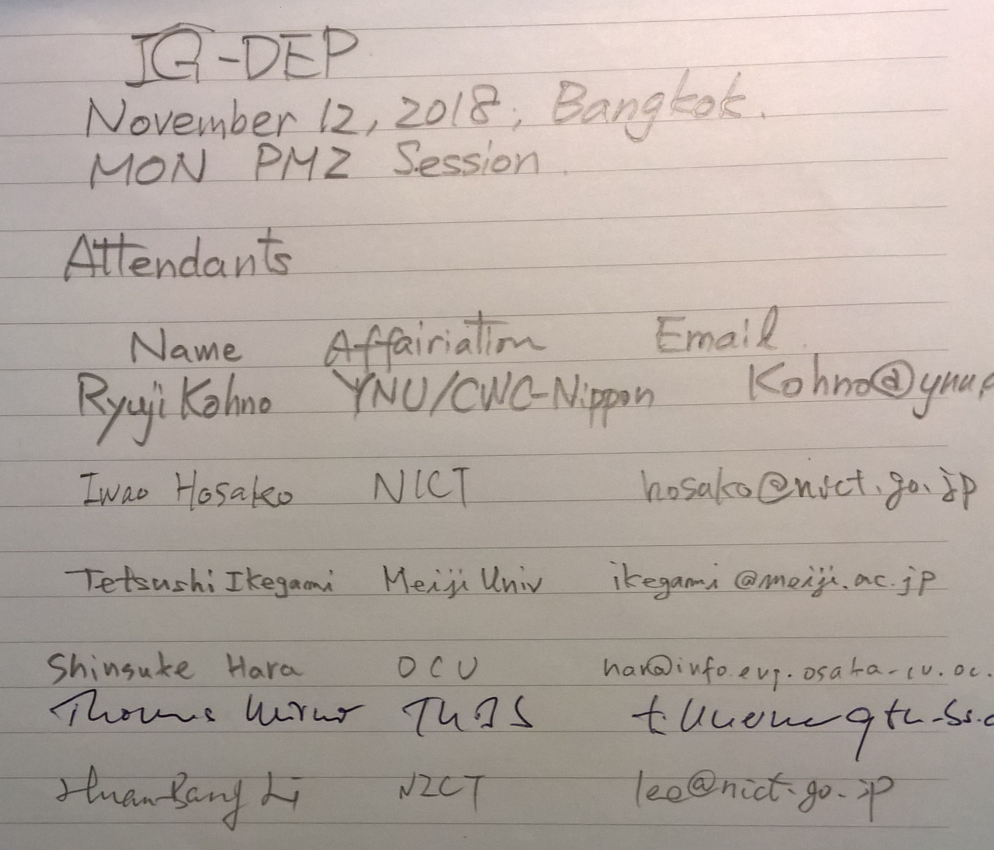

Tuesday 13 November, 2018, PM2, 16:00-17:48
Room; Apartment 8

  - Meeting called to order 16:01
By Chair Ryuji Kohno (YNU / CWC-Nippon)

  - Roll Call
Notepad for Attendance circulated.

  - Quick review of the last session

  - Presentation
To consider other possible collaboration different from ETSI TC smartBAN, Prof. Shinsuke Hara gave two presentation to introduce two IEICE activities of TC Reliable Communications and Control, i.e. RCC and TC Healthcare Medical ICT, ICT, i.e. MICT.
- Reviewing IEICE TC on Reliable Communication and Control (RCC)
- doc.#15-18-0304-02-0dep
- Reviewing IEICE TC on Healthcare and Medical Information Communication Technology (MICT) doc.#15-18-0305-02-0dep
In an introduced example of RCC published paper, multicasting vehicle controlling data to adjacent driving vehicles and multi-hop relay for dependable intervehicle communications physical and MAC layers technologies were discussed as a typical use case of IG DEP focused applications.

  - Discussion
Since Kohno gave a talk on “Update of Japanese UWB Radio Regulation,” doc.#18-15-0546-02-0dep in AM1 session of 802.15.4z EIR(extended impulse radio UWB), several members of 15.4z attended in IG-DEP session.
- A killer application of 15.4z such as keyless entry for a car may have common PHY with a main application of IG DEP such as internal car network or CAR BAN. If a common chip set is employed for the both applications, a size of market will be enlarged.
- One of core PHY technologies in IG-DEP is assumed UWB radio as well as 4z.
- Approach of 15.4z such as amendment of 15.4 MAC and two PHYs such as HDR and LDR(1Mbps) could be simpler than approach of IG-DEP to make a new standard.

  - Update of Technical Requirement
If IG-DEP includes more use cases medical BAN and UAV remote sensing and controlling as well as the already selected focused use cases of automotive, then technical requirement may be too wide to implement every requirement.
However, IG-DEP started listing up technical requirement for dependable BAN in the table to compare with the ready listed technical requirement for the focused use case such as internal car, Inter cars, and car and car electronics factory manufacturing line. If most of technical requirement for dependable BAN are similar to any of the focused three use cases, both the use cases will be able to be merged.

A draft of updating technical requirement was discussed.
- Focused and Additional Applications, and Updated Technical Requirements
doc.#15-18-0575-02-0dep

  - Recess at 17.50.
  - Attendees 11
Fredserf Borens(FB Consulting Save)
Iwao Hosaka(NICT)
Time Harrrington(UWB Alliance)
Tetsushi Ikegami(Meiji University)
Shinsuke Hara(OCU)
Thomas Kurner(TU Braunschweig)
Huanbang Li(NICT)
Franl Leong(NXP)
Hendrik Ahlecdorf(NXP)
Brima Ibrahim(NXP)
Ryuji Kohno(YNU/CWC-Nippon)
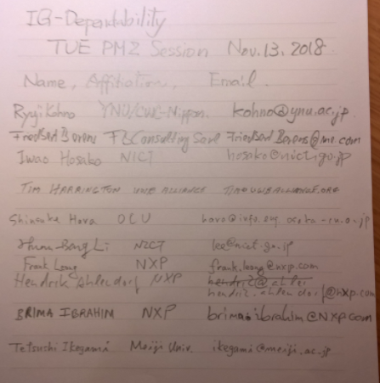

Wednesday 14 November, 2018, PM1, 13:30-15:30
Room; Apartment 8

  - Meeting called to order at 13:33

  - Roll Call

  - Presentation & Discussion
ETSI TC smartBAN and smartM2M joint meeting doc.#15-18-0586-00-0dep
  - ETSI 103 378 SmartBAN open data model & ontology specification and
  - ETSI TR 103 327 SmartBAN reference architecture
  - ETSI SmartM2M STF “SAREF extensions for Automotive, eHealth/Ageing-well and Water domains”
  - ETSI TS 102 690 M2M Device: A device that runs M2M Application(s) using M2M Service Capabilities. M2M Area Network and Gateway
have been reviewed.

  - Discussion
Since the last session remained technical requirement for dependable BAN in the table has been discussed and updated to compare with the ready listed technical requirement for the focused automotive use cases. It has been completed.
Focused and Additional Applications, and Updated Technical Requirements
doc.#15-18-0575-02-0dep
Due to absence of both chair and secretary in January meeting, IG-DEP will decide the next step to SG/TG in March meeting.

  - Adjourn 13:31

  - Attendees 6

Iwao Hosaka(NICT)
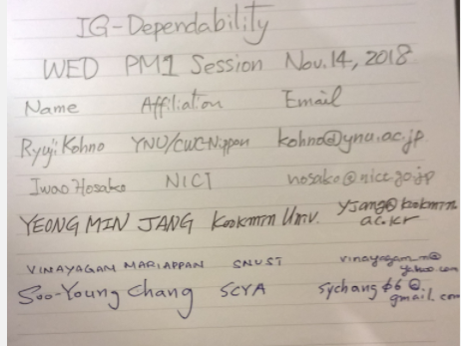
Demir Rakanovic (U-BLOX)
Yeong Min Jang (Kookmin Univ.)
Vinayagam Mariappan (SNUST)
Soo-Young Chang(SCYA)
Ryuji Kohno (YNU/CWC-Nippon)

