**IEEE P802.15**

**Wireless Personal Area Networks**

|  |  |  |
| --- | --- | --- |
| Project | IEEE P802.15 Working Group for Wireless Personal Area Networks (WPANs) | |
| Title | Text proposal for including channel #3 for enhancing LRP UWB | |
| Date Submitted | [November, 2018] | |
| Source | H.-B. Li, K. Takizawa and F. Kojima (NICT)  H. Nishikawa (GIT Japan Inc.) | E-Mail:[lee (at) nict.go.jp |
| Re: | [If this is a proposed revision, cite the original document.]  [This is a text proposal for including channel #3 into the draft of 15.4z for enhancing LRP UWB]  [Note: Contributions that are not responsive to this section of the template, and contributions which do not address the topic under which they are submitted, may be refused or consigned to the “General Contributions” area.] | |
| Abstract | [Contribute a proposal to the enhanced impulse radio group 15.4z] | |
| Purpose | [Proposed text for including channel #3 into the LRP UWB] | |
| Notice | This document has been prepared to assist the IEEE P802.15. It is offered as a basis for discussion and is not binding on the contributing individual(s) or organization(s). The material in this document is subject to change in form and content after further study. The contributor(s) reserve(s) the right to add, amend or withdraw material contained herein. | |
| Release | The contributor acknowledges and accepts that this contribution becomes the property of IEEE and may be made publicly available by P802.15. | |

**Proposed changes are given with tracks.**

10.1.1 Operating frequency range

A compliant device shall operate in one or several frequency bands summarized in this subclause.

For devices other than LECIM, TVWS, and RCC PHYs, the frequency bands are listed in Table10-1.

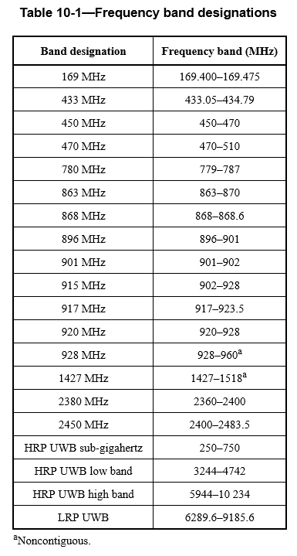10.1.2.7 Channel numbering for LRP UWB PHY

10184.0

The LRP UWB PHY uses channel page 8 with the channel numbers defined in Table10-9. A total of four frequency channels, numbered 0 to 3, are available in the 6289.6 MHz to 10184.0 MHz frequency bands. Different subsets of these frequency channels are available in different regions of the world. Channel 1 and Channel 2 can be shared in North America and Europe, while Channel 3 can be shared in North America, Japan and Korea.

Table 10-9—LRP UWB PHY channel frequencies

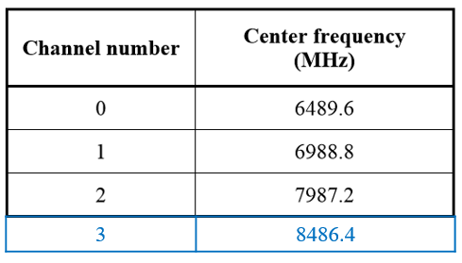

1. LRP UWB PHY specification

**19.7.3 Transmit PSD mask**

The transmitter shall operate with a power spectral density contained by one of three PSD masks defined in Table19-9 and shown in Figure19-7. The permitted spectral density is defined in dBr relative to the maximum spectral density of the signal, and shall be made using a 1MHz resolution bandwidth and a 1 MHz video bandwidth. Additionally, the upper -10 dBr point of the transmitter PSD shall be at least 200 MHz above a nominal frequency, fn, and the lower -10 dBr point shall be at most 200MHz below the same nominal frequency.

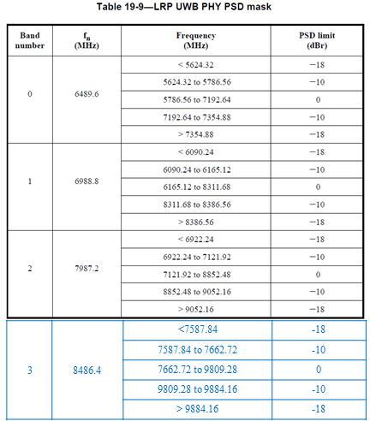

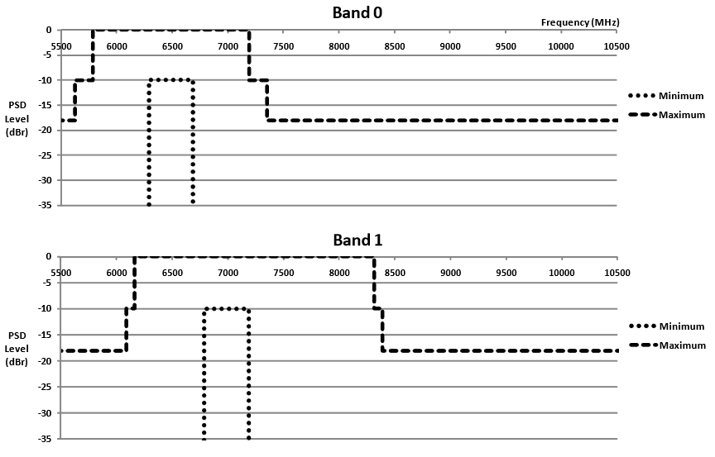

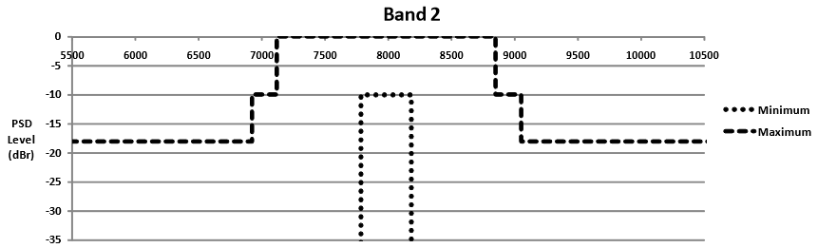



D.7.2.4 Channel capabilities for LRP UWB PHY

The LRP UWB channel requirements are described in TableD.5.

