IEEE P802.15
Wireless Personal Area Networks

Project | IEEE P802.15 Working Group for Wireless Personal Area Networks (WPANs)
Title | TG4md November 1, 2018 BRC Notes
Date Submitted | [November 1, 2018]
Source | [Gary Stuebing]  [Cisco Systems]  [North Myrtle Beach, SC] | Voice: 803 230-3027  Fax: [ ]  E-mail: [gstuebin@cisco.com]
Re:
Abstract | [IEEE 802.15 TG4md BRC Minutes.]
Purpose | [Report progress to WG.]
Notice | This document has been prepared to assist the IEEE P802.15. It is offered as a basis for discussion and is not binding on the contributing individual(s) or organization(s). The material in this document is subject to change in form and content after further study. The contributor(s) reserve(s) the right to add, amend or withdraw material contained herein.
Release | The contributor acknowledges and accepts that this contribution becomes the property of IEEE and may be made publicly available by P802.15.

IEEE 802.15.4md Ballot Resolution Committee Teleconference

Attendees:
Gary Stuebing - Chair
Kunal Shaw - Editor
Donald Sturek – Co-chair
Ruben Salazar
Hidetoshi Yokata
Tero Kivinen
Billy Verso
Clint Powell
Chris Hett
Shoichi Kitazawa

Attendance was taken and quorum was achieved.

Kunal invited Billy Verso on the call as we wished to get clarification on his submitted comments. We reviewed his comments:

CID #89 – Rejected – with approval by submitter
CID #97 – Rejected – with approval by submitter
CID #103 – Accepted – Updated language

Billy left the call. He offered to be part of the next BRC.

Clint asked for an update on where we were in the comments. He also asked about the comments submitted by Bob and Pat. Kunal indicated that they have been added.

The Chair reviewed schedule for Bangkok Meetings and discussed Agenda:
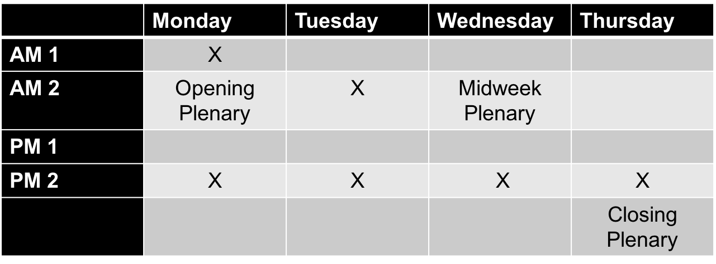

Proposed Agenda:
Monday AM 1
- Review Current Status of Comment Resolution
- Update Action Items
Monday PM 2
- Comment Resolution
Tuesday AM2
- Comment Resolution
Tuesday PM 2
- Comment Resolution
Wednesday PM 2
- Comment Resolution
Thursday PM 2
- Review Schedule
- Set BRC and Meetings
- ?

There was concern from Kunal about overlap with 4x. We will resolve that in Bangkok.

Group started review of comment resolutions submitted by Ruben Salazar:
CID #77 – Accept Update Figure 6-5
CID #78 – Defer – New Text to be submitted
CID #80 – Revised – New text

The group decided to cancel the BRC call for next week and we will get together in Bangkok for the Face to Face. First meeting November 12, 2018. I will cancel the meeting for the 8th.

