**IEEE P802.15**

**Wireless Personal Area Networks**

|  |  |  |
| --- | --- | --- |
| Project | IEEE P802.15 Working Group for Wireless Personal Area Networks (WPANs) | |
| Title | **Draft 0.1 of TG4w Coexistence Document** | |
| Date Submitted | 15 January, 2019 | |
| Source | Joerg Robert *) FAU Erlangen-Nuernberg Am Wolfsmantel 33, 91058 Erlangen  *\*) List of co-authors and contributors in the document* | Voice: +49 9131 8525373 Fax: +49 9131 8525102 E-mail: [joerg.robert@fau.de](mailto:joerg.robert@fau.de) |
| Abstract | Analysis on coexistence of 802.15.4w with other 802 systems within the same spectrum bands. | |
| Purpose | To address the coexistence capability of 802.15.4w. | |
| Notice | This document has been prepared to assist the IEEE P802.15. It is offered as a basis for discussion and is not binding on the contributing individual(s) or organization(s). The material in this document is subject to change in form and content after further study. The contributor(s) reserve(s) the right to add, amend or withdraw material contained herein. | |
| Release | The contributor acknowledges and accepts that this contribution becomes the property of IEEE and may be made publicly available by P802.15. | |

Main contributors of the CA document are sorted by alphabetical order of last name:

* Nabil Loghin (Sony)
* Raimund Meyer (ComResearch/Fraunhofer IIS)
* Sally Nafie (FAU Erlangen-Nuernberg)
* Frank Obernosterer (ComResearch/Fraunhofer IIS)
* Sebastian Rauh (FAU Erlangen-Nuernberg)
* Joerg Robert (TG4w chair, FAU Erlangen-Nuernberg)
* Johannes Wechsler (Fraunhofer IIS)

1. Introduction 4

1.1 Bibliography 4

2. Overview 5

2.1 Overview of IEEE 802.15.4w 5

2.2 Regulatory Information 6

2.3 Changes to the 802.15.4k LECIM FSK PHY 6

2.4 Overview of Coexistence Mechanisms in 802.15.4w 7

3. Dissimilar IEEE 802 Systems Sharing the Same Frequency Bands with 802.15.4w 8

3.1 Coexisting Systems in 169.4 – 169.475 MHz Band 8

3.2 Coexisting Systems in 433.05 – 434.79 MHz Band 8

3.3 Coexisting Systems in 470 – 510 MHz Band 8

3.4 Coexisting Systems in 779 – 787 MHz Band 9

3.5 Coexisting Systems in 863 – 870 MHz Band 9

3.6 Coexisting Systems in 902 – 928 MHz Bands 10

4. Coexistence Scenarios and Analysis 11

4.1 PHY Modes in the 802.15.4w System 11

4.1.1 Parameters of the 802.15.4w PHY Modes 11

4.2 Performance of the 802.15.4w PHY Modes 11

4.2.1 AWGN Channel 12

4.2.2 Erasure Channel 13

4.2.3 LPWAN Interference Channel 14

4.3 Interference Modeling for Dissimilar Systems Analyses 16

4.4 802.15.4 Coexistence Performance 16

4.5 802.11ah Coexistence Performance 17

4.5.1 Victim 802.11ah 17

4.5.2 Victim 802.15.4w 20

5. Interference Mitigation and Avoidance Techniques 22

5.1 Split mode with Forward Error Correction 22

5.2 Clear Channel Assessment (CCA) 22

6. Conclusions 24

# Introduction

## Bibliography

|  |  |
| --- | --- |
| [1] | "802.15.4w PAR," DCN 15-18/50r6, 2018. |
| [2] | Q. Li and S. Jillings, "TG4k Coexistence Document," DCN 15-12/314r1, 2012. |
| [3] | J. Robert, S. Rauh, H. Lieske and A. Heuberger, "IEEE 802.15 Low Power Wide Area Network (LPWAN) PHY Interference Model," in *2018 IEEE International Conference on Communications*, Kansas City, 2018. |
| [4] | C.-S. Sum, "TG4g Coexistence Assurance Document," DCN 15-10/668r5, 2011. |
| [5] | P. J. Nair, C. Thejaswi , K. Bynam and H. de Ruijter, "TG4q Coexistence Assurance Document," DCN 15-14/709r0, 2014. |
| [6] | R. Porat, S. Yong and K. Doppler, "TGah Channel Model – Proposed Text," DCN 11-11/968r4, 2015. |

# Overview

This clause gives on overview on IEEE 802.15.4w. Additionally, it lists the used frequency bands and highlights the changes compared to the existing IEEE Std 802.15.4 LECIM FSK system. Finally, it introduces the coexistence mechanisms for improved performance and coexistence in license-exempt frequency bands.

## Overview of IEEE 802.15.4w

The IEEE 802.15 Task Group 4w defines a PHY amendment and related MAC extensions based on the 802.15.4k LECIM FSK PHY. According to the 802.15.4w PAR [1], the objective of the amendment is to provide a global open standard for Low Power Wide Area Networks (LPWAN) in highly interfered license exempt frequency bands. Such LPWAN offer long-range transmissions over several kilometers using transmit powers of e.g. 14 dBm or less. This goal is achieved by three main modifications of the existing 802.15.4k FSK PHY: Lower bit-rates, the introduction of the split mode, and the definition of stronger forward error correction (FEC) codes in case of the split mode.

According to information theory, the long-range capability with low transmit powers can only be achieved using very low payload bit-rates. Therefore, IEEE 802.15.4w introduces lower bit-rates to improve the long-range capability. However, low bit-rates also cause long on-air times, which can easily exceed the maximum dwell time of 400ms to comply with FCC regulations. For this purpose the split transmission is introduced. Split transmission uses frequency hopping with defined inactive periods between the hops. For this the payload data is split into at least 12 radio-bursts (fragments), which are then transmitted on different frequencies at different points of time. However, unlike existing 802.15.4 fragmentation solutions, the re-assembly is not achieved by means of MAC signaling information, but using a well-known time and frequency patterns for the radio-bursts. First, this approach significantly reduces the signaling overhead. And second, because the FEC is done before the fragmentation, a significant increase of robustness is achieved. In most cases interfering signals will only impair a limited number of the radio-bursts, which can then be recovered by means of the FEC. In order to improve the FEC performance compared to the existing LECIM FSK PHY, additional powerful FEC codes are added. In particular these are a convolutional code with rate 1/3, and a highly sophisticated rate 1/4 Low Density Parity Check (LDPC) code. Using these FEC schemes more than 50% of the radio-bursts can be lost without any significant impact on the required reception level.

Caused by the very low required reception levels classical co-existence techniques – such as listen before talk (LBT) – do not work properly, as the co-existing system may not be able to detect the very low 802.15.4w signal levels. Thus, the split transmission provides the required co-existence and interference robustness as requested in the PAR, and additionally, it provides additional diversity in time and frequency selective channels.

The defined amendment is intended to cover larges cells with low payload bit-rates, which gives the impression that the overall achievable system capacity is very limited. However, using split transmission with different time and frequency patterns, many 4w systems can be operated in parallel using identical frequency resources. This leads to a very high system capacity in a given area by using many simultaneous transmissions, even if the bit-rate of a single link seems highly limited.

## Regulatory Information

The allocated frequency bands for 802.15.4w are given below:

1. 169.4 – 169.475 MHz (Europe)
2. 262 – 264 MHz (Korea)
3. 433.05 – 434.79 MHz (North America, Europe)
4. 470 – 510 MHz (China)
5. 779 – 787 MHz (China)
6. 863 – 876 MHz (Europe)
7. 902 – 928 MHz (Americas)
8. 915 – 928 MHz (Australia)
9. 917 – 923 MHz (Korea)
10. 920.5 – 923.5 MHz (Japan)
11. 921 – 928 MHz (New Zealand)

All frequency bands – with the exception of (b) – were already defined according to IEEE Std 802.15.4 LECIM FSK. Only frequency band (b) is added to cover the market demand in Korea.

## Changes to the 802.15.4k LECIM FSK PHY

The amendment defined by the 802.15.4 Task Group 4w enhances the performance of the existing 802.15.4k LECIM FSK PHY for highly interfered license-exempt frequency bands by defining lower bit-rates, the split mode and improved FEC capabilities.

For this purpose 802.15.4w uses existing LECIM FSK modulation schemes. It adds additional lower rates to cover the demands of LPWAN, and reduces the FSK deviation tolerance (only split mode). Hence, no new PHY modulation scheme is introduced and 802.15.4w can be transmitted using most existing 802.15.4 chips that support FSK modulation.

An additional change to the 802.15.4k LECIM FSK PHY is the introduction of the split mode. The split mode is required to meeting the FCC requirement of a maximum dwell time of 400ms for low bit-rates, and to improve the performance in highly interfered channels. Fragmentation was already defined for the 802.15.4k LECIM DSSS PHY, but was missing in case of the amended FSK PHY. However, for improved robustness 4w splits (or fragments) the transmit data after the FEC encoding, which is required to achieve the required interference robustness as requested in the PAR. Furthermore, the re-assembly of the radio-bursts (fragments) in case of the split mode is done using well-known time and frequency patterns, which reduces the overhead compared to existing fragmentation schemes in case of short fragments. As the FEC encoding uses convolutional codes already defined in 802.15.4, or Low Density Parity Check (LDPC) codes that can be implemented in software, existing 802.15.4 chips can be utilized to generate 802.15.4w compliant signals.

For the split mode special symbol-rates and channel spacings are defined. A symbol rate matching the channel spacing allows for very efficient detection and decoding algorithms based on the Fast Fourier Transform (FFT). The defined therefore value bases on multiples of approx. 2.38 kHz. This value has been chosen as it can be easily generated in most existing 802.15.4 chips using standard frequency synthesizers and standard crystal oscillator frequencies.

## Overview of Coexistence Mechanisms in 802.15.4w

The developed amendment follows the coexistence mechanisms defined for 802.15.4. In addition, it furthermore adds or improves existing mechanisms. These mechanisms are e.g.:

* Split Mode: In the split mode the data is transmitted in at least 12 radio-bursts on at least 12 different frequencies. Hence, the available frequency spectrum is uniformly deployed, leading to less channel use for co-existing systems. Additionally, many different 802.15.4w systems can operate on the same frequency band without impairing each other band by using different time and frequency hopping patterns.
* Forward Error Correction (FEC): The powerful FEC codes defined within 802.15.4w can recover a significant number of interfered symbols. Especially in the split mode the robust FEC is able to recover more than 50% of lost radio bursts without significant performance degradation.
* Clear Channel Assessment (CCA): 802.15.4w uses CCA to reduce its impairment onto co-existing systems. In splitting mode, CCA is used per radio-burst. Consequently, the transmissions of detected co-existing systems are not impaired. Occupied channels are left out and the resulting missing radio-bursts are recovered using the FEC without any impact on the transmission latency.
* Narrow-band transmission: 802.15.4w uses variants of frequency shift keying (FSK) with very low symbol rates that result in a very low overall system bandwidth. Consequently, this low system bandwidth significantly reduces the impairment of broadband signals with low power spectral density, e.g. 802.11ah. On the other hand, 802.15.4w will only affect few sub-carriers of broadband OFDM (Orthogonal Frequency Division Multiplex) signals, which may be recovered using FEC.

# Dissimilar IEEE 802 Systems Sharing the Same Frequency Bands with 802.15.4w

This clause presents an overview on other 802 systems which are specified to operate in the same frequency bands that are also specified for the 802.15.4w. These frequencies basically include all specified frequencies for 802.15.4w according to section 2.2 with the exception of the Korean frequency band 262 – 264 MHz. Please note that all 900 MHz bands are merged into a single table.

The tables in the following sections list the latest standard (or amendment) and the corresponding PHY specifications that share the same frequency bands as 802.15.4w.

## Coexisting Systems in 169.4 – 169.475 MHz Band

Table 1: Dissimilar systems co-existing with the 802.15.4w PHY within the 169.4-169.475 MHz band (a)

|  |  |
| --- | --- |
| **System** | **PHY Specification** |
| 802.15.4-2015 | SUN FSK |
| LECIM FSK |
| 802.15.4q | ULP-GFSK |

## Coexisting Systems in 433.05 – 434.79 MHz Band

Table 2: Dissimilar systems co-existing with the 802.15.4w PHY within the 433.05-434.79 MHz band (c)

|  |  |
| --- | --- |
| **System** | **PHY Specification** |
| 802.15.4-2015 | MSK |
| LECIM FSK |
| 802.15.4q | ULP-GFSK |
| ULP-TASK |

## Coexisting Systems in 470 – 510 MHz Band

Table 3: Dissimilar systems co-existing with the 802.15.4w PHY within the 470-510 MHz band (d)

|  |  |
| --- | --- |
| **System** | **PHY Specification** |
| 802.15.4-2015 | SUN FSK |
| SUN OFDM |
| SUN O-QPSK |
| LECIM DSSS |
| LECIM FSK |
| 802.15.4q | ULP-GFSK |
| ULP-TASK |

## Coexisting Systems in 779 – 787 MHz Band

Table 4: Dissimilar systems co-existing with the 802.15.4w PHY within the 779-787 MHz band (e)

|  |  |
| --- | --- |
| **System** | **PHY Specification** |
| 802.15.4-2015 | O-QPSK |
| SUN FSK |
| SUN OFDM |
| SUN O-QPSK |
| LECIM DSSS |
| LECIM FSK |
| 802.15.4q | ULP-GFSK |
| ULP-TASK |
| 802.11ah | S1G OFDM |

## Coexisting Systems in 863 – 870 MHz Band

Table 5: Dissimilar systems co-existing with the 802.15.4w PHY within the 863-870 MHz band (f)

|  |  |
| --- | --- |
| **System** | **PHY Specification** |
| 802.15.4-2015 | O-QPSK |
| BPSK |
| ASK |
| SUN FSK |
| SUN OFDM |
| SUN O-QPSK |
| LECIM DSSS |
| LECIM FSK |
| 802.15.4q | ULP-GFSK |
| ULP-TASK |
| 802.11ah | S1G OFDM |

## Coexisting Systems in 902 – 928 MHz Bands

Table 6: Dissimilar systems co-existing with the 802.15.4w PHY within the 902-928 MHz bands (g), (h), (i), (j), (k)

|  |  |
| --- | --- |
| **System** | **PHY Specification** |
| 802.15.4-2015 | O-QPSK |
| BPSK |
| ASK |
| SUN FSK |
| SUN OFDM |
| SUN O-QPSK |
| LECIM DSSS |
| LECIM FSK |
| 802.15.4q | ULP-GFSK |
| ULP-TASK |
| 802.11ah | S1G OFDM |

# Coexistence Scenarios and Analysis

This clause presents the coexistence performance of 802.15.4w. First, it defines typical PHY parameters sets and analyses their performance in different channel types. Next, the co-existence with dissimilar systems is analyzed using interference models that have already been used for previous coexistence analyses.

## PHY Modes in the 802.15.4w System

### Parameters of the 802.15.4w PHY Modes

Table 7 lists typical parameter sets for 802.15.4w. As 802.15.4w requires a robust transmission all parameter sets use Forward Error Correction (FEC) coding.

Table 7: Typical 802.15.4w parameter sets

|  |  |  |  |  |  |
| --- | --- | --- | --- | --- | --- |
| **System** | **PHY** | **PHY Mode** | **Eff. Bit-rate** | **Transmit Power (dBm)** | **Average Frame Length (Octet)** |
| 802.15.4w | FSK (h=1) | 6.25kS/s (SF=1), CR 1/2 | 3.1kb/s | 14 | 37 |
| FSK (split mode) | 19.04kS/s (SF=1), CR 1/2  9.52kS/s (SF=1), CR 1/3  2.38kS/s (SF=1), CR 1/3  2.38kS/s (SF=2), CR 1/4 | 9.5kb/s  3.2kb/s  0.8kb/s  0.3kb/s | 14 | 37 |

For the non-split mode 802.15.4w only introduces new lower bit-rates compared to the IEEE Std 802.15.4-2015 LECIM FSK PHY. Reducing the bit-rate will only scale the performance compared to the existing standard. Therefore, no additional analyses are performed for the non-split mode within this document, as the results will be practically identical to the results presented in the 802.15.4k coexistence document [2].

The split mode adds additional functionalities to the LECIM FSK PHY. Consequently, the following analyses will focus on these additional features.

All additional modes added in 802.15.4w are focusing on increased robustness. Hence, they offer a payload bit-rate of less than 30kBit/s as requested in the PAR [1].

## Performance of the 802.15.4w PHY Modes

The following paragraphs show the performance in different channel types. First, the performance in the Additive White Gaussian Noise (AWGN) channel is analyzed. Next, the performance in case of lost radio-bursts in the erasure channel is shown. Finally, the performance in the LPWAN interference channel [3] – a channel model for the simulation of interfered long-range scenarios – is presented.

### AWGN Channel

Figure 1 shows simulation results for the frame error rate in the AWGN channel as a function of the signal-to-noise ratio (SNR). The simulations for the different code-rates offered by 802.15.4w assume a perfect receiver. Like in the other coexistence documents the comparison criteria is a frame error rate of 1%. The convolutional code rate 1/2 requires approx. 0dB to achieve this goal, the convolutional code rate 1/3 requires approx. -2dB, and the LDPC code rate 1/4 requires approx. -4dB.

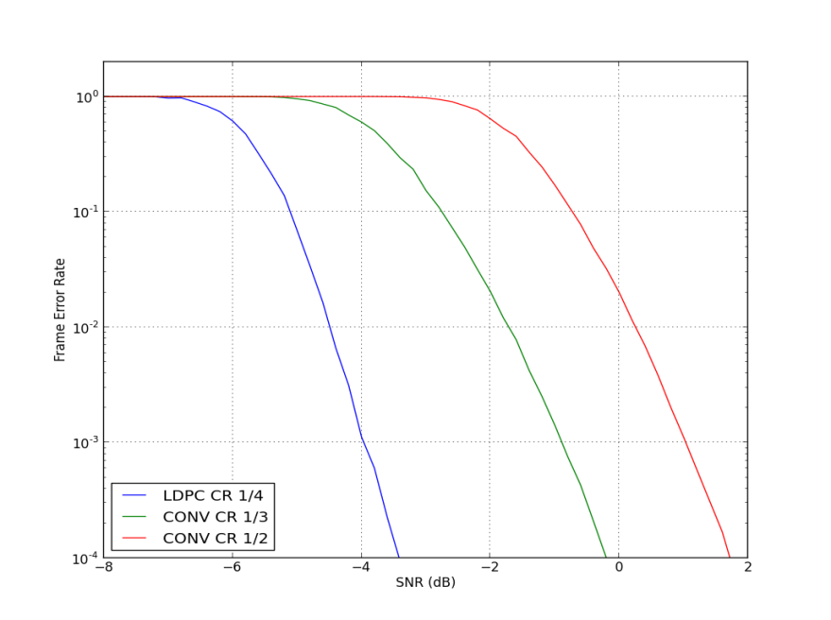

Figure 1: Frame Error Rate vs. SNR for different forward error correction modes in the AWGN channel (SF=1, frame length 37 octets)

Assuming a correlation receiver, the SNR values can be expressed as sensitivity levels. For this we a assume noise power spectral density of -174dBm/Hz and no additional noise figure. For the defined typical parameter sets this leads to the sensitivity and effective bit-rates as shown in Table 8.

According to the PAR [1] 802.15.4w should be able to support sensitivity levels of less than $-140dBm$. This aim is still achieved if we also consider a high noise figure and implementation loss in the receiver.

Table 8: Typical 802.15.4w parameters and the resulting theoretical sensitivity in the AWGN channel

|  |  |  |  |  |  |  |
| --- | --- | --- | --- | --- | --- | --- |
| **System** | **PHY** | **PHY Mode** | **Coding** | **SNR for FER < 1%** | **Sensitivity** | **Eff. Bit-rate*)** |
| 802.15.4.w | MSK, SF1 | 19.04kS/s | Conv. 1/2 | 0.3 dB | -131 dBm | 9.5kb/s |
| 9.52kS/s | Conv. 1/3 | -1.7 dB | -136 dBm | 3.2kb/s |
| 2.38kS/s | Conv. 1/3 | -1.7 dB | -142 dBm | 0.8kb/s |
| MSK, SF2 | 2.38kS/s | LDPC 1/4 | -7.5dB | -148 dBm | 0.3kb/s |

**\*) Note: The effective payload bitrate is only valid for one client. The channel may be used by multiple devices simultaneously, resulting in a significantly higher rate per network cell.**

### Erasure Channel

In case of the split mode transmission, the data is divided into 12 (FEC code-rate 1/2), 18(FEC code-rate 1/3), or 23 (FEC code-rate 1/4) radio-bursts. In case of interference some of these radio-bursts may be completely lost. This may also be the case if the CCA in the transmitter detects an occupied channel, which requires it to not transmit the corresponding radio-burst.

In order to improve the performance in highly occupied license-exempt frequency bands, the recovery of lost radio-bursts was a main design goal of 802.15.4w. Figure 2 shows simulation results for different ratios of erased radio-bursts in the AWGN channel. For the simulations the LDPC code with rate 1/4 has been used, which results in a total number of 23 radio-bursts.

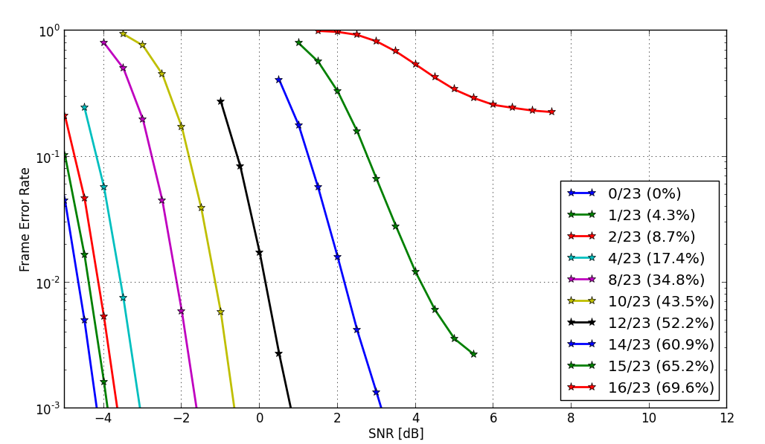

Figure 2: Resulting frame error rate (packet error rate) as function of the SNR for different ratios of lost radios-bursts for the LDPC code with rate 1/4. In case of the LDPC code the data is split into 23 radio-bursts. The figure shows results for different numbers of lost radio bursts ranging from 0 (all radio-bursts received) to 16 (69.6% of the radio-bursts are completely lost).

In case of no erased radio-burst the system reaches its highest sensitivity. It only requires a SNR of approx. $-4.5dB$ to achieve a Frame Error Rate of less than 1%. A small number of erased radio-bursts only slightly increase the required SNR level for the remaining radio-bursts. For 12 erased radio-bursts approx. 52.2% of the data is lost, which corresponds to an energy loss of $3dB$. Due to the imperfectness of the code and the modulation the error-free decoding requires slightly more SNR than the lost 3dB. However, error-free decoding is still possible with approx. 0dB. The absolute theoretical limit for the used code is an erasure rate of 75% of the erased hops, as 75% of the LDPC code-word is redundancy. The results show that this value is almost reached, highlighting the high performance of the code. In summary it gets obvious that 802.15.4w is able to compensate a very high fraction of lost radio-bursts with low additional SNR, which is required to achieve a high robustness in highly occupied license-exempt frequency bands.

### LPWAN Interference Channel

The 802.15.4w PAR [1] especially requests an improved robustness against interference in license-exempt frequency bands. For achieving this goal 802.15.4w introduces the split mode. In order to compare the performance the TG 802.15.4w developed a special interference model [3]. Figure 3 shows an exemplary channel realization of the developed interference model. The shown configuration assumes an antenna height of 140m above ground, resulting in a very high interference level. Furthermore, it assumes 50 active interfering devices per second per square kilometer per MHz. This results in approx. 10,000 active interferers that are present in Figure 3 that shows a period of 2s with a bandwidth of 2 MHz.

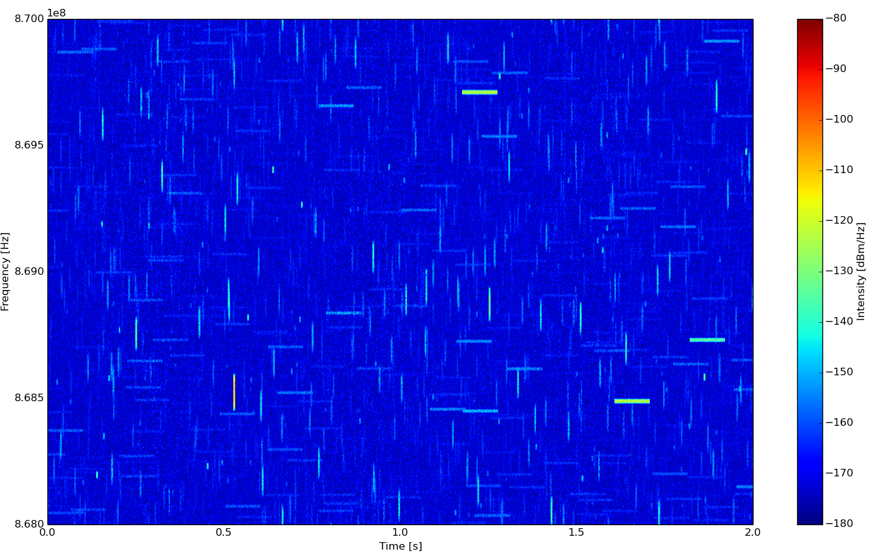

Figure 3: Modelled interference using the 802.15.4w interference model [3]. The shown exemplary configuration assumed an antenna height of 140m and 50 active interferers per second per square kilometer per MHz. Approximately 10,000 active interferers are present in the shown frequency range over a period of 2s.

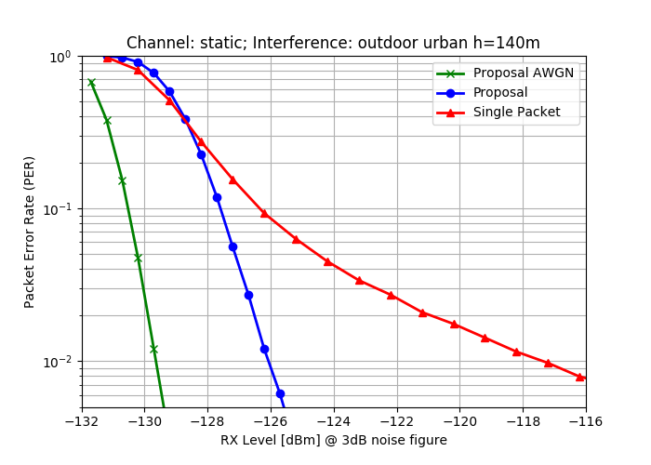

Figure 4: Packet error rate in interference channel with 19.04kS/s and convolutional code with rate 1/3 assuming the interference parameter configuration as shown in Figure 2. Furthermore, a receiver noise figure of 3dB is assumed.

Figure 4 shows the improved performance of the split mode (blue) against the classical transmission (red). The split mode only shows a degradation of few dB compared to the non-interfered AWGN curve (green). However, the non-split mode results in a flat error curve, showing a degraded performance. The reason for this behavior is clear. In case of the split-mode the data are interleaved in multiple radio-bursts over large parts of the spectrum. Consequently, only a subset of the radio-bursts gets affected by interference, which can then be recovered by means of the FEC. Though, in case of the non-split mode a significant part of a complete packet is affected by one interferer, which may not be recovered by the FEC with a high probability.

## Interference Modeling for Dissimilar Systems Analyses

802.15.4g’s interference model, described in section 4.2 of the TG4g Coexistence Assurance Document [4], is adopted for the 802.15.4w coexistence simulation modeling. This is also identical to the interference model assumed in the TG4k and TG4q Coexistence Assurance Documents [2] [5].

* In the coexistence model, the transmitting power and the distance between the victim transmitter and victim receiver are fixed. Within this document we assume a distance of $d_{D}=10m$. Hence, the received signal strength of the victim signal at the receiver is fixed, too. In contrast, the distance $d_{U}$ of the interfering transmitter to the victim receiver is modified, which allows different inference levels at the victim receiver.
* The Hata model (large scale urban) is used for the path-loss calculation in case of the 802.15.4 interference. For 802.11ah the 802.11ah indoor channel path-loss model is used instead ( [6], Sec. 3.5, model A, no shadow fading), as most coexistence issues are expected in case of indoor applications. Furthermore, the results for the outdoor model will most likely be almost identical.
* No AWGN is included to focus on the impact of the interference only.
* All antenna gains are assumed to be 0dBi. The transmit power of the 802.15.4w system is set to 14dBm, which is the maximum allowed transmit power for many license-exempt frequency bands in Europe. Higher transmit powers are very unlikely, as 802.15.4w is intended for operation with tiny batteries. In case of 802.15.4w as victim the interferer powers are set to 14dBm and 30dBm.
* Ideal channel knowledge is assumed to obtain reproducible results.
* All 802.15.4w simulations assume FEC coding, as the use of uncoded 802.15.4w will not be relevant in practical applications.

## 802.15.4 Coexistence Performance

802.15.4w does not include any new modulation schemes compared to the existing IEEE Std 802.15.4-2015. In case of the split mode CCA can be used for each radio-burst. Therefore, all required coexistence scenarios with existing IEEE 802.15.4 standards as victims are already covered in the existing coexistence assurance document for 802.15.4g [4], 802.15.4k [2], and 802.15.4q [5].

In case of 802.15.4w as victim the performance will be significantly increased if the split mode is used. It is very unlikely that multiple 802.15.4w radio-bursts will be affected by a single 802.15.4 interferer. Thus, only few radio-bursts will be lost in most cases. The robust performance of 802.15.4w in these cases has already been shown in section 4.2.2 and section 4.2.3.

## 802.11ah Coexistence Performance

In order to analyze the coexistence between 802.11ah and 802.15.4w extensive work haven been performed. This was required as the 802.15.4k coexistence document [2] did not consider 802.11ah that has been developed in the meantime. Furthermore, IEEE 802.11ah uses wideband transmission of at least 1 MHz and has therefore different properties than most other 802.15.4 signals.

All simulations were done using the MATLAB WiFi Toolbox. This has the benefit that the simulation results are reproducible. Additionally, all simulations assume worst-case parameters. Therefore, significantly higher coexistence robustness can be expected in real applications.

### Victim 802.11ah

This subsection shows the coexistence analyses with 802.11ah as victim. As aforementioned, the MATLAB WiFi Toolbox was used to simulate the 802.11ah signals. A bandwidth of 2 MHz was selected. The assumed MCS levels cover the complete range from very robust (MCS 1: QPSK, CR 1/2), median robustness (MCS 2: 16-QAM, CR 1/2), and high throughput (MCS 7: 64-QAM, CR 5/6). These MCS levels are identical to the MCS levels used for the coexistence analyses within the 802.19 Task Group 3.

In order to obtain reproducible simulation results, perfect channel knowledge and the use of a single transmit and receive antenna were assumed. Furthermore, the simulation results assume the weaker convolutional code instead of the more powerful LDPC codes. Additionally, no special means were done to reduce the effects of the narrow-band 802.15.4w transmission on the 2 MHz wide 802.11ah signal, which would most likely be implemented in actual chips. Therefore, the results shown here assume worst case parameters, where much better coexistence results can be expected in actual implementations.

The PPDU size for 802.11ah was selected such that the overall packet length was fixed to 10ms. The length of the radio bursts for 802.15.4w with split transmission was 7.25ms for the symbol rate of 9.52kS/s and 29ms for the 2.38kS/s, respectively.

Collisions occur in all simulated 802.11ah packets. Furthermore, a maximum overlap of the 802.11ah and the 802.15.4w signals was assumed. Therefore, also this corresponds to an absolute worst case assumption, as CCA would most likely avoid this situation.

Figure 5 and Figure 6 show the simulated frame error rates (packet error rates). For the modes MCS1 and MCS3 error-free operation is possible if the interferer is closer than the desired transmitter. This is caused by the different bandwidth of the signals. The bandwidth of less than 10 kHz acts like a narrow-band interferer on the 2MHz wide 802.11ah signal. The disturbed 802.11ah OFDM sub-carriers can then be recovered by means of the convolutional code. It has to be re-mentioned that no special means have been take to limit the resulting bandwidth of the narrow-band interferer after the OFDM demodulation in the 802.11ah device. Techniques such as OFDM windowing – which are most likely integrated in actual implementations – would further improve the robustness of 802.11ah.

The convolutional code with rate 5/6 for MCS3 is not fully able to recover the interfered OFDM sub-carriers due to its high rate. Therefore, higher distances are required to achieve an error-free transmission of the 802.11ah signals. The slight different between both symbol-rates is caused by the total length of the 802.15.4w signal. The 9.52kS/s mode has a radio-burst duration of 7.25ms, and consequently, does not affect the complete 10ms long 802.11ah signal.

However, the presented figures show worst case results that will never be reached in practical application scenarios. Section 5.2 will show that CCA is a suitable mean to completely eliminate any harmful interference from 802.15.4w on 802.11ah. Additionally, 802.11ah may be used with higher transmit powers, further reducing any potential impairments from 802.15.4w on 802.11ah.



Figure 5: Impact of 802.15.4w with symbol rate 9.52kS/s on a 2MHz wide 802.11ah transmission for different MCS modes as function of the distance between the 802.15.4w transmitter and the 802.11ah receiver. The distance between the 802.11ah transmitter and the 802.11ah receiver is fixed to 10m. All transmit powers are fixed to 14dBm.



Figure 6: Impact of 802.15.4w with symbol rate 2.38kS/s on a 2MHz wide 802.11ah transmission for different MCS modes as function of the distance between the 802.15.4w transmitter and the 802.11ah receiver. The distance between the 802.11ah transmitter and the 802.11ah receiver is fixed to 10m. All transmit powers are fixed to 14dBm.

### Victim 802.15.4w

This subsection shows the impact of an 802.11ah interferer on the reception of 802.15.4w. Again worst case parameters have been assumed. This means that all 802.15.4w data (i.e. all radio-bursts) are interfered, which would correspond to a continuous 802.11ah signal covering the frequencies of all radio-bursts. Obviously, this is unrealistic in real scenarios, and consequently, again a worst-case assumption.

Figure 7 and Figure 8 show the high robustness of the 802.15.4w transmission even for this worst-case assumption. For the 2.38kS/s and the 19kS/s mode the code rate 1/3 convolutional code has been used.

The reason for the high robustness of 802.15.4w is caused by the relatively low power spectral density of the 2MHz wide 802.11ah signal. Consequently, the 802.15.4w receiver with a bandwidth in the range of few kHz only receives a tiny fraction of the overall 802.11ah signal power. Even if the transmit power of the 802.11ah signal is increased from 14dBm to 30dBm, a successful operation in very close proximity is still possible.

In realistic scenario continuous 802.11ah signals will not be present. This will result in additional robustness introduced by the split mode. Consequently, any significant co-existence problems from 802.11ah on 802.15.4w are highly unlikely.



Figure 7: Impact of 802.11ah interferer with 2MHz bandwidth on an 802.15.4w transmission with 2.38kS/s and 19kS/s and code rate 1/3 as function of the distance. The distance between the 802.15.4w transmitter and the 802.15.4w receiver is fixed to 10m. All transmit powers are fixed to 14dBm.



Figure 8: Impact of 802.11ah interferer with 2MHz bandwidth on an 802.15.4w transmission with 2.38kS/s and 19kS/s and code rate 1/3 as function of the distance. The distance between the 802.15.4w transmitter and the 802.15.4w receiver is fixed to 10m. The transmit power of the 802.15.4w device is set to 14dBm, the transmit power of the 802.11ah device is set to 30dBm.

# Interference Mitigation and Avoidance Techniques

The developed amendment 802.15.4w aims at long distance transmission with low transmit powers in license-exempt frequency bands. This leads to very low required reception levels and to long effective on-air times. Hence, Clear Channel Assessment (CCA) used by dissimilar systems is only effective in close proximity to the 802.15.4w transmitter. Consequently, the development of effective interference mitigation techniques to reduce the impact of interference from dissimilar systems has been the main design focus of 802.15.4w. On the other hand also the protection of dissimilar systems was considered. First, this minimizes the impact on existing installations of dissimilar systems. And second, it improves the energy efficiency as collisions on the channel are minimized. The following sections introduce the main interference mitigation and avoidance techniques deployed by 802.15.4w.

## Split mode with Forward Error Correction

IEEE 802.15.4w adds the split mode to the IEEE 802.15.4-2015 LECIM FSK PHY. As aforementioned, the data of one packet is forward error encoded and then transmitted in multiple short radio-bursts that are transmitted on different frequencies. This has the following benefits concerning interference mitigation and avoidance:

* As described in section 2.4, this approach significantly improves the interference mitigation capabilities of 802.15.4w. The forward error correction is able to recover the data of lost radio-bursts. Additionally, the frequency hopping minimizes the probability that many radio-burst are lost. Therefore, the results shown in section 4.5.2 are worst-case scenarios, as 100% if the hops are affected by interference which is unrealistic in real applications. In such real applications practically 100% of the packets would be decodable without errors.
* Caused by the low payload bit-rates, the overall transmit time of one packet can reach values in the order of a second. However, frequency hopping introduced by the split mode reduces the channel load on specific channels, and consequently, does not block specific channels for seconds.
* Different 802.15.4w networks can use different hopping patterns. Consequently, multiple separately operated 802.15.4w networks can be operated on the same frequency in the same geographical area without significantly impairing each other.

## Clear Channel Assessment (CCA)

As aforementioned, the very low possible reception levels of the 802.15.4w signals do not allow for an effective protection of 802.15.4w signals using Listen before Talk (LBT). However, 802.15.4w uses CCA to protect the signals of dissimilar systems. For this purpose 802.15.4w uses a separate CCA for each radio-burst. If the CCA indicates an occupied channel the 802.15.4w device does not transmit the radio-burst. The information in the lost burst can then be recovered by means of the forward error correction. As a result, the interference on dissimilar system can be avoided effectively. Furthermore, the 802.15.4w device can reduce its power consumption, as data in radio-bursts that would be anyhow lost due to a collision can be saved.

A general question is, whether CCA can be effectively used by 802.15.4w to detect signals of dissimilar 802 systems. In order to show this we can consider the following example based on a power detection threshold. A 802.11ah signal with 2 MHz bandwidth and 14 dBm transmit power results in a transmit power spectral density of $-49 dBm/Hz$. The lowest symbol rate of 802.15.4w is approx. 2.38kS/s, resulting in an effective receiver bandwidth of $2.38 kHz$ if a correlation receiver is assumed. Thus, the 802.11ah transmit power within the $2.38 kHz$ bandwidth corresponds to $-15.2 dBm$.

Section 4.5.1 has shown that a distance of 25m is sufficient to achieve a maximum frame error rate of 1% for MCS 7 (high throughput). This results in a maximum distance of $35 m$ between the 802.11ah transmitter and the interfering 802.15.4w device, if both are at the opposite side of the victim 802.11ah receiver. According to Figure 9, the $35 m$ correspond to a path loss of approx. $70 dB$.

Consequently, the 802.15.4w device is still able to receive a power level of $-85.2 dBm$ within its bandwidth, which is far higher than the thermal noise level ( $-140 dBm$ for 2.38 kHz bandwidth).

Hence, an 802.15.4w device will have a detection margin of 55dB, which will be absolutely sufficient in most cases to detect all potential 802.11ah transmissions that may be impaired by an 802.15.4w signal. Consequently, CCA per radio-burst can avoid practically all interference from 802.15.4w on 802.11ah. This will naturally also work for other 802 systems with higher power spectral densities.



Figure 9: Path loss as function of the distance for the assumed indoor propagation model

# Conclusions

This document presented the coexistence analysis of 802.15.4w.

The presented results show that 802.15.4w fulfills the requirements defined in the 802.15.4w PAR. Especially the split mode offers a high robustness in impaired channels, and therefore enables a robust long-range transmission with very low transmit powers.

The presented analyses show the excellent performance of 802.15.4w as victim. It can be operated in close proximity to other 802 networks without a significant loss of performance. 802.15.4w can especially take benefit of the remaining spectrum gaps in case of highly occupied license-exempt frequency bands.

As an interferer 802.15.4w also shows excellent characteristics. Due to its low transmit power and low bandwidth it does not significantly harm existing 802 systems, even in case of worst-case assumptions. Furthermore, techniques as Listen before Talk can be used very effectively, removing almost all relevant impairments on existing 802 systems.