**IEEE P802.15**

**Wireless Personal Area Networks**

|  |  |  |
| --- | --- | --- |
| Project | IEEE P802.15 Working Group for Wireless Personal Area Networks (WPANs) | |
| Title | **Draft 0.03 of TG4w Coexistence Document** | |
| Date Submitted | 05 January, 2019 | |
| Source | *) FAU Erlangen-Nuernberg Am Wolfsmantel 33, 91058 Erlangen  *\*) List of co-authors in the document* | Voice: +49 9131 8525373 Fax: +49 9131 8525102 E-mail: [joerg.robert@fau.de](mailto:joerg.robert@fau.de) |
| Abstract | Analysis on coexistence of 802.15.4w with other 802 systems within the same spectrum bands. | |
| Purpose | To address the coexistence capability of 802.15.4w. | |
| Notice | This document has been prepared to assist the IEEE P802.15. It is offered as a basis for discussion and is not binding on the contributing individual(s) or organization(s). The material in this document is subject to change in form and content after further study. The contributor(s) reserve(s) the right to add, amend or withdraw material contained herein. | |
| Release | The contributor acknowledges and accepts that this contribution becomes the property of IEEE and may be made publicly available by P802.15. | |

Main contributors of the CA document are sorted by alphabetical order of last name:

* Nabil Loghin (Sony)
* Joerg Robert (TG4w chair, FAU Erlangen-Nuernberg)
* Johannes Wechsler (Fraunhofer IIS)

1. Introduction 4

1.1 Bibliography 4

2. Overview 5

2.1 Overview of IEEE 802.15.4w 5

2.2 Regulatory Information 5

2.3 Changes to the 802.15.4k LECIM FSK PHY 6

2.4 Overview of Coexistence Mechanisms in 802.15.4w 6

3. Dissimilar IEEE 802 Systems Sharing the Same Frequency Bands with 802.15.4w 8

3.1 Coexisting Systems in 169.4 – 169.475 MHz Band 8

3.2 Coexisting Systems in 433.05 – 434.79 MHz Band 8

3.3 Coexisting Systems in 470 – 510 MHz Band 8

3.4 Coexisting Systems in 779 – 787 MHz Band 9

3.5 Coexisting Systems in 863 – 870 MHz Band 9

3.6 Coexisting Systems in 902 – 928 MHz Bands 10

4. Coexistence Scenarios and Analysis 11

4.1 PHY Modes in the 802.15.4w System 11

4.1.1 Parameters of the 802.15.4w PHY Modes 11

4.1.2 BER / FER Calculations for the 802.15.4w PHY Modes 11

4.2 Interference Modeling 13

4.3 802.15.4 Coexistence Performance 14

4.4 802.11ah Coexistence Performance 14

4.4.1 Victim 802.11ah 15

4.4.2 Victim 802.15.4w 16

5. Interference Mitigation and Avoidance Techniques 19

5.1 Frequency Hopping Spread Spectrum with Forward Error Correction 19

5.2 Listen Before Talk 19

6. Conclusions 21

# Introduction

## Bibliography

|  |  |
| --- | --- |
| [1] | C.-S. Sum, "TG4g Coexistence Assurance Document," DCN 15-10/668r5, 2011. |
| [2] | Q. Li and S. Jillings, "TG4k Coexistence Document," DCN 15-12/314r1, 2012. |
| [3] | P. J. Nair, C. Thejaswi , K. Bynam and H. de Ruijter, "TG4q Coexistence Assurance Document," DCN 15-14/709r0, 2014. |
| [4] | R. Porat, S. Yong and K. Doppler, "TGah Channel Model – Proposed Text," DCN 11-11/968r4, 2015. |

# Overview

## Overview of IEEE 802.15.4w

The IEEE 802.15.4 Task Group 4w defines a PHY amendment and related MAC extensions based on the 802.15.4k LECIM FSK PHY. The objective of the standard is to provide a global open standard for Low Power Wide Area Networks (LPWAN) in highly interfered license exempt frequency bands. Such LPWAN offer long-range transmissions over several kilometers with transmit powers of e.g. 14dBm or less.

The long-range capability with low transmit powers is achieved by very low payload bitrates in addition to strong forward error correction, which enables for sensitives required for error-free reception of -140dBm or less. In order to comply with FCC regulations that limit the dwell time to 400ms, frequency hopping spread spectrum (FHSS) is introduced. For this the payload data is split into at least 12 radio bursts (fragments), which are then transmitted on different frequencies at different points of time. However, unlike existing 802.15.4 fragmentation solutions, the re-assembly is not achieved by means of MAC signaling information, but using a well-known hopping pattern. First, this approach significantly reduces the signaling overhead. And second, because the forward error correction (FEC) is done before the fragmentation, a significant increase of robustness is achieved. In most cases interfering signals will only impair a limited number of the radio bursts, which can then be easily recovered by means of the FEC. Using the powerful convolutional code with rate 1/3 – or the even more powerful rate 1/4 Low Density Parity Check (LDPC) code – more than 50% of the radio bursts can be lost without any significant impact on the reception level.

Caused by the very low required reception levels classical co-existence techniques – such as listen before talk – do not work, as the co-existing system may not be able to detect the low signal levels. Thus, FHSS provides the required co-existence and interference robustness as requested in the PAR, and additionally, FHSS provides additional diversity in time and frequency selective channels.

The defined amendment is intended to cover larges cells with low payload bitrates, which gives the impression that the overall achievable system capacity is very limited. However, using FHSS with different frequency hopping sequences, many 4w systems can be operated in parallel using identical frequency resources. This leads to a very high system capacity in a given area by using many simultaneous transmissions, even if the bitrate of a single link seems highly limited.

## Regulatory Information

The allocated frequency bands for 802.15.4w are given below:

1. 169.4 – 169.475 MHz (Europe)
2. 262 – 264 MHz (Korea)
3. 433.05 – 434.79 MHz (North America, Europe)
4. 470 – 510 MHz (China)
5. 779 – 787 MHz (China)
6. 863 – 876 MHz (Europe)
7. 902 – 928 MHz (Americas)
8. 915 – 928 MHz (Australia)
9. 917 – 923 MHz (Korea)
10. 920.5 – 923.5 MHz (Japan)
11. 921 – 928 MHz (New Zealand)

## Changes to the 802.15.4k LECIM FSK PHY

The amendment defined by the 802.15.4 Task Group 4w enhances the performance of the existing 802.15.4k LECIM FSK PHY for highly interfered license-exempt frequency bands by defining lower bitrates and improved error correction capabilities.

For this purpose 802.15.4w uses existing LECIM FSK modulation schemes and only adds additional rates to cover the demands of LPWAN. Hence, no new PHY modulation scheme is introduced and 802.15.4w can be transmitted using most existing 802.15.4 chips that support FSK modulation.

An additional change to the 802.15.4k LECIM FSK PHY is the introduction of Frequency Hopping Spread Spectrum (FHSS). In order to meet the FCC requirement of a maximum dwell time of 400ms fragmentation and frequency hopping are introduced. Fragmentation was already defined for the 802.15.4k LECIM DSSS PHY, but was missing in case of the amended FSK PHY. However, for improved robustness 4w fragments the transmit data after the Forward Error Correction (FEC) encoding, which is required to achieve the required interference robustness as requested in the PAR. Furthermore, the re-assembly of the radio bursts (fragments) in case of FHSS is done using well-known time and frequency positions, which reduces the overhead compared to existing fragmentation schemes for short fragments. As the FEC encoding uses convolutional codes already defined in 802.15.4, or Low Density Parity Check (LDPC) codes that can be implemented in software, existing 802.15.4 chips can be utilized to implement the features of 802.15.4w.

## Overview of Coexistence Mechanisms in 802.15.4w

The developed amendment follows the coexistence mechanisms defined for 802.15.4. In particular it uses the following techniques:

* Frequency Hopping Spread Spectrum (FHSS): In the FHSS mode the fragmented data is transmitted in at least 12 radio bursts on at least 12 different frequencies. Hence, the available frequency spectrum is uniformly deployed, leading to less channel use for co-existing systems. Additionally, many different 802.15.4w systems can operate on the same frequency band without impairing each other band by using different hopping sequences.
* Forward Error Correction (FEC): The powerful FEC codes defined within 802.15.4w can recover a significant number of interfered symbols. Especially in the FHSS with robust FEC more than 50% of the fragments may be fully destroyed by interference of other systems without significant performance degradation.
* Listen Before Talk (LBT): 802.15.4w uses LBT to reduce its impairment onto co-existing systems. Consequently, the transmissions of detected co-existing systems are not impaired. In the FHSS mode LBT is used for each fragment. Occupied channels are left out and the resulting missing radio bursts are recovered using the FEC without any impact on the transmission latency.
* Narrow-band transmission: 802.15.4w uses variants of frequency shift keying (FSK) with very low symbol rates that result in a very low overall system bandwidth. Consequently, this low system bandwidth significantly reduces the impairment of broadband signals with low power spectral density, e.g. 802.11ah. On the other hand, 802.15.4w will only affect few sub-carriers of broadband OFDM signals, which may be recovered using FEC.

# Dissimilar IEEE 802 Systems Sharing the Same Frequency Bands with 802.15.4w

This clause presents an overview on other 802 systems which are specified to operate in the same frequency bands that are also specified for the 802.15.4w. These frequencies basically include all specified frequencies for 802.15.4w according to section 2.2 with the exception of the Korean frequency band 262 – 264 MHz. Please note that all 900 MHz bands are merged into a single table.

The tables in the following sections list the latest standard (or amendment) and the corresponding PHY specifications that share the same frequency bands as 802.15.4w.

## Coexisting Systems in 169.4 – 169.475 MHz Band

Table 1: Dissimilar systems co-existing with the 802.15.4w PHY within the 169.4-169.475 MHz band (a)

|  |  |
| --- | --- |
| **System** | **PHY Specification** |
| 802.15.4-2015 | SUN FSK |
| LECIM FSK |
| 802.15.4q | ULP-GFSK |

## Coexisting Systems in 433.05 – 434.79 MHz Band

Table 2: Dissimilar systems co-existing with the 802.15.4w PHY within the 433.05-434.79 MHz band (c)

|  |  |
| --- | --- |
| **System** | **PHY Specification** |
| 802.15.4-2015 | MSK |
| LECIM FSK |
| 802.15.4q | ULP-GFSK |
| ULP-TASK |

## Coexisting Systems in 470 – 510 MHz Band

Table 3: Dissimilar systems co-existing with the 802.15.4w PHY within the 470-510 MHz band (d)

|  |  |
| --- | --- |
| **System** | **PHY Specification** |
| 802.15.4-2015 | SUN FSK |
| SUN OFDM |
| SUN O-QPSK |
| LECIM DSSS |
| LECIM FSK |
| 802.15.4q | ULP-GFSK |
| ULP-TASK |

## Coexisting Systems in 779 – 787 MHz Band

Table 4: Dissimilar systems co-existing with the 802.15.4w PHY within the 779-787 MHz band (e)

|  |  |
| --- | --- |
| **System** | **PHY Specification** |
| 802.15.4-2015 | O-QPSK |
| SUN FSK |
| SUN OFDM |
| SUN O-QPSK |
| LECIM DSSS |
| LECIM FSK |
| 802.15.4q | ULP-GFSK |
| ULP-TASK |
| 802.11ah | S1G OFDM |

## Coexisting Systems in 863 – 870 MHz Band

Table 5: Dissimilar systems co-existing with the 802.15.4w PHY within the 863-870 MHz band (f)

|  |  |
| --- | --- |
| **System** | **PHY Specification** |
| 802.15.4-2015 | O-QPSK |
| BPSK |
| ASK |
| SUN FSK |
| SUN OFDM |
| SUN O-QPSK |
| LECIM DSSS |
| LECIM FSK |
| 802.15.4q | ULP-GFSK |
| ULP-TASK |
| 802.11ah | S1G OFDM |

## 

## Coexisting Systems in 902 – 928 MHz Bands

Table 6: Dissimilar systems co-existing with the 802.15.4w PHY within the 902-928 MHz bands (g), (h), (i), (j), (k)

|  |  |
| --- | --- |
| **System** | **PHY Specification** |
| 802.15.4-2015 | O-QPSK |
| BPSK |
| ASK |
| SUN FSK |
| SUN OFDM |
| SUN O-QPSK |
| LECIM DSSS |
| LECIM FSK |
| 802.15.4q | ULP-GFSK |
| ULP-TASK |
| 802.11ah | S1G OFDM |

# Coexistence Scenarios and Analysis

## PHY Modes in the 802.15.4w System

### Parameters of the 802.15.4w PHY Modes

Typical 802.15.4w parameter sets list typical parameter sets for 802.15.4w. As 802.15.4w requires a robust transmission all parameter sets use coding. Modes without error-correction are not suitable to reach this aim and are therefore not considered.

Table 7: Typical 802.15.4w parameter sets

|  |  |  |  |  |  |
| --- | --- | --- | --- | --- | --- |
| **System** | **PHY** | **PHY Mode** | **Eff. Bit-rate** | **Transmit Power (dBm)** | **Average Frame Length (Octet)** |
| 802.15.4w | FSK (h=1) | 6.25kS/s (SF=1), CR 1/2 | 3.1kb/s | 14 | 37 |
| MSK FHSS | 19.04kS/s (SF=1), CR 1/2  9.52kS/s (SF=1), CR 1/3  2.38kS/s (SF=1), CR 1/3  2.38kS/s (SF=2), CR 1/4 | 9.5kb/s  3.2kb/s  0.8kb/s  0.3kb/s | 14 | 37 |

The non-FHSS modes are identical to the modes defined in the IEEE Std 802.15.4-2015 LECIM FSK PHY with the exception of lower data rates. Reducing the bit-rate by a factor of two will result in a gain of 3dB wrt. the existing specification. Therefore, no additional analyses are performed for these modes within this document.

The FHSS adds additional functionalities to the amended LECIM FSK PHY. Consequently, the following analysis will focus on these additional features.

### BER / FER Calculations for the 802.15.4w PHY Modes

The following paragraphs show the performance in different channel types. First, the performance in the Additive White Gaussian Noise (AWGN) channel is analyzed. Next, the performance in case of lost radio bursts in the erasure channel is shown. Finally, the performance in the LPWAN interference channel – a channel model to simulate the long-range transmission in interfered channels – in presented.

#### AWGN Channel

TODO: Show simulation results for 802.15.4w in the AWGN and the defined interference channel. These simulations already exist from the call for proposals and can be copy paste.

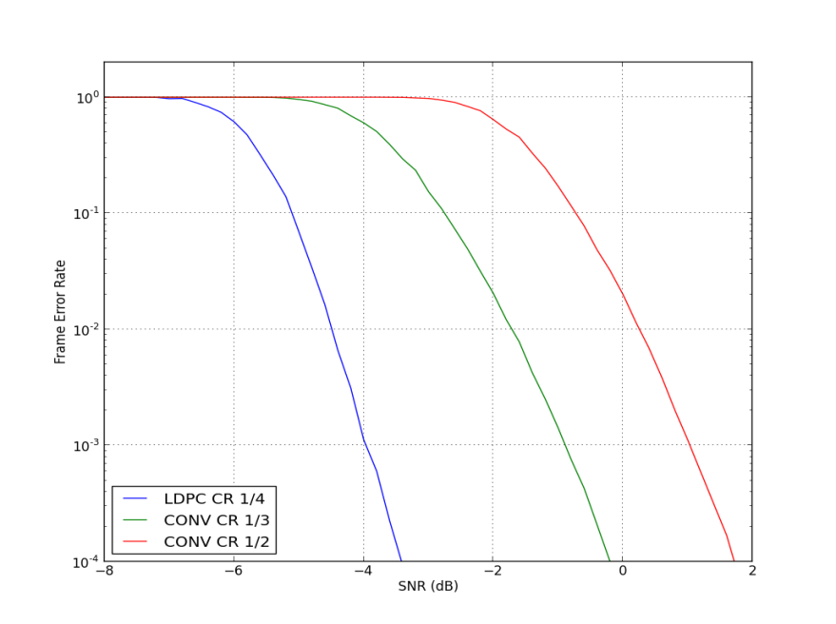

Figure 1: Frame Error Rate vs. SNR for different forward error correction modes in the AWGN channel (SF=1, frame length 37 octets)

Table 8: Typical 802.15.4w parameters and the resulting theoretical sensitivity in the AWGN channel

|  |  |  |  |  |  |  |
| --- | --- | --- | --- | --- | --- | --- |
| **System** | **PHY** | **PHY Mode** | **Coding** | **SNR for FER < 1%** | **Sensitivity** | **Eff. Bitrate*)** |
| 802.15.4.w | MSK, SF1 | 19.04kS/s | Conv. 1/2 | 0.3 dB | -131 dBm | 9.5kb/s |
| 9.52kS/s | Conv. 1/3 | -1.7 dB | -136 dBm | 3.2kb/s |
| 2.38kS/s | Conv. 1/3 | -1.7 dB | -142 dBm | 0.8kb/s |
| MSK, SF2 | 2.38kS/s | LDPC 1/4 | -7.5dB | -148 dBm | 0.3kb/s |

**\*) Note: The effective payload bitrate is only valid for one client. The channel may be used by multiple devices simultaneously, resulting in a significantly higher rate per network cell.**

#### Erasure Channel

TODO: Simulation results for different numbers of erased radio bursts

#### LPWAN Interference Channel

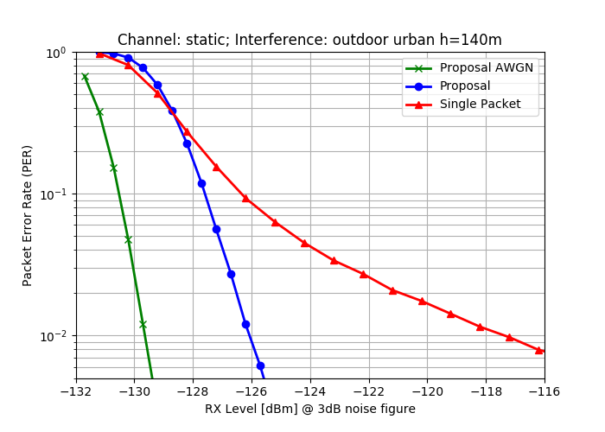

Figure 2: Frame error rate in interference channel with 2.38kb/s and convolutional code with rate 1/3

[Geben Sie ein Zitat aus dem Dokument oder die Zusammenfassung eines interessanten Punkts ein. Sie können das Textfeld an einer beliebigen Stelle im Dokument positionieren. Verwenden Sie die Registerkarte 'Zeichentools', wenn Sie das Format des Textfelds 'Textzitat' ändern möchten.]

## Interference Modeling

802.15.4g’s interference model, described in section 4.2 of the TG4g Coexistence Assurance Document [1], is adopted for the 802.15.4w coexistence simulation modeling. This is also identical to the interference model used for the TG4k and TG4Qq Coexistence Assurance Documents [2] [3].

* In the coexistence model, the transmitting power and the distance between the victim transmitter and victim receiver are fixed. Within this document we assume a distance of $d_{D}=10m$. Hence, the received signal strength of the victim signal at the receiver is fixed, too. In contrast, the distance $d_{U}$ of the interfering transmitter to the victim receiver is modified, which allows different inference levels at the victim receiver.
* The Hata model (large scale urban) is used for the path-loss calculation for the interference calculation in case of 802.15.4 interference. For 802.11ah interference the 802.11ah indoor channel path-loss model is used instead ( [4], Sec. 3.5, model A, no shadow fading), as most coexistence issues are expected for indoor applications.
* No AWGN is included to focus on the impacts of the interference only.
* All antenna gains are assumed to be 0dBi. The transmit power of the 802.15.4w system is set to 14dBm, which is the maximum allowed transmit power for most frequency bands in Europe. Higher transmit powers are very unlikely, as 802.15.4w is intended for operation with tiny batteries. In case of 802.15.4w as victim the interferer powers are set to 14dBm and 30dBm (high power use-cases).
* For 802.15.4w the maximum spreading factor used is SF=2, as higher values would result in very low effective bitrates.
* Ideal channel knowledge is assumed.

## 802.15.4 Coexistence Performance

802.15.4w does not include any new modulation schemes compared to the existing IEEE Std 802.15.4-2015. Therefore, all required coexistence scenarios with IEEE Std 802.15.4-2015 as victims are already covered in the existing coexistence assurance document for 802.15.4g [1], 802.15.4k [2], and 802.15.4q [3].

The changes

## 802.11ah Coexistence Performance

Extensive coexistence analyses between 802.11ah and 802.15.4w were performed. The simulations were done using the MATLAB WiFi Toolbox, which makes the simulation results reproducible.

<explain model>

<we always used worst-case parameters>

TODO: The existing 802.15.4 coexistence documents do not cover 802.11ah, which did not exist when the previous new PHY modes were defined. Hence, we have to show the impact of 802.15.4w on 802.11ah and vice versa. We will do this by assuming worst case conditions, e.g. maximum overlap between both systems. Following the discussions within the 802.19 GHz coexistence study group we would use the same MCS modes as defined there, i.e. MCS1, MCS3, and MCS7. We would limit our simulations to the PHY only. Within the TG4w we already discussed to use the MATLAB WiFi Toolbox for the simulations, which makes the simulation results reproducible to others.

### Victim 802.11ah

This subsection shows the coexistence analyses with 802.11ah as victim. As aforementioned, the MATLAB WiFi Toolbox was used to simulate the 802.11ah signals. Different MCS levels ranging from very robust (MCS 1: QPSK, CR ½), median robustness (MCS 2: 16-QAM, CR ½), and high throughput (MCS 7: 64-QAM, CR 5/6). These MCS levels correspond to the robustness levels currently discussed within the 802.19 Coexistence Study Group.

In order to reduce the simulation effort, perfect channel knowledge and the use of a single transmit and receive antennae was assumed. Furthermore, the simulation results assume the weaker convolutional code instead of the more powerful LDPC codes. Additionally, no special means were done to reduce the effects of the narrow-band 802.15.4w transmission on the 2MHz wide 802.11ah signal, which would be implemented in actual chip implementations. Therefore, the results shown here are worst case assumption, where much better coexistence results can be expected in actual implementations.





### Victim 802.15.4w

All results with realistic channel estimation

100% of the hops are affected

Simulation results for realistic channel use not shown as 100% error free transmission achieved





# Interference Mitigation and Avoidance Techniques

The developed amendment 802.15.4w aims at long distance transmission with low transmit powers in license-exempt frequency bands. This leads to very low required reception levels and to long effective on-air times. Hence, Listen before Talk (LBT) used by dissimilar systems is only effective in close proximity to the 802.15.4w transmitter. Consequently, the development of effective interference mitigation techniques to reduce the impact of interference from dissimilar systems has been the main design focus of 802.15.4w. On the other hand also the protection of dissimilar systems was considered. First, this minimizes the impact on existing installations of dissimilar systems. And second, it improves the energy efficiency as collisions on the channel are minimized. The following sections introduce the main interference mitigation and avoidance techniques deployed by 802.15.4w.

## Frequency Hopping Spread Spectrum with Forward Error Correction

IEEE 802.15.4w adds fast frequency hopping to IEEE 802.15.4 LECIM FSK PHY. As aforementioned, the data of one packet is forward error encoded and then transmitted in multiple short radio bursts that are transmitted on different frequencies. This has the following benefits concerning interference mitigation and avoidance:

* As described in section 2.4, this approach significantly improves the interference mitigation capabilities of 802.15.4w. The forward error correction is able to recover the data of lost radio bursts. Additionally, the frequency hopping minimizes the probability that many radio burst are lost. Therefore, the results shown in section 4.4.2 are worst-case scenarios, as 100% if the hops are affected by interference which is unrealistic in real applications. In such real applications practically 100% of the packets would be decodable without errors.
* Caused by the low payload bit-rates, the overall transmit time of one packet can reach values in the order of a second. However, frequency hopping reduces the channel load on specific channels, and consequently, does not block specific channels for seconds.
* Different 802.15.4w networks can use different hopping patterns. Consequently, multiple separately operated 802.15.4w networks can be operated on the same frequency in the same geographical area without significantly impairing each other.

## Listen Before Talk

As aforementioned, the very low possible reception levels of the 802.15.4w signals do not allow for an effective protection of 802.15.4w signals using Listen before Talk (LBT). However, 802.15.4w can use LBT to protect the signals of dissimilar systems. For this purpose 802.15.4w can use a separate Clear Channel Assessment (CCA) for each radio burst. In case of an occupied channel the 802.15.4w device does not transmit the radio burst. The information in the lost burst can then be recovered by means of the forward error correction. As a result, the interference on dissimilar system can be avoided effectively. Furthermore, the 802.15.4w device can reduce its power consumption, as data in radio bursts that would be anyhow lost due to a collision can be saved.

The CCA using assuming a receiver bandwidth of $2.38 kHz$ is fully sufficient to detect a wide-band signal. In order to show this we can consider the following example. A 802.11ah signal with 2 MHz bandwidth and 14 dBm transmit power results in a transmit power spectral density of $-49 dBm/Hz$. The lowest symbol rate of 802.15.4w is approx. 2.38kSymbols/s, resulting in an effective receiver bandwidth of $2.38 kHz$ if a correlation receiver is assumed. Thus, the 802.11ah transmit power in the $2.38 kHz$ bandwidth corresponds to $-15.2 dBm$.

Section 4.4.1 has shown that a distance of 25m is sufficient to achieve a maximum frame error rate of 1%. This results in a maximum distance of 35 m between the 802.11ah transmitter and the interfering 802.15.4w device. According to Figure 3 this results in a path loss of approx. 70 dB.

Consequently, the 802.15.4w device is able to receive a power level of $-85.2 dBm$, which is far higher than the thermal noise level for 2.38 kHz bandwidth, which is at approx.. $-140 dBm$.

Hence, a 802.15.4w device will have a margin of 55dB, which are absolutely sufficient to detect all 802.11ah transmissions that may be impaired by a 802.15.4w signal. Consequently, LBT per radio burst can avoid practically all interference from 802.15.4w on 802.11ah.



Figure 3: Path loss as function of the distance for the assumed indoor propagation model

# Conclusions