IEEE P802.15
Wireless Specialty Networks
IEEE 802.15.13
High level description for structure in non-beacon-enabled OWPAN
Date: 2018-10-25
Author:
Name | Affiliation | Address | Phone | Email
Nikola Serafimovski | pureLiFi |  |  | nikola.serafimovski@purelifi.com
Chong Han | pureLiFi |  |  | Chong.han@purelifi.com
Abstract

This document contains a text proposal for the high level description of the MAC structure in non-beacon-enabled OWPAN.
- Overview

- Normative references

- Definitions, acronyms, and abbreviations

- General description

  - Functional overview
    - Superframe structure
    - Non-beacon-enabled OWPAN
This standard allows the use of a non-beacon-enabled MAC structure. The structure is flexible and determined by the coordinator, which does not have a fixed length nor format. It does not rely on a Beacon frame to start the transmissions.

The general structure consists of two types of durations, namely a random access period and a contention-free period. An example is given in Figure 1. The random access period is initiated by the coordinator via broadcasting a control frame (RA). Hearing the control frame, new devices joining the reference OWPAN and previously associated devices know they are allowed to compete for the uplink communicating to the coordinator. Following the short competition period, the coordinator starts polling devices via Poll frames to which devices response with Poll Response frames and acknowledgement if needed. All devices listen to the downlink and then start communications if polled by the coordinator. Different from the superframe structure, all transactions by devices are free to continue as long as the coordinator does not send a control frame to start the next period. The polling mechanism is given in detail in 5.1.2.
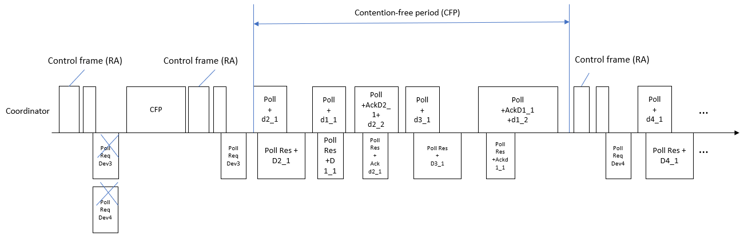
Figure 1 non-beacon-enabled structure example

