IEEE P802.15
Wireless Personal Area Networks

Project | IEEE P802.15 Working Group for Wireless Personal Area Networks (WPANs)
Title | 802.15.4w Fraunhofer IIS proposal technical guidance topics
Date Submitted | [7 September, 2018]
Source | [Wechsler, Johannes]  [Fraunhofer Institute for Integrated Circuits IIS]  [Nordostpark 84, 90411 Nürnberg, Germany] | Voice: [+49 911 58061 3334]  Fax: [+49 911 58061 3299]  E-mail: [johannes.wechsler@iis.fraunhofer.de]
Re: | [IEEE P802.15.4w Low Power Wide Area Call for Proposals, IEEE 802.15-18-0147-01-004w]
Abstract | [Discussion on technical guidance compliance of proposal from Fraunhofer IIS for 802.15.4w.]
Purpose | [Compliance discussion of the proposed PHY layer extension with the technical guidance document.]
Notice | This document has been prepared to assist the IEEE P802.15. It is offered as a basis for discussion and is not binding on the contributing individual(s) or organization(s). The material in this document is subject to change in form and content after further study. The contributor(s) reserve(s) the right to add, amend or withdraw material contained herein.
Release | The contributor acknowledges and accepts that this contribution becomes the property of IEEE and may be made publicly available by P802.15.

Fraunhofer IIS 802.15.4w proposal technical guidance topics
This document describes, how the Fraunhofer IIS 802.15.4w proposal [1] complies with the requirements from the technical guidance document [2].

Data Rate and Symbol/Chip Rate
The proposal defines a minimal symbol rate of ~2,380 kSymbols per second and allows additional spreading to achieve even lower data rates.

Forward Error Correction
A rate 1/3 Convolutional Code is added, a placeholder has been set to allow for an additional rate 1/4 LDPC code.

Modulation / Coding
A precoded GFSK modulation with a modulation factor of 0.5 is proposed.

Fragmentation
A fragmentation scheme with interleaver is introduced.

Time- / Frequency Patterns
Two different fragmentation schemes are introduced.
- A hard-coded, table based fragmentation intended for ALOHA access. With an example table consisting of 8 different fragmentation time- / frequency patterns is included.
- A flexible time- frequency pattern generation is proposed for time slotted, beacon based PANs

Frequency, Synchronisation and Timing
No new requirements were introduced, as the existing requirements are sufficient.

PHY Frame Structure
The PHY frame structure has stayed untouched. However a new PHY frame for easy initial synchronization is proposed.

Transmit PSD
The actual channelization is not a mandatory requirement of the PHY as it should be chosen according to the regulatory needs of each region. However, the GFSK modulation with m=0.5 and BT of 1.0 will allow for channels almost as narrow as the symbol rate in Hz. Additionally the channels typically are required to be at least 25 kHz (FCC FHSS), hence systems with a symbol rate of 10 kSymbols/s and below will not have a considerable impact on adjacent channels.

Coexistence
Narrow band transmission with sub-packet fragmentation combined with LBT allows flexible adjustment to channel conditions as the transmission gap in-between sub-packets enables the devices to analyze the channel before every radio burst intended for transmission. If the channel is considered occupied the sub-packet will simply not be transmitted, as the FEC and interleaver a specifically designed to can handle the loss of sub-packets.
The fragmentation also gives more opportunities to check for activity of other systems compared to non-fragmented single packet transmission of the same length and gives the system more agility to avoid interference with other systems.
The high success rate (resulting from high power efficiency and interference robustness) reduces the requirement for many retransmissions and therefore the load on the channel.
SHR is deliberately short and cannot be mistaken for a legacy SHR or SHR of other systems.
Channels can be spread very wide in frequency domain, which gives a high frequency dynamic and reduces the impact on systems operating at less frequency dynamic.

Operational Bands
Due to the narrow band nature of the LECIM FSK extension with data rates lower than 30 kbit/s and GMSK modulation, the spectral mask of the transmission is commonly narrower than the smallest allowed channelization required by common regulatory bodies. Combining this with the FHSS component of the fragmented transmission allows a certification as FHSS system in ETSI and FCC in the targeted Sub-GHz spectrum: ETSI 169 MHz, 433 MHz, 868 MHz; FCC 433 MHz, 915 MHz.

Simulation Results

Minimum Required Sensitivity
It is required to achieve a PER < 1% at the minimal receive sensitivity of -140 dBm [2]. To achieve this, the phyLecimFskFragmentedSymbolMultiple is set to 1 to use a symbol rate of ~2380 Symbols/s. Additionally a spreading of factor 2 is applied, resulting in an effective data rate of ~0.29 kbit/s, when FEC and overhead are considered. An overview of how the effective data rates are linked to the chosen symbol rate can be found in Table:
Table 6 Effective data rate at rate 1/3 FEC dependent on symbol rate and spreading factor
Symbol Rate (kSymbols/s) | 2.38 | 2.38 | 4.76 | 19.04
Spreading factor | 2 | 1 | 1 | 1
Effective data rate (kbit/s) | 0.29 | 0.58 | 1.17 | 4.66

Setup / Parameters
- Effective data rate settings: see Table
- 10,000 transmissions
- PSDU Size 37 Byte [3]
- AWGN channel
- FEC Rate 1/3 convolutional code
- Packet fragmentation
- Noise figure of 3dB at the receiver [4]

Results
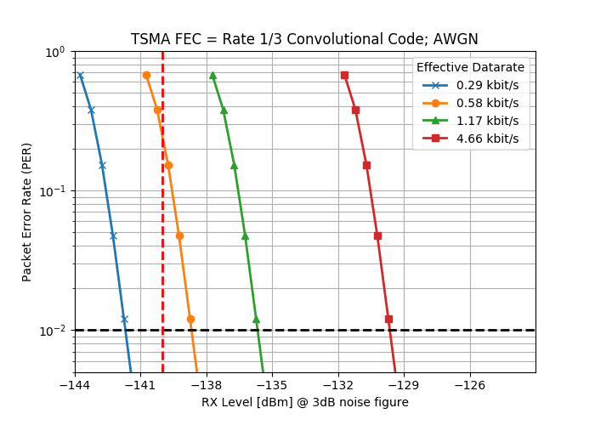
Figure 10 AWGN Performance of different effective data rates with focus on PER of 1% and sensitivity of -140 dBm and better

Mobility Performance
The impact of multipath fading has to be shown [3]. To model the multipath channel, a 6-TAP typical urban channel model with a movement speed of 30km/h was considered as defined in [5] and [3].
The performance in a mobile channel decreases roughly by 4dB compared to a static channel as shown in Figure 10.

Setup / Parameters
- Effective data rate settings: 0.58 kbit/s
- 10,000 transmissions
- PSDU Size 37 Byte [3]
- AWGN channel
- FEC Rate 1/3 convolutional code
- Packet fragmentation
- Noise figure of 3dB at the receiver [4]
- Multipath channel 6 TAP @ 30km/h [3]

Results
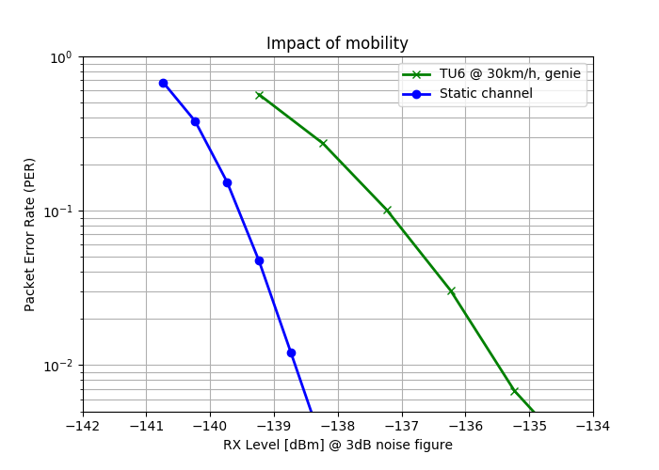
Figure 11 Impact of multipath fading on the fragmented transmission

Multipath Performance
As required by [2], the multipath performance shall be evaluated. The considered multipath channel is designed as a two-tap channel with equally strong taps and a tap distance of 1/8th of the symbol rate.. Compared to the one tap channel, the performance drop is below 0.5 dB and multipath not an issue considering these even the high symbol rate for this PHY of 8x 2,380 kSymbols/ . At lower symbol rates the impact is even less.

Setup / Parameters
- Symbol rate 8x 2,380 kSymbols/s
- 10,000 transmissions
- PSDU Size 37 Byte [3]
- Noise figure of 3dB at the receiver [4]
- Channel TU6, 0km/h (block fading)
- With ISI: two tap channel with equally strong taps paced 6.6µs apart (1/8th of a symbol duration)
- Witouth ISI: single tap channel

Result

Interference Robustness

Gain of TSMA with FEC
Compared to uncoded transmission without fragmentation, the fragmented and FEC coded transmission gains dramatically when the transmission time of both systems is identical.

Setup / Parameters
- 10,000 transmissions
- PSDU Size 37 Byte [SDM]
- FEC 1/3 coded packet fragmentation
  - Effective data rate ~4.66 kbit/s
  - Total on-air time 60ms
- Uncoded
  - 35.25 Byte = 282 bits @ 4.76 kbit/s
  - Total on-air time 59ms
- Channel TU6, 0km/h (block fading)
- Interference: Outdoor urban, h = 140m [IG]

Results

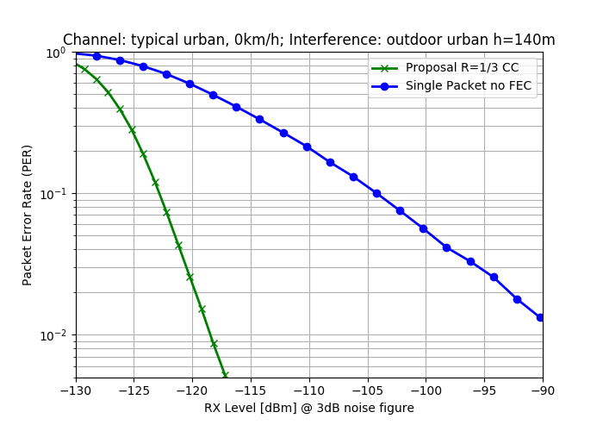
Figure 12 Impact of interference on FEC and fragmented transmission compared to non FEC coded single packet transmission

Gain of packet fragmentation with different interference models
In Figure 12, the antenna is simulated at a height of 140m. Compared to FEC coded transmission without fragmentation, the fragmented transmission gains about 9dB at a PER of 1%.

In Figure 13, the results for the same simulation with an antenna height of 32m are shown. The interference seen by the antenna with less height is lower, due to the less exposed position and smaller cell. The absolute performance increases slightly compared to the more exposed antenna.

With increased interference the performance gain of fragmented over non-fragmented also increases.

In both figures, the AWGN performance is additionally plotted as reference.

Setup / Parameters
- 10,000 transmissions
- PSDU Size 37 Byte [SDM]
- Effective data rate ~4.66 kbit/s
- Proposal
  - FEC 1/3 coded packet fragmentation
- Channel TU6, 0km/h (block fading)
- Interference: Outdoor urban, h = 140m/32m [5] [4]

Results
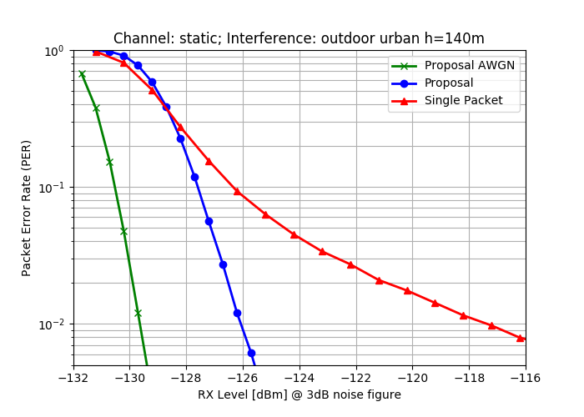
Figure 13 Impact of interference on fragmented transmission compared against non-fragmented and AWGN with an antenna height of 32m
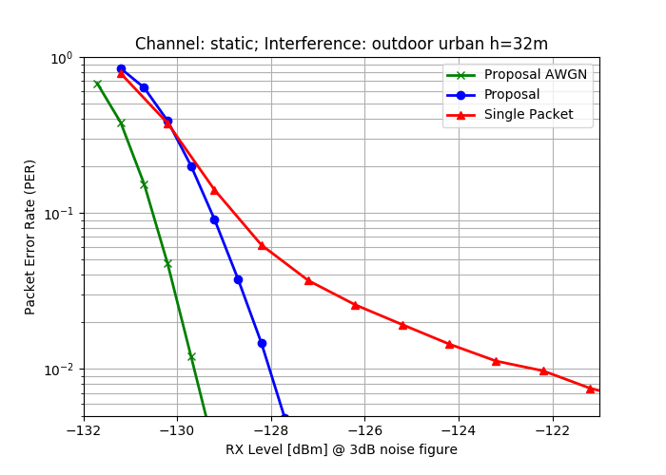
Figure 14 Impact of interference on fragmented transmission compared against non-fragmented and AWGN with an antenna height of 32m

References

[1] | LAN/MAN Standards Committee, IEEE Standard for Low-Rate, IEEE Std 802.15.4-2015, 2015.
[2] | R. Heile, P802.15.4w PAR, IEEE P802.15-18-0050-03-0000.
[3] | J. Robert, TG 802.15.4w LPWA Agenda July 2018 Plenary, IEEE P802. 15-18-0319-04-004w.
[4] | J. Robert, 802.15.4w Technical Guidance Document, IEEE P802.15-18-0161-00-004w.
[5] | J. Robert, Draft IG LPWA Report, IEEE P802.15-17-0528-01-lpwa.
[6] | J. Robert, IEEE P802.15.4w Low Power Wide Area Call for Proposals, IEEE P802-15-18-0147-01-004w.

