IEEE P802.15
Wireless Personal Area Networks

Project | IEEE P802.15 Working Group for Wireless Personal Area Networks (WPANs)
Title | Text proposal for LPWA repeater
Date Submitted | [07 September, 2018]
Source | [Kunmin Yeo, Tae-Joon Park, Seong-Soon Joo, Eun-Hee Kim]  [ETRI]  [218 Gajeong-ro, Yuseong-gu, Daejeon, 34129, KOREA] | Voice: [+82-42-860-5438]  E-mail: [kunmin@etri.re.kr]
Re: | [P802-15-18-0147-00-004w-call-for-proposals.docx 8 (08-Mar-2018)]
Abstract | [This is a proposal for single-hop LPWA repeater to resolve harsh environment applications]
Purpose | [Contribution to IEEE 802.15.4w]
Notice | This document has been prepared to assist the IEEE P802.15. It is offered as a basis for discussion and is not binding on the contributing individual(s) or organization(s). The material in this document is subject to change in form and content after further study. The contributor(s) reserve(s) the right to add, amend or withdraw material contained herein. This work was supported by IITP funded by MSIT (No. R-20160227-002863, LPWA IoT network core technology development).
Release | The contributor acknowledges and accepts that this contribution becomes the property of IEEE and may be made publicly available by P802.15.

1. Add the following paragraph at the end of 5.5.1:

5.5.1 Star network formation

For the LPWA star topology, a single-hop frame repeater may be used to extend the transmission range for connecting the end devices in harsh communication environment.

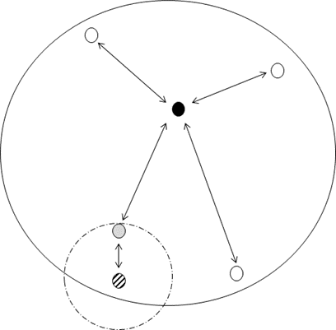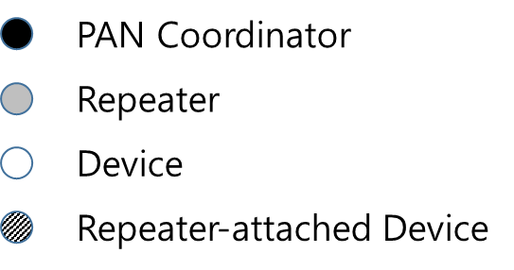

2. Add the following attributes in Table 8-81

Table 8-81 MAC PIB attributes
Attribute | Type | Range | Description | Default
macLpwaRepeaterEnabled | Boolean | TRUE, FLASE | A value of TRUE indicates that single-hop frame repeaters are used to extend the transmission range. | -
macLpwaRepeaterBeaconOffset | Integer | - | The time offset at the air interface from the trailing edge of the last chip (of the last symbol) of a received beacon to the time of transmitting the leading edge of the first chip (of the first symbol) of the repeated beacon, if phyLpwaRepeaterEnabled is set to TRUE. | -

3. Add the following paragraphs at the end of 24.2.2:

24.2.2 PHR field format

In a LPWA, if phyLpwaRepeaterEnabled is set to TRUE, the format of the PHR is shown in Figure xx-x

Bits: 0 | 1 | 2 | 3 | 4 | 5-15
Repeat Request | Repeat Indicator | Parity | FCS Type | Data Whitening | Frame Length

where the Parity field is calculated in the following way:
Parity field = b0 ⊕ b1 ⊕ b3 ⊕ b4 ⊕ b5 ⊕ b6 ⊕ b7 ⊕ b8 ⊕ b9 ⊕ b10 ⊕ b11 ⊕ b12 ⊕ b13 ⊕ b14 ⊕ b15.

