**IEEE P802.15**

**Wireless Personal Area Networks**

|  |  |  |
| --- | --- | --- |
| Project | IEEE P802.15 Working Group for Wireless Personal Area Networks (WPANs) | |
| Title | Text proposal to 15.4z for enhancing UWB PHYs | |
| Date Submitted | [6 July, 2018] | |
| Source | H.-B. Li, K. Takizawa and F. Kojima (NICT)  H. Nishikawa (GIT Japan Inc.) | E-Mail:[lee (at) nict.go.jp |
| Re: | [If this is a proposed revision, cite the original document.]  [This is a response to the IEEE 802.15.4Z EIR.4z EIR Call for Proposals Doc. 15-18-0259-00-004z, which is issued in May 2018]  [Note: Contributions that are not responsive to this section of the template, and contributions which do not address the topic under which they are submitted, may be refused or consigned to the “General Contributions” area.] | |
| Abstract | [Contribute a proposal to the enhanced impulse radio group 15.4z] | |
| Purpose | [Propose the modifications of the HRP as well as LRP UWB PHYs] | |
| Notice | This document has been prepared to assist the IEEE P802.15. It is offered as a basis for discussion and is not binding on the contributing individual(s) or organization(s). The material in this document is subject to change in form and content after further study. The contributor(s) reserve(s) the right to add, amend or withdraw material contained herein. | |
| Release | The contributor acknowledges and accepts that this contribution becomes the property of IEEE and may be made publicly available by P802.15. | |

**Proposed add-ons are highlighted in blue.**

16. HRP UWB PHY

**… …**

**16.2.2 Symbol structure**

In the BPM-BPSK modulation scheme, each symbol is capable of carrying two bits of information: one bit is used to determine the position of a burst of pulses, while an additional bit is used to modulate the phase (polarity) of this same burst.

The structure and timing of a symbol is illustrated in Figure16-3. Each symbol shall consist of an integer number of possible chip positions, Nc, each with duration Tc. The overall symbol period denoted by Tdsym is given by Tdsym = NcTc. Furthermore, for combined BPM and BPSK mode, each symbol is divided into two BPM intervals each with duration TBPM =Tdsym /2, which enables binary position modulation. For OOK/BPSK mode, one symbol period is half of that of the BPM and BPSK mode.

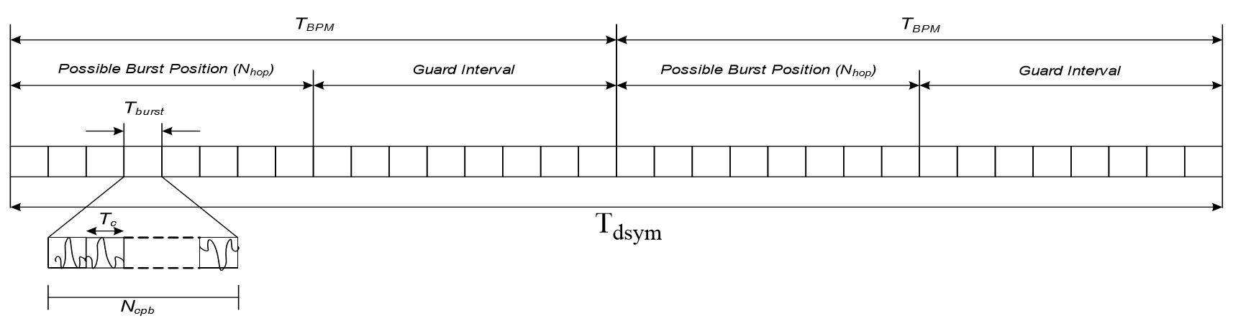

1. Symbol frame structure of combined BPM and BPSK

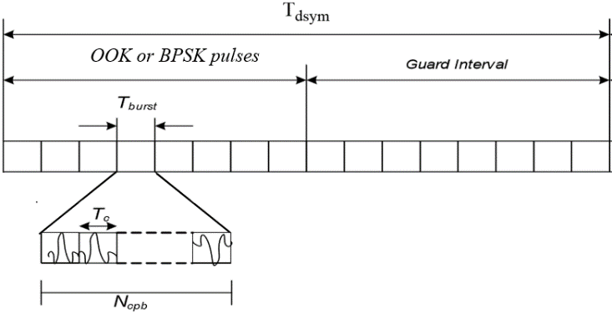

1. Symbol frame structure of OOK/BPSK

Figure 16-3—HRP UWB PHY symbol structure

A burst is formed by grouping Ncpb consecutive chips and has duration Tburst = NcpbTc. The location of the burst in either the first half or the second half of the symbol indicates one bit of information. Additionally, the phase of the burst (either –1 or +1) is used to indicate a second bit of information.

In each symbol interval, a single burst event shall be transmitted. The fact that burst duration is typically much shorter than the BPM duration, i.e., Tburst << TBPM, provides for some multi-user access interference rejection in the form of time hopping. The total number of burst durations per symbol, Nburst, is given by Nburst = Tdsym /Tburst. In order to limit the amount of inter-symbol interference caused by multipath, only the first half of each TBPM period shall contain a burst. Therefore, only the first Nhop= Nburst/4 possible burst positions are candidate hopping burst positions within each BPM interval. Each burst position can be varied on a symbol-to-symbol basis according to a time hopping code as described in 16.3.

10.1.2.7 Channel numbering for LRP UWB PHY

The LRP UWB PHY uses channel page 8 with the channel numbers defined in Table10-9. A total of three frequency channels, numbered 0 to 2, are available in the 6289.6 MHz to 9185.6 MHz frequency bands. Different subsets of these frequency channels are available in different regions of the world. In North America and Europe, a shared channel may be used.

Table 10-9—LRP UWB PHY channel frequencies

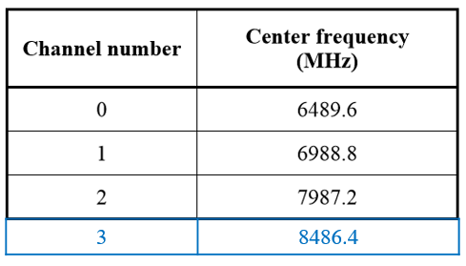

10.1.2.8 Channel numbering for SUN and TVWS PHYs

The channel center frequency ChanCenterFreq for all SUN and TVWS PHYs, except the SUN O-QPSK PHY operating in the 868–870 MHz band, shall be derived as follows: ChanCenterFreq = ChanCenterFreq0 + NumChan × ChanSpacing

Table 10-9—LRP UWB PHY channel frequencies

1. LRP UWB PHY specification

The LRP UWB PHY waveform is based upon an impulse radio signaling scheme using band-limited data pulses. I

… …

**19.7.3 Transmit PSD mask**

The transmitter shall operate with a power spectral density contained by one of three PSD masks defined in Table19-9 and shown in Figure19-7. The permitted spectral density is defined in dBr relative to the maximum spectral density of the signal, and shall be made using a 1MHz resolution bandwidth and a 1 MHz video bandwidth. Additionally, the upper -10 dBr point of the transmitter PSD shall be at least 200 MHz above a nominal frequency, fn, and the lower -10 dBr point shall be at most 200MHz below the same nominal frequency.

