**IEEE P802.15**

**Wireless Personal Area Networks**

|  |  |  |
| --- | --- | --- |
| Project | IEEE P802.15 Working Group for Wireless Personal Area Networks (WPANs) | |
| Title | Change Proposal for LRP UWB PHY | |
| Date Submitted | [8 May, 2018] | |
| Source | David Barras (3db Access AG)  Boris Danev (3db Access AG)  Peter Sauer (Microchip)  Bernd Baer (Marquardt) |  |
| Re: | [If this is a proposed revision, cite the original document.]  [If this is a response to a Call for Contributions, cite the name and date of the Call for Contributions to which this document responds, as well as the relevant item number in the Call for Contributions.]  [Note: Contributions that are not responsive to this section of the template, and contributions which do not address the topic under which they are submitted, may be refused or consigned to the “General Contributions” area.] | |
| Abstract | [Change Proposal for LRP UWB PHY in 802.15.4z] | |
| Purpose | [Propose elements of LRP UWB PHY and related MAC changes for 802.15.4z] | |
| Notice | This document has been prepared to assist the IEEE P802.15. It is offered as a basis for discussion and is not binding on the contributing individual(s) or organization(s). The material in this document is subject to change in form and content after further study. The contributor(s) reserve(s) the right to add, amend or withdraw material contained herein. | |
| Release | The contributor acknowledges and accepts that this contribution becomes the property of IEEE and may be made publicly available by P802.15. | |

**Proposed add-ons and new contributions are highlighted in blue.**

**Modifications of the existing standard are highlighted in red.**

1. General radio specifications

The loopback time specification is added for devices supporting fixed return times as used in two-way round-trip time-of-flight ranging measurements without exchange of timestamps between the two ranging devices (RDEV). Two-way round-trip time-of-flight only needs a fixed time constraint for Rx-to-Tx messages. For Tx-to-Rx turnaround time, previous definition in the standard can be used.

* 1. Rx-to-Tx Loopback Time

The Rx-to-Tx loopback time is defined as the time at the air interface from the leading edge of the last chip of the last symbol of a received PPDU to the time of the leading edge of the last chip of the first symbol of the next transmitted PPDU.

The RX-to-TX loopback time shall be equal to PHY PIB attribute *aLoopbackTime*, as defined in Table 11-1.

1. PHY Service
   1. PHY PIB attributes

**Table 11-1 – PHY PIB attributes**

|  |  |  |
| --- | --- | --- |
| **Attribute** | **Description** | **Value** |
| *aTurnaroundTime* | RX-to-TX or TX-to-RX turnaround time (in symbol periods), as defined in 10.2.1 and 10.2.2 | For the SUN, TVWS, and LECIM FSK PHYs, the value is 1 ms expressed in symbol periods, rounded up to the next integer number of symbol periods using the ceiling() function.a For the LECIM DSSS PHY, the value is 1 ms expressed in modulation symbol periods, rounded up to the next integer number of symbol periods using the ceiling() function.  The value is 12 for all other PHYs. |
| *aLoopbackTime* | RX-to-TX or TX-to-RX loopback time (in pulse periods) | For the LRP UWB PHY supporting Round-Trip Time-of-flight with fixed Rx-to-Tx loopback time, the value is 16 pulses periods for PRR=1 MHz and 32 pulses periods for PRR=2 MHz, i.e. 16 us.  The Tx-to-Rx loop is less or equal than 16 us.  If RTToF is not supported the value 0 is used. |

**Table 11-2 – PHY PIB attributes**

|  |  |  |  |
| --- | --- | --- | --- |
| Attribute | Type | Range | Description |
| *phyRttof* | Boolean | TRUE, FALSE | TRUE if Round-Trip Time-of-Flight with fixed Rx-to-Tx turnaround time is supported; FALSE otherwise. |

1. LRP UWB PHY specification

The LRP UWB PHY waveform is based upon an impulse radio signaling scheme using band-limited data pulses. It consists of three frequency channels and occupies the spectrum from 6.2896 to 9.1856 GHz

A combination of on off keying (OOK) modulation or pulse position modulation PPM or pulse binary FSK is used to support both coherent and non-coherent receivers using a common signaling scheme. Either OOK or PPM or BFSK are used to modulate the symbols, as defined by the mode. Symbols are composed of one or more active bursts of UWB pulses. The various data rates are supported through the use of variable-length bursts.

The LRP UWB PHY supports five transmission modes:

* Base mode, for highest data rate
* Extended mode, for moderate data rate but improved sensitivity
* Long range mode, for best sensitivity
* Dual-frequency mode, for enhanced data rate and efficient management of network of ranging devices
* Extended dual-frequency mode, for improved ranging sensitivity

~~All transmit modes are optional, but all modes shall be implemented in the receiver and operational concurrently. Active RFID systems are often simplex systems so mandatory modes are not defined for the PHY but separately for the transmitter (RFD-TX) and receiver (RFD-RX).~~

Base mode shall be implemented in the receiver and the transmitter, other modes are optional.

The PHY has different characteristics depending on the transmission mode. These characteristics are defined for each mode separately as shown in Table 121. Otherwise, the characteristics of the PHY are independent of transmission mode.

**Table 121—Signaling modes and data rates (for LRP UWB PHY)**

|  |  |  |  |  |  |
| --- | --- | --- | --- | --- | --- |
| **Mode** | **PRF (MHz)** | **DataRate as used in MCPS-DATA**  **primitives** | **Data Rate** | **Modulation** | **Implementation** |
| Long range mode | 2.0 | 1 | 31.25 kb/s | PPM | optional |
| Extended mode | 1.0 | 2 | 250 kb/s | OOK | optional |
| Base mode | 1.0 | 3 | 1 Mb/s | OOK | mandatory |
| Dual-frequency mode | 2.0 | 4 | 2 Mb/s | 2-FSK | optional |
| Extended dual-frequency mode | 2.0 | 5 | 500 kb/s | 2-FSK | optional |

* 1. LRP UWB PHY symbol structure

In base mode, a LRP UWB PHY symbol consists of presence/absence of pulses in 1 MHz PRF train.

In extended mode, LRP UWB PHY symbol consists of presence/absence of pulses in 1 MHz PRF train generated by convolution code with octal generators (5,7,7,7).

In long range mode, LRP UWB PHY symbol consists of Manchester-encoded groups of 64 pulses (32 on, 32 off) in 2 MHz PRF train.

In dual-freqency mode, LRP UWB PHY symbol consists of the presence of pulses at either one of the center frequencies defined in Table TBD, transmitted in 2 MHz PRF train.

In extended dual-frequency mode, LRP UWB PHY symbol consists of the presence of pulses at either one of the center frequencies defined in TBD, transmitted in 2 MHz PRF train and generated by convolution with octal generators (5,7,7,7).

* + 1. Dual-frequency LRP UWB PHY symbol structure

In the base mode of the dual-frequency LRP UWB modulation scheme, each symbol carries one bit of information. The dual-frequency mode operates at 1 chip per symbol with a PRF of 2 MHz, so the symbol time TDSYM is 500 ns and the chip time TCHIP is also 500 ns. Binary data values 0 and 1 are encoded by shifting the center frequency of the pulse carrier, a described in Table 19-aaa. The data rate is thus 2 Mb/s. The pulse duration TPULSE is much shorter than the symbol time. The pulse is nominally sent in the center of the chip and symbol period TDSYM as shown in Figure xx.

**Table 19-aaa**

|  |  |
| --- | --- |
| **Binary value being encoded** | **Transmitted signal** |
| 0 | The RF carrier of the pulse is shifted by -fdev |
| 1 | The RF carrier of the pulse is shifted by +fdev |

* + 1. Extended dual-frequency LRP UWB PHY symbol structure

In the extended dual-frequency mode of LRP UWB modulation scheme, each symbol consists of four chips generated by a rate 1/4 convolutional code using octal generators 5,7,7,7 for k = 3, as shown in Figure 19-2.

The extended mode receiver may employ a relatively simple Viterbi decoder with hard or soft decisions to

make use of the coding gain afforded by the transmitter convolution code.

Extended dual-frequency mode employs a PRF of 2 MHz with a rate 1/4 code giving a symbol time of 2 μs. The data rate is thus 500 kb/s. The pulses are nominally centered within the chip periods as shown in Figure 19-3 for OOK extended mode. These four pulses are transmitted in order with pulse 1 transmitted first. The individual pulses carrier center frequency is depending on whether the pulse out value is binary 1 or binary 0 as indicated in Table 19-aaa.

* + - 1. Extended dual-frequency LRP UWB PHY PSDU synchronisation signal

No additional synchronization measures are needed in this mode since its BFSK modulation scheme ensures that sufficient pulses are transmitted.

* 1. LRP UWB transmitter specification
     1. Pulse shape

The LRP UWB_UWB PHY shall employ an impulse transmitter that instantaneously produces an ultra-wideband frequency response. There are no constraints on the specific pulse shape providing that the pulse shall comply with the Transmit PSD Mask defined in section 19.7.3.

For both dual-frequency and extended dual-frequency modes using 2-FSK modulation, the un-modulated instantaneous frequency response (fdev=0) as well as the modulated frequency response shall comply with the Transmit PSD Mask defined in section 19.7.3. An example is given in the figure below for Band 0.

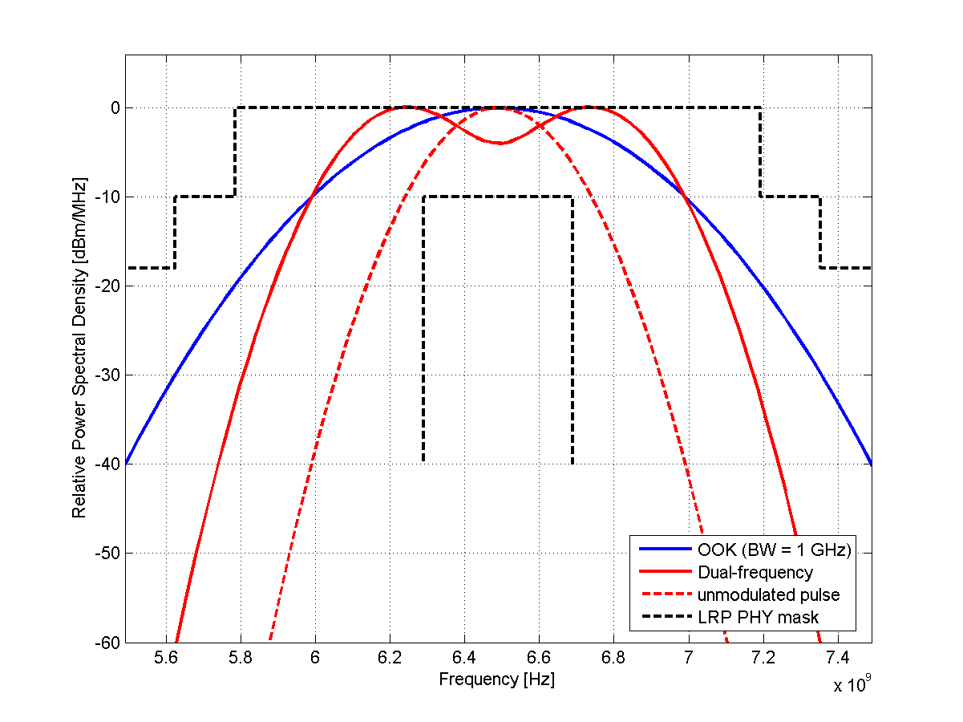

* 1. LRP UWB receiver specification
  2. LRP UWB Turnaround Requirements
     1. Rx-to-Tx Loopback Time

LRP UWB device capable of Round-Trip Time-of-Flight measurement (defined by the PHY PIB attribute *phyRttof* in Table 10-2) shall implement a **fixed** Rx-to-Tx loopback time of 16μs (16 chip periods in Base Mode and Extended Modes, 32 chip periods in TBD, Extended TBD and Long Range modes).

* + 1. Tx-to-Rx turnaround time

LRP UWB device capable of Round-Trip Time-of-Flight measurement (defined by the PHY PIB attribute phyRttof in Table 10-2) shall implement a Tx-to-Rx turnaround time **of at least** 16μs (16 chip periods in Base Mode and Extended Modes, 32 chip periods in TBD, Extended TBD and Long Range modes).

* 1. LRP UWB receiver specification

The receiver shall support only base mode. Other modes are optional.