IEEE P802.15

Wireless Personal Area Networks

Project | IEEE P802.15 Working Group for Wireless Personal Area Networks (WPANs)
Title | Response to comment 7 against draft 2
Date Submitted | 10 May 2018
Source | John LI (Huawei) | Voice: [ ]  Fax: [ ]  E-mail: [ ]
Re: | [If this is a proposed revision, cite the original document.]  [If this is a response to a Call for Contributions, cite the name and date of the Call for Contributions to which this document responds, as well as the relevant item number in the Call for Contributions.]  [Note: Contributions that are not responsive to this section of the template, and contributions which do not address the topic under which they are submitted, may be refused or consigned to the “General Contributions” area.]
Abstract | Response to comment 7 against draft 2
Purpose | [Inform TG13 about most recent work.]
Notice | This document has been prepared to assist the IEEE P802.15. It is offered as a basis for discussion and is not binding on the contributing individual(s) or organization(s). The material in this document is subject to change in form and content after further study. The contributor(s) reserve(s) the right to add, amend or withdraw material contained herein.
Release | The contributor acknowledges and accepts that this contribution becomes the property of IEEE and may be made publicly available by P802.15.
The group received below comment regarding relaying.

page (pdf) | Page (text) | Sub-clause | Line # | Comment
58 | 41 | 5.1.4 | 44 | "NumberDetectDevice" in Table 2.  "NumberDetectDevice" is shown twice in Table 2. If they are used for different things, the same name should not be used.

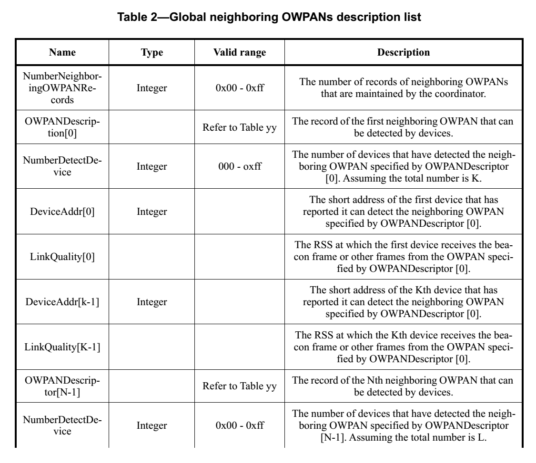
We suggest the following as resolution.

Modify the current table 2 into the following

Table 2 Global neighboring OWPAN description list

Name | Type | Valid range | Description
NumberNeighboringOWPANRecords | Integer | 0x00 – 0xff | The number of records of neighboring OWPANs that are maintained by the coordinator
OWPANDescriptorList | List of OWPANDescriptor value | Refer to table 24 | The list of record of neighboring OWPAN that can be detected by devices. The lengh of the list is NumberNeighboringOWPANRecords.
OWPANLinkQualityDescriptorList | List of OWPANLinkQuality value | Refer to table 3 | The link quality of neighboring OWPAN in the OWPANDescriptorList measured by devices. The lengh of the list is NumberNeighboringOWPANRecords.

Table 3 OWPAN link quality descriptor

Name | Type | Valid range | Description
NumberDetectDevice | Integer | 0x00 – 0xff | The number of devices that have detected the neighboring OWPAN
OWPANMeasurementList | List of OWPANMeasurement | Refer to table 4 | The list of measurement of the neighboring OWPAN. The lengh of the list is NumberDetectDevice

Table 4 OWPAN Measurement

Name | Type | Valid range | Description
DeviceAddr | Integer | TBD | The address of the device reports the measurement of neighboring OWPAN
LinkQuality | Integer | TBD | The measured LinkQuality by the device of the neighboring OWPAN

