IEEE P802.15
Wireless Personal Area Networks

Project | IEEE P802.15 Working Group for Wireless Personal Area Networks (WPANs)
Title | LB-D2-Comment-Resolution-Based-Changes-On-PHY-Layer-General-Description
Date Submitted | May 2018
Source | Jaesang Cha (SNUST),  Soo Young Chang (SYCA),  Minwoo Lee (SNUST),  Vinayagam Mariappan (SNUST ) | Voice: [ ]  Fax: [ ]  E-mail: [chajs@seoultech.ac.kr]
Re: | LB D2 Comment Resolution supportive documents for PHY Layer General Description Section Revision
Abstract | Details of Resolutions regarding to the submitted Comments on LB D2 are suggested for OWC Draft Introduction Section. The OWC Draft Introduction Section based on Modulation Schemes is provides the specification to design of LED ID / CAMCOM based application services like IoT/IoL, LED ID, Digital Signage with Advertisement Information, LBS, Emergency EXIT Signage, etc.
Purpose | LB D0 Comments Resolutions and Editorial Revision.
Notice | This document has been prepared to assist the IEEE P802.15. It is offered as a basis for discussion and is not binding on the contributing individual(s) or organization(s). The material in this document is subject to change in form and content after further study. The contributor(s) reserve(s) the right to add, amend or withdraw material contained herein.
Release | The contributor acknowledges and accepts that this contribution becomes the property of IEEE and may be made publicly available by P802.15.

Comment 14, 15, and 16
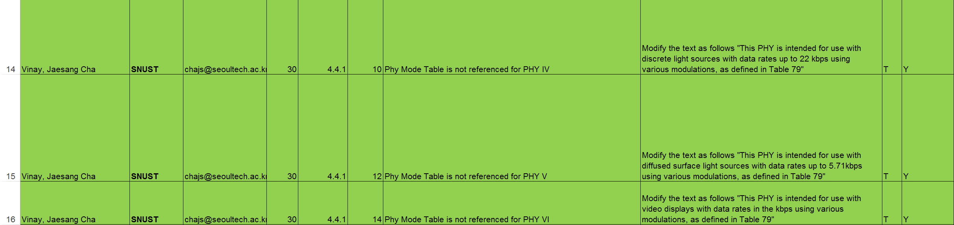

Comment Resolution Based Change

PDF Page 29 and 30

4.4.1 PHY layer

The PHY layer supports multiple PHY types.

- PHY I: This PHY type is intended for outdoor usage with low data rate applications. This mode uses on-off keying (OOK) and variable pulse position modulation (VPPM) with data rates in the tens to hundreds of kbps, as defined in Table 76.
- PHY II: This PHY type is intended for indoor usage with moderate data rate applications. This mode uses OOK and VPPM with data rates in the tens of Mbps, as defined in Table 77.
- PHY III: This PHY type is intended for applications using color-shift keying (CSK) that have multiple light sources and detectors. This mode uses CSK with data rates in the tens of Mbps, as defined in Table 78.
- PHY IV: This PHY type is intended for use with discrete light sources with data rates up to 22 kbps using various modulations, as defined in clause 13.
- PHY V:
- This PHY type is intended for use with diffused surface light sources with data rates up to in the kbps, as defined in clause 14.
- PHY VI: This PHY type is intended for use with video displays with data rates in the kbps using various modulations, as defined in clause 15.

