IEEE P802.15
Wireless Personal Area Networks

Project | Dependability Interest Group
Title | Meeting Minutes for March 2018
Date Submitted | March 8th, 2018
Source | [Ryuji Kohno]  [YNU(Yokohama National University)/CWC-Nippon] | Voice: +81 90 3061 7978  +358 40 354 0034  E-mail: kohno@ynu.ac.jp  ryuji.kohno@oulu.fi
Re: | Meeting Minutes
Abstract
Purpose | Minutes of Dependability Interest Group sessions
Notice | This document has been prepared to assist the IEEE P802.15. It is offered as a basis for discussion and is not binding on the contributing individual(s) or organization(s). The material in this document is subject to change in form and content after further study. The contributor(s) reserve(s) the right to add, amend or withdraw material contained herein.
Release | The contributor acknowledges and accepts that this contribution becomes the property of IEEE and may be made publicly available by P802.15.

Tuesday, March 6, 2018, PM1, 13:30-15:30

  - Meeting called to order 13:30
By Chair Ryuji Kohno (YNU / CWC-Nippon)

  - Roll Call
Notepad for Attendance circulated.

  - Opening Report
Chair presented Opening report Doc #091
Chair showed IEEE Patent policy.
Chair issued Call for Potentially Essential Patents
No essential intellectual property in the scope of IG DEP was declared.
Chair presented agenda this week Doc.#092

  - Approval of previous meeting minutes
Upon no comments on the previous meeting minutes, doc #17-637 was approved.

  - Review of ID DEP activities
Overview of IG DEP activity: Ryuji presented doc #176r2
Review of FFPJ in March joint tutorial of IEEE802.1 & 15 doc #17-0379
Review of two invited speeches from car manufacturer and car component company in Berlin meeting
- Demand of Highly Reliable Wireless Network and Future Doc.#398-00
- Way to Industry 4.0 Doc.#399-01

  - Presentation
- Wireless Dependable IoT M2M for Reliable Machine Centric Sensing and Controlling of Medical Devices, Cars, UAVs and Others Doc.#15-18-0124-00
Kohno presented to summarize focused use cases and necessary technical requirement for a new standard as a part of his plenary keynote speech in the 28th Annual IEEE International Symposium on Personal, Indoor and Mobile Radio Communications (PIMRC2017), Montreal, QC, Canada October 8-13, 2017.

(2) Wireless Technologies to Assist Search and Localization of Victims of Wide-scale Natural Disasters by Unmanned Aerial Vehicles(UAVs) Doc.#15-18-0132-00
It was presented as a part of the authort’s plenary keynote in 20th International Symposium On Wireless Personal Multimedia Communications (WPMC2017), Royal Ambarrukmo Yogyakarta, Indonesia, December 19, 2017 in order to introduce a typical use case of dependable wireless networks, reliable sensing and controlling multiple UAVs. This is a result of joint Japan and New Zealand project on 2016-2017 NZ(UC)-Japan(YNU) Joint Project: Dependable Wireless Body Area Networks to Support Search and Rescue and Medical Treatment in Disaster Scenarios Using Multiple UAVs.

  - Discussion
Permissible feedback controlling loop delay, heterogeneous traffic in up 6 down links between drones and base station. Localizing algorithm among 4 drones, MAC protocol for calibration among anchor drone nodes and so on were discussed.

  - Recess at 17.57.
  - Attendees 5
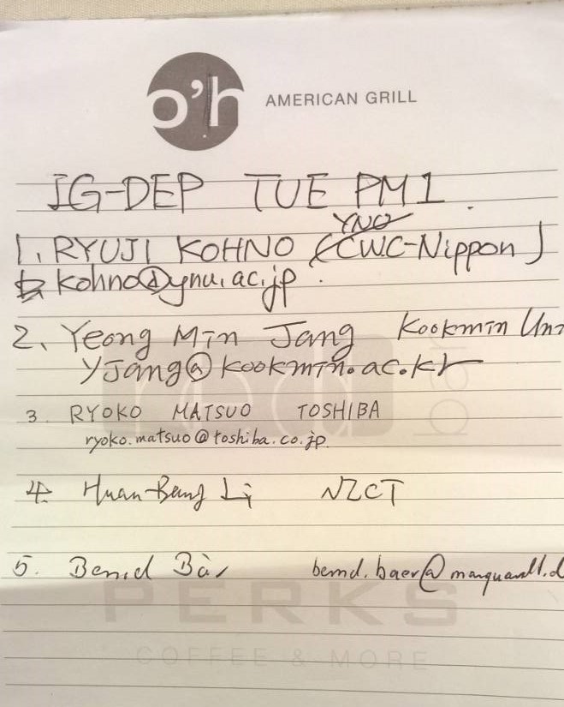
Bend Baer(Marquardt),
HuanBang Li(NICT)
Yeong Min Jang(Kookmin Univ.)
Ryoko Matsuo(Toshiba)
Ryuji Kohno(YNU/CWC-Nippon)

Tuesday 6 March, 2018, PM3, 18:30-20:30

  - Meeting called to order at 18:30

  - Roll Call
Notepad was circulated

  - Presentation
- Dependable wireless feedback controlling schemes considering errors and delay in sensing data and controlling command packets doc.#15-18-0116-00-0dep

It was presented to focus two major design criteria, i.e. channel errors and loop delay for wireless remote sensing and controlling feedback loop. As a typical example, wireless remote controllable implant capsule endoscopy applies a new proposed joint stop-and-wait ARQ and video image recognition scheme and compression coding etc.

- An Adaptive Control System for Anesthesia during Surgery Operation Using Model Predictive Control of Anesthetic Effects doc.#15-18-0129-00-0dep

It was presented to demonstrate a model-base remote sensing and controlling in which a human body can be modeled for predictive controlling for deep learning.

  - Discussion
Manner of modelling a target machine such as implant capsule endoscopy and wearable insulin pump, and input/output response of a human body etc. were discussed. In particular, prediction errors and learning time are keen for feedback control loop.

  - Recess at 20:05

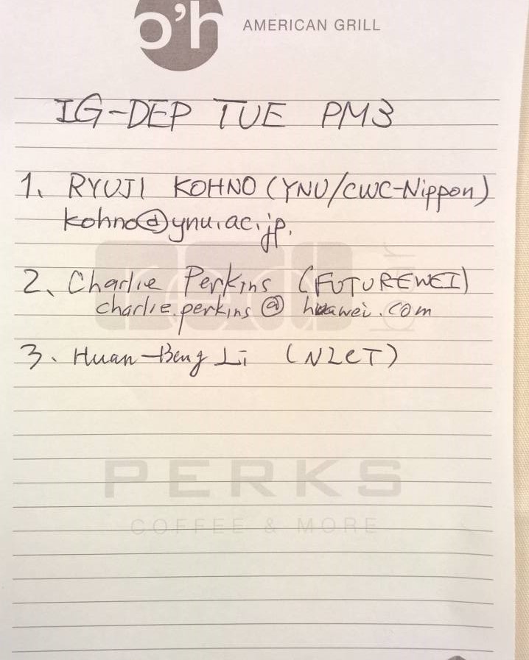
  - Attendees 3

Charlie Perkins(FUTUREWEI)
HungBang Li(NICT)
Ryuji Kohno(YNU/CWC-Nippon)

WedneCorresday 7 March, 2018, PM1, 13:30-15:30

  - Meeting called to order at 13:01

  - Roll Call
Notepad was circulated.

  - Agenda
Agenda was updated as doc #092r1.

  - Review of previous two sessions on Tuesday and discussion
- Correlated packs of sensing data and its corresponded controlling command in feedback loop. MAC protocol should take into account of this correlation in terms of expected loop delay between the data and the command.
- Different impact of channel errors in the sensed data and the controlling command in stable controlling car, UAV, robots etc.
- Various importance or priority in data packets from sensor nodes and command packets from coordinator.

  - Presentation
- A dependable MAC protocol matched to bi-directional transmission in WBAN
doc.#15-18-0115-00-odep
To guarantee dependability in WBAN, a new MAC protocol for bi-directional transaction between sensor nodes and corrdinator node in WBAN is presented to correspond for the correlated packs of sensing data and its corresponded controlling command in feedback loop. Two major proposals are modified EAP(M-EAP) and guaranteed slot(G-Slot) like guaranteed period in IEEE802.15.4.

- Superframe controlling scheme based on IEEE802.15.6 for dependable WBAN
doc.#15-18-0138-00-0dep

Another new proposed MAC protocol for dependable WBAN for human body and car, UAV, robot bodies is presented. In particular, DS IR-UWB is applied in hybrid contention free and contention base MAC protocol in which various spreading ratio is assigned to different QoS levels of packets.

  - Discussion

  - Update of technical requirement

Corresponding to the above -mentioned key issues, technical requirement according to a new subclasss of case cases doc#15-16-0557-06-odep

- Individual device reliability assessment and aggregate reliability assessment needs to be defines.
- Multipath forwarding protocol needs to include redundant coding to cope with lost/corrupted/missing frames.

  - Scheduling of May meeting
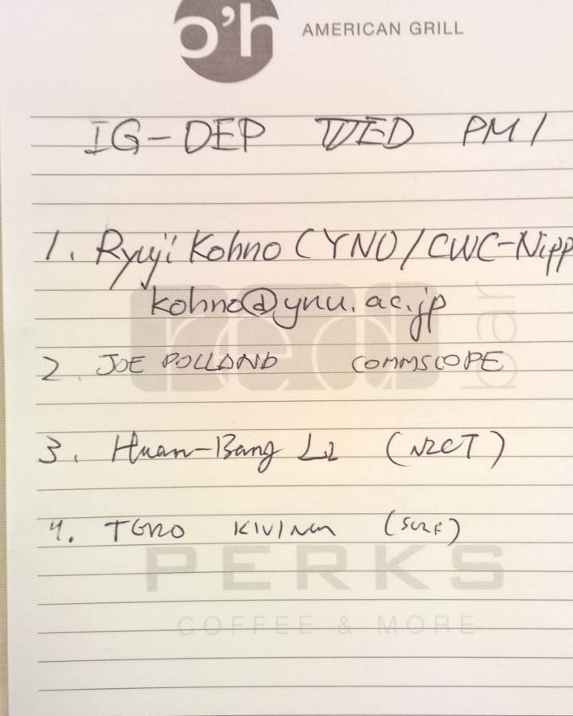
  - Adjourn 15:29

  - Attendees 4

Joe Polland (Commscope)
Timo Kivlim(Surf)
HuanBang Li(NICT)
Ryuji Kohno(YNU/CWC-Nippon)

