IEEE P802.15
Wireless Personal Area Networks

Project | IEEE P802.15 Working Group for Wireless Personal Area Networks (WPANs)
Title | LB D0 Comment Resolution based Changes on Dimming and Flicker Mitigation Section
Date Submitted | January 2017
Source | Jaesang Cha (SNUST), SangWoon Lee (Namseoul Univ.) , Jeonggon Kim (Korea Polytechnic Univ. ), Soo Young Chang (CSUS), Vinayagam Mariappan (SNUST ) | Voice: [ ]  Fax: [ ]  E-mail: [chajs@seoultech.ac.kr]
Re: | LB1 D0 Comment Resolution supportive documents for Dimming and Flicker Mitigation Revision
Abstract | Details of Resolutions regarding to the submitted Comments on LB D0 are suggested for Dimming and Flicker Mitigation. The Dimming and Flicker Mitigation Revision based on Modulation Schemes is provides the specification to design of LED ID / OCC based application services like IoT/IoL, LED ID, Digital Signage with Advertisement Information, LBS, Emergency EXIT Signage, etc.
Purpose | LB D0 Comments Resolutions and Editorial Revision.
Notice | This document has been prepared to assist the IEEE P802.15. It is offered as a basis for discussion and is not binding on the contributing individual(s) or organization(s). The material in this document is subject to change in form and content after further study. The contributor(s) reserve(s) the right to add, amend or withdraw material contained herein.
Release | The contributor acknowledges and accepts that this contribution becomes the property of IEEE and may be made publicly available by P802.15.

Comment 152 and 153

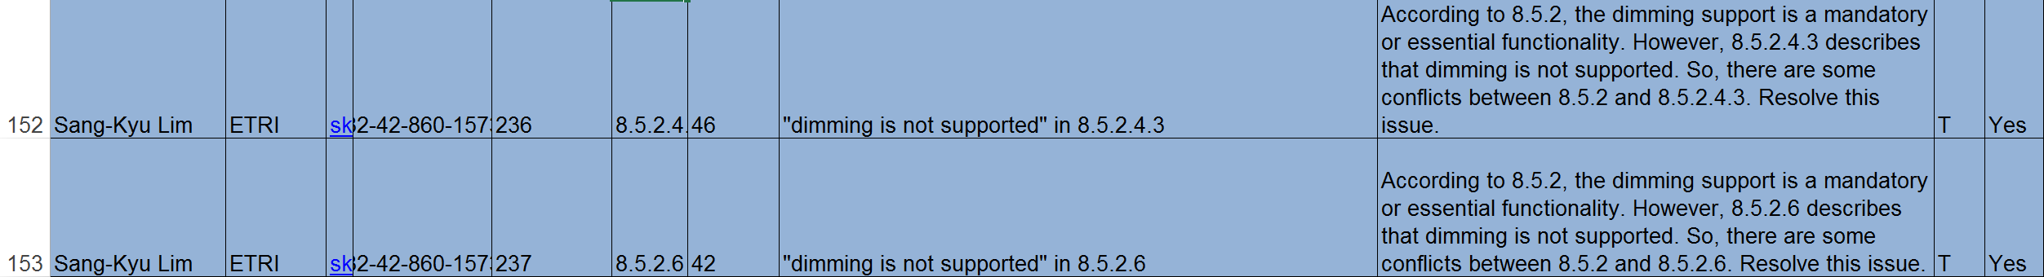

152 Comment Resolution Based Change

PDF Page 236

[RESOLUTION NOTE:

1-Change the text to "Offset VPWM causes flicker and dimming is supported by pulse width dimming."

2-Change the dimming method for offset-VPWM in table 83]

8.5.2.4.3 Offset-VPWM dimming

Offset VPWM causes flicker and dimming is supported by pulse width dimming.

153 Comment Resolution Based Change

PDF Page 237

[RESOLUTION NOTE:

1- Change to "PHY VI modes operate with flicker and dimming is supported by analog dimming but not during data transmission."

2-Change the dimming method for PHY VI accordingly in table 83]

8.5.2.6 PHY VI dimming

PHY VI modes operate with flicker and dimming is supported by analog dimming but not during data transmission.

PDF Page 234

Table 83—Choice of dimming methods for PHY operating modes

Mode | Compensation symbol insertion dimming | Pulse width dimming | Amplitude dimming | out-of-band dimming
PHY I, II, III
OOK | x |  | x | x
VPPM |  | x | x | x
CSK |  |  | x | x
PHY IV
UFSOOK |  | x | x | x
S2-PSK |  |  | x | x
Twinkle VPPM |  | x | x | x
HS-PSK |  | x | x | x
Offset-VPPM |  | x
PHY V
RS-FSK |  | x | x | x
CM-FSK |  | x | x | x
C-OOK |  |  | x | x
MPM | x | x | x | x
PHY VI
A-QL |  |  | x
VTASC |  |  | x
SS2DC |  |  | x
IDE |  |  | x
HA-QL |  |  | x

