IEEE P802.15
Wireless Personal Area Networks

Project | IEEE P802.15 Working Group for Wireless Personal Area Networks (WPANs)
Title | LB D0 Comment Resolution based Changes on OWC Draft Introduction Section
Date Submitted | January 2017
Source | Jaesang Cha (SNUST), SangWoon Lee (Namseoul Univ.) , Jeonggon Kim (Korea Polytechnic Univ. ), Soo Young Chang (CSUS), Vinayagam Mariappan (SNUST ) | Voice: [ ]  Fax: [ ]  E-mail: [chajs@seoultech.ac.kr]
Re: | LB1 D0 Comment Resolution supportive documents for OWC Draft Introduction Section Revision
Abstract | Details of Resolutions regarding to the submitted Comments on LB D0 are suggested for OWC Draft Introduction Section. The OWC Draft Introduction Section based on Modulation Schemes is provides the specification to design of LED ID / OCC based application services like IoT/IoL, LED ID, Digital Signage with Advertisement Information, LBS, Emergency EXIT Signage, etc.
Purpose | LB D0 Comments Resolutions and Editorial Revision.
Notice | This document has been prepared to assist the IEEE P802.15. It is offered as a basis for discussion and is not binding on the contributing individual(s) or organization(s). The material in this document is subject to change in form and content after further study. The contributor(s) reserve(s) the right to add, amend or withdraw material contained herein.
Release | The contributor acknowledges and accepts that this contribution becomes the property of IEEE and may be made publicly available by P802.15.

Comment 13

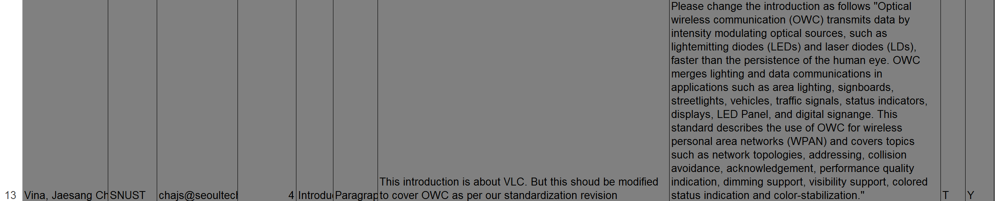

Comment Resolution Based Change

PDF Page 4

Introduction

Optical wireless communication (OWC) transmits data by intensity modulating optical sources, such as light emitting diodes (LEDs) and laser diodes (LDs), faster than the persistence of the human eye. OWC merges lighting and data communications in applications such as area lighting, signboards, streetlights, vehicles, traffic signals, status indicators, displays, LED Panel, and digital signage. This standard describes the use of OWC for wireless personal area networks (WPAN) and covers topics such as network topologies, addressing, collision avoidance, acknowledgement, performance quality indication, dimming support, visibility support, colored status indication and color-stabilization.

Comment 67

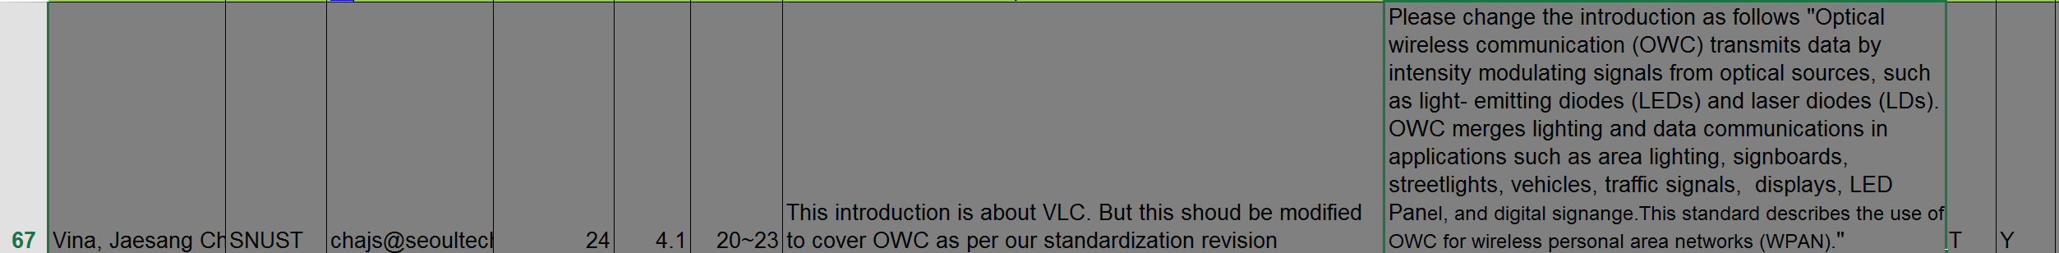

PDF Page 24

4.1 Introduction

Optical wireless communication (OWC) transmits data by intensity modulating signals from optical sources, such as light- emitting diodes (LEDs) and laser diodes (LDs). OWC merges lighting and data communications in applications such as area lighting, signboards, streetlights, vehicles, traffic signals, displays, LED Panel, and digital signage. This standard describes the use of OWC for wireless personal area networks (WPAN).

a) Star, peer-to-peer, or broadcast operation
b) 16-bit short or 64-bit extended addresses
c) Scheduled or slotted random access with collision avoidance transmission
d) Fully acknowledged protocol for transfer reliability
e) Wavelength quality indication (WQI)
f) Dimming support
g) Visibility support
h) Color function support
i) Color-stabilization support

