IEEE P802.15
Wireless Personal Area Networks

Project | IEEE P802.15 Working Group for Wireless Personal Area Networks (WPANs)
Title | Intel Comment Resolutions
Date Submitted | Jan 2018
Source | [Roberts, Richard D]  [<company>]  [address] | Voice: [ ]  Fax: [ ]  E-mail: [ ]
Notice | This document has been prepared to assist the IEEE P802.15. It is offered as a basis for discussion and is not binding on the contributing individual(s) or organization(s). The material in this document is subject to change in form and content after further study. The contributor(s) reserve(s) the right to add, amend or withdraw material contained herein.
Release | The contributor acknowledges and accepts that this contribution becomes the property of IEEE and may be made publicly available by P802.15.

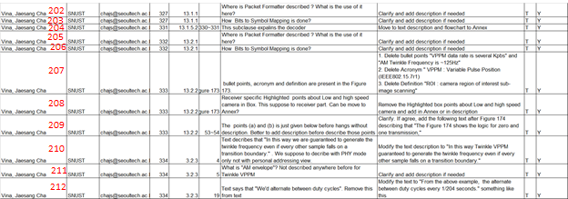

178. Synchronization text clarification

Comment accepted. The text shall be rewritten to reflect only the PSDU field and the current text shall be move to an informative annex as discussed in the resolution of comment 208.

- UFSOOK Packet Format
All PHY PPDU formats are described in clause 8.6 PPDU format. The clauses pertinent to UFSOOK are 8.6.1.2.1 and 8.6.5.2.1.

- Bit to symbol mapping
UFSOOK maps one bit per symbol. The bit to symbol mapping is in clause 13.1.2.

- Decoder and Figure 171
Clause 13.1.5.2 was intended to discuss the protocol encoder. Your comment is a good one since the flowchart in figure 171 emphasizes the decoder and not the encoder. The flowchart of figure 171 will be rewritten to reflect only the encoding process, after which clause 13.1.5.2 should remain.

- Twinkle VPPM Packet Format
All PHY PPDU formats are described in clause 8.6 PPDU format. The clauses pertinent to Twinkle VPPM are 8.6.1.2.2, 8.6.5.2.1 and 8.6.5.2.2.

- Bit to symbol mapping
Twinkle VPPM maps one bit per symbol. There are two possible symbols, each with a different duty cycle, depending upon the phase of the amplitude envelope. This is discussed in clause 13.2.2.

- Amplitude envelope encoder and Figure 173
Thank you for the comment. The intention was to emphasis the amplitude envelope encoding process. Clause 13.2.2 will be rewritten to discuss the encoder, after which it should remain.

- Twinkle VPPM receiver highlights
An informative annex will be added to discuss the reasoning behind the generation of the Twinkle VPPM amplitude envelope and all the information comments in regards to decoding will be moved to that informative annex.

- Clarification
Comment accepted. In addition, as discussed in the resolution of comment 208, reference will be made to an informative annex which provides additional explanation in regards to generating and decoding the amplitude envelope.

- Text modification
Comment accepted. In addition, as discussed in the resolution of comment 208, reference will be made to an informative annex which provides additional explanation in regards to generating and decoding the amplitude envelope.

- AM envelope
Agree that the term “AM envelope” was the introduction of an undefined acronym. This can be remedied by replacing the acronym with the phrase “amplitude modulation envelope”. In addition, as discussed in the resolution of comment 208, reference will be made to an informative annex which provides additional explanation in regards to generating and decoding the amplitude envelope.

- Alternate between duty cycles
This particular text will be removed and replaced with a reference to an informative annex that provides these details as discussed in the resolution of comment 208.

