**IEEE P802.15**

**Wireless Personal Area Networks**

|  |  |  |
| --- | --- | --- |
| Project | IEEE P802.15 Working Group for Wireless Personal Area Networks (WPANs) | |
| Title | Text input into D1 for Pulsed Modulation PHY | |
| Date Submitted | 19 July 2017 | |
| Source | Volker Jungnickel (Fraunhofer HHI)  Mohammad Noshad (VLNComm)  Tae-Gyu Kang (ETRI)  Sang-Kyu Lim (ETRI)  Jonas Hilt (HHI) | Voice: [ ] Fax: [ ] E-mail: [ ] |
| Re: | [If this is a proposed revision, cite the original document.]  [If this is a response to a Call for Contributions, cite the name and date of the Call for Contributions to which this document responds, as well as the relevant item number in the Call for Contributions.]  [Note: Contributions that are not responsive to this section of the template, and contributions which do not address the topic under which they are submitted, may be refused or consigned to the “General Contributions” area.] | |
| Abstract | [Proposal for pulsed modulation PHY in D1 of 802.15.13] | |
| Purpose | [Inform TG13 about most recent work.] | |
| Notice | This document has been prepared to assist the IEEE P802.15. It is offered as a basis for discussion and is not binding on the contributing individual(s) or organization(s). The material in this document is subject to change in form and content after further study. The contributor(s) reserve(s) the right to add, amend or withdraw material contained herein. | |
| Release | The contributor acknowledges and accepts that this contribution becomes the property of IEEE and may be made publicly available by P802.15. | |

*Descriptive part of Pulsed Modulation PHY*

b) Pulsed Modulation PHY: This PHY is intended for applications requiring moderate data rate from 1 Mbit/s up to few 100 Mbit/s. The main target here is to achieve higher data rates by increasing the optical clock rate. Also it includes techniques to adapt the data rate to varying channel conditions while using a constant optical clock rate. Therefore, it uses PAM modulation with variable line coding and code rates as defined in Table 107.

*Normative part*

**10 Pulsed Modulation PHY**

**10.1 Transmitter Structure**



Figure ??? –Transmitter Structure in Pulsed Modulation PHY

**10.2 Forward Error Correction Encoder**

The Pulsed Modulation PHY uses Reed-Solomon Coding denoted as RS(*n*, *k*) where n denotes the number of input bits and *k* the number of output bits. The code rate can be changed depending on the required error protection.

**10.3 Line Encoder**

The line encoder uses 8B10 and Binary PPM. Note that, for maintaining a constant average light output, both the systematic output of the FEC ( $n$ bits) and the redundant part (*k*-*n* bits) should pass through the line encoder.

**10.4.1 PAM Mapper**

**10.4.2 PAM Mapper**

The PAM mapper is using 4-PAM only. It puts two consecutive bits into a symbol and maps them as {00, 01, 10, 11} to {0, $\frac{1}{3}$. $\frac{2}{3}$, 1}.

**10.4.3 HCM Mapper**

Hadamard Coded Modulation (HCM) is a bit to symbol mapper that is applied on the signal after OOK or PAM, and removes the need for line coding. In this block, as shown in Figure 180, a block of $N$ (where $N$ is a power of two) data symbols are inserted into a fast Walsh-Hadamard transform (FWHT). As described in [Ref A], the HCM signal $x = [x_{0}, x_{1}, · · · , x_{N-1}]$ is generated from the data sequence $u = [u_{0}, u_{1}, · · · , u_{N-1}]$ as $x = H_{N} u + \overline{H_{N}} (1-u)$, where $H_{N}$ is the binary Hadamard matrix of order $N$ [Ref B], and $\overline{H_{N}}$ is the complement of $H_{N}$. The components of $u$ are assumed to be $M$-ary pulse amplitude modulated (PAM), where $u_{n} ∈\{0,\frac{1}{M-1},\frac{2}{M-1}, . . . , 1\}$ o for $n = 0, 1, . . . , N-1$.

As shown in [Ref A], the DC part of HCM signals can be reduced without losing any information, making HCM more average power efficient. Let the first component of $u$ ($u_{0}$) be set to zero and only $N - 1$ codewords of the Hadamard matrix be modulated, as proposed in [Ref A]. In this scheme, the average transmitted power is reduced by sending ($x –\min{x}$) instead of $x$, An example of DC reduction is shown in Figure 181. The reduced DC level is per HCM symbol and its value can be different for each symbol. This makes the transmitted signals orthogonal to DC bias at a $1/N$ overhead cost on data-rate. The overhead for different $N$’s are listed in Table 145.

../../UVA%20-%20HCM%20(JSAC)/Main/HCM-TCOM/HCM-Transmitter.pdf

Figure 180. HCM encoder structure

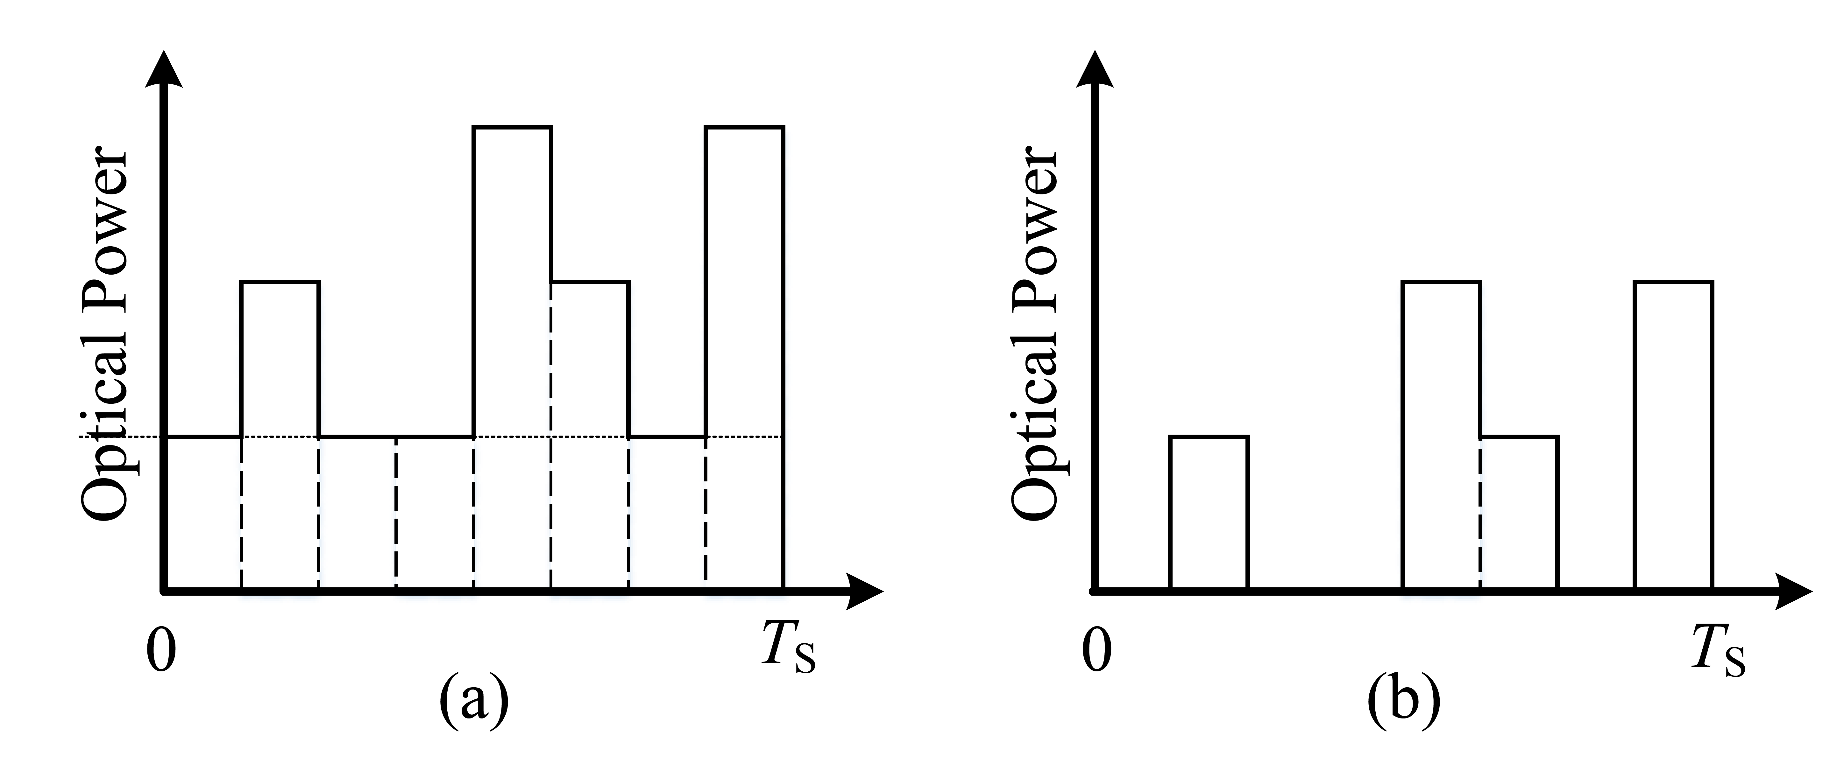

Figure 181. (a) An HCM signal, and (b) its corresponding DC reduced signal.

|  |  |
| --- | --- |
| Size of Hadamard Matrix ( $N)$ | Data-rate overhead |
| 4 | 25% |
| 8 | 12.5% |
| 16 | 6.25% |
| 32 | 3.125% |

Table 145. Over-head of HCM for different $N$’s

At the receiver side, the decoder is realized by an inverse FWHT (IFWHT) as shown in Figure 182.

../../UVA%20-%20HCM%20(JSAC)/Main/HCM-TCOM/HCM-Receiver.pdf

Figure 182. HCM decoder structure

**Parameter settings**

|  |  |  |  |  |  |  |
| --- | --- | --- | --- | --- | --- | --- |
| Modulation | Level | FEC RS(n,k) | Line code | HCM | Optical Clock Rates/MHz | Data Rate/Mbps |
| PAM | 2 | (550, 524)  (255, 248)  (160, 128)  (36,24) | 8B10B | (1,1) | 200/2N with N=0…7 | t.b.d. |
| Binary PPM |
| 2 | 1B1B | (7,8) |
| 4 | (15,16) |

[Ref A] Noshad, Mohammad, and Maïté Brandt-Pearce. "Hadamard-coded modulation for visible light communications." *IEEE Transactions on Communications* 64.3 (2016): 1167-1175.

[Ref B] K. J. Horadam, Hadamard Matrices and Their Applications. Princeton University Press, 2006.