**IEEE P802.15**

**Wireless Personal Area Networks**

|  |  |  |
| --- | --- | --- |
| Project | IEEE P802.15 Working Group for Wireless Personal Area Networks (WPANs) | |
| Title | Text input into D1 for Pulsed Modulation PHY | |
| Date Submitted | 19 July 2017 | |
| Source | Volker Jungnickel (Fraunhofer HHI)  Mohammad Noshad (VLNComm)  Tae-Gyu Kang (ETRI)  Sang-Kyu Lim (ETRI)  Jonas Hilt (HHI) | Voice: [ ] Fax: [ ] E-mail: [ ] |
| Re: | [If this is a proposed revision, cite the original document.]  [If this is a response to a Call for Contributions, cite the name and date of the Call for Contributions to which this document responds, as well as the relevant item number in the Call for Contributions.]  [Note: Contributions that are not responsive to this section of the template, and contributions which do not address the topic under which they are submitted, may be refused or consigned to the “General Contributions” area.] | |
| Abstract | [Proposal for pulsed modulation PHY in D1 of 802.15.13] | |
| Purpose | [Inform TG13 about most recent work.] | |
| Notice | This document has been prepared to assist the IEEE P802.15. It is offered as a basis for discussion and is not binding on the contributing individual(s) or organization(s). The material in this document is subject to change in form and content after further study. The contributor(s) reserve(s) the right to add, amend or withdraw material contained herein. | |
| Release | The contributor acknowledges and accepts that this contribution becomes the property of IEEE and may be made publicly available by P802.15. | |

*Descriptive part of Pulsed Modulation PHY*

Goes into Section 4.4.1

b) Pulsed Modulation PHY: This PHY type is intended for applications requiring moderate data rate from 1 Mbit/s up to few 100 Mbit/s. The main target here is to achieve higher data rates by increasing the optical clock rate. Also it includes techniques to adapt the data rate to varying channel conditions while using a constant optical clock rate. Therefore, it uses modulation schemes like PPM, OOK and PAM and variable code rates as defined in Table 107.

**4.4.3 Dimming Support**

Dimming in general is an optional feature and designed so that it is independent of the communication functionality. The receiver is not required to know what dimming level is used while communication is ongoing.

**4.4.3.1 Dimming Support Using Constant Bias Current**

Dimming can be controlled via a bias current which is constant over time and orthogonal to the modulator output signal used for the data transmission (denoted as modulation signal).

The OWC system is responsible for the modulation while the lighting system provides a dimming level which is processed in a control unit being independent of the OWC system. The control unit can set both, the bias and the modulation index to achieve the required dimming level and to avoid clipping. Finally, the bias and the modulation are added, as shown in Figure 9.

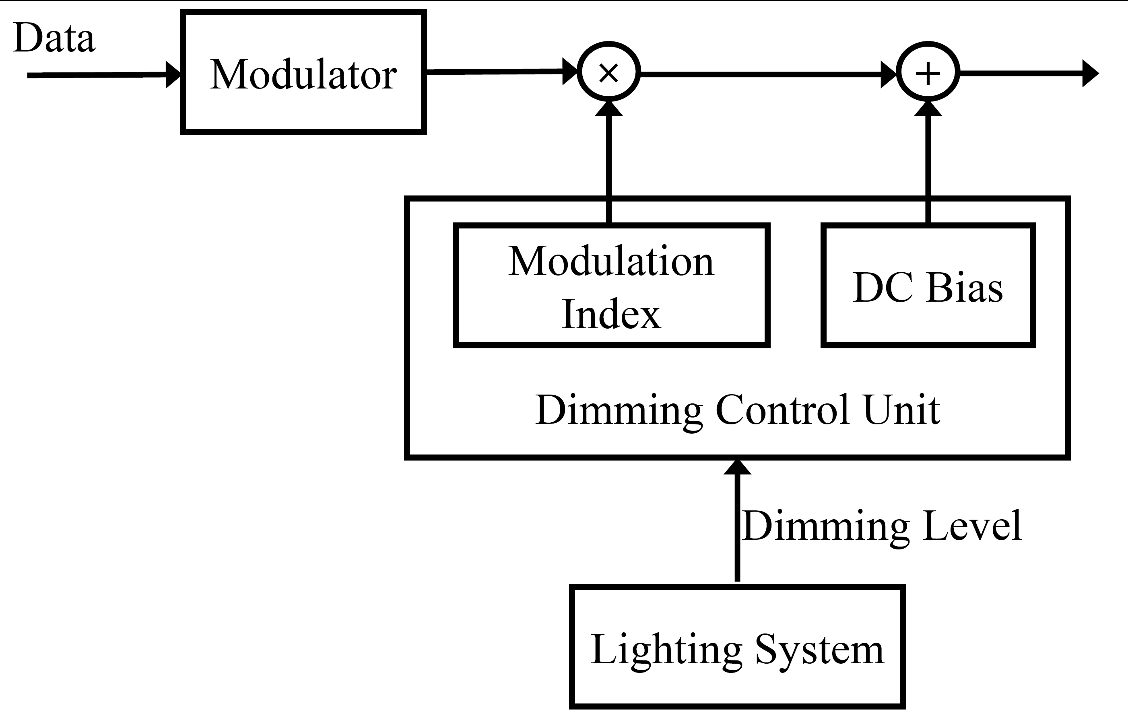

Figure 9. Dimming control through modulation index and DC bias

In this way, the receiver does not even need to know the dimming level for decoding the data from the compound signal received after the PD, and if needed, the transmitter is free to set the dimming level independent of the receiver. Accordingly, there is no need for signalling fields telling the receiver the dimming level used at the transmitter, or an accordingly used parameter setting of the modulation scheme.

**4.4.3.2 Dimming support by using the pulse width control**

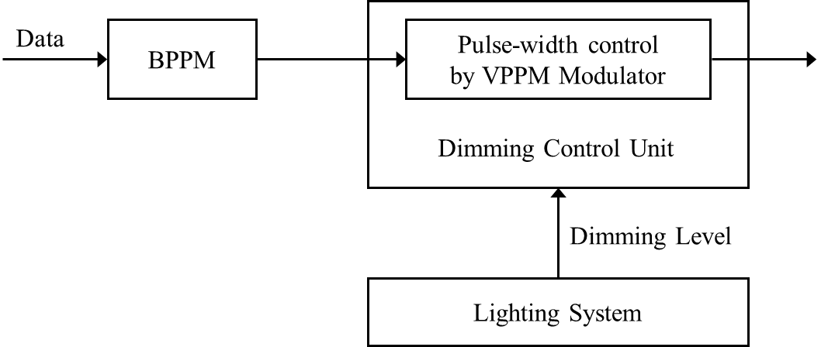

Figure 10. Dimming control through the VPPM modulation

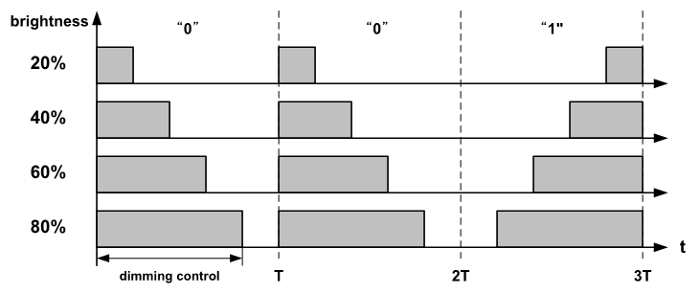

Figure 11. Schematic mechanism for dimming control using VPPM modulation

This method is using the pulse width control in the pulse-shaping filter following the modulation part of the system, as e.g. in combination with the VPPM modulation shown in Figure 11. Instead of changing the bias current, here the pulse width of VPPM symbol is adapted according to the dimming level, yielding shorter pulse width for lower light level, for instance.

*Normative part*

**10 Pulsed Modulation PHY**

**10.1 Transmitter Structure**



Figure ??? –Transmitter Structure in Pulsed Modulation PHY

**10.2 Forward Error Correction**

The Pulsed Amplitude Transmitter is using Reed-Solomon Coding denoted as RS(*n*, *k*) where n denotes the number of input bits and *k* the number of output bits. In particular, there are short and long block lengths *n* for control and data, accordingly. Moreover, the code rate is adaptable in several steps.

**10.3 Line Encoder**

The line coder uses simple formats such as the Manchester code, or more complex schemes such as 4b6b or 8b10b for OOK and 5S6S in case of 4-PAM. Note that, for maintaining a constant average light output, both the systematic output of the FEC ( $n$ bits) and the redundant part (*k*-*n* bits) should pass through the line encoder.

**10.4. Symbol Mapper**

**10.4.1 OOK Mapper**

The OOK mapper is transparent, it maps {0, 1} to {0, 1}.

**10.4.2 PAM Mapper**

The PAM mapper is using 4-PAM only. It puts two consecutive bits into a symbol and maps them as {00, 01, 10, 11} to {0, $\frac{1}{3}$. $\frac{2}{3}$, 1}.

**10.4.3 HCM Mapper**

Hadamard Coded Modulation (HCM) is a bit to symbol mapper that is applied on the signal after OOK or PAM, and removes the need for line coding. In this block, as shown in Figure 180, a block of $N$ (where $N$ is a power of two) data symbols are inserted into a fast Walsh-Hadamard transform (FWHT). As described in [Ref A], the HCM signal $x = [x_{0}, x_{1}, · · · , x_{N-1}]$ is generated from the data sequence $u = [u_{0}, u_{1}, · · · , u_{N-1}]$ as $x = H_{N} u + \overline{H_{N}} (1-u)$, where $H_{N}$ is the binary Hadamard matrix of order $N$ [Ref B], and $\overline{H_{N}}$ is the complement of $H_{N}$. The components of $u$ are assumed to be $M$-ary pulse amplitude modulated (PAM), where $u_{n} ∈\{0,\frac{1}{M-1},\frac{2}{M-1}, . . . , 1\}$ o for $n = 0, 1, . . . , N-1$.

As shown in [Ref A], the DC part of HCM signals can be reduced without losing any information, making HCM more average power efficient. Let the first component of $u$ ($u_{0}$) be set to zero and only $N - 1$ codewords of the Hadamard matrix be modulated, as proposed in [Ref A]. In this scheme, the average transmitted power is reduced by sending ($x –\min{x}$) instead of $x$, An example of DC reduction is shown in Figure 181. The reduced DC level is per HCM symbol and its value can be different for each symbol. This makes the transmitted signals orthogonal to DC bias at a $1/N$ overhead cost on data-rate. The overhead for different $N$’s are listed in Table 145.

../../UVA%20-%20HCM%20(JSAC)/Main/HCM-TCOM/HCM-Transmitter.pdf

Figure 180. HCM encoder structure

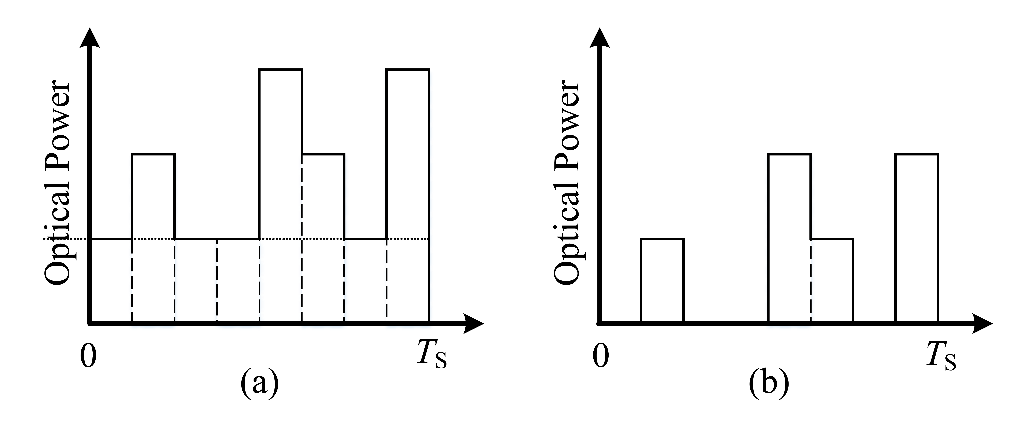

Figure 181. (a) An HCM signal, and (b) its corresponding DC reduced signal.

|  |  |
| --- | --- |
| Size of Hadamard Matrix ( $N)$ | Data-rate overhead |
| 4 | 25% |
| 8 | 12.5% |
| 16 | 6.25% |
| 32 | 3.125% |

Table 145. Over-head of HCM for different $N$’s

At the receiver side, the decoder is realized by an inverse FWHT (IFWHT) as shown in Figure 182.

../../UVA%20-%20HCM%20(JSAC)/Main/HCM-TCOM/HCM-Receiver.pdf

Figure 182. HCM decoder structure

**Current parameter settings**

(to be discussed and finally included in new Table 107).

|  |  |  |  |  |  |
| --- | --- | --- | --- | --- | --- |
| Mode | FEC | Line code | Bit-to-symbol mapping | Clock Rate/MHz | Data Rate/Mbps |
| OOK | RS(n,k) with  (550, 524) | 8B10B | OOK | $n_{1}$ MHz  ($n_{1}=2,...,9$) $n_{2}×10$ MHz  ($n_{2}=1,…,10$) | 1.52 Mbps…  76.1 Mbps |
| RS with  (36, 24) | 8B10B | OOK | 1.06 Mbps… 53.3 Mbps |
| RS(n,k) with  (160, 128) | 4B6B | OOK | 4, 8, 16, 32, 64 MHz | 2.13 Mbps… 34.13 Mbps |
| RS(n,k) with  (160, 128) | Binary PPM | OOK | 4, 8, 16, 32, 64 MHz | 1.6 Mbps… 25.6 Mbps |
| PAM | RS(n,k) with  (550, 524) | 5S6S | 4-PAM | 2, 4, 8, 16, 32, 64 MHz | 3.14 Mbps…  100.5 Mbps |
| HCM | RS(n,k) with  (255, 248) | None | OOK + (7,8) HCM…  4-PAM + (31, 32) HCM | 3.125, 6.25, 12.5, 25, 50, 100 MHz | 2.66 Mbps…  188.4 Mbps |

[Ref A] Noshad, Mohammad, and Maïté Brandt-Pearce. "Hadamard-coded modulation for visible light communications." *IEEE Transactions on Communications* 64.3 (2016): 1167-1175.

[Ref B] K. J. Horadam, Hadamard Matrices and Their Applications. Princeton University Press, 2006.