IEEE P802.15
Wireless Personal Area Networks

Project | IEEE P802.15 Working Group for Wireless Personal Area Networks (WPANs)
Title | Text input into D1 for Pulsed Modulation PHY
Date Submitted | 19 July 2017
Source | Volker Jungnickel (Fraunhofer HHI)  Mohammad Noshad (VLNComm)  Tae-Gyu Kang (ETRI)  Sang-Kyu Lim (ETRI)  Jonas Hilt (HHI) | Voice: [ ]  Fax: [ ]  E-mail: [ ]
Re: | [If this is a proposed revision, cite the original document.]  [If this is a response to a Call for Contributions, cite the name and date of the Call for Contributions to which this document responds, as well as the relevant item number in the Call for Contributions.]  [Note: Contributions that are not responsive to this section of the template, and contributions which do not address the topic under which they are submitted, may be refused or consigned to the “General Contributions” area.]
Abstract | [Proposal for pulsed modulation PHY in D1 of 802.15.13]
Purpose | [Inform TG13 about most recent work.]
Notice | This document has been prepared to assist the IEEE P802.15. It is offered as a basis for discussion and is not binding on the contributing individual(s) or organization(s). The material in this document is subject to change in form and content after further study. The contributor(s) reserve(s) the right to add, amend or withdraw material contained herein.
Release | The contributor acknowledges and accepts that this contribution becomes the property of IEEE and may be made publicly available by P802.15.

Descriptive part of Pulsed Modulation PHY

Goes into Section 4.4.1

b) Pulsed Modulation PHY: This PHY type is intended for applications requiring moderate data rate from 1 Mbit/s up to few 100 Mbit/s. The main target here is to achieve higher data rates by increasing the optical clock rate. Also it includes techniques to adapt the data rate to varying channel conditions while using a constant optical clock rate. Therefore it uses modulation schemes like PPM, OOK and PAM and variable code rates as defined in Table 107.

4.4.3 Dimming support

Dimming in general is an optional feature and designed so that it is independent of the communication functionality. The receiver is not required to know what dimming level is used while communication is ongoing.

4.4.3.1 Dimming support using constant bias current

Dimming can be controlled via a bias current which is constant over time and orthogonal to the modulator output signal used for the data transmission (denoted as modulation signal). This property of the modulation signal can be realized using several techniques, e.g. by using line coding (e.g. Manchester coding, 4B6B or 8B10B) or Hadamard Coded Modulation (HCM)) as described in section 10.x.

The OWC system is responsible for the modulation while the lighting system provides a dimming level which is processed in a control unit being independent of the OWC system. The control unit can set both, the bias and the modulation index to achieve the required dimming level and to avoid clipping. Finally, the bias and the modulation are added, as shown in Figure XXX.

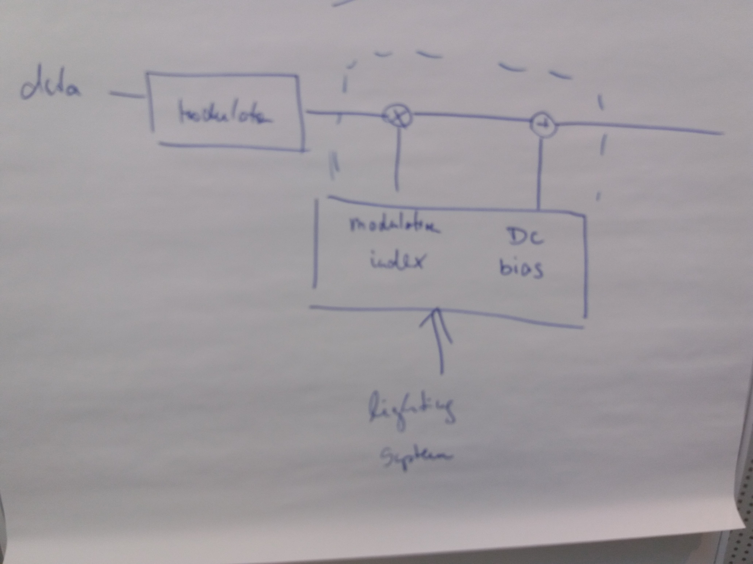
Figure XXX

In this way, the receiver does not even need to know the dimming level in order to decode the data from the compound signal received after the PD, and if needed, the transmitter is free to set the dimming level independent of the receiver. Accordingly, there is no need for signalling fields telling the receiver the dimming level used at the transmitter, or an accordingly used parameter setting of the modulation scheme.

4.4.3.2 Dimming support by using the pulse width

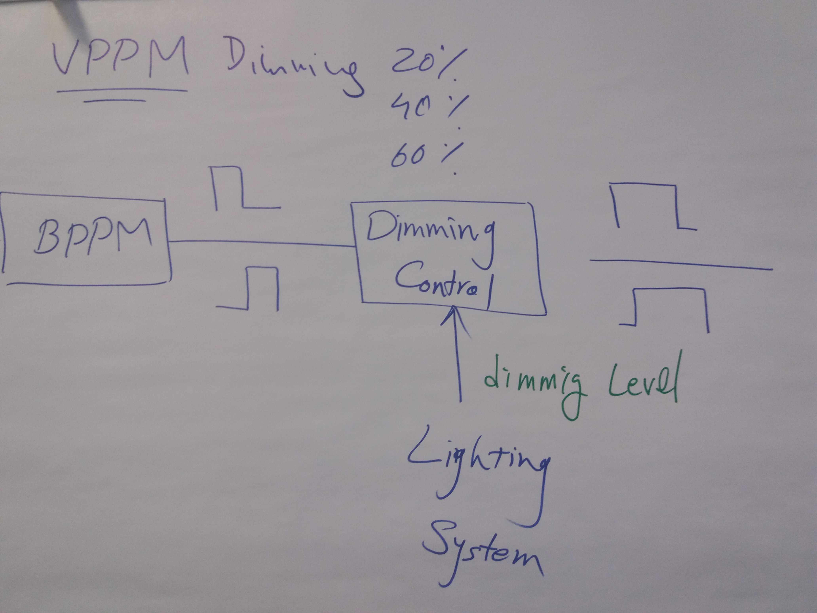

Figure XXX+1 Dimming for VPPM

This method is using the pulse width in the pulse-shaping filter following the modulation part of the system, as e.g. in combination with the VPPM modulation described in section 10.x. Instead of changing the bias current, here the pulse width is adapted according to the dimming level, yielding shorter pulse width for lower light level, for instance.

Updated text will be provided by Mohammad Noshad (vlncomm) and Sang-Kyu Lim (ETRI)
in a revised version of this document.

Normative part

10 Pulsed Modulation PHY

10.1 Transmitter architecture

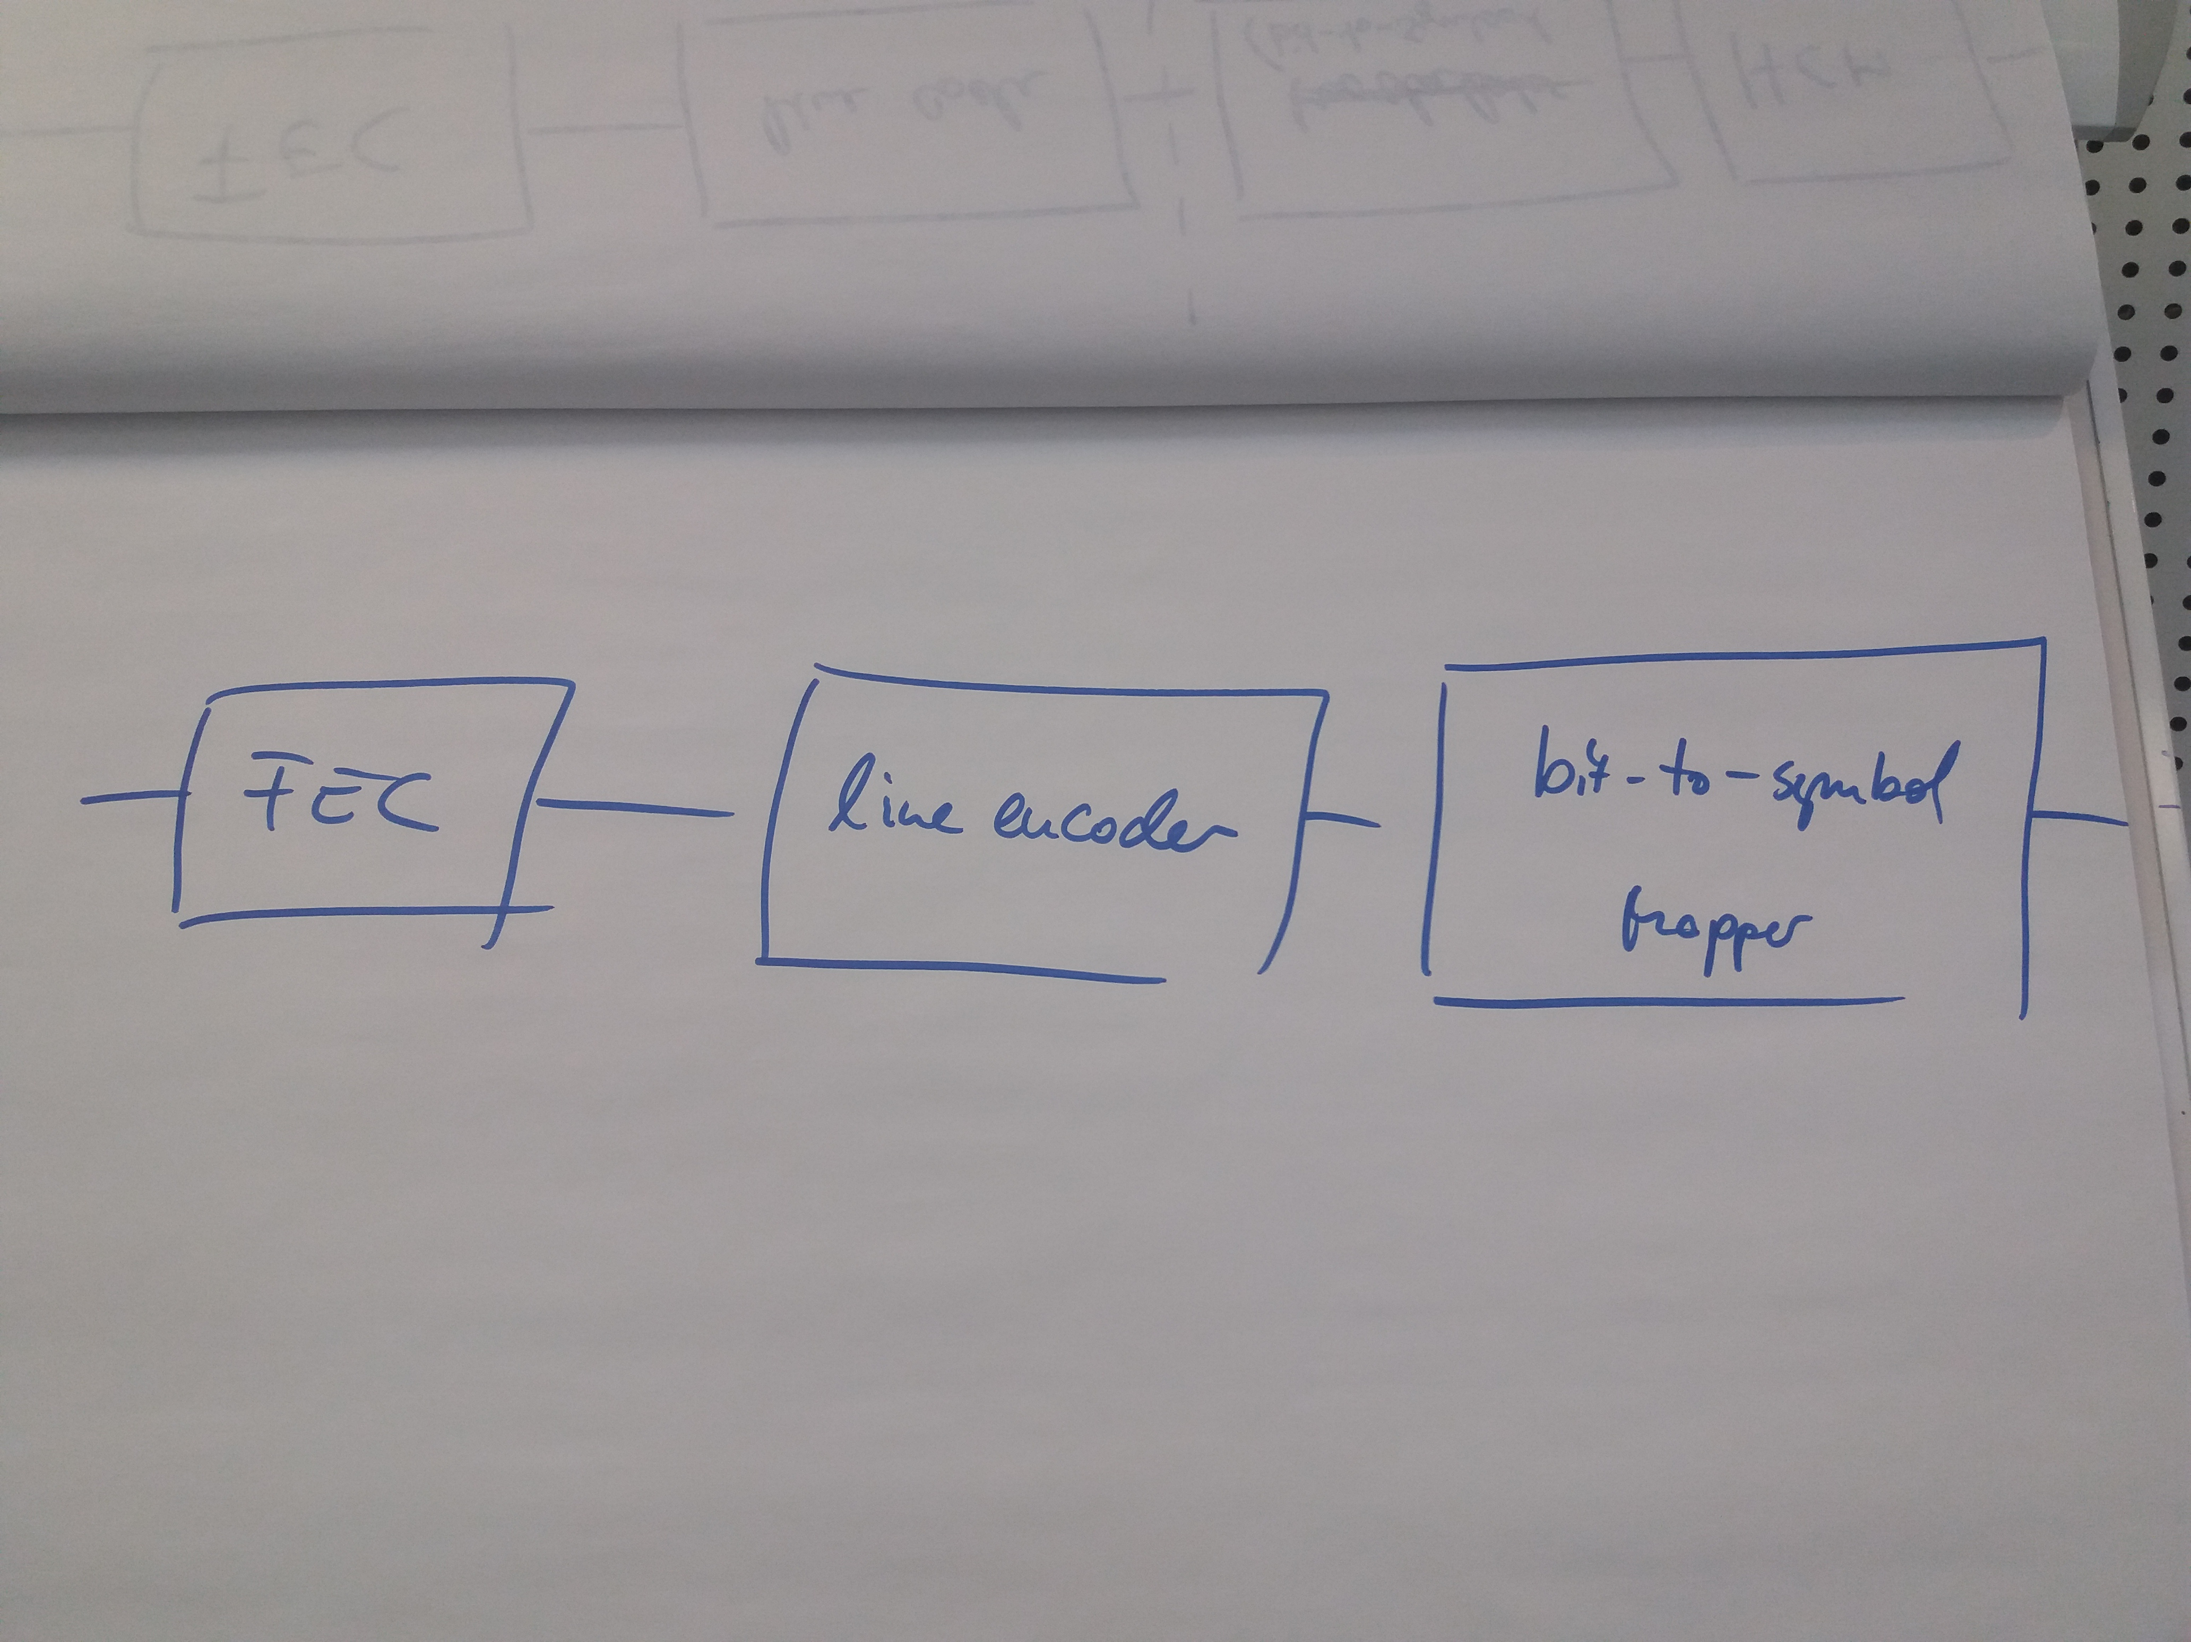

Figure YYY – Pulsed Amplitude Transmitter

10.2 Forward error correction

The Pulsed Amplitude Transmitter is using Reed-Solomon Coding denoted as RS(n, k) where n denotes the number of input bits and k the number of output bits. In particular, there are short and long block lengths n for control and data, accordingly. Moreover, the code rate is adaptable in several steps.

10.3 Line encoder

The line coder uses simple formats such as the Manchester code, or more complex schemes such as 4b6b or 8b10b for OOK and 5S6S in case of 4-PAM. Note that, for maintaining a constant average light output, both the systematic output of the FEC (n bits) and the redundant part (k-n bits) have to be passed through the line encoder.

10.4. Symbol mapper

10.4.1 OOK mapper

The OOK mapper is transparent, it maps {0, 1} to {0, 1}.

10.4.2 PAM mapper

The PAM mapper is using 4-PAM only. It puts two consecutive bits into a symbol and maps them as {00, 01, 10, 11} to {0, $\frac{1}{3}$. $\frac{2}{3}$, 1}.

10.4.3 HCM mapper

Text will be provided by Mohammad Noshad (vlncomm).

Current parameter settings

(to be discussed and finally included in new Table 107).

Mode | FEC | Line code | Modulation | Clock Rate/MHz | Data Rate/Mb/s
OOK | RS(n,k) with  (550, 524) | 8B10B | OOK | 2, 4, 8, 16, 32, 64 MHz | 1.52 Mb/s…  38.1 Mb/s
 | RS with  (36, 24) | 8B10B | OOK |  | 1.06 kb/s… 33.9 Mb/s
 | RS(n,k) with  (160, 128) | Manchester | VPPM | 4, 8, 16 MHz | 1.6 Mb/s, 3.2 Mb/s, 6.4 Mb/s
PAM | RS(n,k) with  (550, 524) | 5S6S | 4-PAM | 2, 4, 8, 16, 32, 64 MHz | 3.14 Mb/s…  100.5 Mb/s
HCM | RS(n,k) with  (255, 248) | none | OOK + (7,8) HCM…  4-PAM + (31, 32) HCM | 3.125, 6.25, 12.5, 25, 50, 100 MHz | 2.66 Mb/s…  188.4 Mb/s

