IEEE P802.15
Wireless Personal Area Networks

Project | IEEE P802.15 Working Group for Wireless Personal Area Networks (WPANs)
Title | Discussion on Dimming methods and Proposed Changes
Date Submitted | [July 2017]
Source | Trang Nguyen, Yeong Min Jang (Kookmin University)  Hideki Aoyama (Panasonic)
Re: | D3 comments and resolutions
Abstract | Dimming methods for OCC, Proposed changes in 4.4.3 and 8.5.2.4
Purpose | D3 comments and resolution
Notice | This document has been prepared to assist the IEEE P802.15. It is offered as a basis for discussion and is not binding on the contributing individual(s) or organization(s). The material in this document is subject to change in form and content after further study. The contributor(s) reserve(s) the right to add, amend or withdraw material contained herein.
Release | The contributor acknowledges and accepts that this contribution becomes the property of IEEE and may be made publicly available by P802.15.

Subclause 4.4.3.2
Remove from Line 36 to Line 47. Connect paragraphs of line 34 and line 49.
(This information is shown in the Table ABC. And these normative sentences conflict a description in 8.5 (The PHY shall support dimming using one of the techniques specified in either 8.5.1 or 8.5.2, when the phyDim PHY PIB attribute is set.).)

Subclause 4.4.3.2.1
- Correct reference in Line 16: Figure 8 to Figure 7
- Remove duplicated sentence “An example … Figure 8” in Line 31 to 32.
- Correct reference in Line 38: Figure 9 to Figure 8
- Replace Figure 9 with the following figure
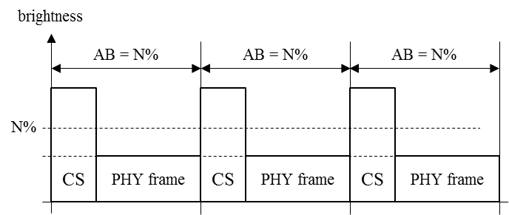

Comment 1: Page 37 – Section 4.4.3.2.2
1- Insert a figure at the beginning of Section 4.4.3.2.2 Dimming by controlling pulse width (PWM) to describe an overall method for pulse width dimming (see figure 10 below)
Figure 10. Mechanism for pulse width dimming
2- Also, add a sentence to describe the inserted figure
“The mechanism for dimming by controlling the pulse width is illustrated in Figure 10.”

3- Remove a sentence “An example of MPM dimming by controlling PWM is as shown in Figure 11.” and Figure 12. (This content is moved to 4.4.3.2.4.)

Comment 2: Page 39 (line 30)
Replace Figure 13 and 14 with a new figure (below)

Figure 13—Mechanism for amplitude dimming

Subclause 4.4.3.2.4 (new subclause)
4.4.3.2.4 Dimming by controlling brightness in out-of-band frequency
Controlling duty cycle in out-of-band frequency region can adjust averaged brightness. The modulated signal is received like amplitude dimming signal via receiver’s band pass filter as shown in Figure AAA.
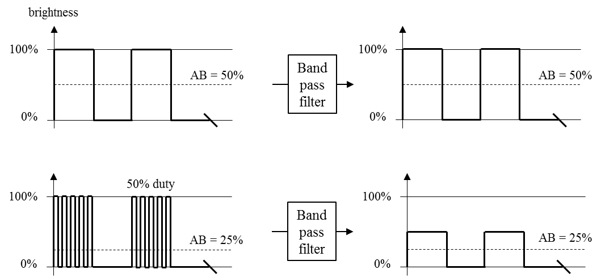
Figure AAA – Out-of-band dimming

Comment 3: Page 262 –line 46:
Change "The PHY shall support dimming using one of the techniques specified in either 8.5.1 or 8.5.2, when the phyDim PHY PIB attribute is set"

into=> "The PHY shall support dimming using at least one of the techniques specified in either 8.5.1 or 8.5.2 or both, when the phyDim PHY PIB attribute is set."

Comment 4: Page 264 –line 38: Section 8.5.2 Dimming during transmission.

Tran’s proposal
Insert the following text and table as the second paragraph of the subclause 8.5.2 to summarize the dimming methods being used for individual PHY modes:

The dimming methods are applied to individual PHY operating modes as descried as follows:
- Dimming method 1 (Compensation symbol insertion) shall be applied for PHY-I OOK and PHY-V MPM.
- Dimming method 2 (Pulse width modulation) shall be applied for PHY-II VPPM; PHY-IV UFSOOK, Twinkle VPPM, and HS-PSK; PHY-V MPM, RS-FSK, and CM-FSK.
- Dimming method 3 (Amplitude modulation) shall be applied for PHY-III CSK; PHY-IV S2-PSK, Twinkle VPPM, and HS-PSK; PHY-V C-OOK.
Table ABC summaries the selection of dimming methods for PHY operating modes.
Table ABC- Choice of Dimming methods for PHY operating modes
Mode | Selection of dimming method | Remark
PHY I, II, III
OOK | Compensation insertion dimming | Method 1
VPPM | PWM dimming | Method 2
CSK | AM dimming | Method 3
PHY IV
UFSOOK | PWM dimming | Method 2
S2-PSK | AM dimming | Method 3
Twinkle VPPM | PWM dimming/ AM dimming | Method 2/ hybrid method
HS-PSK | PWM dimming/ AM dimming
Offset-VPPM | Not supported | Flicker mode
PHY V
RS-FSK | PWM dimming | Method 2
CM-FSK | PWM dimming
C-OOK | AM dimming | Method 3
MPM | PWM dimming/  Compensation insertion dimming/  AM dimming | Method 2/  Method 1/  Method 3
PHY VI
A-QL | Not supported | Screen modulation modes operate at optical clock rates below the flicker-limit.
HA-QL | Not supported
VTASC | Not supported
Invisible data embedded display | Not supported

Hideki’s proposal
(Insert the following text and table as the second paragraph of the subclause 8.5.2 to summarize the dimming methods being used for individual PHY modes.)
The PHY modes utilizes compensation symbol insertion dimming (4.4.3.2.1), pulse width dimming (4.4.3.2.2), amplitude dimming (4.4.3.2.3), and/or out-of-band dimming (4.4.3.2.4). Table ABC shows a summary of available dimming methods for each PHY operating modes.

Table ABC – Available dimming methods for PHY operating modes
Mode | Compensation symbol insertion dimming | Pulse width dimming |  | Amplitude dimming | out-of-band dimming
PHY I, II, III
OOK | x |  |  | x | x
VPPM |  | x |  | x | x
CSK |  |  |  | x | x
PHY IV
UFSOOK |  | x |  | x | x
S2-PSK |  |  |  | x | x
Twinkle VPPM |  | x |  | x | x
HS-PSK |  | x |  | x | x
Offset-VPPM |  |  |  | x | x
PHY V
RS-FSK |  | x |  | x | x
CM-FSK |  | x |  | x | x
C-OOK |  |  |  | x | x
MPM | x | x |  | x | x
PHY VI
all |  |  | Dimming is not supported

Comment 5: Kookmin Updates their dimming subsections of Section 8.5.2 according to updates in 4.4.3 as described bellows

8.5.2.4 PHY IV dimming
8.5.2.4.1 UFSOOK dimming (no change)
8.5.2.4.2 Offset VPWM dimming
Offset VPWM is flicker, and dimming is not supported.

8.5.2.4.3 S2-PSK dimming
S2-PSK dimming is achieved by amplitude modulation as described in the sub-clause “4.4.3.2.3 dimming by controlling pulse amplitude (AM)”
The configuration of dimming level for S2-PSK shall be implemented over the PHY PIB attribute phyDim.
8.5.2.4.4 HS-PSK dimming
HS-PSK is a hybrid modulation method, it may implement both PWM dimming and AM dimming as a hybrid dimming. The DS8-PSK implements dimming over PWM because the DS8-PSK waveform consists of multiple VPPM waveforms. However, two dimming levels (a low dimming level and a high dimming level) shall be applied to the DS8-PSK to generate the AM envelop of the HS-PSK output waveform.
The configuration of two dimming levels is implemented via two PHY PIB attributes phyHSpskLowDim and phyHSpskHighDim.
The configuration of either the PHY PIB attribute phyHSpskLowDim or the PHY PIB attribute phyHSpskHighDim or both is to change to OFF and ON of the AM envelope of the HS-PSK waveform.

8.5.2.5 PHY V dimming
8.5.2.5.1 Twinkle VPPM
Twinkle VPPM utilizes amplitude dimming.
8.5.2.5.2 RS-FSK dimming
RS-FSK dimming is achieved by controlling the pulse width as described in the sub-clause “4.4.3.2.2 dimming by controlling pulse width (PWM)”.
The configuration of RS-FSK dimming level shall be implemented via the PHY PIB phyDim.
8.5.2.5.3 CM-FSK dimming
CM-FSK and RS-FSK both implement the FSK waveform, thus CM-FSK dimming is achieved by the same manner as RS-FSK.

8.5.2.5.4 C-OOK dimming
The preamble symbol and data symbols are all symmetric symbols, and the average brightness of those is constant at 50%. The optical clock rate is also constant at a considerable low frequency, 2.2kHz or 4.4kHz.
C-OOK PHY modes achieve dimming by controlling the amplitude of either ones or zeros or both in OOK signal. The configuration of ones' amplitude generates the average brightness output at the dimmed level (<50%). Meanwhile, the configuration of zeros' amplitude achieves the average brightness output at the bright level (>50%). The achieved dimming level is the average brightness of one and zero.
8.5.2.5.5 MPM dimming
(Replace original text and Figure 127 with the following text.)
MPM utilizes dimming by compensation symbol insertion, amplitude dimming, and out-of-band dimming. Additionally, MPPM utilizes pulse width dimming.

8.5.2.6 PHY VI dimming
PHY VI modes operates with flicker, and dimming is not supported.

MPM mode rename
To avoid confusion with “PWM dimming”, rename MPM PWM mode to MPWM mode (and rename MPM PPM mode to MPPM mode).
- PDF page 25
Add the following two acronyms into the list
MPWM: Mirror Pulse Width Modulation
MPPM: Mirror Pulse Position Modulation
- PDF page 317, line 23, Table 125
Replace
0: PWM mode
1: PPM mode
with
0: MPWM mode
1: MPPM mode
- PDF page 370, line 18
replace
"PWM mode and PPM mode,"
with
"MPWM mode and MPPM mode,"
- PDF page 371, line 16
replace "In PWM mode" with "In MPWM mode"
- PDF page 371, line 22
replace "In PPM mode" with "In MPPM mode"
- PDF page 372 line 20
replace "In PWM mode" with "In MPWM mode"
- PDF page 372, line 52, Title of Figure 209
replace "MPM PHY PWM mode waveform" with "MPWM mode waveform"
- PDF page 373 line 1
replace "In PPM mode" with "In MPWM mode"
- PDF page 373, line 33, Title of Figure 210
replace "MPM PHY PPM mode waveform" with "MPPM mode waveform"

