IEEE P802.15
Wireless Personal Area Networks

Project | Dependability Interest Group
Title | Meeting Minutes for July 2017
Date Submitted | July 11, 2017
Source | [Jussi Haapola]  [Centre for Wireless Communications / University of Oulu] | Voice: +358 40 8363 018  E-mail: jussi.haapola@oulu.fi
Re: | Meeting Minutes
Abstract
Purpose | Minutes of Dependability Interest Group sessions
Notice | This document has been prepared to assist the IEEE P802.15. It is offered as a basis for discussion and is not binding on the contributing individual(s) or organization(s). The material in this document is subject to change in form and content after further study. The contributor(s) reserve(s) the right to add, amend or withdraw material contained herein.
Release | The contributor acknowledges and accepts that this contribution becomes the property of IEEE and may be made publicly available by P802.15.

Monday, July 7, 2017, AM1, 8:00

  - Meeting called to order 8:00
By Chair Ryuji Kohno (YNU / CWC-Nippon)
Secretary Jussi Haapola (CWC)

  - Roll Call
Notepad for Attendance circulated.

  - Opening Report

Chair presented Opening report Doc #365

Chair showed IEEE Patent policy.

Chair issued Call for Potentially Essential Patents
No essential intellectual property in the scope of IG DEP was declared.

  - Approval of previous meeting minutes
Upon no comments on the previous meeting minutes, doc #219 was approved.

  - Overview of IG DEP activity
Ryuji presented doc #176r1
Discussion on role of existing standards and standard developments (TSN, DetNet, 15.10, 15.12, TG4s) impacts on IG DEP uniqueness criteria.

  - Recess at 9.56.

  - Attendees

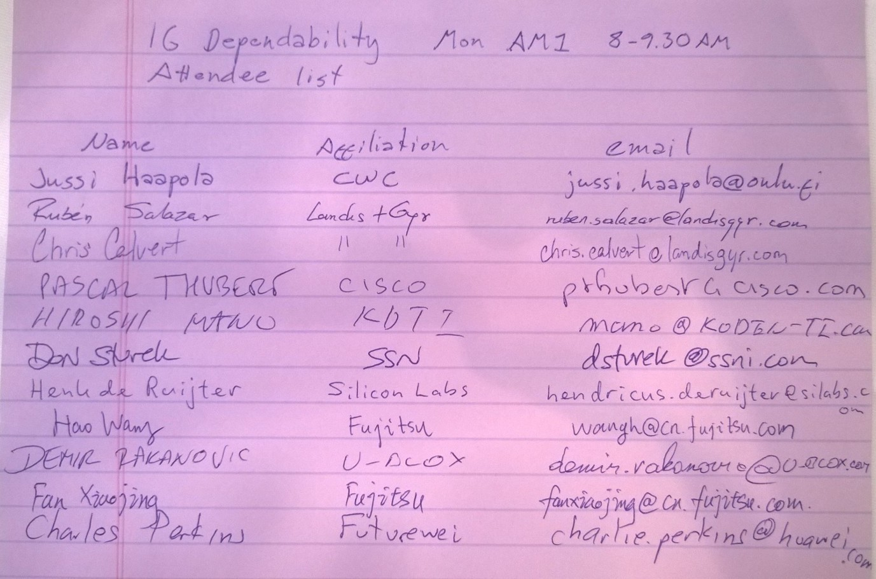

Tuesday 11 July, 2017, AM1, 08:00

  - Meeting called to order at 08:05

  - Roll Call
Notepad was circulated

  - IETF related activities
Pascal Thubert presented routing mechanisms for deterministic wireless communications.

  - Discussion on collaboration with FFPJ
Ryuji presented doc #394

  - Review WNG presentations
Ryuji presented doc #398 on behalf of Hiroshi Kobayashi

  - Recess at 10:01

  - Attendees

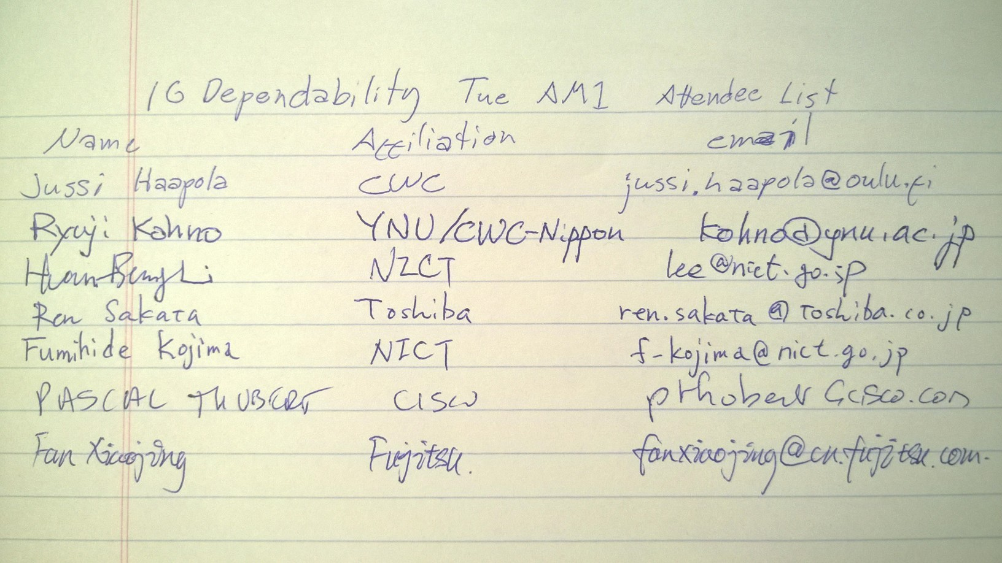

Wednesday 12 July, 2017, AM1, 08:00

  - Meeting called to order at 08:03

  - Roll Call
Notepad was circulated.

  - Agenda
Agenda was updated as doc #410r3.

  - Continue reviewing WNG presentations
WNG #1: Ryuji continued presenting doc #398.
- Inter-network coordination was identified as a necessary item to define, which is not covered by current 802.15 standards.

Ryuji presented doc #420.
- A solution could be multiple projects. Contribution to 802.15.12 with timing requirements and parameter exchange between MAC and higher layer helps deterministic networking (cross-layer interaction piece for control loops).
- Inter-network coordination and dynamic parameter reconfiguration could be a recommended practice or standard amendment.
- Cross-layer management messaging needs to be defined and the feedback interval to be determined.
- Management of duplicate messaging needs to relate to multipath delivery requirements.
- Individual device reliability assessment and aggregate reliability assessment needs to be defines.
- Multipath forwarding protocol needs to include redundant coding to cope with lost/corrupted/missing frames.

Four main points to address:
- Cross-layer information exchange and management PHY&MAC <-> higher layers
- To guarantee service levels
- To know flow characteristics
- To know dynamic media characteristics
- Be energy aware

- Application of metrics at specific layers and cognition in layers
- To improve stability
- To improve predictability
- To enable feedback loops

- Forwarding protocol
- To apply path diversity and redundancy adaptively
  - Routing and forwarding time scales are vastly different
  - Application stability is yet another order of magnitude longer time scale, but may change over time.
- Coordination and management across independent PANs
- Other PAN interference mitigation

Task is to reflect the above to the key three applications in vehicular automation.
(c.f. 802.15.9 PAR)

  - AoB
Telcos to be determined via the reflector. Target 10 days notice before telco.

  - Adjourn 9:59

  - Attendees
