IEEE P802.15
Wireless Personal Area Networks

Project | IEEE P802.15 Working Group for Wireless Personal Area Networks (WPANs)
Title | Kookmin D3 Text Revision
Date Submitted | [July 2017]
Source | Trang Nguyen, and Yeong Min Jang (Kookmin University)
Re: | Revise from the original document: 17-0019-02
Abstract | D3 PHY 4, 5, 6 specifications are revised.
Purpose | D3 comments and resolutions
Notice | This document has been prepared to assist the IEEE P802.15. It is offered as a basis for discussion and is not binding on the contributing individual(s) or organization(s). The material in this document is subject to change in form and content after further study. The contributor(s) reserve(s) the right to add, amend or withdraw material contained herein.
Release | The contributor acknowledges and accepts that this contribution becomes the property of IEEE and may be made publicly available by P802.15.

PHY IV specifications

13.3 S2-PSK

13.3.1 Reference Architecture
A reference architecture to implement S2-PSK is shown in Figure TBD1. The data may be protected by FEC coding, and then the output is feed into the ½-rate line encoder. The bit sequence is mapped into pairs of waveforms to drive a pair of LEDs (LED-1 and LED-2).
Figure TBD1. S2-PSK block diagram

13.3.1 S2-PSK Bit-to-symbol Mapping
The signal to each LED shall have a square shape which ON and OFF amplitudes are configurable to achieve the required dimming level. Two waveforms to drive a pair of LEDs have the same phase or inverse phases depending on a single bit input (see Figure TBD2).
The optical clock rate (equivalent to bit rate) is configured via the PHY PIB attribute phyOccOpticalClockRate that is chosen to be no greater than the camera frame rate to ensure every bit is sampled at least twice.
The configuration of modulation rate is performed over the PHY PIB attribute phyS2pskModulationRate that ensures being non-flicker.
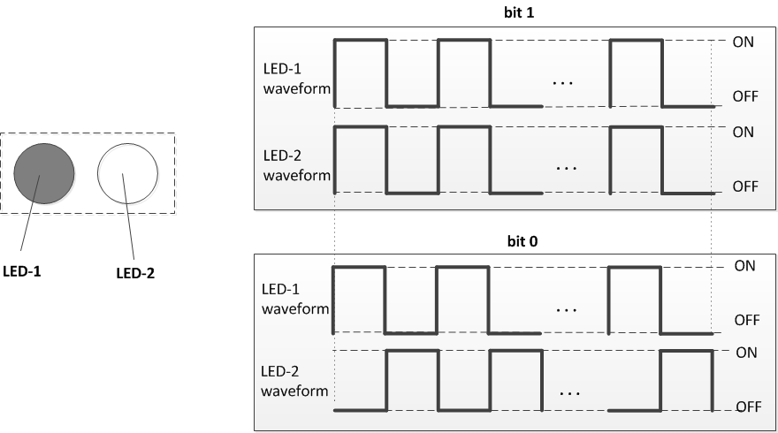
Figure TBD2 –S2-PSK bit-to-symbol mapping

13.3.2 S2-PSK ½-rate Line Coding
Unlike typical RLL code that is to provide DC balance, the waveform output of S2-PSK is always DC-balanced no matter the mapping bit is zero or one. Thus, a new line coding at the ½-code rate shall be optionally implemented serving two different purposes:
(i) to support Rx decoding under the dismiss of one LED among a pair of LEDs seen by Rx, and
(ii) to protect the signal from the error caused by the rotation of camera and the error caused by the time deviation between a pair of light sources on the rolling image.
The guideline for the S2-PSK decoder is described in Annex J.1 “S2-PSK Decoding Guideline”.
The configuration of ½-rate coder is implemented over the PHY PIB attribute phyS2pskLineCode. Once the ½-rate coding is applied, the PPDU shall map a single bit into a pair of bits as shown in Table TBD3.
Table TBD3 – ½-rate line coding for S2-PSK
Data bit Input | Bits output
0 | 0 0
1 | 0 1

13.3.3 S2-PSK Error Correction
Error correction may be implemented for S2-PSK that is configurable via the PHY PIB attribute phyOccFec.
In addition, a majority bit voting shall be optionally applied on the receiver side in case the camera frame rate is multiple times of the optical clock rate, being considered as a temporal error correction (see Annex L.2).

13.5 Hybrid Spatial-Phase Shift Keying

13.5.1 Reference Architecture
A reference architecture to implement HS-PSK is illustrated in Figure TBD4. At first, two data streams are modulated individually in which a low rate data stream is modulated by S2-PSK and a high rate data stream is modulated by DS8-PSK. Then, the outputs of the S2-PSK modulator are to control the dimming levels of the outputs of DS8-PSK; therefore, the output waveforms are hybrid modulation of S2-PSK and DS8-PSK.

Figure TBD4. HS-PSK block diagram
The operation of S2-PSK modulator is described in Section 13.3 S2-PSK, and the operation of DS8-PSK modulator is described in the following section.

13.5.2 DS8-PSK modulator

13.5.2.1 DS8-PSK Bits-to-symbol mapping
This subsection describes the mapping from three bits into a pair of two sets of waveforms to drive a pair of light sources. Herein, the number of time slots available on a duty cycle of DS8-PSK waveform is eight (a constant value). In order to divide a DS8-PSK duty cycle into eight time slots, each light source shall consist of a configurable number of LEDs that is minimum at eight. The configuration of the number of LEDs per light source shall be implemented via the PHY PIB attribute phyHSpskNoLightSources.
Waveforms to drive LEDs shall have a rectangular shape at the same modulation rate but different phases. In a group of waveforms to drive LEDs within a light source, the (i+1)^{th} waveform is delayed 1/8 duty cycle compared to the (i)^{th} waveform as shown in Fig. TBD5. The modulation rate of waveform signals (=1/ duty cycle) is configurable by the PHY PIB attribute phyHSpskModulationRate.
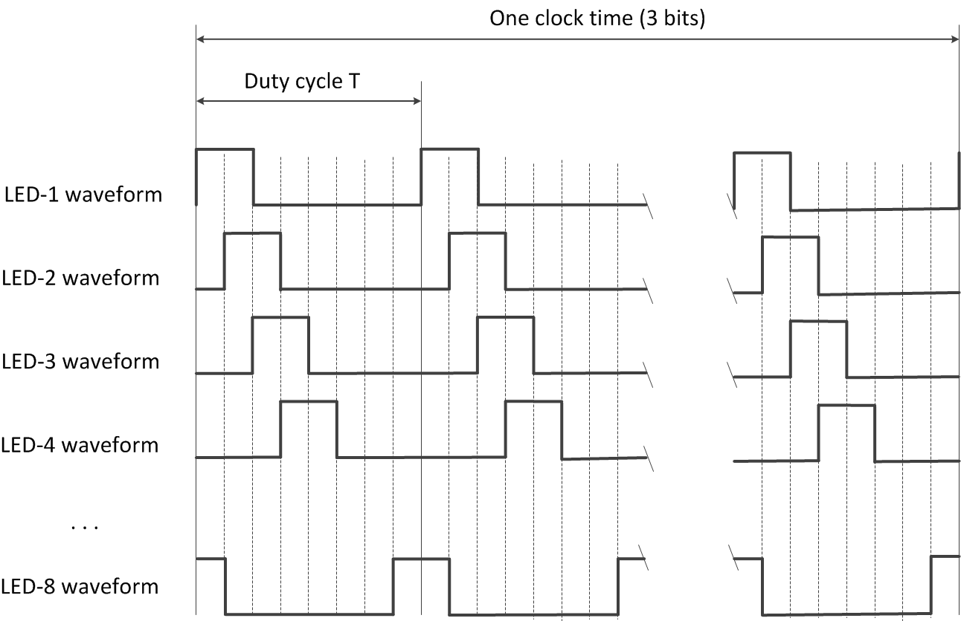
Figure TBD5. Waveforms to drive a group of eight LEDs within a light source (example of 25% dimming)

By using a pair of two light sources and each light source has eight LEDs, three bits are transmitted per optical clock by controlling the shifting value (called S_Phase_Shift) of the phases of waveforms driving two light sources. This is implemented by maintaining all the phases of the waveforms of the first group (at 0; T/8; 2T/8; 3T/8; …; 7T/8 respectively) while shifting all the phases of the waveforms of the second group a (S_Phase_Shift =i ×T/8) in compared to that of the first group, where i is an integer depending upon 3-bits input.
The mapping from 3 bits to the value of S_Phase_Shift (represented by the value of i) is shown in Table TBD6.
Table TBD6. Mapping table from bits to S_Phase_Shift
3-bits  Input | S_Phase_Shift / (T/8)  Output
000 | 0
001 | 1
010 | 2
011 | 3
100 | 4
101 | 5
110 | 6
111 | 7

Finally, the optical clock rate (i.e. the frequency at which a block of 3-bit is clocked out) shall be configured via the PHY PIB attribute phyOccOpticalClockRate.

13.5.2.2 DS8-PSK Forward Error Correction
The configuration of error correction for DS8-PSK shall be implemented over the PHY PIB attribute phyOccFec. When the use of FEC is enable, RS (15, 11) shall be used for DS8-PSK error correction.
Also, a majority bit voting shall be optionally applied on the receiver side if the camera frame rate is multiple times the optical clock rate and being considered as a type of temporal error correction (see Annex L.2 Majority voting).
Also, the decoding under the bad-sampling condition is considered as an error correction with the code rate equals 1. In the DS8-PSK decoder, a bad-sampling that happens when the camera captures the transition time of a single LED among LEDs of the group presents an unclear state (x_state) among a set of eight states. The demodulation process with the presence of the x_state is descried in Annex J-2. DS8-PSK Decoding Guideline.

13.5.3 HS-PSK Waveform
The DS8-PSK modulator shall map 3 bits into a pair of two sets of waveforms driving a pair of light sources at a high optical clock rate (such as 10kHz) as described in Section “13.5.1.1 DS8-PSK bit-to-Symbol mapping”. Meanwhile, it periodically changes the dimming level from a selected low dimming level to a selected high dimming level. The change of dimming level during DS8-PSK encoding that generates an AM signal at a low frequency (configurable in PHY PIB attribute phyS2pskModulationRate) shall be controlled by the S2-PSK modulator. As a result, the S2-PSK clock interval is multiple times the DS8-PSK clock interval.
Figure TBD7 illustrates the output waveform of HS-PSK.

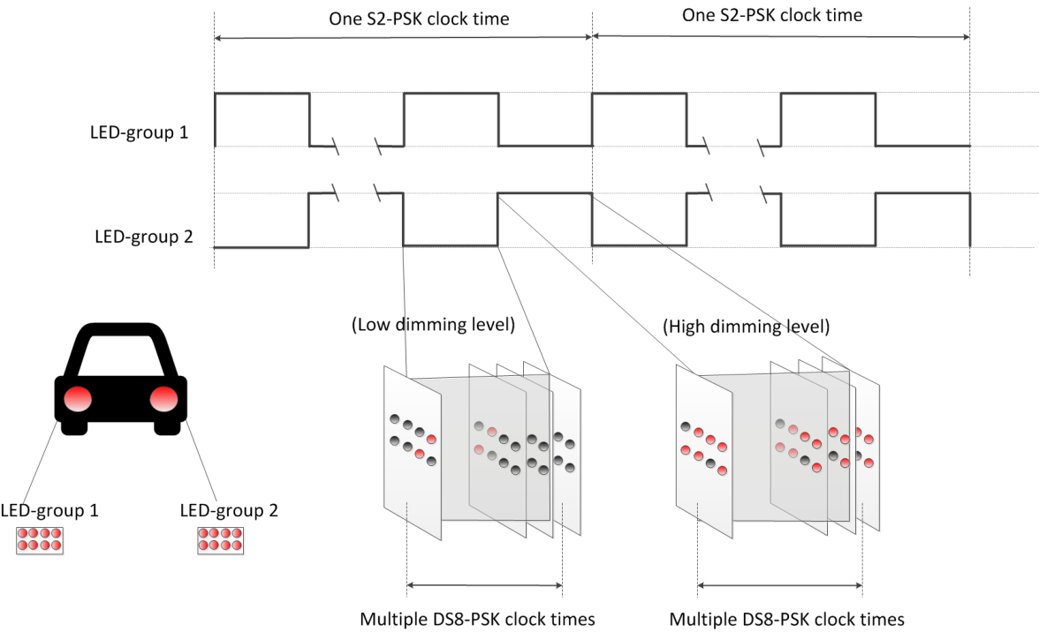
Figure TBD7 –HS-PSK waveform to modulate vehicular light sources

13.5.4 Forward Error Correction
The configuration of error correction for HS-PSK, including FEC for S2-PSK and FEC for DS8-PSK, shall be implemented via the PHY PIB attribute phyOccFec. The suggested configuration is given as follows.
No error correction is needed for S2-PSK. However, a majority bit voting shall be optionally applied in the receiver side if the camera frame rate is multiple times the optical clock rate, and being considered as a type of temporal error correction (see Annex L-2 majority voting).
For DS8-PSK in HS-PSK, RS (15, 11) shall be used. Also, a majority bit voting shall be optionally applied in the receiver side if the camera frame rate is multiple of the optical clock rate, being considered as a type of temporal error correction. (see Annex L-2 majority voting). Also, the decoding under the bad-sampling condition is considered as an error correction with the code rate equals 1 (see the DS8-PSK decoder in Annex L-2).

PHY V Specifications

14.2 CM-FSK Modulation

14.2.1 Reference Architecture
The CM-FSK modulation scheme is applied to a system as shown in figure TBD8. Ab bit(s) shall be inserted into a block of data bits before mapping from bits into frequency (and bi-phase, if used). Finally, the IFFT converts the frequency value into the waveform to drive LED.
A camera that has the sampling rate satisfying the Nyquist sampling is used to receive the modulated light.

Figure TBD8– Reference Architecture for CM-FSK system

14.2.2 Asynchronous bit(s) insertion
Before being feed into the bits-to-frequency mapper, a number of clock information bits (Ab) shall be inserted at the beginning of a data symbol as shown in Figure (that has four or five bits depending on 32-FSK or 64-FSK being used) to form a packet of bits to support asynchronous communication (see 14.2.3).
The number of Ab to insert can be one to support the time-variant frame rate Rx decoding (see Annex J –CM-FSK decoding method), or greater than one to support the detection of missing symbols during reception time in the receiver side (see section “14.3.2 Missing packet detection”). The configuration of Ab is implemented via the PHY PIB attribute phyCmfskAb.

14.2.3 CM-FSK Encoder
After inserting Ab, the packet of bits (including data bits and Ab) is feed into the CM-FSK encoder to map from bits into a frequency. Table TBD9 shows the packet of bits with Ab bits inserted at the beginning of the packet. The bit length of this packet (equals to n+1) depends on how many bits a frequency can carry.
Table TBD9: Packet structure
b₀ | b₁ – b_{n}
Ab | Data bits

14.2.3.1 Encoder configuration
The number of frequencies used to map data shall be configured over the PHY PIB attribute phyCmfskNoFrequency. 32 or 64 frequencies are suggested to use for selected devices. Also, the number of frequencies is extendable with reserved values of phyCmfskNoFrequency.
The frequency separation is fixed during a selected mode, but configurable via the PHY PIB attribute phyCmfskFrequencySeparation.
In addition to the frequency modulation, the phase of the waveform can also be modulated in which the number of phases is configurable via the PHY PIB attribute phyCmfskNoPhase. If phyCmfskNoPhase=1, 2-PSK shall be additionally used in conjunction with the frequency modulator, utilizing the bandwidth and coverage efficiency.
Finally, the optical clock rate that controls the rate frequency symbols are clocked out is configured via the PHY PIB attribute phyOccOpticalClockRate. Camera with the frame rate higher than twice of the optical clock rate can decode data.

14.2.3.2 32-FSK bits-to-frequency mapping
32-FSK is a specific case of CM-FSK encoder. It shall map a packet of bits, including one Ab and four data bits into a frequency among 32 frequencies f₁-f₃₂. The bits-to-symbol mapping table is shown in Table TBD10.
Table TBD10: C32-FSK encoding table
Packet of bits  Input | Frequency Output
Preamble 1 | f₀
00000 | f₁
00001 | f₂
. . . | . . .
11110 | f₃₁
11111 | f₃₂
Preamble 2 | f₃₃

Beside 32 frequencies (f₁ – f₃₂) are selected to encode bits, two additional frequencies are selected as preamble symbols (f_{SF} = f₀ and f’_{SF=} f₃₃). The relationship between data frequencies and preamble frequencies is as follow:
- f_{i} = f_{SF} + i.∆f (i=1; 2;…; 33)
where ∆f is the selected frequency separation value.
The selection of all frequencies shall be configured over the first frequency preamble (f_{SF}) which shall be implemented over the PHY PIB attribute phyCmfskPreamble and the frequency separation, which shall be implemented over the PHY PIB attribute phyCmfskFrequencySeparation.

14.2.3.3 64-FSK bits-to-frequency mapping
64-FSK is also a specific case of CM-FSK encoder. It shall map a packet of bits, including one asynchronous bit and five data bits into a frequency among selected 64 frequencies. The bits-to-symbol mapping table is shown in Table TBD11.
Table TBD11- C64-FSK encoding table
Packet of bits  Input | Frequency  Output
Preamble 1 | f_{o}
00000 | f₁
00001 | f₂
…
11110 | f₃₁
11111 | f₃₂
Preamble 2 | f₃₃
010000 | f₃₄
010001 | f₃₅
…
111110 | f₆₄
111111 | f₆₅

The 64-FSK frequency band is a twice extension of the 32-FSK frequency band. The first 32 data frequencies and two preamble frequencies (f₀-f₃₃) are the same values as addressed in the 32-FSK modulation. Also, the remaining 32 frequencies (f₃₄-f₆₅) are allocated on higher frequencies of the 32-FSK modulation band to achieve a higher capacity of data per frequency symbol.
- f_{i} = f_{SF} + i.∆f (i=1; 2;…; 65)
where ∆f is the selected frequency separation value.

14.2.3.4 Hybrid Frequency-Phase Shift Keying
The hybrid frequency and phase mode is also an extended case of CM-FSK encoder. The frequency encoding is achieved by implementing the 32-FSK encoding or the 64-FSK encoding. When phyCmfskNoPhase =1, 2-PSK modulation is additionally used in conjunction with the frequency encoder as a hybrid modulation to tackle the bandwidth efficiency and spatial redundancy.
In an example of using a pair of light sources with phyCmfskNoPhase=1, both light sources shall utilize the same bits-to-frequency mapping; thus two light sources carry the same frequency at any time. On the other hand, the relationship of phases of two waveforms shall be modulated by a single Ab bit. If Ab= “0”, two signals are at the same phases. If Ab= “1”, a signal shall have phase inverted compared to another signal. Figure TBD12 shows the reference architecture for the hybrid modulator.

Figure TBD12– Reference architecture for modulator of using a pair of LEDs

14.2.3.1 Outer FEC
The payload carried by frequency symbols (i.e. sub-packets that consist of data bits and Ab) shall not be coded. However, PHR and PSDU may be protected by RS(15,11) as an outer FEC. The generation of RS(15,11) is described in section “10.2 Outer forward error correction encoder”. This option of outer FEC is implemented by the configuration of the PHY PIB attribute phyOccFEC.

14.3 C-OOK

14.3.1 Reference Architecture
A reference architecture to implement C-OOK is shown in Figure TBD13.
Figure TBD13. C-OOK block diagram

14.3.1 C-OOK Encoder

14.3.1.1 Encoder configuration
A sub-packet of data shall be modulated using OOK modulation. The optical clock rate at which OOK symbols are clocked out is configurable over PHY PIB attribute phyOccOpticalClockRate.
The data packet structure is as shown in figure TBD14. A packet is the multiple-time repetition of a data subpacket to avoid missing data in between the gap time of adjacent images. The times of repetition depends on the selected mode and is configurable over the PHY PIB attributes phyCookPacketRate and phyCookSubPacketRate. For example, if phyCookPacketRate =1 specifying 10 packet/sec and phyCookSubPacketRate =0 specifying 60 sub-packet/sec, every data sub-packet shall be repeated 6 times.

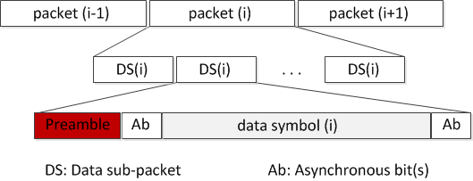
Figure TBD14– Data packet structure

A Data Sub-packet (DS) shall consist of two subfields, a preamble symbol, and a payload section. The configuration of the preamble is performed over the PHY PIB attribute phyCookPreambleSymbol. The preamble shall be configured being suitable for the selected RLL coding used in payload subfield. Manchester coded payload shall require a short preamble while 4B6B coded payload shall require a longer preamble. Table TBD15 shows the suitable preamble for selected RLL code.
Table TBD15: Data Sub-packet (DS) format
Preamble | DS Payload
 | Front Ab | Data | Rear Ab
011100 | Manchester coding
0011111000 | 4B6B coding

14.3.1.2 RLL coding
RLL coding shall be applied in payload subfield to maintain the average brightness at 50%. The configuration of RLL code shall be implemented over the PHY PIB attribute phyOccRLLCode. Manchester code and 4B6B code are suggested for C-OOK mode.

14.3.1.3 Ab insertion
The payload of DS (see table B7) shall consist of three subparts: a front Ab, data, and a rear Ab. The front Ab and the rear Ab shall carry the same information which consists of a single asynchronous bit or more. The configuration of the number of asynchronous bits for the front Ab and the rear Ab subparts shall be implemented over the PHY PIB attribute phyCookAb.
The use of a single Ab to support Asynchronous Decoder shall be described in section 14.3.2. A pair of Ab bits to support the detection of missing packets shall be described in section 14.3.3.

14.3.1.4 Forward Error Correction
The DS payload, including data bits and Ab bits, may be coded by inner FEC to protect the payload from error. Hamming (8,4) or (15,11) code may be used as an inner FEC.
Additionally, outer FEC may also be used to protect PHR and PSDU. In the case of outer FEC is enable, RS(15,11) shall be implemented. The generation of RS(15,11) is described in section “10.2 Outer forward error correction encoder”. Also, if outer FEC is applied, the output of FEC shall be feed into a block interleaver with the interleaver height n=15. The implementation description of the block interleaver is described in Section “10.3 Interleaving and puncturing block”
Both inner FEC and outer FEC shall be configured via the PHY PIB attribute phyOccFEC.
Finally, a receiver may implement repeating the data reception to vote data and correct a possible error. This is considered as a temporal error correction.

14.3.2 Missing packet detection on frame rate drop
In some circumstance, the frame rate may drop to less than the packet rate, causing to an entire packet is missed. The detection of the missed packet is proposed herein for a later process.
Instead of a single Ab, some Ab (two bits or more) shall be inserted into the payload of every sub-frame. In this case, Ab bits
In an example, two bits (Ab₁Ab₂) are inserted at the forward and the backward of the body payload. Those two bits together bring the clock information of the subpacket and being modulated as shown in Figure TBD16.

Preamble | DS payload
 | Ab (front) | data bits | Ab (rear)
 | 2 bits (Ab₁Ab₂) | Variable | 2 bits  (Ab₁Ab₂)

Figure TBD16– Data Sub-Packet Structure
Ab₁ and Ab₂ are square signals. Ab1 changes from zero/one into one/zero every time of single data packet, while Ab2 changes every time of two data packets.
The combination of two Ab (Ab₁ and Ab₂) generates four different values, 00 01 10 and 11. Therefore, the usage of those two Ab enables the detection of maximum two missed packets continuously (see figure TBD17). It means the detection of missed packets is successful for any frame rate drop to no less than 1/3 of the packet rate. For example, a packet rate at 10Hz with 2 Ab allows the frame rate drops to 3.3fps while all the missed packets are detectable.

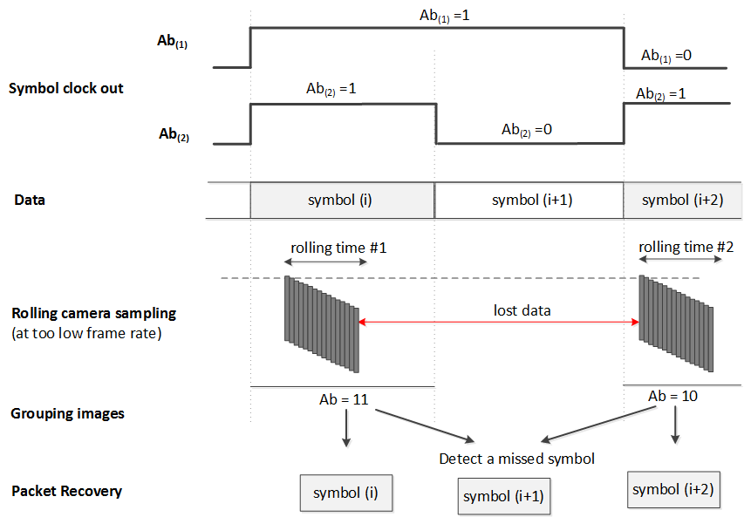
Figure TBD17–An example of the detection of a missed symbol by using two Ab inserted

14.3.3 Packet Structure Specification Modes
Tables TBD18 and TBD19 below suggest some parameters for C-OOK modes.
Table TBD18 – Suggested Parameters for C-OOK modes
 | Mode 1 | Mode 2 | Mode 3 | Mode 4
Optical clock rate | 2.2 kHz | 2.2 kHz | 4.4 kHz | 4.4 kHz
Sub-Packet rate | 100 DS/s | 60 DS/s | 60 DS/s | 60 DS/s
RLL code | Manchester | 4B6B | Manchester | 4B6B
Uncoded bit rate | 80 bps | 180 bps | 330 bps | 400 bps

Table TBD19– SubPacket Structure on Suggested C-OOK modes
 | Mode 1 | Mode 2 | Mode 3 | Mode 4
DS clocks | 22B | 37B | 74B | 74B
Preamble | 6B | 10B | 6B | 10B
DS payload  (Ab, data bits, Ab) | (16B)  8 bits | 18 bits  (27B) | 33 bits  (66B, 2B unused) | 40 bits  (60B, 4B unused)
Inner FEC | Hamming (8,4) | Hamming (15,11)  3 bits unused | Hamming (15,11)  3 bits unused | None
Bit rate | 40bps | 110bps | 220bps | 400bps

PHY VI Specifications

15.1 A-QL Mode

15.1.1 Reference Architecture
Figure 221 shows the A-QL system diagram with light sources of three colors (band i, j, k). The valid selection of these three bands is described in table 132. The selection of tri color bands shall be read by the PHY PIB attribute phyAqlColorSelection. An example of color band combination (110, 010, 000) for band i, j, k respectively is called red, green, and blue throughout this section.
Figure 221: A-QL system diagram
The data sequence including PHR, PSDU, and Ab bits shall be feed into the channel encoder. This A-QL channel encoder controls the intensity of RGB channels (P_{i}, P_{j}, and P_{k}) based on the input bits. However, unlike CSK system in PHY III, the intensity modulation of each color channel in A-QL system is independent of the others, and there is no requirement of color combination such as P_{i} +P_{j} +P_{k} =1. Thus, A-QL modulation operates with flickering, and no effort is made to generate a desired color within the triangle IJK on the xy color coordinates.

15.1.1.1 2D color code design
A two-dimensional design of A-QL code for sequential transmission is shown in Figure Cx2. The outer area of the code is to support the detection of the code. The inner area is to modulate data. The configuration of the size of individual cells to be modulated and the size of the outer border are read by the PHY PIB attributes phyAqlCellSize and phyAqlBolderSize.
The number of cells on the A-QL code (m×n) is read by the PHY PIB attribute phyAqlNoCells.
Four cells (each cell is 2x2) at the four corners of the code called reference cells are to support the receiver in identifying the starting corner of the code. The intensity of these reference cells do not change over time (see Section 15.1.2.1 Encoder configuration). Also, a corner has the number of reference cells that is configurable via the PHY PIB phyAqlNoCellReference.
The remaining cells are to be modulated their intensity to transmit data, called data cells.

Figure Cx2. (a) Design example of 16x16-cell A-QL code, and (b) Allocation of bits onto A-QL code

The matrix of m×n cells is
$$C_{m×n}=\left(\begin{aligned}c_{0,0} c_{0,1} … c_{0,n-2} { c}_{0,n-1} \\ c_{1,0} c_{1,1} … c_{1,n-2} c_{1,n-1} \\ … \\ c_{m-2,0} c_{m-2,1} … c_{m-2,n-2} c_{m-2,n-1} \\ c_{m-1,0} c_{m-1,1} … c_{m-1,n-2} c_{m-1,n-1} \end{aligned}\right)$$
When each corner has four reference cells (totally 16 reference cells), the matrix of 4x4 reference cells is
$$R_{4×4}= \left(\begin{aligned}c_{0,0 } c_{0,1} c_{0,n-2} { c}_{0,n-1} \\ c_{1,0} c_{1,1} c_{1,n-2} c_{1,n-1} \\ c_{m-2,0} c_{m-2,1} c_{m-2,n-2} c_{m-2,n-1} \\ c_{m-1,0} c_{m-1,1} c_{m-1,n-2} c_{m-1,n-1}\end{aligned}\right)$$

15.1.2 Channel Encoder

15.1.2.1 Encoder configuration
A block of coded bits shall be mapped into the matrix of intensity values (binary values) to drive the data cells via three color channels, red, green, and blue independently. The optical clock rate at which the intensity of all data cells is updated is configurable via PHY PIB attribute phyOccOpticalClockRate.
In a m×n cell Tx, (m×n -16) data cells can carry 3× (m×n -16) binaries each time through three color bands (i, j, and k) if the number of reference cells is phyAqlNoCells =16.
The forming process of a matrix of binaries to drive all m×n cells is described as follows.
- The intensity matrix (bands i, j, and k respectively) to drive 4x4 reference cells are constant over time:
${P_{i}}_{ (4×4)}= \left(\begin{aligned}1 1 1 1 \\ 1 1 1 1 \\ 1 1 0 0 \\ 1 1 0 0\end{aligned}\right)$, ${P_{j}}_{ (4×4)}= \left(\begin{aligned}0 0 0 0 \\ 0 0 0 0 \\ 0 0 0 0 \\ 0 0 0 0\end{aligned}\right)$, ${P_{k}}_{ (4×4)}= \left(\begin{aligned}0 0 0 0 \\ 0 0 0 0 \\ 0 0 0 0 \\ 0 0 0 0\end{aligned}\right)$

- The intensity values of data cells at the color bands are mapped from bits as described in section “15.1.3 bit-to-intensity mapping”. When the length of data does not fit the size of the HA-QL code, zeros are inserted to the end of data; and Rx reads the value of the PHY PIB attribute phyPSDUlength to pad the inserted bits.

15.1.2.3 Asynchronous bits (Ab) insertion
To support Rx dealing with its frame rate variation, Ab shall be generated and inserted into every block of data bits, and then, error correction is applied and coded bits are mapped into intensity. The number of Ab bits generated for each block of data is configurable via PHY PIB phyAqlNoAb. The A-QL decoding method with Ab support is described in Annex J-5.
When phyAqlNoAb =1, a single bit (zero or one) shall be generated for each block of data bit as described in table A1 and then added at the beginning of the block of data.
Table A1: Generation of single Ab for each block of data bits (phyAqlNoAb =1)
Optical clock index | 2i | 2i+1
Block of data | block(2i) | block(2i+1)
Ab | 1 | 0

When phyAqlNoAb = 7, Ab that has 7 binaries (0101010, 1010101, 1111000, or 0000111) shall be generated for each block of data (as described in table A2) according to the optical clock index of the block of data, and then added at the beginning of the block of data. The Ab plays like a sequence number of each data block.
Table A2: Generation of Ab for each block of data bits (phyAqlNoAb = 7)
Optical clock index | 4i | 4i+1 | 4i+2 | 4i+3
Block of data | block(4i) | block(4i+1) | block(4i+2) | block(4i+3)
Ab | 0101010 | 1010101 | 1111000 | 0000111

15.1.2.3 Error correction
The PHR, PSDU, and Ab bits are coded to protect from noisy channel as described as follows.
Table 1: Error correction for A-QL
 | Outer code | Interleaver (optional) | Inner code (optional)
PHR, PSDU, Ab bits | RS(15,7) | n=15 | CC (1/4)

RS(15,7) shall be applied for A-QL system. The generation of RS(15,7) is described in section “10.2 Outer forward error correction encoder”.
In addition, the inner code based on a rate-1/3 mother convolutional code of constraint length seven (K=7) shall be optionally used for each block of data. The generation of inner FEC is described in section “10.4 Inner forward error correction encoder”.
The selection of error correction is configurable by the value of PHY PIB attribute phyOccFec.
When both RS(15,7) and CC(1/3) are applied, a block interleaver with the interleaver height n=15 shall be implemented between the inner convolutional code and the outer RS code. The description of the block interleaver is described in Section “10.3 Interleaving and puncturing block”

15.1.3 Bits-to-intensity mapping
The intensity of band i, j, k is modulated independently based on the value of 3 bits input (b0b1b2). Notably, there is no requirement of color combination while modulating the intensity, thus P_{i} +P_{j} +P_{k} ≠1.
The mapping from coded bits to intensity (P_{i}, P_{j}, P_{k}) is given in table A3.
Table A3: Bits to (P_{i}, P_{j}, P_{k}) mapping
Data Input | Intensity Output
b0b1b2 | P_{i} | P_{j} | P_{k}
000 | 0 | 0 | 0
001 | 1 | 0 | 0
010 | 0 | 1 | 0
011 | 1 | 1 | 0
100 | 0 | 0 | 1
101 | 1 | 0 | 1
110 | 0 | 1 | 1
111 | 1 | 1 | 1

15.1.4 Color calibration at the receiver
A channel estimation sequence shall be added as an extended subfield after the PHR subfields to support a receiver dealing with multi-color imbalance or multi-color interference. The block diagram with color calibration is described in Figure B1.
Figure B1. A-QL system with color calibration
Three Walsh codes W(1,4), W(2,4), and W(3,4) are used for band R, G, B respectively for channel estimation before data communication. Each bit of the Walsh code is transmitted twice. Accurate channel estimation can also be obtained as described in Section “12.9 CSK calibration at the receiver”.
Figure: A block with the preamble and Walsh code for color calibration

15.6 Hidden A-QL (HA-QL)

15.6.1 Reference Architecture
The reference architecture for HA-QL is specified as shown in figure x1. Data bits are feed into FEC Encoder. The coded sequence is split; and then goes to line encoder to generate pairs of images according to the data input. The channel encoder will allocate data to fit the screen size.
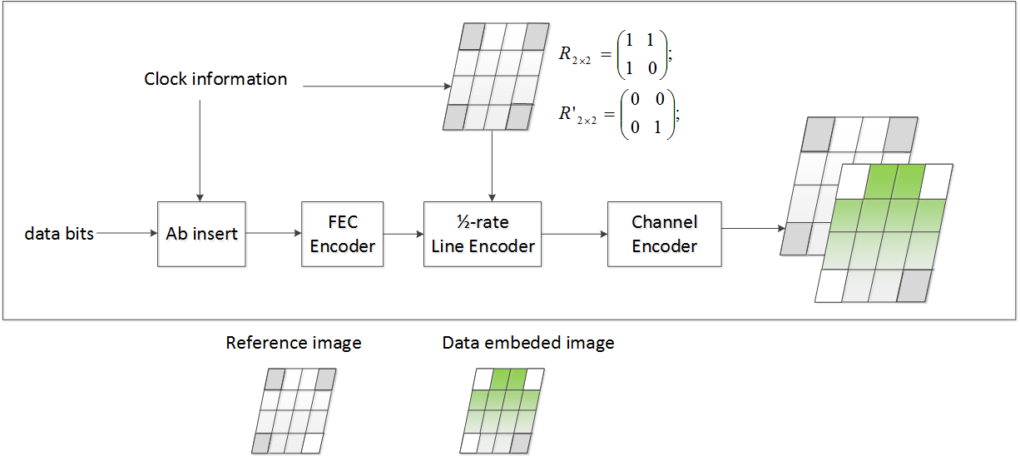
Figure x1. Reference Architecture

15.6.2 Channel encoder

15.6.2.1 Encoder configuration
The number of hidden cells on the screen (m×n) to be modulated is read by the value of PHY PIB attribute phyHAqlNoCells. The Tx checks the screen resolution and reads the number of cells to determine the size of individual cells.

15.6.2.2 ½-rate line encoder
The HA-QL encoder shall utilize 1/2-rate line coding (see table x1).
Unlike the typical RLL code that is to maintain the average brightness, the line coding applied here is to provide the reference image (i.e. the image that has unmodulated intensity) for the decoder to extract the modulated intensity. Thus, from a block of data, the RLL encoder utilizes the 1/2-rate line code to generate a pair of two images, a reference image, and a data-embedded image.
Table x1. RLL encoding table
Binary Input | RLL Output | Cell(ij) intensity description
“0” | 0 0 | the state of the cell does not change between two image frames
“1” | 0 1 | the state of the cell changes between two image frames.

Additionally, within both reference image and data image, the reference cells at the corners of each image shall not carry any data but the rotation information of the HA-QL code. These reference cells are modulated by a pair of the intensity matrix, R_{2×2} for the reference image and R’_{2×2} for the data image, to support the determination of the starting corner of Tx (see table x2).
Table x2– HA-QL RLL and channel encoding
 | Data block time (2i) |  | Data block time (2i+1)
 | Reference image | Data emdeded image | Reference image | Data emdeded image
$m×n$ cells Tx | $$C_{m×n}=\left(\begin{aligned}c_{0,0} c_{0,1} … c_{0,n-2} { c}_{0,n-1} \\ c_{1,0} c_{1,1} … c_{1,n-2} c_{1,n-1} \\ … \\ c_{m-2,0} c_{m-2,1} … c_{m-2,n-2} c_{m-2,n-1} \\ c_{m-1,0} c_{m-1,1} … c_{m-1,n-2} c_{m-1,n-1} \end{aligned}\right)$$
reference-cells  $R_{2×2}=\left(\begin{aligned}c_{0,0} c_{0,n-1} \\ c_{m-1,0} c_{m-1,n-1}\end{aligned}\right)$ | $\left(\begin{aligned}1 1 \\ 1 0\end{aligned}\right)$ | $$\left(\begin{aligned}0 0 \\ 0 1\end{aligned}\right)$$ | $\left(\begin{aligned}1 1 \\ 1 0\end{aligned}\right)$ | $$\left(\begin{aligned}0 0 \\ 0 1\end{aligned}\right)$$
where R_{2×2} is the intensity matrix to modulate four reference-cells for supporting the identification of the starting corner of the HA-QL code under rotation.

To support a receiver dealing with its frame rate variation, Ab shall be inserted at the beginning of every block of data. The number of Ab is configurable via the PHY PIB atrribute phyHAqlAb. After that, a block of data along with Ab shall also be protected from error by using inner FEC (see 15.6.2.2 Error correction)
The decoding guideline is described in section J-5. HA-QL decoding method.
When the length of data does not fit the size of the HA-QL code, zeros are inserted to the end of data. Rx reads the value of the PHY PIB attribute phyPSDUlength and then it pads the inserted bits.

15.6.2.2 Error correction
RS(15,7) shall be implemented as an inner FEC to protect data from error.
 | Error correction
PHR, PSDU, Ab | RS(15,7)

The value of PHY PIB attribute phyOccFec shall determine the error correction used if any change is applied.

15.6.3 Bits-to-Intensity mapping
The channel encoder converts a block of data bits into a pair of matrixes, in which the first matrix contains all zeros and the second matrix contains the data bits. The value of each element in a matrix (element # ij) shall be mapped into the intensity (Pij) to control the corresponding data cell (cell ij) of the HA-QL layer that is to be added in front of the original image.
bit 0: Pg(ij) = 0
bit 1: Pg(ij) = 1
where Pg(ij) = 0 and Pg(ij) = 1 indicates that the intensity of data cell (ij) is unmodulated and modulated respectively in compared to that intensity value the original image. The change should less than 0.008 on Cb channel of YCbCr color space to be imperceptible to human eyes. The configuration of the level of intensity modulation is along with the PHY PIB attribute phyHAqlIntensity.
Consequently, a block of data is carried by a pair of images including a reference image with unmodulated intensity of all data cells and a data-embedded image with the modulated intensity of data cells.

Four reference cells at corners are modulated by the clock information (2x2 matrix via reference-cells). Thus only data bits (nxm – 4) bits are carried by data cells.
The optical clock rate at which the cells on Tx are updated is configurable over PHY PIB attribute phyOccOpticalClockRate.

Annex J:

PHY 4,5,6 OCC-Waveforms Decoding Guide

J-1. S2-PSK Decoding Method
At a sampling time, a camera captures two light sources (LED-1 and LED-2). The Rx determines the states of LEDs from the captured image and implements the XOR operator. The data bit is the output from the XOR operator which inputs are a pair of LED states (see Figure 1).
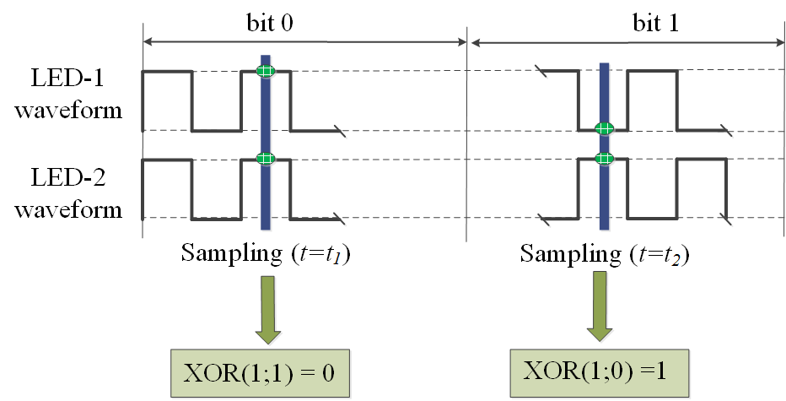
Figure 1. An example of S2-PSK Decoding
When the Rx captures in the ON-OFF transition time of the waveform, the states of LEDs are unclear. Thus, an error may happen at the output of the XOR operator. The ratio of the exposure time and the duty cycle of the transmitted waveform has the effect to the error probability caused by the long exposure.
Suggested solutions for this problem can be:
- Rx samples multiple times per bit period (in which the sampling period = (n+0.5) times the duty cycle of the transmitted waveform to avoid all samplings are unclear).
- Moreover, FEC is helpful.

J-2. DS8-PSK Decoding Method
At a sampling time, a camera captures two groups of light sources; and from an image, each group forms a set of eight ON/OFF states. The decoding procedure is illustrated as in Figure 2.
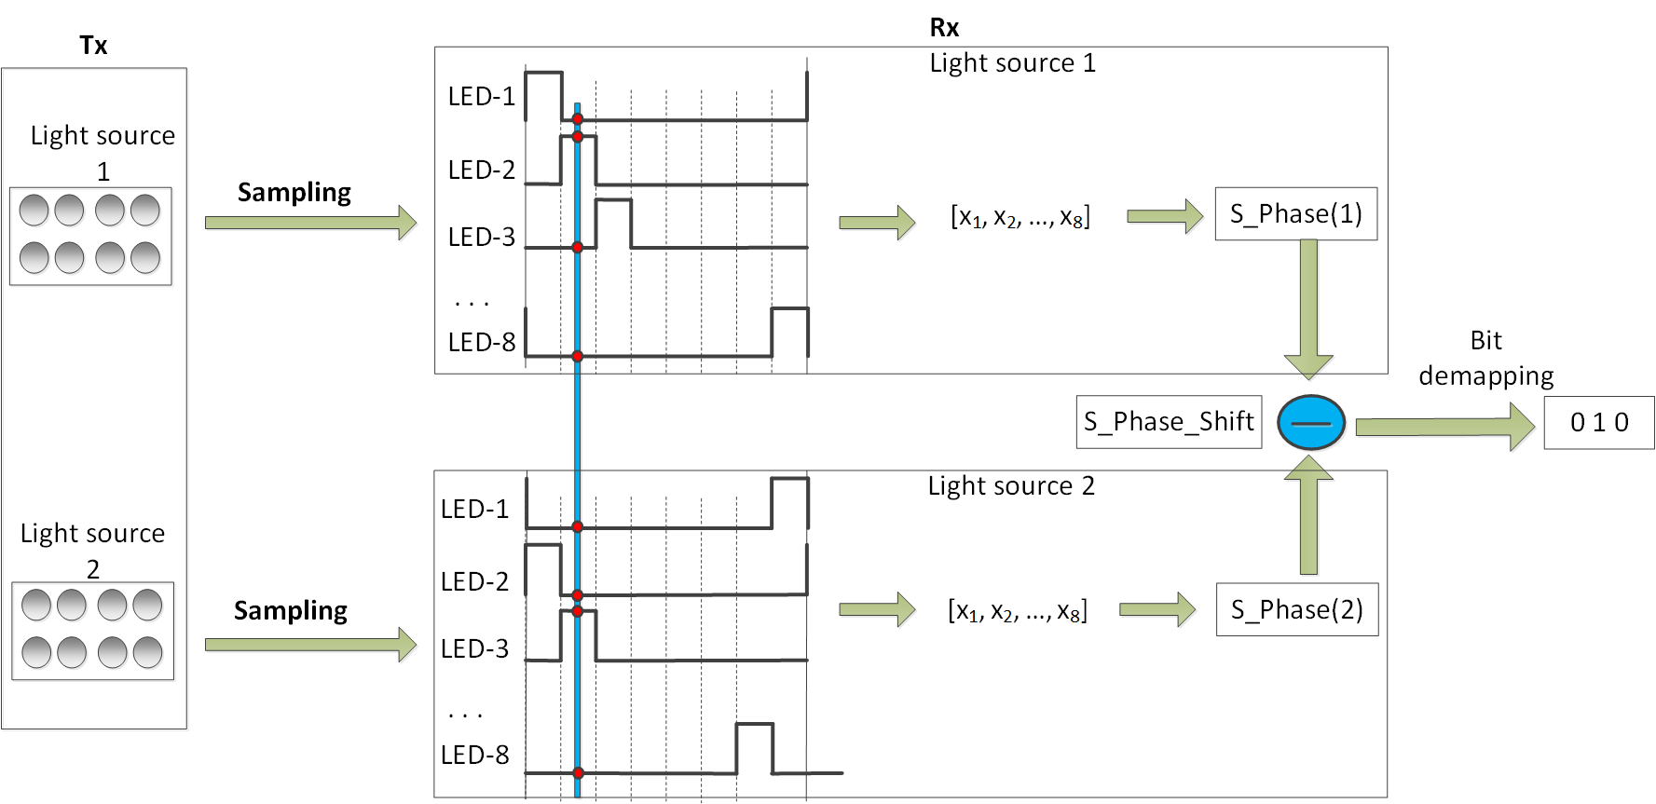
Figure 2. DS8-PSK decoding procedure

The captured set of a group shall be represented by S_Phase as shown in Table 166.
Table 166: S_Phase representing the captured set of states of a light source under dimming
8-states Input |  |  |  |  |  |  | S_Phase Output
Dimming 1/8 | Dimming 2/8 | Dimming 3/8 | Dimming 4/8 | Dimming 5/8 | Dimming 6/8 | Dimming 7/8
1000 0000 | 1000 0001 | 1000 0011 | 1000 0111 | 1000 1111 | 1001 1111 | 1011 1111 | 1
0100 0000 | 1100 0000 | 1100 0001 | 1100 0011 | 1100 0111 | 1100 1111 | 1101 1111 | 2
0010 0000 | 0110 0000 | 1110 0000 | 1110 0001 | 1110 0011 | 1110 0111 | 1110 1111 | 3
0001 0000 | 0011 0000 | 0111 0000 | 1111 0000 | 1111 0001 | 1111 0011 | 1111 0111 | 4
0000 1000 | 0001 1000 | 0011 1000 | 0111 1000 | 1111 1000 | 1111 1001 | 1111 1011 | 5
0000 0100 | 0000 1100 | 0001 1100 | 0011 1100 | 0111 1100 | 1111 1100 | 1111 1101 | 6
0000 0010 | 0000 0110 | 0000 1110 | 0001 1110 | 0011 1110 | 0111 1110 | 1111 1110 | 7
0000 0001 | 0000 0011 | 0000 0111 | 0000 1111 | 0001 1111 | 0011 1111 | 0111 1111 | 8

Also, a sampling called bad-sampling (when the camera captures the transition time of a single LED among LEDs of the group) shall generate a presence of an unclear state (x_state) among a set of eight states. The determination of S_Phase value under the presence of x_state is as shown in Table 167.
Table 167: S_Phase representing the captured set of states of a light source (with x_state) under dimming
8-states Input |  |  |  |  |  |  | S_Phase Output
Dimming 1/8 | Dimming 2/8 | Dimming 3/8 | Dimming 4/8 | Dimming 5/8 | Dimming 6/8 | Dimming 7/8
xx00 0000 | 1x00 000x | 1x00 00x1 | 1x00 0x11 | 1x00 x111 | 1x0x 1111 | 1xx1 1111 | 1
0xx0 0000 | x1x0 0000 | 11x0 000x | 11x0 00x1 | 11x0 0x11 | 11x0 x111 | 11xx 1111 | 2
00xx 0000 | 0x1x 0000 | x11x 0000 | 111x 000x | 111x 00x1 | 111x 0x11 | 111x x111 | 3
000x x000 | 00x1 x000 | 0x11 x000 | x111 x000 | 1111 x00x | 1111 x0x1 | 1111 xx11 | 4
0000 xx00 | 000x 1x00 | 00x1 1x00 | 0x11 1x00 | x111 1x00 | 1111 1x0x | 1111 1xx1 | 5
0000 0xx0 | 0000 x1x0 | 000x 11x0 | 00x1 11x0 | 0x11 11x0 | x111 11x0 | 1111 11xx | 6
0000 00xx | 0000 0x1x | 0000 x11x | 000x 111x | 00x1 111x | 0x11 111x | x111 111x | 7
x000 000x | x000 00x1 | x000 0x11 | x000 x111 | x00x 1111 | x0x1 1111 | xx11 1111 | 8

From an image, two group of light sources shall produce a pair of S_Phase values (S_Phase(1) representing the captured state of the group 1 and S_Phase(2) representing the captured state of the group 2). And then, the value of S_Phase_Shift is calculated as follows:
S_Phase_Shift = S_Phase(1) - S_Phase(2)

Finally, the de-mapping from S_Phase_Shift to 3 bits shall be done inversely as the mapping table (Table 136) showed.

J-3. HS-PSK Decoding Method
For a dual-camera receiver system, the hybrid signal can be demodulated as below:
  - A low frame rate camera (the frame rate should be greater than the S2-PSK optical clock rate) is to detect the S2-PSK signal. Either a global shutter or a rolling shutter camera can be used.
  - A global shutter and high-speed camera (the frame rate should be greater than the D8M-PSK optical clock rate) is to decode the DS8-PSK signal.

J-4. C-OOK Decoding Method
To demodulate the entire data sub-packet DS, the distance from a camera to the LED transmitter should be close enough. Figure B8 shows the relationship between the amount of data being captured by the camera and the distance from the camera to the LED transmitter.

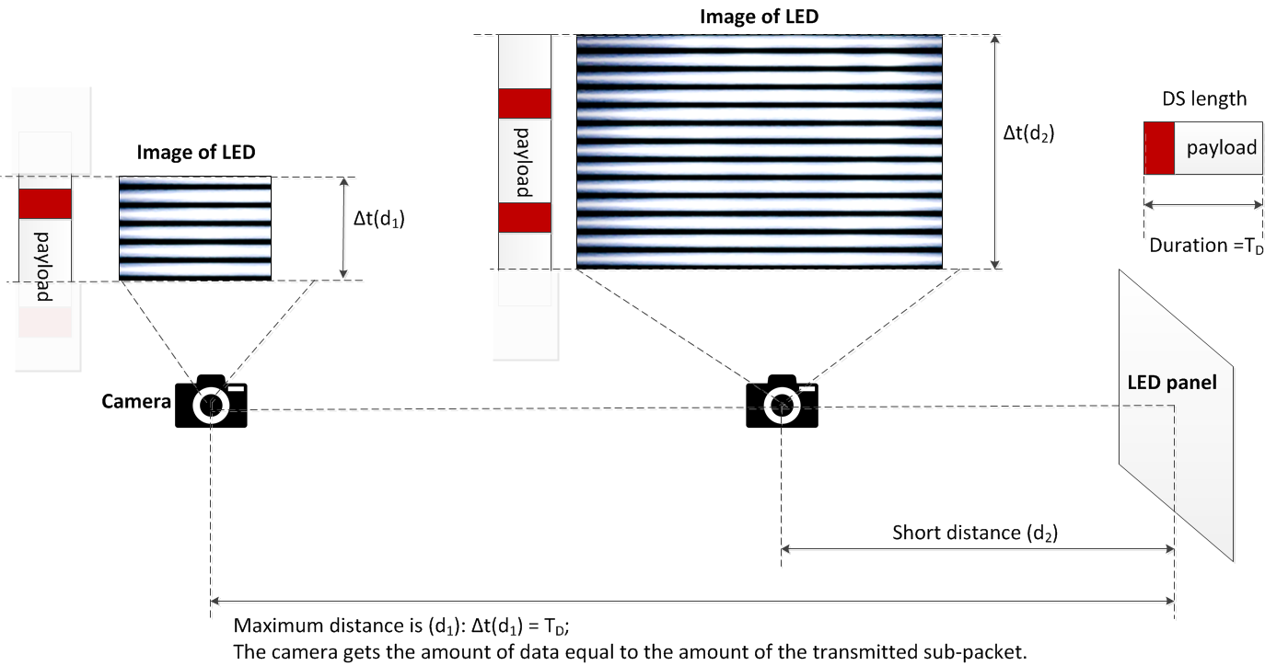
Figure B8– Decoding scenario

From the figure 258, the maximum distance achieved is the distance at which the camera gets the amount of data equal to the amount of the sub-packet.
Decoding case 1: Fuse incomplete parts of a subpacket into a complete one
At this distance far, the distance d₁ as shown in figure 258, the camera detects the preamble symbol and then demodulates the amount of data enough for a subpacket; however, the uncertainty whether the forward part and the backward part counted from the position of the preamble belong to a sub-packet or not is problematic. The problem of a small amount of data also happens at a shorter distance when the transmitted subpacket is long.
Asynchronous bits representing the clock information of the packet are used for the asynchronous decoding algorithm in this case.

Figure 259– Decoding algorithm at a far distance

Figure 259 illustrates the decoding algorithm to recover a packet of data from the forward part and the backward part of an image when the size of LED is small in the captured image. By observing the values of an asynchronous bit before and an asynchronous bit after the preamble, two statements of fusing those two parts of a subpacket are addressed:
- Case 1- Inter-frame data fusion: Fusing two parts of a packet at two different images into a complete packet.
This type of data fusion is applied in case two Ab on an image are different.
- Case 2- Intra-frame data fusion: Recovering a complete packet from an image.
This type of data fusion is applied in case two Ab on an image are similar.

Decoding case 2: Combination of Data Fusion and Majority Voting
When the camera goes closer to the LED transmitter, the amount of data being captured per image is greater than that of a subpacket. Therefore, the extra amount of data is used for correcting the possible error by applying a majority vote.
At distance d₂ on figure 158, the amount of data equivalent to two subpackets is captured. The majority voting is used in this case to correct the error throughout the entire sub-packet.
Figure 260 shows an experimental example of decoding under Intra-frame data fusion. The extra data after fusion a subpacket is used for correcting the error by voting.
Assume that the camera frame rate may vary but be greater than the packet rate of transmission. Therefore, any extra data after fusion is useful for the error correction by grouping multiple images which belong to a subpacket to vote. The voting is on the amount of data grouped from all of the forward parts and backward parts of images as well as extra data.
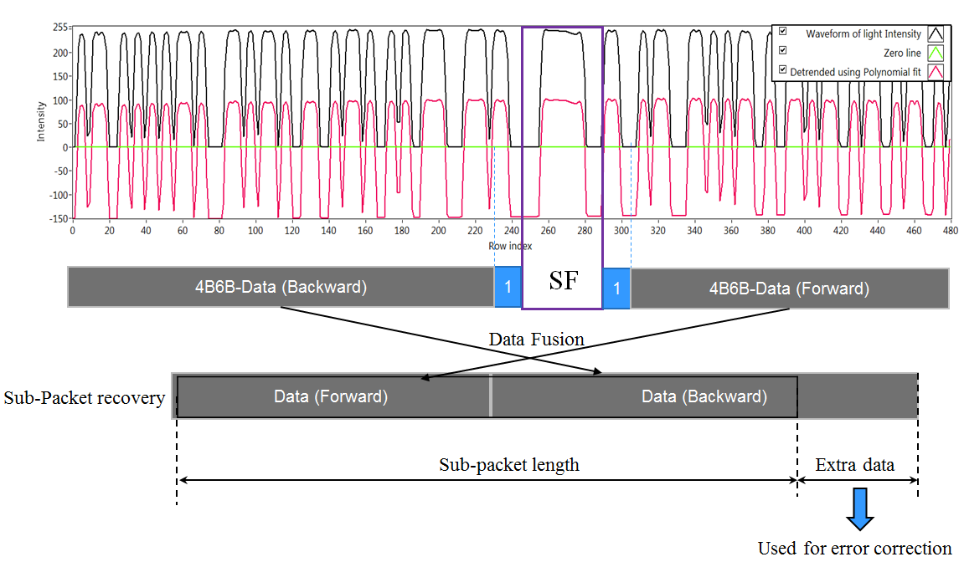
Figure 260– An example of decoding employing intra-frame fusion along with error correction.

J-5. A-QL Decoding Method
- Rotation Support
From the reference cells at the corners of the A-QL code, the rotation angle can always be determined. The rotation support is mandatory in A-QL system.
Non-Rotated A-QL code | 120⁰ Rotated A-QL code
Figure. The starting corner determination from reference cells under rotation

- Downsampling using Ab
A camera that has frame rate greater than the optical clock rate (three times at least, to avoid the sampling in the symbols transition time) is to receive data. The downsampling is challenging in the case of time-variant frame rate Rx.
Assume that there is more than one image sampled per block of data (no symbol is missed during the sampling). The decoder demodulates data from every block, and extract the Ab bit. The adjacent blocks that have the same Ab bits as shown in Figure 261 will be down-sampled. During the downsampling process, the majority voting may be applied for each group of adjacent blocks that have the same Ab to mitigate possible error.
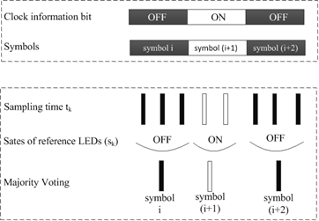
Figure C261 –Asynchronous decoding
- Rolling effect detection and removal
In case a rolling shutter camera captures in between the transition time of two adjacent blocks of data, four Ab bits at four reference cells on the captured image shall not be the same. The image is detected as a rolling affected image as shown in Figure C262, and be discarded.

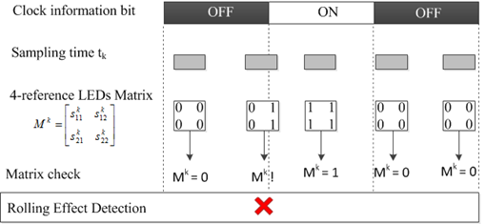
Figure C262 – Detection and Removal of a Rolling Effected Image

Also, to support a rotated camera decoding, the transmission of four rotation-indication bits via reference cells over the blue channel allows a receiver in identifying the starting corner of the code. The starting corner shall have the similar values with its two adjacent reference cells.

J-6. HA-QL decoding method
Rx with frame rate no less than three times the optical clock rate is used to demodulate HA-QL code. The Rx extracts the code area and then it extracts the m×n matrix of intensity with the number of hidden cells m×n is read from the PHY PIB attribute phyHAqlNoCells.
The matrix of intensity is extracted by comparing a data embedded image to its adjacent reference image (see Figure 1)
Figure 1. Illustration of a reference image and a data-embedded image

Annex L:

L-1. Generation of Hamming code
The generator matrix G is defined as
$$G= {\left(\begin{aligned}1 1 1 0 \\ 1 0 0 1 \\ 0 1 0 1 \\ 1 1 0 1\end{aligned} | \begin{aligned}0 0 0 1 \\ 1 0 0 1 \\ 0 1 0 1 \\ 0 0 1 0\end{aligned}\right)}_{4,8}$$
The parity check matrix is defined as
$$H= {\left(\begin{aligned}1 0 1 0 \\ 0 1 1 0 \\ 0 0 0 1 \\ 1 1 1 1\end{aligned} | \begin{aligned}1 0 1 0 \\ 0 1 1 0 \\ 1 1 1 0 \\ 1 1 1 1\end{aligned}\right)}_{4,8}$$
- Encoding rule
a = 1011,
x = aG = (1 0 1 1)$\left(\begin{aligned}1 0 0 0 \\ 0 1 0 0 \\ 0 0 1 0 \\ 0 0 0 1\end{aligned} | \begin{aligned}0 1 1 1 \\ 1 0 1 1 \\ 1 1 0 1 \\ 1 1 1 0\end{aligned}\right)$ = (2 3 1 2 0 1 1 2) = (0 1 1 0 0 1 1 0)
1011 is encoded into 01100110 where blue digits are data; red digits are parity bits from the [7,4] Hamming code, and the green digit is the parity bit added by the [8,4] code. Finally, it can be shown that the minimum distance has increased from 3, in the [7,4] code, to 4 in the [8,4] code.
Table: 4-to-8 Hamming encoding
Input bits | Output bits
0 0 0 0 | 0 0 0 0 0 0 0 0
0 0 0 1 | 1 1 0 1 0 0 1 0
0 0 1 0 | 0 1 0 1 0 1 0 1
0 0 1 1 | 1 0 0 0 0 1 1 1
0 1 0 0 | 1 0 0 1 1 0 0 1
0 1 0 1 | 0 1 0 0 1 0 1 1
0 1 1 0 | 1 1 0 0 1 1 0 0
0 1 1 1 | 0 0 0 1 1 1 1 0
1 0 1 1 | 0 1 1 0 0 1 1 0
1 0 0 1 | 0 0 1 1 0 0 1 1
1 0 1 0 | 1 0 1 1 0 1 0 0
1 0 1 1 | 0 1 1 0 0 1 1 0
1 1 0 0 | 0 1 1 1 1 0 0 0
1 1 0 1 | 1 0 1 0 1 0 1 0
1 1 1 0 | 0 0 1 0 1 1 0 1
1 1 1 1 | 1 1 1 1 1 1 1 1

- Decoding guideline
Error may occur at the receiver side,
r = x+ e
By using the parity check matrix H, the syndrome parity checking result is calculated by
s = rH^{T}
If s = 0, the r is an effective codeword. Otherwise, see if r is correctible by checking the error pattern.

L-2. Temporal Error Correction using Majority bit voting
Assume that the number of samplings repeated in the Rx is no less than three. The majority voting is applied to a selected set of three samplings (which belong to a transmitted bit) is given as follows.
Transmitted bit | Received sequence
0 | 0 0 0
1 | 1 1 1

When there is error happened, a majority bit voting is applied to a set of three bits (repeating code R3). The decoding algorithm for R3 is given as follows
Table: Decoding rule for R3
Received sequence | decoded bit
000 | 0
001 | 0
010 | 0
100 | 0
101 | 1
110 | 1
011 | 1
111 | 1

If there are two or more errors fall into a single bit, then the decoding rule gets a wrong output.

