IEEE P802.15
Wireless Personal Area Networks

Project | IEEE P802.15 Working Group for Wireless Personal Area Networks (WPANs)
Title | Kookmin - Revised PPDU formats on D3
Date Submitted | [July 2017]
Source | Trang Nguyen, and Yeong Min Jang (Kookmin University)
Re: | Revise from the original document: 16-0460-05
Abstract | Text for D3 comments’ resolution
Purpose | Resolution for D3 technical comments
Notice | This document has been prepared to assist the IEEE P802.15. It is offered as a basis for discussion and is not binding on the contributing individual(s) or organization(s). The material in this document is subject to change in form and content after further study. The contributor(s) reserve(s) the right to add, amend or withdraw material contained herein.
Release | The contributor acknowledges and accepts that this contribution becomes the property of IEEE and may be made publicly available by P802.15.

#3: PPDU frame formats

8.6.1 Preamble field
8.6.1.4 PHY VI

8.6.1.4.2 A-QL preamble field
The preamble field for A-QL is within a data-block time long. The preamble sequence (1010..10) shall have 64 bits length. The remainder of a block carrying the preamble is for PHR subfields and the training sequence (see Figure X).
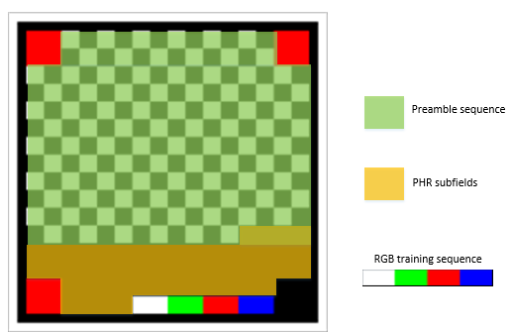
Figure. Preamble sequence, PHR subfields and training sequence of A-QL

8.6.1.4.3 Hidden A-QL (HA-QL) preamble field
The preamble field for HA-QL is two data-block times long. The second block is the inverse form of the first block that is constructed as follow.
The preamble sequence (1010…10) along with four reference cells have 64 bit-length, and fill up a block of HA-QL code (e.g. 8x8 HA-QL block) as shown in Figure Y.
Figure. The first block of HA-QL Preamble

Deleted S8-PSK preamble

8.6.2 PHY header

8.6.2.2 PHY IV

8.6.2.2.1 S8-PSK PHY header (deleted)

8.6.2.2.2 HS-PSK PHY header
PHY header subfields shall be mandatory configured by PHY PIB attributes. Besides, PHR field shall be used to notice the change of the following PHY PIB attributes:
Table – HS-PSK PHR subfields
PHY header subfields | Bit-width | Explanation on usage
Addressing field
PSDU length | 16 | Length available at phyHSpskPsduLength configuration
HSC | 16 | Header check sequence

8.6.2.3 PHY V

8.6.2.3.2 CM-FSK PHY header
Not used

8.6.2.3.3 C-OOK PHY header
Not used

8.6.2.4 PHY VI

8.6.2.4.2 A-QL PHY header
PHY header subfields shall be mandatory configured by PHY PIB attributes. Besides, PHR field shall be used to notice the change of the following PHY PIB attributes:
Table – HS-PSK PHR subfields
PHY header subfields | Bit-width | Explanation on usage
PSDU length | 16 | Length available at phyAqlPsduLength configuration
HSC | 16 | Header check sequence

8.6.2.4.3 A-QL PHY header
Not used.

8.6.3 Header check sequence (HCS)

8.6.3.2 PHY IV

8.6.3.2.1 HS-PSK HSC
CRC-16 shall be used as HSC. The generation of CRC-16 (with polynomial generator 0x1021) is described in Annex C.

8.6.3.3 PHY V (not use)
Deleted all these subsections.

8.6.3.4 PHY VI

8.6.3.4.1 A-QL HSC
CRC-16 shall be used as HSC. The generation of CRC-16 (with polynomial generator 0x1021) is described in Annex C.

8.6.3.4.1 Hidden A-QL HSC (deleted)

8.6.4 Optional fields

8.6.4.4 PHY VI

8.6.4.4.1 A-QL optional field
A channel estimation sequence shall be added as an extended subfield after the PHR subfields to support a receiver dealing with multi-color imbalance or multi-color interference. The channel estimation sequence details are discussed in section “15.1.4 A-QL Color calibration at the receiver.”

