IEEE P802.15
Wireless Personal Area Networks

Project | IEEE P802.15 Working Group for Wireless Personal Area Networks (WPANs)
Title | D2 Comments Resolution Based PHY VI Super Frame Structure, Dimming, and PPDU Format Specification Revision
Date Submitted | May, 2017
Source | Jaesang Cha (SNUST), Kim Chan (SNUST), Soonho Jung (SNUST), Sooyoung Chang (CSUS), Seongjin Choi (SNUST), Vinayagam Mariappan SNUST) | Voice: [ ]  Fax: [ ]  E-mail: [chajs@seoultech.ac.kr]¹
Re: | Draft D2 Comment Resolution based PHY VI Super Frame Structure, Dimming and PPDU Format Specification Revision
Abstract | Details of Resolutions regarding to the submitted Comments on D2 are suggested for PHY VI Super Frame Structure, Dimming and PPDU Format Specification Revision. The PHY VI is designed to operate on the application services like LED ID, LiFi/CamCom, Digital Signage with Advertisement Information etc.
Purpose | Draft D2 Comments Resolutions and Editorial Revision.
Notice | This document has been prepared to assist the IEEE P802.15. It is offered as a basis for discussion and is not binding on the contributing individual(s) or organization(s). The material in this document is subject to change in form and content after further study. The contributor(s) reserve(s) the right to add, amend or withdraw material contained herein.
Release | The contributor acknowledges and accepts that this contribution becomes the property of IEEE and may be made publicly available by P802.15.

1. PHY VI SUPERFRAME STRUCTURE

VTASC Superframe Structure

The Display Light Pattern Based Transmitter with VTASC uses the unslotted ALOHA; that is, when the Display Light Pattern Based Transmitter with VTASC uses has a packet to send, it just sends it. This support with beacon and without beacon support and the transmitter does not do a listen before talk channel activity check.

Sequential Scalable 2D Code Superframe Structure

The Display Light Pattern Based Transmitter with Sequential Scalable 2D Code uses the unslotted ALOHA;that is, when the Display Light Pattern Based Transmitter with Sequential Scalable 2D Code uses has a packet to send, it just sends it. This support with beacon and without beacon support and the transmitter does not do a listen before talk channel activity check.

Invisible Data Embedding Superframe Structure

The Invisible Data Embedded Display TX Schemes use unslotted ALOHA; that is, when the Invisible Data Embedded Display transmitter has a packet to send, it just sends it. This support with beacon and without beacon support and the transmitter does not do a listen before talk channel activity check.

2. PHY VI DIMMING

Invisible Data Embedding Dimming

The display to camera communication dimming control is depending on the mode of embedding data (Visible or Invisible) on display system, rate at which data is repeatedly coding on video frame, and rate at which data refresh on display. The Invisible Data Embedding based display transmitter for optical camera communication uses the invisibly embedding the data on video display frame by overlaying patterns on displays visual area using Alpha Blending and Watermarking. Dimming is supported by controlling visual scene high frequency background color.

VTASC Dimming

The display to camera communication dimming control is depending on the mode of embedding data (Visible or Invisible) on display system, rate at which data is repeatedly coding on video frame, and rate at which data refresh on display. The VTASC based Display Transmitter for optical camera communication uses the visibly embedding the data on Video display frame by overlaying patterns on displays visual area at optical clock rate from 1Hz to 30Hz that is perceptible by human eyes, dimming is not supported.

Sequential Scalable 2D Code Dimming

The display to camera communication dimming control is depending on the mode of embedding data (Visible or Invisible) on display system, rate at which data is repeatedly coding on video frame, and rate at which data refresh on display. The Sequential Scalable 2D Code based Display Transmitter for optical camera communication uses the visibly embedding the data on Video display frame by overlaying patterns on displays visual area at optical clock rate from 1Hz to 30Hz that is perceptible by human eyes, dimming is not supported.

3. PHY VI PPDU Format

8.6.1.4.1 Invisible Data Embedding Preamble Field
The SHR field is used by the transceiver to obtain optical clock synchronization with an incoming message is called Preamble. The standard defines one fast locking pattern (FLP) followed by choice of four topology dependent patterns (TDPs) for the purposes of distinguishing different PHY topologies is shown in Table 129.
Table 129 – Preamble Pattern with Topologies
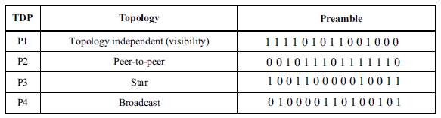
8.6.1.4.4 Sequential scalable 2D code Preamble Field
The Sequential scalable 2D Code preamble field follows the Invisible data embedding preamble field mode. Refer 8.6.1.4.1 for more details.
8.6.1.4.6 VTASC Preamble Field
The VTASC preamble field follows the Invisible data embedding preamble field mode. Refer 8.6.1.4.1 for more details.
8.6.2.4.1 Invisible Data Embedded Header Field
The Invisible Data Embedded Header Field is described as shown in Table 140 and shall be transmitted with data to identify the PHY Mode, Data rate, and PSDU length to identify the transmission specification.
Table 140 – PHY Header
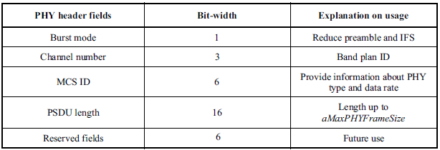
Burst Mode Field: The burst mode bit indicates that the next frame following the current frame is part of the burst mode. The Burst Mode bit shall be set TRUE if the burst mode is being used otherwise, the Burst Mode bit shall be set FALSE.
Channel Number Field: The channel number field for PHY shall be the band plan ID of the lowest wavelength. Refer to 9.3.1 for more detailed information.
MCS ID Field: The modulation and coding scheme (MCS) ID shall be indicated in the PHY header based on Table 83.
PSDU Field: The PSDU length field specifies the total number of octets contained in the PSDU.
8.6.2.4.4 Sequential scalable 2D code Header Field
The Sequential scalable 2D Code header field follows the Invisible data embedding header field mode. Refer 8.6.2.4.1 for more details.
8.6.2.4.6 VTASC Header Field
The VTASC header field follows the Invisible data embedding preamble field mode. Refer 8.6.2.4.1 for more details.
8.6.5.4.1 Invisible Data Embedded PSDU Field
The PSDU field has a variable length and carries the data of the PHY VI frame. The FCS is appended if the PSDU has a non-zero byte payload. The structure of the PSDU field is as shown in Figure 197.
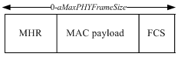
Figure 197 – Invisible Data Embedding PHY PSDU Field Structure
8.6.5.4.4 Sequential scalable 2D code PSDU Field
The Sequential scalable 2D Code PSDU field follows the Invisible data embedding PSDU field mode. Refer 8.6.5.4.1 for more details.
8.6.5.4.6 VTASC PSDU Field
The VTASC PSDU field follows the Invisible data embedding PSDU field mode. Refer 8.6.5.4.1 for more details.

