**IEEE P802.15**

**Wireless Personal Area Networks**

|  |  |  |
| --- | --- | --- |
| Project | IEEE P802.15 Working Group for Wireless Personal Area Networks (WPANs) | |
| Title | **D2 Comments Resolution Based PHY-VI PHY Specification Revision** | |
| Date Submitted | May, 2017 | |
| Source | Jaesang Cha (SNUST), Minwoo Lee (SNUST), Soonho Jung (SNUST), Kim Chan (SNUST), Ilkyoo Lee (Kongju Nat’Univ.), Gilsik Lee (The Univ. of Texas at Dallas), Sooyoung Chang (CSUS), Vinayagam Mariappan (SNUST), | Voice: [ ] Fax: [ ] E-mail: [chajs@seoultech.ac.kr]1 |
| Re: | Draft D2 Comment Resolution based PHY-VI PHY Specification Revision | |
| Abstract | Details of Resolutions regarding to the submitted Comments on D2 are suggested for PHY-VI PHY Specification Revision. The PHY VI is designed to operate on the application services like LED ID, LiFi/CamCom, Digital Signage with Advertisement Information etc. | |
| Purpose | Draft D2 Comments Resolutions and Editorial Revision. | |
| Notice | This document has been prepared to assist the IEEE P802.15. It is offered as a basis for discussion and is not binding on the contributing individual(s) or organization(s). The material in this document is subject to change in form and content after further study. The contributor(s) reserve(s) the right to add, amend or withdraw material contained herein. | |
| Release | The contributor acknowledges and accepts that this contribution becomes the property of IEEE and may be made publicly available by P802.15. | |

# **1. PHY VI SPECIFICATIONS**

# **15. PHY VI Specifications**

# **15.2 VTASC Specification**

The VTASC PHY supported data rates and operating conditions are shown in Table 116 – PHY VI Operating Modes. The Display Light Pattern Based VTASC Transmitter works with variable size and different shape of the patterns. The data embedded on visual frame by overlaying visual patterns displays visual area. The PHY system diagram illustrated in Figure 279 is 2 Dimensional / Screen Source based Transmitter using VTASC.

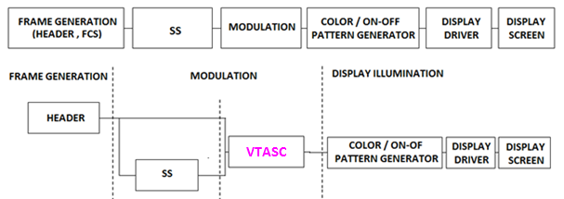

**Figure 279 – Display Light Pattern Based Transmitter with VTASC** **PHY System Diagram**

The VTASC is used for effective display to camera communication in the real-time usage scenario. The VTASC works on,

* Receiver angle free and distance adaptive communication
* Receiver distance adaptive communication achieved by screen with interactive Camera
* Asynchronous communication
* Receiver OCC device frame rate independent transmission
* Scalable bitrate controller
* Distance adaptive data rate control
* Effective multi-display model for transmission

The spread spectrum used with VTASC to have effective asynchronous communication, distance adaptive scalable data rate control.

**15.2.1 VTASC Modulation**

VTASC is a modulation scheme for visible-light communication involving single / multiple light sources with variable transparent level, size, shape model, and color. VTASC enables the VLC system with improved VLC throughput by increasing the bit per symbol rate, and avoiding the single color interference.

The VTASC is coded by T (Transparency) / A (Amplitude nothing but Size of the color block) / S (Shape) / C (Color) State as described in the Figure 280;

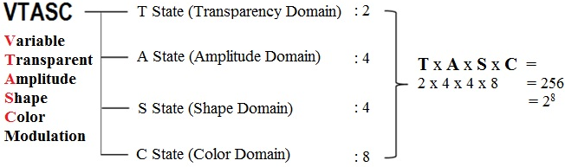

**Figure 280—VTASC coding**

The no of coded Levels in the VTASC schemes (TxAxSxC): 256 = 28 and this makes place to code 8 bit Symbol with 2/4/4/8 (Transparency/Amplitude/Shape/Color). The coded sample model is given Figure 281.

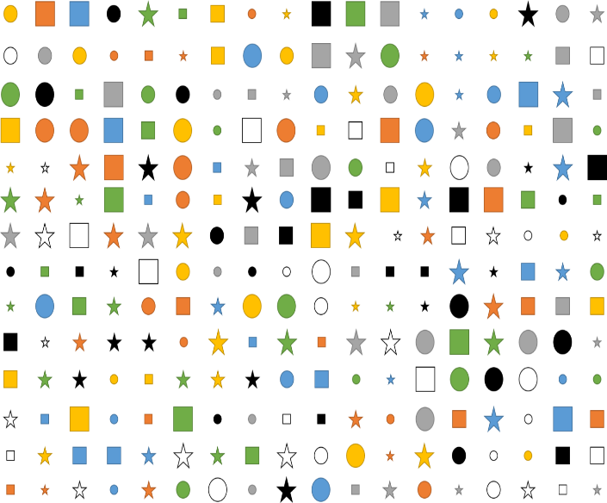

**Figure 281—VTASC Coded Pattern Model**

The following Table 206 describes the Symbol bit mapping using VTASC schemes. The VTASC is able to expand a Domain size and add a transparency or blinking domain.

**Table 206—VTASC Symbol per Bit Mapping**

|  |  |  |
| --- | --- | --- |
| **VTASC Block Model**  **(TxAxSxC)** | **No of Block Types (T*A*S*C)** | **BitsPerSymbol** |
| T = 2, A = 2,S = 2,C = 2 | 16 = 24 | 4 |
| T = 2, A = 4,S = 2, C = 2 | 32 = 25 | 5 |
| T = 2, A = 4,S = 4, C = 2 | 64 = 26 | 6 |
| T = 2, A = 8,S = 4, C = 2 | 128 = 27 | 7 |
| T = 2, A = 2,S = 4, C = 4 | 64 = 26 | 6 |
| T = 2, A = 4,S = 4, C = 4 | 128 = 27 | 7 |
| T = 2, A = 8,S = 4, C = 4 | 256 = 28 | 8 |
| T = 2, A = 4,S = 2, C = 8 | 128 = 27 | 7 |
| T = 2, A = 4,S = 4, C = 8 | 256 = 28 | 8 |
| T = 2, A = 8,S = 2, C = 8 | 256 = 28 | 8 |
| T = 2, A = 8,S = 4, C = 8 | 512 = 29 | 9 |
| T = 2, A = 8,S = 4, C = 16 | 1024 = 210 | 10 |

The Data Rate calculated is described below,

DataRate = (NoofBlocks * BitsPerSymbol * OpticalClockrate * FECRate) / CodeLength)

Where, “CodeLength” is 1 for without SS Coded schemes and respective code length for with SS Coded Schemes

Note this case study designed with Full HD Display (1920x1080) with minimum block size of 32x32 pixels and this data rate calculation vary from Display Screen Size.

NoofBlocks = (1920/32)* (1080/32) = 60 x 32 (Approximated to even multiplication for coding efficiency)

The Data Rate for 2 Color VTASC Code with 8 size scalability & 4 shapes & 2 transparency Level without SS Coded Code (CodeLength is 1),

BitsPerSymbol = 7 (Refer Table 206)

OpticalClockrate = 30

FECRate = 1 (Refer Table 206)

DataRate = ((1920/32)* (1080/32) * 7 * 30 * 1) / 1) = 403200 Approximated to 390 Kbps

The Data Rate for 2 Color VTASC Code with 8 size scalability with SS Coded Code (Minimum CodeLength is 2),

BitsPerSymbol = 4 (Refer Table 206)

OpticalClockrate = 30

FECRate = 1 (Refer Table 206)

DataRate = ((1920/32)* (1080/32) * 4 * 30 * 1) / 2) = 201600 Approximated to 195 Kbps

The Table XXX describes the data rate supported based on predefined block size.

|  |  |  |  |  |
| --- | --- | --- | --- | --- |
| **Modulation**  **(TxAxSxC)** | **RLL Code** | **Optical Clock Rate** | **FEC** | **Data Rate (Kbps)** |
| 2 Color VTASC Code1  (T = 2,A=2/4/8,S=2/4,C=2) | None | 30Hz | RS(64,32)/ RS(160,128)/ None | 390 Kbps |
| 4 Color VTASC Code1  (T = 2,A=2/4/8,S=2/4, C=4) | None | 30Hz | RS(64,32)/ RS(160,128)/ None | 450 Kbps |
| 8 Color VTASC Code1  (T = 2,A=2/4/8,S=2/4,C=8) | None | 30Hz | RS(64,32)/ RS(160,128)/ None | 506 Kbps |
| 16 Color VTASC Code2  (T = 2,A=2/4/8,S=2/4,C=16) | None | 30Hz | RS(64,32)/ RS(160,128)/ None | 1054 Kbps |
| 2 Color SS VTASC Code1  (T = 2,A=2/4/8,S=2/4,C=2) | None | 30Hz | None | 195 Kbps |
| 4 Color SS VTASC Code1  (T = 2,A=2/4/8,S=2/4,C=4) | None | 30Hz | None | 225 Kbps |
| 8 Color SS VTASC Code1  (T = 2,A=2/4/8,S=2/4,C=8) | None | 30Hz | None | 253 Kbps |
| 16 Color SS VTASC Code2  (T = 2,A=2/4/8,S=2/4,C=16) | None | 30Hz | None | 527 Kbps |

**Table XXX – VTASC PHY Data Rate Table**

Note: [32x32 Block Size] 1 and [24x24 Block Size] 2

Where, “T” represents Level of transparency, “A” represents Number of Block Size Amplitude

“S” represents Number of Shapes, “C” represents Number of Colors

**15.2.2 Spread Spectrum**

The spread spectrum adopted with VTASC for Display Light Pattern Based Transmitter to add built-in adaptation on data recovery in addition to achieve the asynchronous communication with Angle free and distance adaptive communication between transmitter and Receiver. The Spread spectrum can use any Orthogonal Codes (like Walsh sequences) or Non-Orthogonal Codes (like PN, Gold, and Kasami shift register sequences).

The Gold Sequence based SS Code Specification is given for example to understand,

* Gold sequence was chosen as a spreading code
* Shifter register length is 5
* Code length is 31 (=25-1)
* 4 family code set was generated via offset 8*n chips of code set 1
* Code Sets

1. Code set 1: 0000000010010100100111101010110 (zero offset)
2. Code set 2: 1001010010011110101011000000000 (8chip offset)
3. Code set 3: 1001111010101100000000010010100 (16chip offset)
4. Code set 4: 1010110000000001001010010011110 (24chip offset)

The Figure 282 shows the SS Gold Sequence Generator model.

5

4

3

2

1

5

4

3

2

1

Gold-Sequence

**Figure 2-3 – Gold Sequence Generator**

**15.2.3 Data Encoder**

The Display Light Pattern Based Transmitter with VTASC Schemes works by overlaying the data mapped color code on visual scene as show in Figure YYY. The data embedded on visual frame by overlaying visual patterns displays visual area. The rule to overlaying data and data rate achievement vary based on the kind of display used to design the Transmitter.



**Figure YYY – VTASC Data Encoder**

The receiver specific information for VTASC Data Decoder is given in Annex M.1

**15.2.4 Asynchronous Communication Mode**

The Asynchronous communication achieved when transmitting data, different spreading code is used per video frame. Each code sets repeated for spreading data according to spreading factor and each spreading code set 1, 2, 3, and 4 are assigned for successive 4 frames as shown in Figure 2-4.

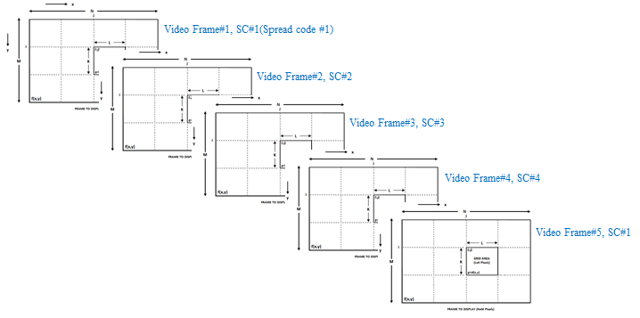

**Figure 2-4 – SS Code Assignment**

The receiver specific information for Asynchronous communication is given in Annex M.2.

**15.2.5 Angle Free Communication**

The receiver specific information for Angle free communication is given in Annex M.3.

**15.2.6 Scalable Bitrate Controller**

The PHY for Display Light Pattern Based Transmitter with VTASC designed with built-in Scalable bitrate Controller. To achieve robust communication, the scalable data transmission mode is proposed in PHY model design is shown in Figure 286. The Screen is divided into Multiple regions and each region has different frame rate controlled data transmission is enabled. This approach adds robustness on system performance for frame rate adaptive communication based on the receiver performance.



**Figure 286 – Scalable Bitrate Controller**

**15.2.7 Distance Adaptive Data Rate Control**

The PHY for VTASC Display TX Schemes designed with distance adaptive data rate control. In this case the Transmitter built-in with camera features as shown in Figure 287. The Transmitter Camera Estimate the Receivers distance using camera. There are different methods used to estimate the distance to receiver. Some of these methods are active by sending some signals to the object such as laser range finder, ultrasonic range finder, radio waves, microwaves, infrared, etc. Some others are passive that only receive information about the target position. The distance estimation method decision left up to the system designer.

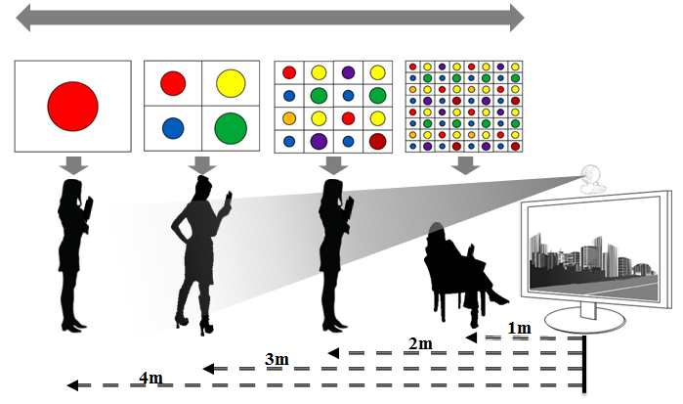

**Figure 287 – Distance Adaptive Data rate Control**

For this conceptual evaluation, Kinect sensor based triangulation method is used for distance estimation. In this approach, the laser source emits a single beam which is split into multiple beams by a diffraction grating to create a constant pattern of speckles projected onto the scene and this pattern is captured by the infrared camera and is correlated against a reference pattern. The reference pattern is obtained by capturing a plane at a known distance from the sensor, and is stored in the memory of the sensor. When a speckle is projected on an object whose distance to the sensor is smaller or larger than that of the reference plane the position of the speckle in the infrared image will be shifted in the direction of the baseline between the laser projector and the perspective center of the infrared camera. These shifts are measured for all speckles by a simple image correlation procedure, which yields a disparity image. For each pixel the distance to the sensor can then be retrieved from the corresponding disparity.

The sequence code length assignment is based the distance of the receiver from transmitter. If the receiver is near then the SF Value is small so Short Sequence Code is assigned otherwise SF values is high so Long Sequence Code is assigned. In this way, PHY model design control the distance adaptive data rate selection.

**15.3 Sequential Scalable 2D Code Modulation**

The Sequential Scalable 2D code PHY supported data rates and operating conditions are shown in Table 116 – PHY VI Operating Modes. The Sequential Scalable 2D Code Transmitter works with variable size 2D Code and different type of 2D Codes like QR Code, Color Code, VTASC, etc. The data embedded on visual frame by overlaying visual patterns displays visual area. The PHY system diagram illustrated in Figure 288 for Sequential Scalable 2D Code.

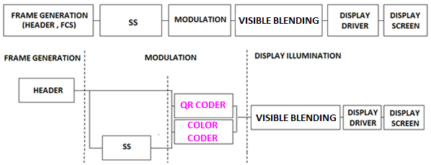

**Figure 288 –Display Light Pattern Based Transmitter with Sequential Scalable 2D Code** **PHY System Diagram**

The Sequential Scalable 2D Code is used for effective display to camera communication in the real-time usage scenario. The Sequential Scalable 2D Code works on,

* Receiver angle free and distance adaptive communication
* Receiver distance adaptive communication achieved by screen with interactive Camera
* Asynchronous communication
* Receiver OCC device frame rate independent transmission
* Scalable bitrate controller
* Distance adaptive data rate control
* Effective multi-display model for transmission

The spread spectrum used with VTASC to have effective asynchronous communication, distance adaptive scalable data rate control.

**15.3.1 Sequential Scalable 2D Code Modulation**

A 2D (Two-Dimensional) Code is a graphical image that stores information both horizontally and vertically for Display based VLC system. In order to improve the distance and angle free with higher bitrate, the new proposed color based modulation scheme called Sequential Scalable 2D Code Modulation is proposed. The Sequential Scalable 2D codes used the QR Code and Color Code to encode the data with visual frame on display. The Sample 2D codes are shown in Figure 2-1.

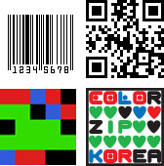

**Figure 2-1 – 2D Codes**

Sequential Scalable 2D Code is one of the promising modulation formats specifically for display based VLC system with improved VLC throughput by increasing the bit per symbol rate, and avoiding the color interference.

The proposed Sequential Scalable 2D Codes for PHY system design to enable distance adaptive data rate control on TX Schemes for OCC. The use case for Sequential Scalable QR code is shown in Figure 289.



**Figure 289 – Sequential Scalable QR Code**

The use case for Sequential Scalable Color code is shown in Figure 290.



**Figure 290 – Sequential Scalable Color Code**

The data rate for Sequential Scalable 2D Coded Display TX Schemes calculated using follow mathematical representation,

DataRate = NoOfCodeSequence* (2DCodeDataCapacity * OpticalClockrate * FECRate) / CodeLength)

Where, “CodeLength” is 1 for without SS Coded schemes and respective code length for with SS Coded Schemes

Note this case study designed with 2D Code decoding Rate is 1 for QR. The maximum data capacity for 2D Codes is 2953 bytes.

The Data Rate for 2x2 Sequential Scalable 2D Code without SS Coded Code (CodeLength is 1),

FECRate = 1 (Refer Table 1-2)

DataRate = 4* (2953 * 8)* 1 * 1) / 1) = 94494 Approximated to 92 Kbps

The Table zzz describes the data rate supported based on predefined block size.

|  |  |  |  |  |
| --- | --- | --- | --- | --- |
| **Modulation** | **RLL Code** | **Optical Clock Rate** | **FEC** | **Data Rate (Kbps)** |
| 1x1  Sequential Scalable 2D Code | None | 2DCodeDecodingRate | RS(64,32)/ RS(160,128)/None | 23 Kbps |
| 2x2  Sequential Scalable 2D Code | None | 2DCodeDecodingRate | RS(64,32)/ RS(160,128)/None | 92 Kbps |
| 4x4  Sequential Scalable 2D Code | None | 2DCodeDecodingRate | RS(64,32)/ RS(160,128)/None | 368 Kbps |
| 1x1  SS Sequential Scalable 2D Code | None | 2DCodeDecodingRate | None | 12 Kbps |
| 2x2  SS Sequential Scalable 2D Code | None | 2DCodeDecodingRate | None | 46 Kbps |
| 4x4  SS Sequential Scalable 2D Code | None | 2DCodeDecodingRate | None | 184 Kbps |

**Table zzz – Sequential Scalable 2D Code Data Rate Table**

**15.3.2 Spread Spectrum**

The spread spectrum used with Sequential Scalable 2D Code for display based Transmitter to add built-in adaptation on data recovery in addition to achieve the asynchronous communication with Angle free and distance adaptive communication between transmitter and Receiver. Refer 15.2.2 for more information about spread spectrum.

**15.3.3 Data Encoder**

The Display Light Pattern Based Transmitter with Sequential Scalable 2D Code Schemes works by overlaying the data mapped color code on visual scene as show in Figure YYY. The data embedded on visual frame by overlaying visual patterns displays visual area. The rule to overlaying data and data rate achievement vary based on the kind of display used to design the Transmitter.

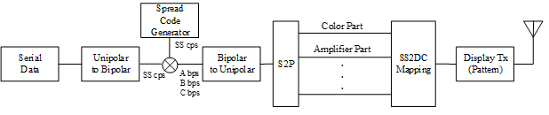

Figure YYY : Sequential Scalable 2D Code Data Encoder

The receiver specific information for Sequential Scalable 2D Code Data Decoder is given in Annex M.4

**15.3.4 Asynchronous Communication Mode**

The PHY for Display Light Pattern Based Transmitter with Sequential Scalable 2D Code designed with Asynchronous communication mode. Refer 15.2.4 for more information about Asynchronous Communication Mode.

**15.3.5 Angle Free Communication**

The PHY for Display Light Pattern Based Transmitter with Sequential Scalable 2D Code designed with Angle Free Communication between Transmitter and Receiver. Refer 15.2.5 for more information about Angle Free Communication.

**15.3.6 Scalable Bitrate Controller**

The PHY for Display Light Pattern Based Transmitter with Sequential Scalable 2D Code designed with built-in Scalable bitrate Controller. Refer 15.2.6 for more information about Scalable Bitrate Controller.

**15.3.7 Distance Adaptive Data Rate Control**

The PHY for Sequential Scalable 2D Coded Display TX Schemes designed with distance adaptive data rate control. Refer 15.2.7 for more information about Refer 15.2.6 for more information about Scalable Bitrate Controller.

.

**15.4 Invisible data-embedding**

The Invisible Data Embedding PHY supported data rates and operating conditions are shown in Table 116 PHY VI operating Modes. The Invisible Data Embedded Display TX Schemes works with Alpha Blending and Watermarking. The PHY system diagram illustrated in Figure 298 for 2 Dimensional / Screen Source for Invisible Data Embedded Display TX Schemes for OWC.

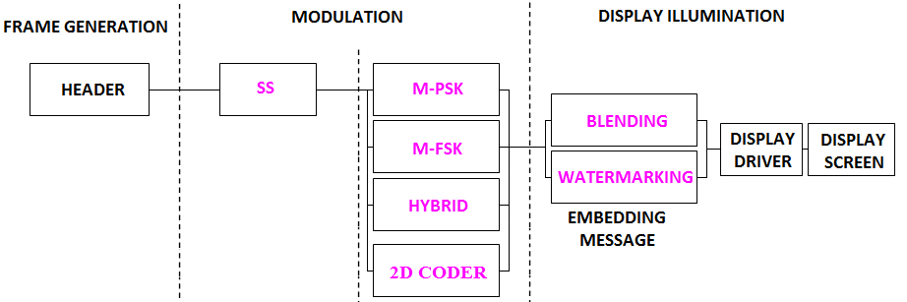

**Figure 298 – Invisible Data Embedded Display TX Schemes PHY System Diagram**

The PHY designed with specific key features in consideration to have error free and effective display to camera communication in the real-time usage of end system. The design goals are,

* Unobtrusive to Screen Viewer
* Works on dynamic visual Scene
* Angle and Distance Free Communication
* Rx Distance Adaptive Communication by Screen with interactive Camera
* Asynchronous Communication
* Rx Frame Rate independent Transmission
* Multi-Display Model for Transmission

To achieve the above described design goal, the PHY designed with Spread Spectrum coded with M-PSK, M-FSK, Hybrid-M-PSK-FSK, 2D-Codes. The use cases of the modulation scheme with or without of SS Modulation parameter are described in this section.

The Table 2-1 describes the data rate supported with different modulation schemes.

|  |  |  |  |  |
| --- | --- | --- | --- | --- |
| **Modulation** | **RLL Code** | **Optical Clock Rate** | **FEC** | **Data Rate (Kbps)** |
| M-PSK | None | 30Hz | RS(64,32)/ RS(160,128)/None | 16 Kbps |
| M-FSK | None | 30Hz | RS(64,32)/ RS(160,128)/None | 16 Kbps |
| HYBRID-PSK/FSK | None | 30Hz | RS(64,32)/ RS(160,128)/None | 32 Kbps |
| 2D-CODE | None | 30Hz | RS(64,32)/ RS(160,128)/None | 128 Kbps |
| Sequential Scalable 2D Code | None | 30Hz | RS(64,32)/ RS(160,128)/None | 256 Kbps |
| SS-M-PSK | None | 30Hz | None | 8 Kbps |
| SS-M-FSK | None | 30Hz | None | 8 Kbps |
| SS-HYBRID-PSK/FSK | None | 30Hz | None | 16 Kbps |
| SS- 2D-CODE | None | 30Hz | None | 64 Kbps |
| SS -Sequential Scalable 2D Code | None | 30Hz | None | 128 Kbps |

**Table 2-1 – Invisible Data Embedding PHY Data Rate Table**

**15.4.1 Invisible Data Embedding Modulations**

**15.4.1.1 M-PSK Modulation**

The Figure 299 describes the M-PSK modulation scheme usage on PHY Layer design.

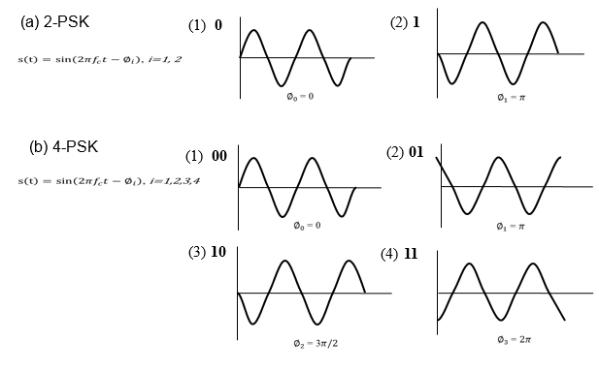

**Figure 299 – M-PSK Modulation**

**15.4.1.2 M-FSK Modulation**

The Figure 300 describes the M-FSK modulation scheme usage on PHY Layer design.

(a) 2-FSK

(b) 4-FSK

(1) **0**

(2) **1**

f1

f2

(1) **00**

(2) **01**

f1

f2

(3) **01**

(4) **10**

f3

f4

**Figure 300 – M-FSK Modulation**

**15.4.1.3 Hybrid (M-PSK-FSK) Modulation**

Hybrid scheme used to achieve double the data rate of M-PSK or F-FSK by combining Frequency and Phase on the modulation. The Figure 301 describes the Hybrid modulation schemeusage on PHY Layer design.

(2) **01**

(1) **00**

(3) **10**

(4) **11**

Phase Frequency

f1

f2

f1

f2

**Figure 301 – Hybrid (M-PSK-FSK) Modulation**

**15.4.2 Spread Spectrum**

The spread spectrum adopted with PHY model design for Display Light Pattern Based Transmitter with Invisible Data Embedding to add built-in adaptation on data recovery in addition to achieve the asynchronous communication with Angle free and distance free communication between transmitter and Receiver. Refer 15.2.2 for more information about spread spectrum.

**15.4.3 Data Encoder**

The Invisible Data Embedded Display TX Schemes works with two data embedding method. The supported data embedding principles are Alpha Blending and Watermarking. The rule to embedding data and data rate achievement vary based on the kind of display used to design the Transmitter. The Invisible data embedding procedure is given in Figure 3-1. First the payload is coded with SS Code and modulated by M-FSK/M-PSK/2D Code modulation schemes. The modulated data frame the Grid Framing to blend/watermarked with original video frame to display on the screen visual region. The GRID framing size can be in order of 4x4, 8x8, 16x16, 32x32, 64x64 etc. The Grid frame size selection decision left up to the system designer.

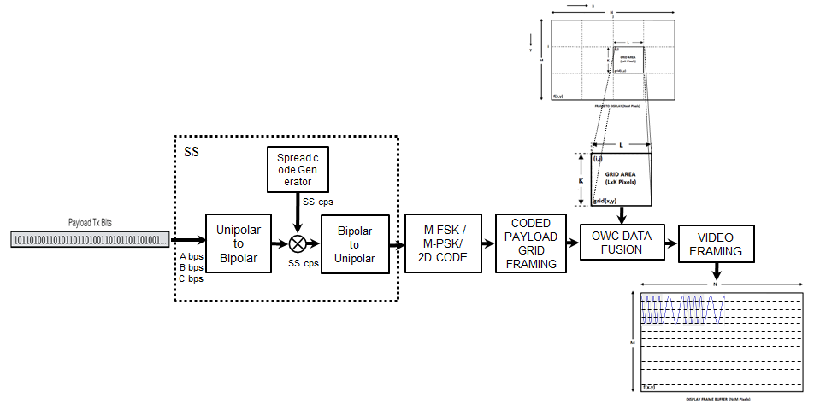

**Figure 3-1 – Display Transmitter Functional Block Diagram**

**15.4.4 Asynchronous Communication Mode**

The PHY for Invisible Data Embedded Display TX Schemes designed with Asynchronous communication mode. Refer 15.2.4 for more information about Asynchronous Communication

**15.4.5 Angle Free Communication**

The PHY for Invisible Data Embedded Display TX Schemes designed with Angle Free Communication between Transmitter and Receiver. Refer 15.2.5 for more information about Angle Free Communication.

**15.4.6 Scalable Bitrate Controller**

The PHY for Invisible Data Embedded Display TX Schemes designed with built-in Scalable bitrate Controller. 15.2.6 for more information about Scalable Bitrate Controller.

**15.4.7 Distance Adaptive Data Rate Control**

The PHY for Invisible Data Embedded Display TX Schemes designed with distance adaptive data rate control. Refer 15.2.7 for more information about Refer 15.2.6 for more information about Scalable Bitrate Controller.

**Annex M (Normative)**

**M.1 VTASC Decoder**

The Smart Device Camera Capture Visual Frame from Screen and VTASC decoding is shown Figure 3-2.



**Figure 3-2 – Receiver Functional Block Diagram**

The ROI of Screen Visual Area is extracted from the captured visual frame and then apply the VTASC detector based on mapping scheme applied on the transmitter. The data recovered by applying SS on the data decoded.

The PHY VI for Display Light Pattern based Transmitter with VTASC designed with built-in Scalable bitrate Controller by controlling the Video display refresh rate or by frames in which data to be encoded repeatedly.

**M.2 Asynchronous Communication Mode**

The receiver side knows the spreading code of the transmitter synchronize the receiver application automatically. If camera CMOS received same frame, for example #1 video frame receive twice, then receiver will despread video frames using SC#1, SC#2. When processing using SC#2, dominant value will not appear so the video frame will be discarded. The orthogonal spread spectrum sequence is best adopt on PHY design to have easy and fast synchronization.

**M.3 Angle Free Communication**

The Angle Free Communication between Transmitter and Receiver is shown in Figure 2-5. The Angle free communication is achieved by Warping the ROI of the transmitter to get the original shape alignment and then the decoded data synchronizing with spread code to extract original information transferred on transmitter. The kind automatic synchronization in receiver is time consuming function but the communication is robust.

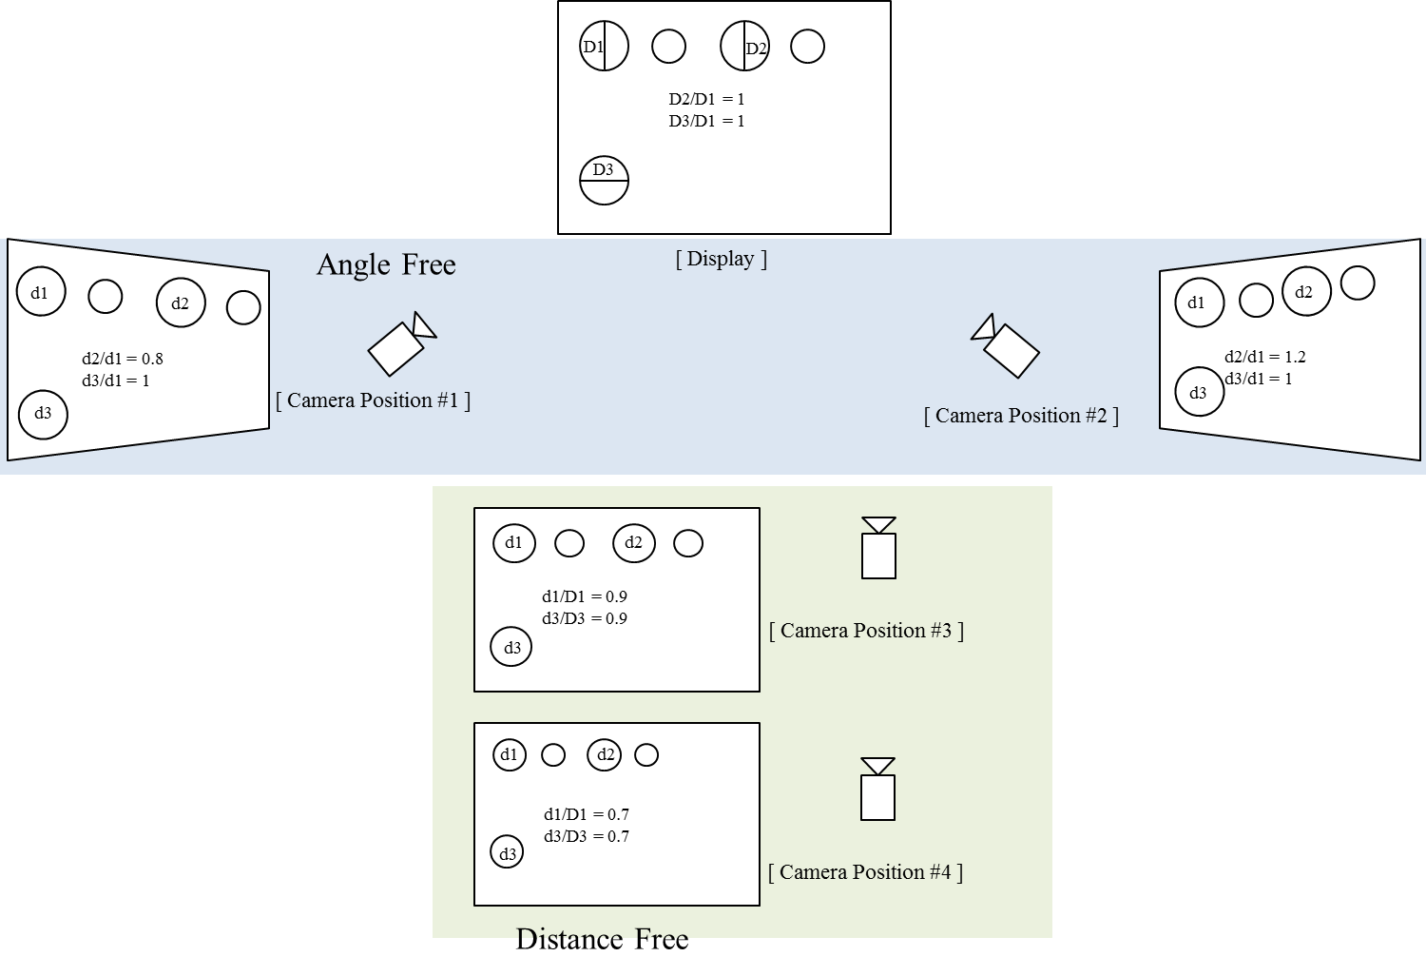

**Figure 2-5 – Angle Free and Distance Adaptive**

**M.4 Sequential Scalable 2D Code Decoder**

The Smart Device Camera Capture Visual Frame from Screen and Sequential Scalable 2D decoding is shown Figure 3-2.

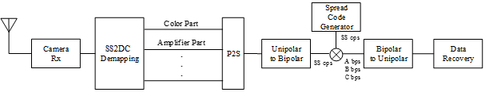

**Figure 3-2 – Receiver Functional Block Diagram**

The ROI of Screen Visual Area is extracted from the captured visual frame and then apply the Sequential Scalable 2D Code detector based on mapping scheme applied on the transmitter. The data recovered by applying SS on the data decoded.

The PHY VI for Display Light Pattern based Transmitter with Sequential Scalable 2D Code designed with built-in Scalable bitrate Controller by controlling the Video display refresh rate or by frames in which data to be encoded repeatedly.

**M.5 Invisible Data Embedding Decoder**

The Smart Device Camera Capture Visual Frame from Screen is Invisible data embedding decoding procedure is shown Figure 3-2.

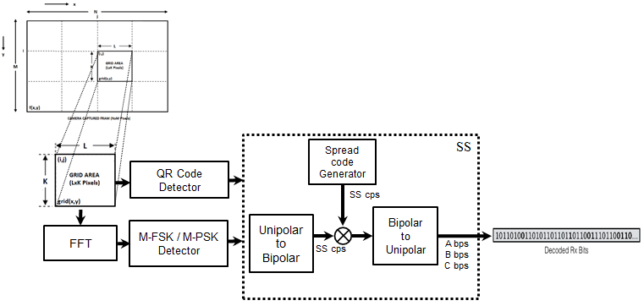

**Figure 3-2 – Receiver Functional Block Diagram**

To decode the data stream, the ROI of display visual area is extracted from the captured visual frame using image processing methods and then invisibly embedded data extracted using blending or watermark extraction procedure. The blending or watermark based data extraction procedure is applied based on modulation scheme used to invisibly embedding the data on the transmitter system (Supported Modulation scheme is described in 2.1 Modulation Schemes). The data embedded on display is SS Coded data so SS decoding is applied to recover original data from the visual sequence.

In addition, the invisible data embedded display TX schemes designed with built-in scalable bitrate controller by controlling visual refresh rate of the display or by frames in which data to be encoded on visual sequence.