IEEE P802.15
Wireless Personal Area Networks

Project | IEEE P802.15 Working Group for Wireless Personal Area Networks (WPANs)
Title | Update Figure 5
Date Submitted | [May 2017]
Source | Trang Nguyen, and Yeong Min Jang (Kookmin University)
Re: | D2 comments and resolutions
Abstract | Figure 5 update or a table replacement
Purpose | D2 comments and resolution
Notice | This document has been prepared to assist the IEEE P802.15. It is offered as a basis for discussion and is not binding on the contributing individual(s) or organization(s). The material in this document is subject to change in form and content after further study. The contributor(s) reserve(s) the right to add, amend or withdraw material contained herein.
Release | The contributor acknowledges and accepts that this contribution becomes the property of IEEE and may be made publicly available by P802.15.

Figure 5 re-drawn

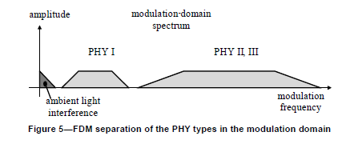

Alternative Table

PHY operating modes | Modulation frequency
Ambient light | < 1 kHz (TBD)
PHY I | 200 kHz – 400 kHz
PHY II | 3.75 MHz – 120 MHz
PHY III | 12 MHz – 24 MHz
PHY IV | 10 Hz – 44 kHz
PHY V | 200 Hz – 100 kHz
PHY VI | 10 Hz – TBD kHz

