IEEE P802.15
Wireless Personal Area Networks

Project | IEEE P802.15 Working Group for Wireless Personal Area Networks (WPANs)
Title | Discussion on Flicker Mitigation and Dimming methods
Date Submitted | [May 2017]
Source | Trang Nguyen, and Yeong Min Jang (Kookmin University)
Re: | D2 comments and resolutions
Abstract | Dimming/Flicker mitigation methods for OCC
Purpose | D2 comments and resolution
Notice | This document has been prepared to assist the IEEE P802.15. It is offered as a basis for discussion and is not binding on the contributing individual(s) or organization(s). The material in this document is subject to change in form and content after further study. The contributor(s) reserve(s) the right to add, amend or withdraw material contained herein.
Release | The contributor acknowledges and accepts that this contribution becomes the property of IEEE and may be made publicly available by P802.15.

A. Proposed change of the structure

Current structure | Proposed change 1
4.4.3 Dimming and flicker-mitigation support | 4.4.3 Dimming and flicker-mitigation support
4.4.3.1 Light dimming | 4.4.3.1 Flicker mitigation
4.4.3.2 Flicker mitigation | 4.4.3.2 Light dimming
Consider describing “flicker mitigation” firstly, because “light dimming” is implemented under the assumption that intra-flicker (flicker within a symbol/packet) is already mitigated.

Note:
Section “4.4.3 Dimming and flicker-mitigation support” should describe the methods of flicker mitigation and dimming in an overall manner. Later, Section “8.5 Dimming and flicker mitigation” under section “8. PHY layer specification” should specify the method for dimming and flicker mitigation for individual modulation scheme.

Current light dimming  (multiple methods according to modulations) | Proposed change 2  (three major methods)
4.4.3.1.3 Color-shift keying (CSK) dimming  ==> Amplitude dimming | - Dimming by adding Compensation Symbols
4.4.3.1.4 OOK dimming  == > adding Compensation Symbols | - Dimming by controlling pulse width (PWM)
4.4.3.1.5 Low-Clock-Rate OOK amplitude dimming  ==> Amplitude dimming | - Dimming by controlling pulse amplitude (AM)
4.4.3.1.6 VPPM dimming
== > controlling PWM
4.4.3.1.7 FSK Dimming
== > controlling PWM

B. Summary of Dimming methods
Currently, there are four sections describing how the light is dimmed, including two existing methods in 802.15.7-2011 std., (OOK dimming and VPPM dimming) and two newly-added methods (OOK amplitude dimming and FSK dimming). Those can be merged and then classified into three supersets of dimming methods as follows.
- Compensation symbol insertion (including PD based-OOK, MPM)
- Pulse width modulation (including PD based VPPM, UFSOOK, Twinkle VPPM, HS-PSK, MPM, RS-FSK, CM-FSK)
- Amplitude modulation (including CSK, S2-PSK, S8-PSK, Twinkle VPPM, HS-PSK, C-OOK)
Table 1- Specific Dimming methods for PHY operating modes
Mode | Dimming method | Remark
PHY I, II, III
OOK | Compensation insertion dimming | Method 1
VPPM | PWM dimming | Method 2
CSK | AM dimming | Method 3
PHY IV
UFSOOK | PWM dimming | Method 2
S2-PSK | AM dimming
S8-PSK | AM dimming
Twinkle VPPM | PWM dimming/ AM dimming | Method 2/ hybrid method
HS-PSK | PWM dimming/ AM dimming
Offset-VPPM | Not supported | Flicker mode
PHY V
RS-FSK | PWM dimming | Method 2
CM-FSK | PWM dimming
C-OOK | AM dimming | Method 3
MPM | PWM dimming/  Compensation insertion dimming  AM dimming (?) | Method 2/  Method 1/  Method 3
PHY VI
A-QL | Not supported | Screen modulation modes operate at optical clock rates below the flicker-limit.
HA-QL | Not supported
VTASC | Not supported
Invisible data embedded display | Not supported

C. Proposed changes on Dimming methods in details

4.4.3.1 Light dimming
4.4.3.1.1 Idle pattern and compensation time dimming
4.4.3.1.2 Visibility pattern dimming
We suggest removing these two subsections because these are a part of Dimming method 1 and method 2 (below), not overall dimming methods that we should address here.
Also, details about these are already allocated as the way that should be in sections:
8.5.1 Dimming during idle time
8.5.2 Dimming during data transmission time

(1) Instead, we can add a paragraph to describe following dimming methods, such as
“Light dimming is defined as controlling the perceived brightness of the light source according to the user’s requirement and is a cross layer function between the PHY and MAC. The details on the light dimming function of MAC sublayer are discussed in 5.4.15.”
//Add the following paragraph
Since intra-flicker is mitigated as given in Section 4.4.3.1 Flicker mitigation, three major dimming methods shall be applied to control the light brightness, including (1) adding compensation symbols, (2) controlling pulse width, and (3) controlling the amplitude of the signal. The selection of a proper dimming method shall follow the selection of the modulation.
- OOK modulations in PHY I –II and MPM modulation shall implement dimming by adding compensation symbols.
- VPPM modulations in PHYs I to II, modulations in PHY IV (UFSOOK), and modulations in PHY V (MPM, RS-FSK, CM-FSK) shall implement dimming by controlling PWM.
- CSK modulation in PHY III, S2-PSK and S8-PSK modulation in PHY IV, C-OOK modulation in PHY V shall implement dimming by controlling the amplitude of the signal.
- Hybrid modulations, such as Twinkle VPPM and HS-PSK modulation in PHY IV, may implement the hybrid dimming method among three given methods. For example, Twinkle VPPM and HS-PSK may implement both PWM dimming and AM dimming as a hybrid dimming.
Details on dimming during data transmission of individual modulation shall be described in section 8.5.
(2) And one Figure should be added here to describe the overall way of three dimming methods, for idle time and transmission time. Figure is modified from below figure (PWM and AM dimming will be added in conjunction with compensation time inserting, VLC data frame is changed into data frame)
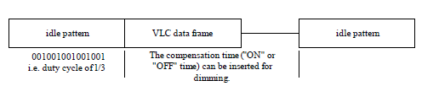
4.4.3.1.1 Dimming by adding Compensation Symbols ==========================> Method 1
OOK modulations in PHY I –II and MPM modulation shall implement dimming by adding compensation symbols.

Since OOK and MPM modulations are always sent with a constant brightness within a symbol (for example, a symmetric Manchester symbol in OOK modulation, or MPM symbol), compensation time may need to be inserted into the data frame to adjust the average intensity of the perceived source.
The frame structure for the dimming method inserting compensation symbols is as shown in Figure 7.
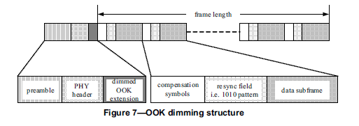

An example of OOK dimming to increase brightness by adding compensation symbols is as shown in Figure 8.
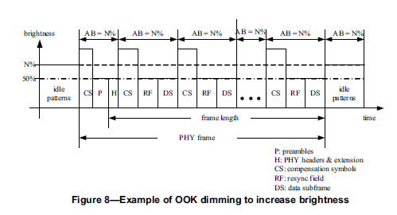
An example of MPM dimming to increase brightness by adding compensation symbols is as shown in Figure 9.
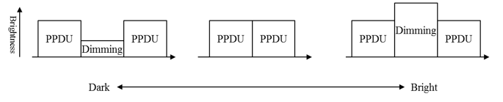
Figure 9 – Example of MPM dimming by adding compensation symbols (Hideki)
4.4.3.1.2 Dimming by controlling PWM ===================================> Method 2
VPPM modulations in PHYs I to II, modulations in PHY IV (UFSOOK), and modulations in PHY V (MPM, RS-FSK, CM-FSK) shall implement dimming by controlling PWM.

VPPM is a modulation scheme adapted for pulse width based light dimming and offers protection from intra-frame flicker. The pulse amplitude in VPPM is always constant and the dimming control is performed by the pulse width, not the amplitude. An example of 2-PPM dimming to increase brightness by controlling PWM is as shown in Figure 9.
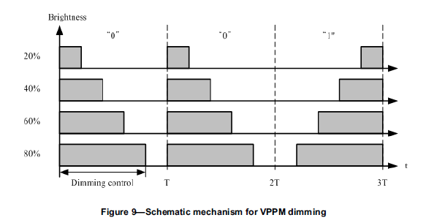
FSK is non-flicker within its symbol time, obtained from the constant pulse amplitude during the transmission of symbols. FSK also performs dimming in within a symbol by controlling the duty cycle of the signal, as shown in Figure 10.
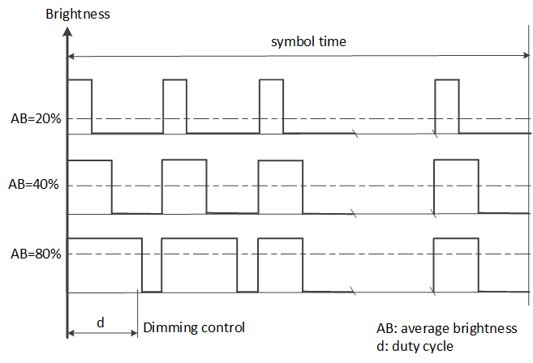
Figure 10- Example of FSK dimming by controlling pulse width
An example of MPM dimming by controlling PWM is as shown in Figure 11.
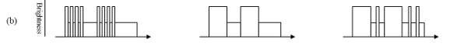
Figure 11- Example of MPM dimming by controlling pulse width

4.4.3.1.3 Amplitude dimming =============================================> Method 3
CSK modulation in PHY III, S2-PSK and S8-PSK modulation in PHY IV, C-OOK modulation in PHY V shall implement dimming by controlling the amplitude of the signal.
Firstly, the flicker on these modulations must be mitigated by balancing the numbers of ones and zeros in bits "1" and "0", maintaining the average brightness of the light source at 50%. This can be done in different manners, that are described in the flicker mitigation section (section 4.4.3.2). After that, the dimming is performed by controlling either the aptitude of ones or the amplitude of zeros or both, as shown in Figure 12.
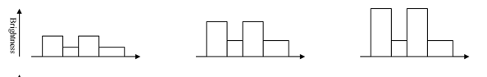
Figure 12- Mechanism for amplitude dimming
Figure 13 shows an example of amplitude dimming for S2-PSK modulation.
Figure 13– Example of S2-PSK amplitude dimming

D. Proposed changes related to “Flicker mitigation” section in details
(TBD) This should adhere all the flicker mitigation methods specified by PHYs I to VI.

