IEEE P802.15
Wireless Personal Area Networks

Project | IEEE P802.15 Working Group for Wireless Personal Area Networks (WPANs)
Title | Discussion on Dimming methods
Date Submitted | [May 2017]
Source | Trang Nguyen, and Yeong Min Jang (Kookmin University)
Re: | D2 comments and resolutions
Abstract | Dimming methods for OCC
Purpose | D2 comments and resolution
Notice | This document has been prepared to assist the IEEE P802.15. It is offered as a basis for discussion and is not binding on the contributing individual(s) or organization(s). The material in this document is subject to change in form and content after further study. The contributor(s) reserve(s) the right to add, amend or withdraw material contained herein.
Release | The contributor acknowledges and accepts that this contribution becomes the property of IEEE and may be made publicly available by P802.15.

General Dimming methods
Currently, there are four methods for light dimming, including two existing methods in 802.15.7-2011 std., (OOK dimming and VPPM dimming) and two newly-added methods (Amplitude dimming and FSK dimming).

4.4.3.1 Light dimming
4.4.3.1.4 OOK dimming ===================================> Method 1
Since OOK modulation is always sent with a symmetric Manchester symbol, compensation time may need to be inserted into the data frame to adjust the average intensity of the perceived source.

The structure for the OOK dimming frame is as shown in Figure 7.
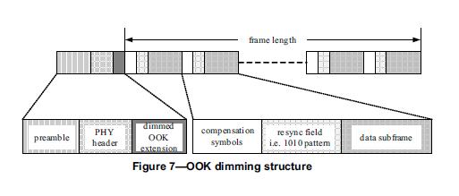

An example of OOK dimming to increase brightness by adding compensation symbols is as shown in Figure 8.
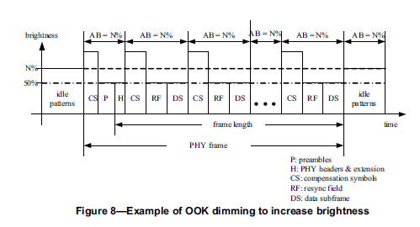

4.4.3.1.5 VPPM dimming ===================================> Method 2
VPPM is a modulation scheme adapted for pulse width based light dimming and offers protection from intra-frame flicker. It does not create a color-shift in the light source that can arise from amplitude dimming because the pulse amplitude in VPPM is always constant and the dimming control is performed by the pulse width, not the amplitude.

VPPM makes use of the characteristics of 2-PPM (pulse position modulation) for non-flicker and PWM (pulse-width modulation) for dimming control and full brightness.
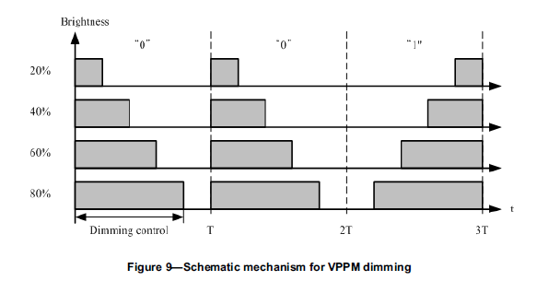

4.4.3.1.6 Low-Clock-Rate OOK amplitude dimming (newly added) ==================> Method 3
Since the flicker on OOK modulation is mitigated by using symmetric symbols, a number of ones and zeros in bits "1" and "0" are equal maintaining the average bright of the light source at 50%. For some Image Sensor Communication PHY modes, the clock rate of modulation is constant at a low frequency, hundreds of Hz on S2-PSK and S8-PSK PHY modes or less than 5kHz on OOK PHY modes; hence, the pulse amplitude modulation is performed to adjust the average brightness.

Figure 11 shows an example of amplitude dimming for OOK modulation.
Figure 11 – Example of OOK amplitude dimming applied for low-clock-rate OOK PHY modes.

4.4.3.1.7 FSK Dimming (newly added) ===================================> Method 4
FSK is non-flicker, obtained from the constant pulse amplitude during the transmission of symbols. FSK performs dimming in within a symbol by controlling the duty cycle of the signal. Figure 13 describes the dimming control mechanism by FSK.
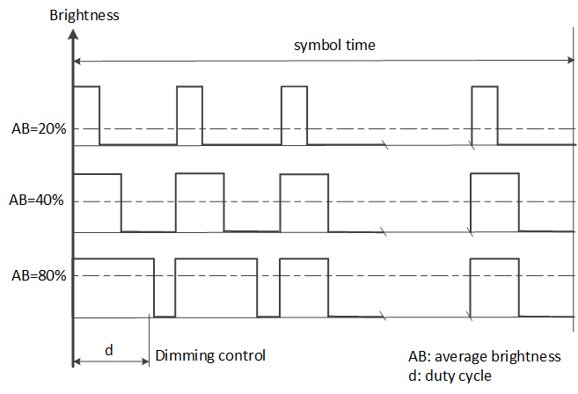
Figure 13- Schematic mechanism for FSK diming

Specific Dimming methods for PHY modes

 | Dimming method | Remark
PHY IV
UFSOOK | Analog dimming | Need to add this “analog dimming” method as the fifth “dimming method” under section “4.4.3.1 Light dimming”
S2-PSK | AM/ Analog dimming
S8-PSK | AM dimming
Twinkle VPPM | VPPM dimming
HS-PSK | VPPM dimming
Offset-VPPM | Not supported | Flicker mode
PHY V
RS-FSK | FSK dimming
CM-FSK | FSK dimming
C-OOK | AM dimming
MPM | VPPM dimming  OOK dimming | - VPPM dimming for both PWM/VPPM modes  - Newly-added: AM dimming/
PHY VI
A-QL | Not supported | Screen modulation mode operate at optical clock rates below the flicker-limit.
HA-QL | Not supported
VTASC | Not supported
Invisible data embedded display | Not supported

Dimming method: not just the way to change the light brightness, it is a factor to the communication performance! Amplitude dimming and analog dimming are not the same.

4.4.3.1.8 Analog Dimming (suggesting for newly add) ==========================> Method 5
Example text: Waveform has two periods equivalent to the “on-time” and “off-time” periods of a PWM signal. Analog dimming is performed by controlling the ratio of two periods equivalent to “on-time” and “off-time” of a PWM period, while the high and low levels of a PWM does not changed.
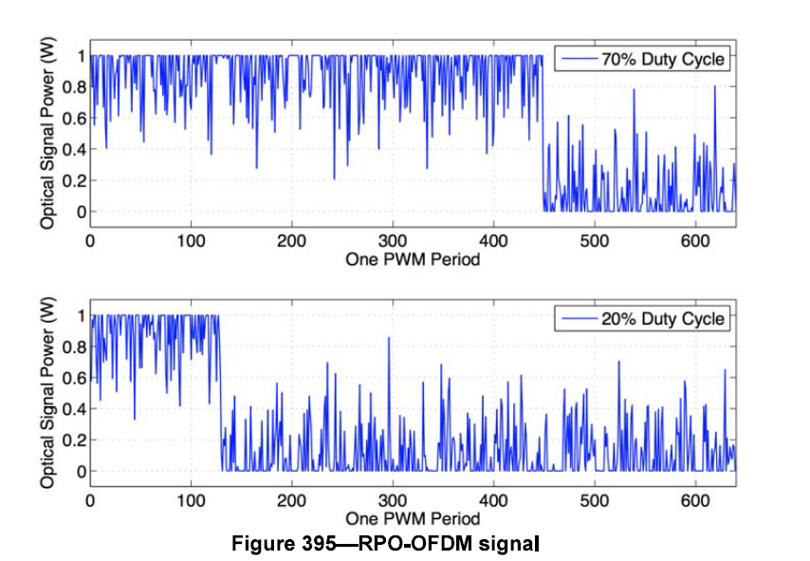
Low level dimming
(Equivalent to “off-time”)
High level dimming
(Equivalent to “on-time”)
Reference figure: Example of Analog dimming in LiFi (Figure is from section 16.2.8 D1)
From our understanding, only two OCC PHY modes need analog dimming support, including
- Twinkle VPPM
- HS-PSK
These two modes are hybrid modulation. The analog dimming is to modulate a low-rate stream. (We call that “Region-of-Interest Signaling over Analog Dimming”)

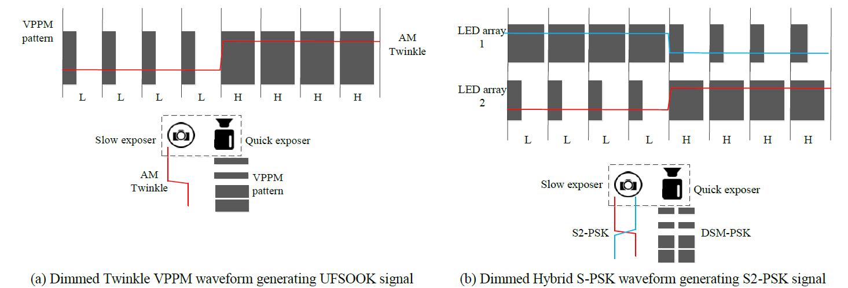Figure: Dual data streaming and dimming

Appendix:
- Panasonic’s previous dimming methods
 | Description (16-365r1) | Dimming method
PWM | 8.6.7.4.2 Packet PWM/PPM PSDU PHY Payload field  PSDU PHY Payload field contains packet address bits, data bits, and a stop bit.  8.6.7.4.3 Packet PWM/PPM Optional field  Packet PWM/PPM field is utilized for DC compensation and dimming control.  14.4.3.1 Packet PWM modulation  A transmitter can transmit any kind of signal in Optional field. However, the signal must not contain SHR field pattern. Optional field can be used for DC compensation and dimming control. | Method 1:  Insert compensation symbols for dimming  Consider to change the section name “4.4.3.1.4 OOK dimming”
PPM | 14.4.1.2 Packet PPM specifications  Packet PPM is modulated with position of short pulse. Packet PPM realizes deep dimming. Formats, wave forms and characteristics other than specially described are given same as Packet PWM.  14.4.3.2 Packet PPM modulation  …  Transmitter can transmit any kind of signal in Optional field. However, the signal must not contain SHR field pattern. Optional field can be used for DC compensation and dimming control. | Method 2:  PWM dimming  Consider to change the section name from “4.4.3.1.5 VPPM dimming” to “PWM dimming” or similar  Method 1:  Insert compensation symbols for dimming

- Panasonic’s current dimming methods (doc. 17-022r1)
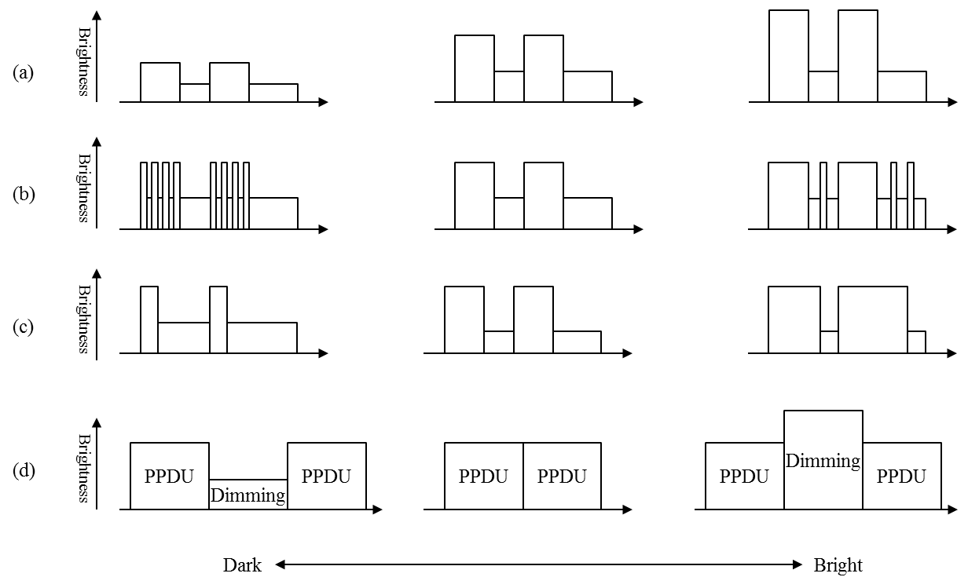
Figure 8.5.2.5.4 --- MPM dimming

