IEEE P802.15
Wireless Personal Area Networks

Project | Dependability Interest Group
Title | Meeting Minutes for March 2017
Date Submitted | March 14, 2017
Source | [Jussi Haapola]  [Centre for Wireless Communications / University of Oulu] | Voice: +358 40 8363 018  E-mail: jussi.haapola@oulu.fi
Re: | Meeting Minutes
Abstract
Purpose | Minutes of Dependability Interest Group sessions
Notice | This document has been prepared to assist the IEEE P802.15. It is offered as a basis for discussion and is not binding on the contributing individual(s) or organization(s). The material in this document is subject to change in form and content after further study. The contributor(s) reserve(s) the right to add, amend or withdraw material contained herein.
Release | The contributor acknowledges and accepts that this contribution becomes the property of IEEE and may be made publicly available by P802.15.

Tuesday, March 14, 2017, PM1, 13:30

  - Meeting called to order 13:50
By Chair Ryuji Kohno (YNU / CWC-Nippon)
Secretary Jussi Haapola (Centre for Wireless Communication / University of Oulu)

  - Roll Call
Notepad for Attendance circulated.

  - Opening Report
- Ryuji presented doc #167
- Minutes of the November meeting doc #16-0796r1 were approved with typo corrections.
  - Overview of IG DEP activities
- Ryuji presented doc #176

  - Updated Use Cases
- Ryuji presented doc #16-0777
  - Plan for Tutorial

  - Update technical requirements

- Jussi presented doc #16-0557r1
- Started updating portions in red.

  - Recess

Recessed at 15:24

  - Attendees
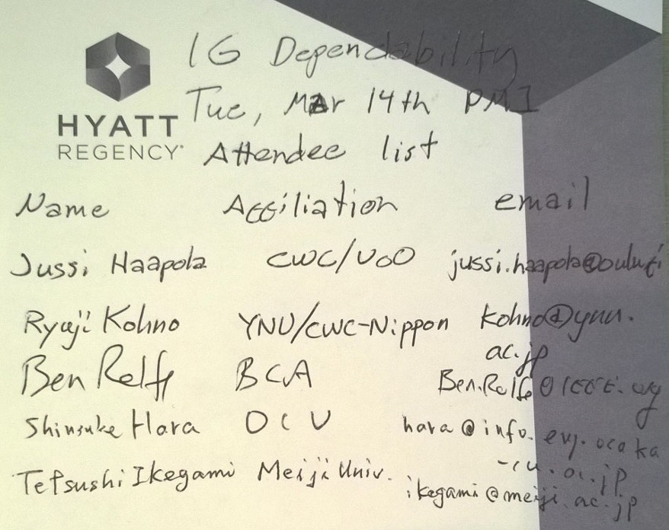

Tuesday, March 14, 2017, PM2, 16:00

  - Meeting called to order 16:50

  - Roll Call

  - Update technical requirements
- Doc #16-0557r1
- Updating portions in red.
- Uploaded doc #16-0557r3.

  - Recess at 5:30

  - Attendees

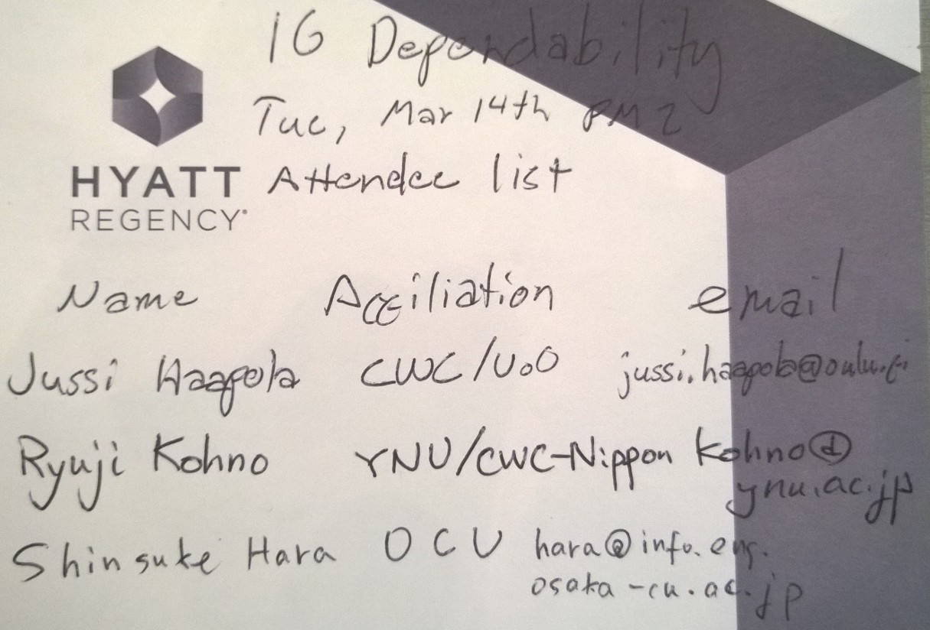

Thursday, March 16, 2017, AM1, 08:00

  - Meeting called to order 08:03

  - Roll Call

  - Discussion on possible collaboration with other groups

- Ryuji presented FFPJ 802.1 docs new-maruhashi-general-industrial-usage-part1-0317-v00.pdf & new-itaya-general-industrial-usage-part2-0317-v00.pdf
- Discussion on including factory automation into IG Dependability scope
  - If the scope does not spread out too much, then possible.
  - It is not entirely clear what are the features expected from the above documents and what is missing currently in IEEE 802 wireless standards.
  - Ryuji to send the IG DEP CFI to the parties and ask for detailed response and ask them to participate.

  - Updating technical requirements
- Revised doc 16-0557 as r4
- Need to define QoS levels and what are the requirements for them, not only in terms of delay but also from other characteristics, e.g. data rate, disconnection ratio, etc.
- Need to survey exiting 802 QoS definitions and find the commonalities and their methods on QoS provisioning. For example, 802.15.6 QoS (UPs) only affect the contention probability selection.
- Three cases for QoS provisioning: factory automation, internal car network, and inter-vehicle network.
- Factory automation QoS: FFPJ docs
- Internal car network: CAN and LIN buses
- Inter-vehicle network: IVC, IEEE 1609 standards as reference.

  - Future telcos
- Once responses from FFPJ regarding CFI questions have been received, telcos will be organized to discuss on collaboration opportunities.
- Discuss QoS level definitions.
- Tutorial details.

  - AoB

  - Adjourn at 09:58

  - Attendees
