IEEE P802.15
Wireless Personal Area Networks

Project | IEEE P802.15 Working Group for Wireless Personal Area Networks (WPANs)
Title | Comment to Single Carrier PHY Low Peak-to-Average Power Ratio Pre-coding
Date Submitted | 6 March 2017
Source | [Wang, Xu]  [VLNComm LLC]  [address] | Voice: [ ]  Fax: [ ]  E-mail: [ ]
Re: | [If this is a proposed revision, cite the original document.]  [If this is a response to a Call for Contributions, cite the name and date of the Call for Contributions to which this document responds, as well as the relevant item number in the Call for Contributions.]  [Note: Contributions that are not responsive to this section of the template, and contributions which do not address the topic under which they are submitted, may be refused or consigned to the “General Contributions” area.]
Abstract | [Description of document contents.]
Purpose | [Description of what the author wants P802.15 to do with the information in the document.]
Notice | This document has been prepared to assist the IEEE P802.15. It is offered as a basis for discussion and is not binding on the contributing individual(s) or organization(s). The material in this document is subject to change in form and content after further study. The contributor(s) reserve(s) the right to add, amend or withdraw material contained herein.
Release | The contributor acknowledges and accepts that this contribution becomes the property of IEEE and may be made publicly available by P802.15.

Low Peak-to-Average Power Ratio PHY for Single Carrier
- Hadamard Coded Modulation Concept:
Hadamard Coded Modulation (HCM) in current specification enables low Peak-to-Average Power Ratio (PAPR) implementation, which reduces the signal distortion due to the nonlinearity of LEDs, channels and amplifiers. HCM enables transmitter design with low complexity by simply operates LED array at the On and Off modes. Furthermore, the specification enables the energy-efficient waveforms such as DC reduced HCM (DCR-HCM), dispersion resistant implementation as interleaved HCM. In addition, the specification supports the application of adaptive bit and energy loading techniques as well as multiple-input multiple-output (MIMO) techniques which can leverage the additional communication capacity of multiple light sources as well as the additional communication capacity introduced by the utilization of different optical wavelengths and light polarization for communication.
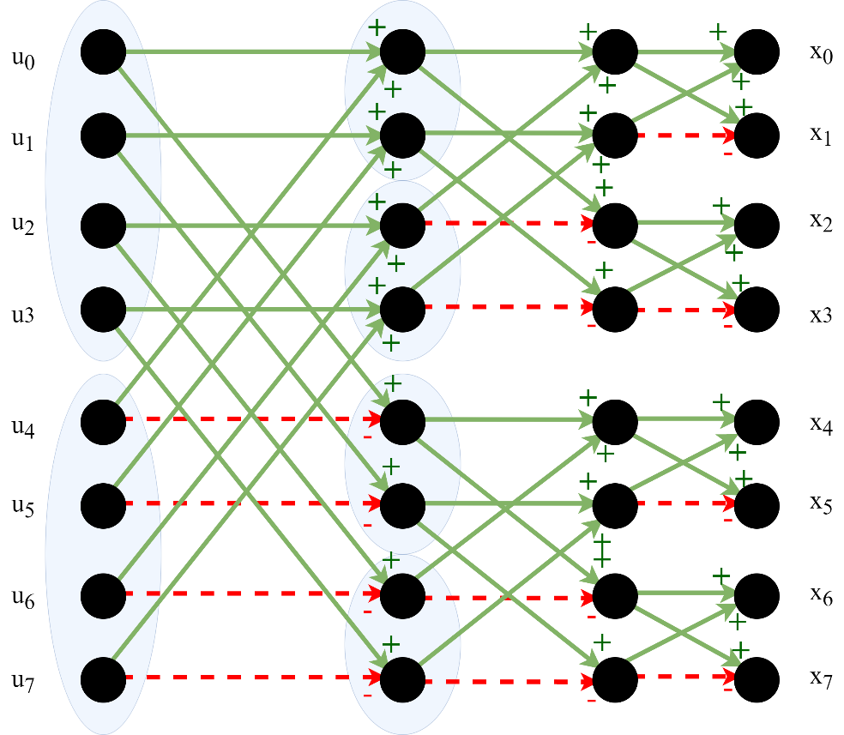
- The binary data sequence is mapped to $M$-ary pulse amplitude modulation (PAM) symbols, where $M$ can be $2, 4, 8$ etc., depending on the required data rate, and assigned to vector $u={\left[u_{0},{ u}_{1}, …, u_{N-1}\right]}^{T}$. The vector $u$ is used to generated the signal $x={\left[x_{0}, x_{1}, …, x_{N-1}\right]}^{T}$ as
$$x=(H_{N}u+\overline{H_{N}}\overline{u})$$
Figure. 1 Illustration of fast Walsh-Hadamard transform
where $H_{N}$is the binary Hadamard matrix of order $N$, which is obtained by replacing $-1$ by $0$ in the original $\left\{-1, 1\right\}$ bipolar Hadamard matrix, $\overline{H_{N}}$ is the complement of $H_{N}$, and the matrix ${(H}_{N}+\overline{H_{N})}$ forms the original bipolar Hadamard matrix. This equation can be rewritten as
$$x=u\left(H_{N}+\overline{H_{N}}\right)+ \frac{N}{2}[0, 1, 1, …, 1]$$
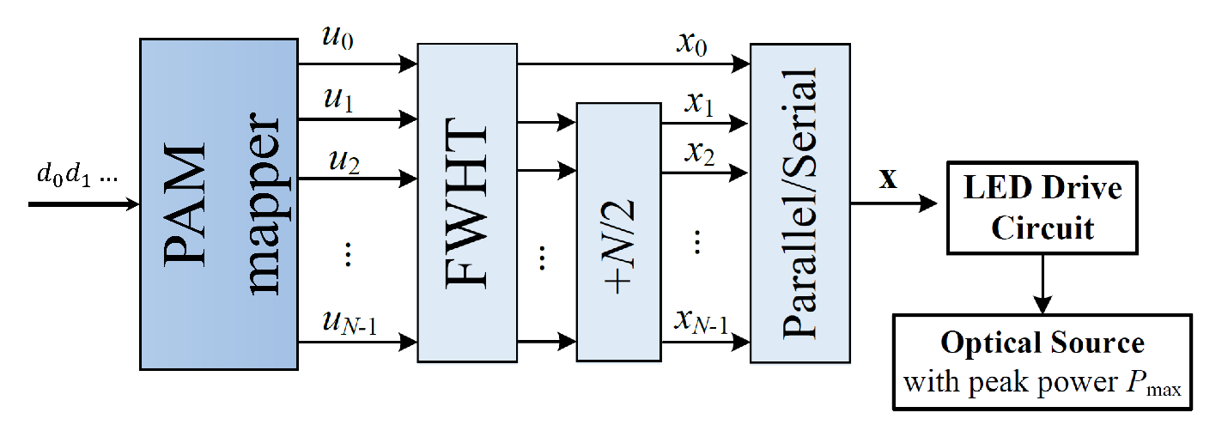
where the first term is the Walsh-Hadamard transform (WHT) of vector $u$ and can be implemented using fast Walsh-Hadamard transform (FWHT). An illustration of FWHT is shown in Fig. 1. The second term is obtained from the product of a $1×N$ vector of all ones and $\overline{H_{N}}$. The transmitter can be implemented as in Fig. 2.

Figure 2. Block diagram of the HCM transmitter using FWHT
The Hadamard transform is applied on the $M$-ary PAM symbols using a FWHT of size $N$, which has a complexity of $N\log_{2}N$. The rate of the $M$-ary PAM HCM is the same as the simple PAM, $\log_{2}M$. The constant value of $N/2$ is added to the output of the FWHT to ensure vector $x$ is positive. The HCM signal can be sent by modulating single LED source with varying driving current or multiple sources by switching different number of LEDs on and off based on the signal.
The decoded vector $v$ is obtained from the received vector $y$ as
$$v=\frac{y}{N}\left({H_{N}}^{T}+\overline{{H_{N}}^{T}}\right)+ \frac{1}{2}[1-N, 1, 1, …, 1]$$
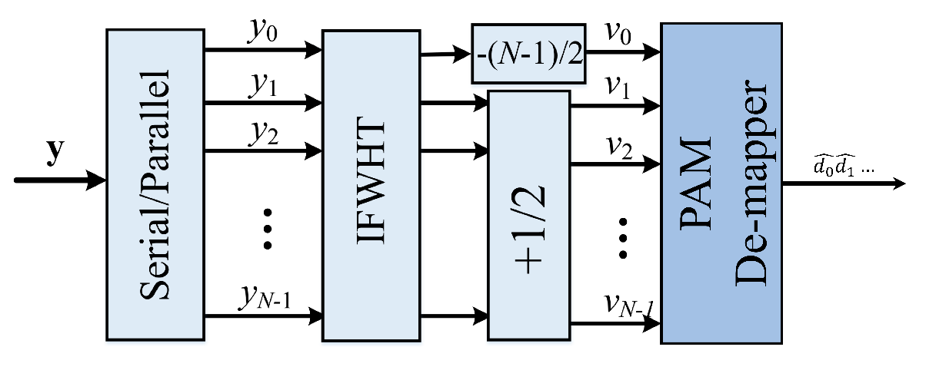
which can be realized by an inverse FWHT (IFWHT) as shown in Fig. 3.
Figure 3. Block diagram of the HCM receiver using IFWHT

- Pulse Shaping
Optional pulse shaping can be used to increase spectral efficiency. Sinc pulses can be used instead of spectral inefficient rectangular pulses to transmit HCM signals by varying the driving current of the LED. Fig. 4(a) illustrates the transmitted pulses for the three rectangular pulses shown in Fig. 4(b).
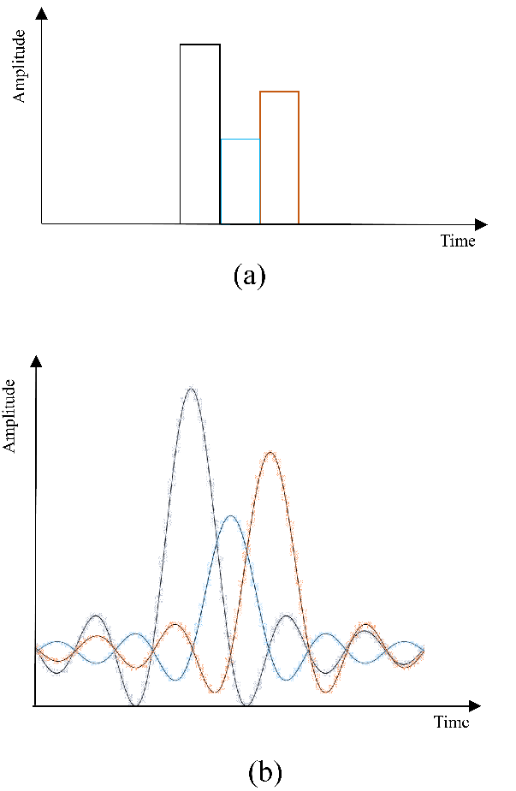
Figure 4. An HCM signal, and (b) the transmitted pulses using Sinc pulse-shaping
- DC-reduced HCM
Optionally, the DC part of the HCM signals (before the pulse shaping) can be reduced to increase the average power efficiency. Based on the general HCM introduced in Section 2, modifications can be made to remove the DC components as follows: Set the first row of $u$, $u_{0}$ to $0$ and does not carry any information data because the first row of HCM matrix which has all ones, represents DC. Hense, only $(N-1)$ codewords of the Hadamard matrix are modulated. In this proposed scheme called DC-reduced HCM (DCR-HCM), the average transmitted power is reduced by sending $(x-\min{x})$ instead of $x$. The rate of the $M$-ary PAM DCR-HCM is $(N-1)/N\log_{2}M$. The transmitter design is shown in Fig. 5.
Figure 6 shows an example of DC reduction in an HCM symbol of size $N=8$, where the transmitted energy of the HCM symbol is reduced by a factor of $3/7$ in its corresponding DCR-HCM symbol.
The DC reduction technique decreases the probability of large amplitude of $x$, which makes the signals less likely to be clipped by the optical source, and therefore, DCR-HCM can achieve lower BERs at lower average power levels compared to HCM in peak-power limited system.
The receiver design can be based on the general HCM design but ignoring the first symbol of the IFWHT as shown in Fig. 7.
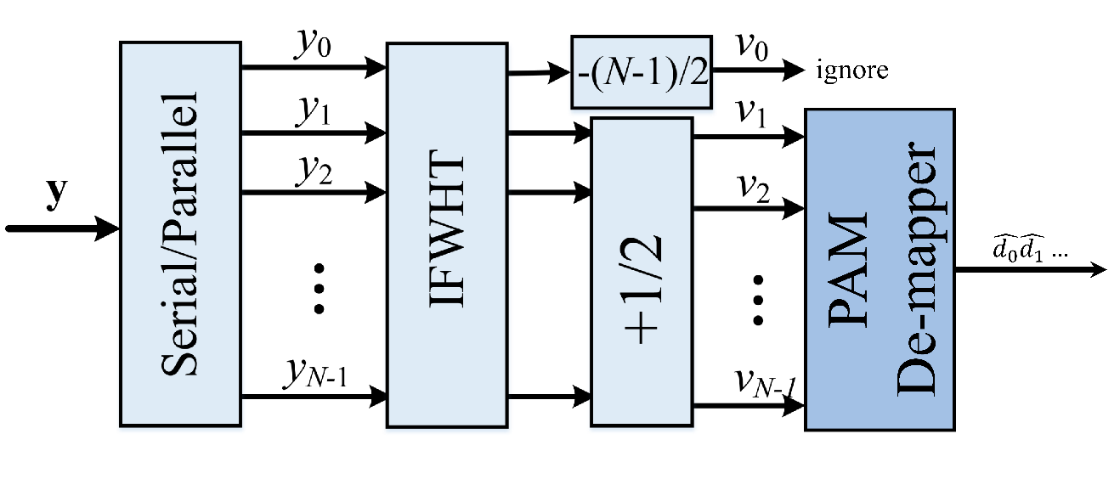
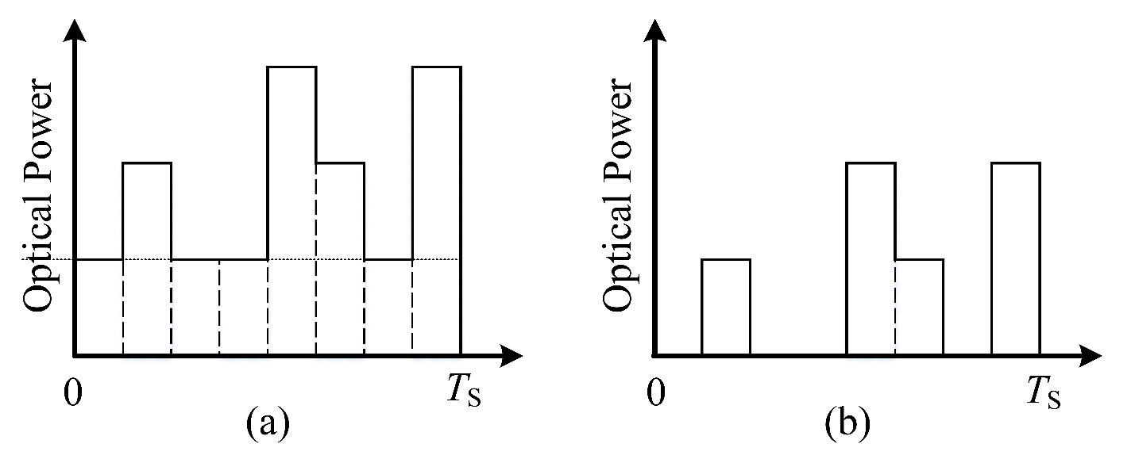
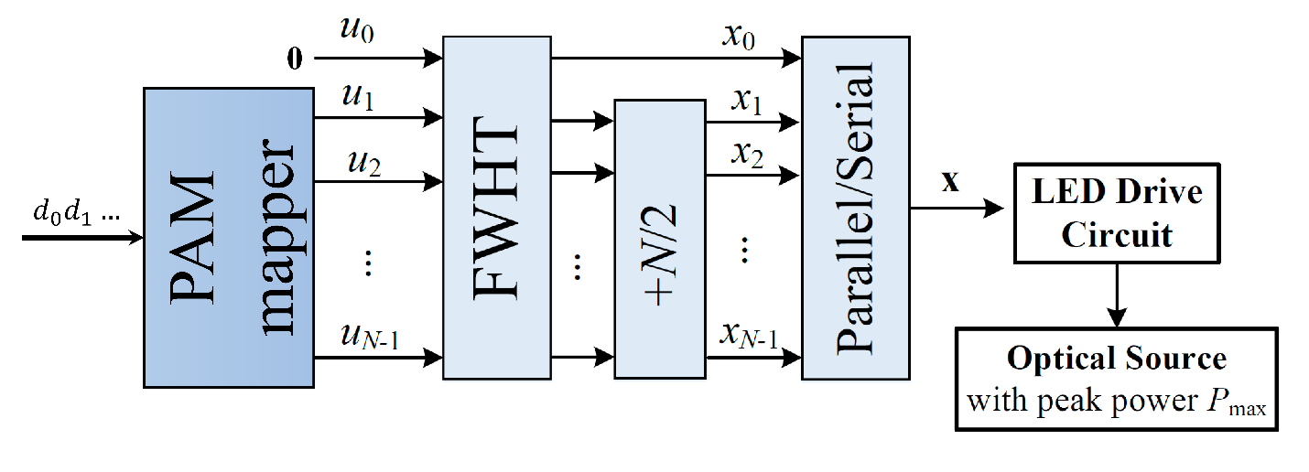
Figure 7. Block diagram of the HCM receiver with $v_{0}$ ignored
Figure 6. (a) An HCM signal, and (b) its corresponding DC reduced signal
Figure 5. Block diagram of the DCR-HCM transmitter with$u_{0}$ set to 0
- Cyclic prefix
Hadamard matrices consist of rows that are cyclic shifts, which increases the similarity between Hadamard codewords in dispersive channels and makes HCM vulnerable to ISI. Interleaving is an effective solution that reduces ISI by decreasing the cross-correlation of the codewords with their cyclic shifts. In this specification, as shown in Fig. 8, an optional symbol-length interleaver and a de-interleaver are used at the transmitter and receiver, respectively, to reduce the effects of inter-symbol interference (ISI) due to a dispersive channel. The interleaver is a permutation matrix, $π$, and the deinterleaveer is its inverse, $π^{-1}$.

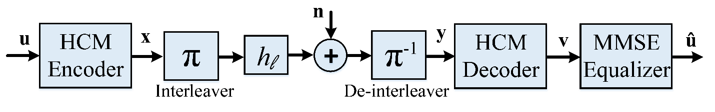
Figure 8. Schematic view of an interleaved HCM system for dispersive channels

