**IEEE P802.15**

**Wireless Personal Area Networks**

|  |  |  |
| --- | --- | --- |
| Project | IEEE P802.15 Working Group for Wireless Personal Area Networks (WPANs) | |
| Title | **<Result of two email reflector discussions: MPDU text reorg and PIB configuration>** | |
| Date Submitted | 6 March 2017 | |
| Source | [Roberts, Richard D] [<company>] [address] | Voice: [ ] Fax: [ ] E-mail: [ ] |
| Re: | [If this is a proposed revision, cite the original document.]  [If this is a response to a Call for Contributions, cite the name and date of the Call for Contributions to which this document responds, as well as the relevant item number in the Call for Contributions.]  [Note: Contributions that are not responsive to this section of the template, and contributions which do not address the topic under which they are submitted, may be refused or consigned to the “General Contributions” area.] | |
| Abstract | [Description of document contents.] | |
| Purpose | [Description of what the author wants P802.15 to do with the information in the document.] | |
| Notice | This document has been prepared to assist the IEEE P802.15. It is offered as a basis for discussion and is not binding on the contributing individual(s) or organization(s). The material in this document is subject to change in form and content after further study. The contributor(s) reserve(s) the right to add, amend or withdraw material contained herein. | |
| Release | The contributor acknowledges and accepts that this contribution becomes the property of IEEE and may be made publicly available by P802.15. | |

**Background Information**

During the January meeting two topics were directed to be discussed on the email reflector prior to the March meeting. These two topics were:

1. Clause 5.2 MAC MPDU reorganization (as proposed by Intel). The directive to open up the discussion can be found in the “note” column of comment 202.
2. PIB MAC/PHY configuration (as opposed to over-the-air configuration) as jointly suggested by Kookmin University, NTU and Intel. The directive to open up the discussion can be found in the “note” column of comment 283.

**MPDU Text Reorganization**

A first email reflector discussion was in regards to MPDU text reorganization. The opening email is shown below.

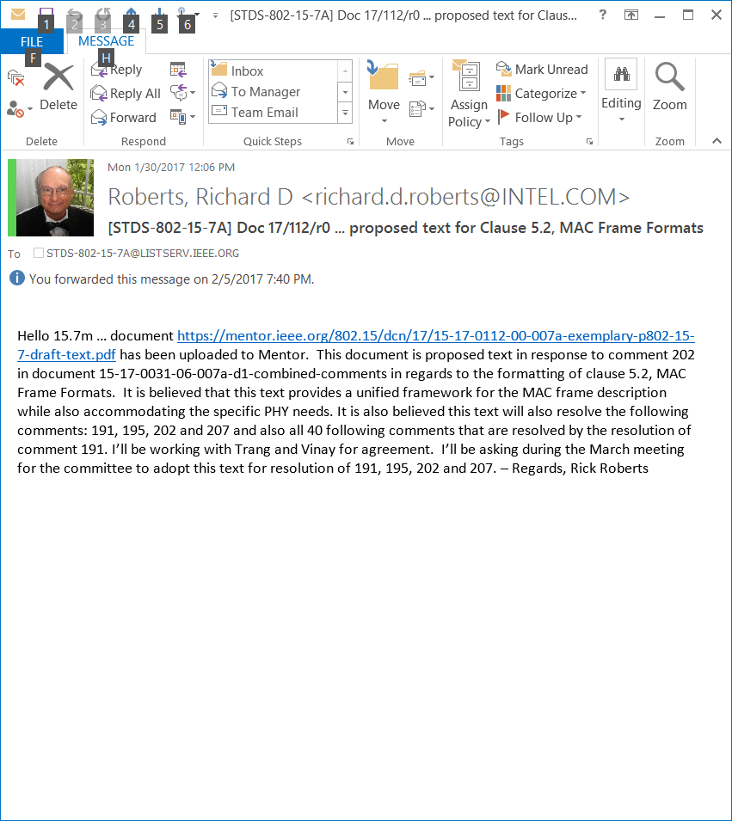

During the January meeting, text was presented in document 17/10r0 to suggest improvement to the MAC MPDU text and the PHY PPDU text. It was suggested that the MPDU and PPDU format only be presented once in the document and then text provided that described how each field was formatted for the various MAC/PHY options. This suggested text was provided due to the fact that in draft D1 the MPDU and PPDU are presented numerous time in regards to the various MAC/PHY options.

The concept of presenting the MPDU and PPDU only once and then including text to describe how the fields are configured is consistent with the original IEEE 802.15.7-2011 format. In fact, I believe every 802.15 standard uses this approach.

The suggested modification to the PPDU presentation format was accepted by the committee during the January meeting; however, the suggested modification to the MPDU presentation format was postponed pending discussion over the 15.7a email reflector. That discussion has taken place and I believe we’ve converged on a solution, as presented in document 17/112r0.

In document 17/112r0 exemplary text was shown that showed the MPDU and included the field clause numbers where MAC/PHY dependent configuration could be found (shown in Figure 71 below). Notice that two LiFi specific fields are still shown (Acknowledge Field and Polling Field).

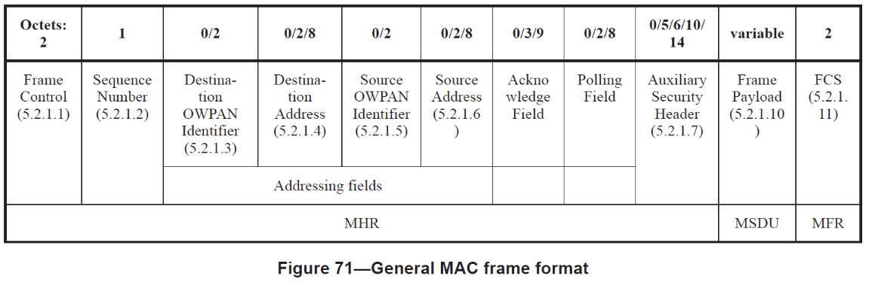

For example, to find out how to configure the Frame Control Field for a particular MAC/PHY type the reader references clause 5.2.1.1. Clause 5.2.1.1 is then further subdivided between the various PHY classes as shown below.

* Clause 5.2.1.1.1 PHY I, II and III
* Clause 5.2.1.1.2 PHY IV
* Clause 5.2.1.1.3 PHY V
* Clause 5.2.1.1.4 PHY VI

Within a specific PHY class clause, the reader references a particular PHY type.

All the details involved with this proposed text is shown in document 17/112r0 which is contribution from Intel and is not draft text.

Acceptance of this proposed text will close out comments 202 (partial), 207, and 210.

**PIB configuration**

A second email reflector discussion was in regards to PIB configuration, as opposed to over-the-air configuration. The opening email is shown below.

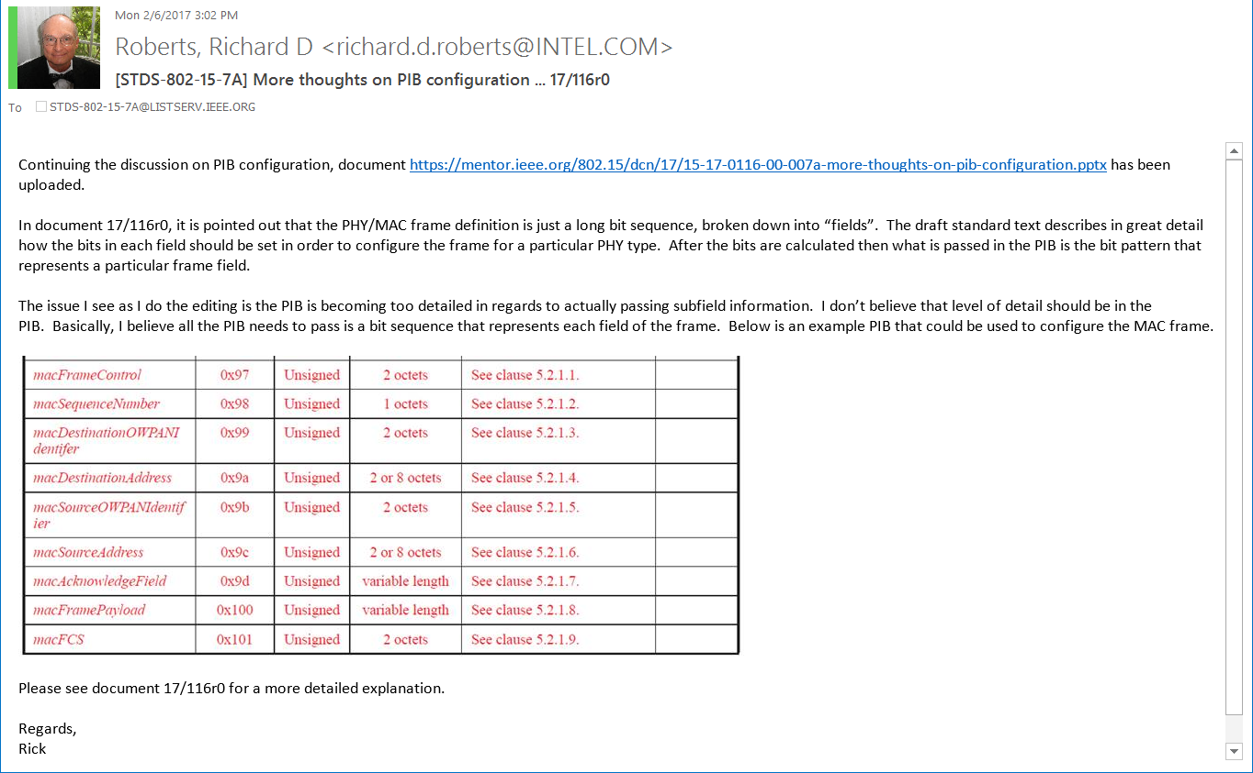

In my opinion the response was “positive”, “agreeing in principle on PIB configuration” but we did not have agreement on the specific details of what parameters would be passed in the PIB, of which there are several opinions (the details shown in doc 17/116r0 is just one approach suggested by Intel). My hope is that during the March meeting have the committee agree that PIB configuration will be used for OCC setup, as opposed to over-the-air setup, but at this time include *ALL* possible PIB parameter options and then sort this out during the D2 comment resolution.

Agreeing upon PIB configuration, while accepting at this time all PIB parameter options, will resolve the following comments: 202 (partial), 283, 317, 321, 418, 449, 461, 509, 602, 609, 661 and 669.