IEEE P802.15
Wireless Personal Area Networks
Project | IEEE P802.15 Working Group for Wireless Personal Area Networks (WPANs)
Title | SNUST - Invisible Data Embedding Super Frame Structure and PHY Dimming Specification Revision
Date Submitted | January, 2017
Source | Jaesang Cha, Kim Chan (SNUST), Chunseop Kim (QUBER Co., Ltd), Kwangmin Kim (Ntriever Co.,Ltd), Kackhee Lee (Kuwoo Information Technology Co., Ltd.), Byongmoon Yang (Sunil Eleccomm Co. Ltd), Jaekwon Shin , Jintae Kim (Fivetek Co., Ltd), Daehyun Kim, Dongwoo Lee (Namuga Co., Ltd), Hyunsuk Hwang (Seoil Univ.), Yunsik Lim (Yeoju Institute of Technology), Gilsik Lee (Univ. of Texas), Yongkyu Yoon (Univ. of Florida), Ilkyoo Lee (Kongju Nat’ Univ.), Sooyoung Chang (CSUS), Vinayagam Mariappan (SNUST) | Voice: [ ]  Fax: [ ]  E-mail: [chajs@seoultech.ac.kr]¹
Re: | Draft D1 Comment Resolution based Invisible Data Embedding Super Frame Structure and PHY Dimming Specification Revision
Abstract | Details of Resolutions regarding to the submitted Comments on D1 are suggested for Invisible Data Embedding Super Frame Structure and PHY Dimming Specification Revision. The Invisible Data Embedding is designed to operate on the application services like LED ID, Digital Signage with Advertisement Information.
Purpose | Draft D1 Comments Resolutions and Editorial Revision.
Notice | This document has been prepared to assist the IEEE P802.15. It is offered as a basis for discussion and is not binding on the contributing individual(s) or organization(s). The material in this document is subject to change in form and content after further study. The contributor(s) reserve(s) the right to add, amend or withdraw material contained herein.
Release | The contributor acknowledges and accepts that this contribution becomes the property of IEEE and may be made publicly available by P802.15.
1. PHY DIMMING FORMART FOR INVISIBLE DATA EMBEDDING

Invisible Data Embedding Dimming

The Display to camera communication dimming control is depending on the mode of embedding data (Visible or Invisible) on display system, rate at which data is repeatedly coding on video frame, and rate at which data refresh on display. The Invisible Data Embedding based Display Light Pattern based Transmitter for OCC uses the invisibly embedding the data on video display frame by overlaying patterns on displays visual area using Alpha Blending and Watermarking.

2. SUPERFRAME STRUCTURE FOR INVISIBLE DATA EMBEDDING

5.1.2.9 Invisible Data Embedding Superframe Structure

The Invisible Data Embedded Display TX Schemes use unslotted ALOHA; that is, when the Invisible Data Embedded Display transmitter has a packet to send, it just sends it. This support with beacon and without beacon support and the transmitter does not do a listen before talk channel activity check.
The super frame structure for Invisible Data Embedding PHY without beacon is shown in Figure 5-1.
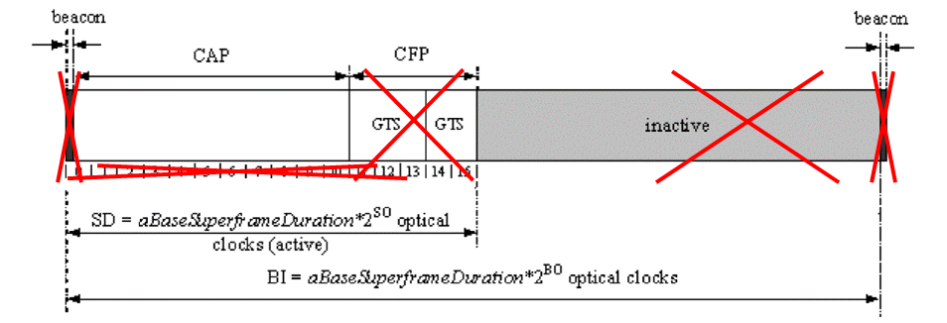
Figure 5-2 – Invisible Data Embedding PHY Superframe Structure without Beacon

The super frame structure for Invisible Data Embedding PHY with beacon is shown in Figure 5-2.
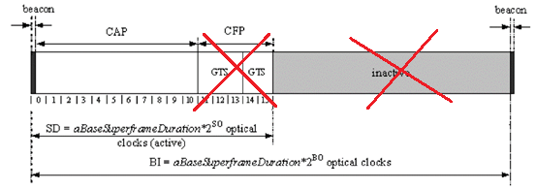
Figure 5-2 – Invisible Data Embedding PHY Superframe Structure with Beacon

