IEEE P802.15
Wireless Personal Area Networks
Project | IEEE P802.15 Working Group for Wireless Personal Area Networks (WPANs)
Title | SNUST - Invisible Data Embedding PHY Layer Operating Modes and Specifications Revision
Date Submitted | January, 2017
Source | Jaesang Cha , Kim Chan (SNUST), Chunseop Kim (QUBER Co., Ltd), Kwangmin Kim (Ntriever Co.,Ltd), Kackhee Lee (Kuwoo Information Technology Co., Ltd.), Byongmoon Yang (Sunil Eleccomm Co. Ltd), Jaekwon Shin , Jintae Kim (Fivetek Co., Ltd), Daehyun Kim , Dongwoo Lee (Namuga Co., Ltd), Hyunsuk Hwang (Seoil Univ.), Yunsik Lim (Yeoju Institute of Technology), Gilsik Lee (Univ. of Texas), Yongkyu Yoon (Univ. of Florida), Ilkyoo Lee (Kongju Nat’ Univ.), Sooyoung Chang (CSUS), Vinayagam Mariappan (SNUST) | Voice: [ ]  Fax: [ ]  E-mail: [chajs@seoultech.ac.kr]
Re: | D1 Comment Resolution based IDE PHY Layer Modes and Specifications
Abstract | Details of Resolutions regarding to the submitted Comments on D1 are suggested for Invisible Data Embedding PHY Layer Operating Modes and PHY Specifications. PHY Layer Operating Modes and PHY Specifications. The Invisible Data Embedding is designed to operate on the application services like LED ID, Digital Signage with Advertisement Information.
Purpose | D0 Comments Resolutions and Editorial Revision.
Notice | This document has been prepared to assist the IEEE P802.15. It is offered as a basis for discussion and is not binding on the contributing individual(s) or organization(s). The material in this document is subject to change in form and content after further study. The contributor(s) reserve(s) the right to add, amend or withdraw material contained herein.
Release | The contributor acknowledges and accepts that this contribution becomes the property of IEEE and may be made publicly available by P802.15.

1. PHY LAYER OPERATING MODES FOR INVISIBLE DATA EMBEDDING

Operating Modes

The display light pattern based Invisible Data Embedding transmitter w uses the PHY VI – 2 Dimensional / Screen Source.
The PHY VI Operating Modes system specifications are given in Table 81. The additional PHY Operating Modes supported by Invisible Data Embedding is presented the Table 81 – PHY IV Operating Modes (continued).
PHY Operating Modes
Modulation | RLL Code | Optical Clock Rate | FEC | Data Rate (Kbps)
IDE-BLEND-MxN-FPSK | None | 30Hz | RS(64,32)/ RS(160,128)/None | 32 Kbps
IDE-WM-2DC | None | 30Hz | RS(64,32)/ RS(160,128)/None | 256 Kbps
SS-IDE-BLEND-MxN-FPSK | None | 30Hz | RS(64,32)/ RS(160,128)/None | 16 Kbps
SS- IDE-WM-2DC | None | 30Hz | RS(64,32)/ RS(160,128)/None | 128 Kbps

Table 81 – PHY VI Operating Modes (continued for Invisible Data Embedding)

2. PHY SPECIFICATIONS FOR INVISIBLE DATA EMBEDDING

15.4 Invisible Data Embedding

The Invisible Data Embedding PHY supported data rates and operating conditions are shown in Table 81 PHY VI operating Modes. The Invisible Data Embedded Display TX Schemes works with two data embedding method. The supported data embedding principles are Alpha Blending and Watermarking. The PHY system diagram illustrated in Figure 2-1 for 2 Dimensional / Screen Source for Invisible Data Embedded Display TX Schemes for OWC.

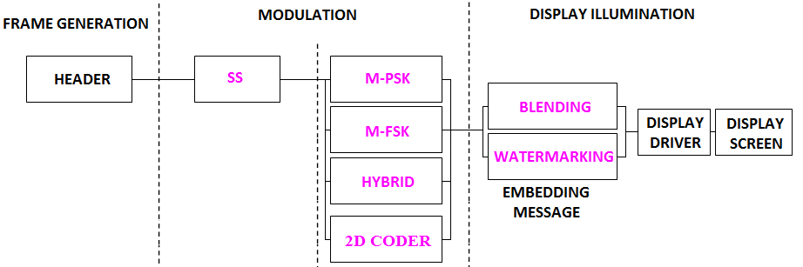

Figure 2-1 – Invisible Data Embedded Display TX Schemes PHY System Diagram
The PHY designed with specific key features in consideration to have error free and effective display to camera communication in the real-time usage of end system. The design goals are,
- Unobtrusive to Screen Viewer
- Works on dynamic visual Scene
- Angle and Distance Free Communication
- Rx Distance Adaptive Communication by Screen with interactive Camera
- Asynchronous Communication
- Rx Frame Rate independent Transmission
- Multi-Display Model for Transmission
To achieve the above described design goal, the PHY designed with Spread Spectrum coded with M-PSK, M-FSK, Hybrid-M-PSK-FSK, 2D-Codes. The use cases of the modulation scheme with or without of SS Modulation parameter are described in this section.
The Table 2-1 describes the data rate supported with different modulation schemes.
Modulation | RLL Code | Optical Clock Rate | FEC | Data Rate (Kbps)
M-PSK | None | 30Hz | RS(64,32)/ RS(160,128)/None | 16 Kbps
M-FSK | None | 30Hz | RS(64,32)/ RS(160,128)/None | 16 Kbps
HYBRID-PSK/FSK | None | 30Hz | RS(64,32)/ RS(160,128)/None | 32 Kbps
2D-CODE | None | 30Hz | RS(64,32)/ RS(160,128)/None | 128 Kbps
Sequential Scalable 2D Code | None | 30Hz | RS(64,32)/ RS(160,128)/None | 256 Kbps
SS-M-PSK | None | 30Hz | None | 8 Kbps
SS-M-FSK | None | 30Hz | None | 8 Kbps
SS-HYBRID-PSK/FSK | None | 30Hz | None | 16 Kbps
SS- 2D-CODE | None | 30Hz | None | 64 Kbps
SS -Sequential Scalable 2D Code | None | 30Hz | None | 128 Kbps

Table 2-1 – Invisible Data Embedding PHY Data Rate Table

15.4.1 Invisible Data Embedding Modulations
15.4.1.1 M-PSK Modulation
The Figure 2-2 describes the M-PSK modulation scheme usage on PHY Layer design.
(a) 2-PSK
(b) 4-PSK
(1) 0
(2) 1 0 1
(1) 00 00
(3) 10 10
(2) 01 01
(4) 11

Figure 2-2 – M-PSK Modulation

15.4.1.2 M-FSK Modulation
The Figure 2-3 describes the M-FSK modulation scheme usage on PHY Layer design.

(a) 2-FSK
(b) 4-FSK
(1) 0
(2) 1
f₁
f₂
(1) 00
(2) 01
f₁
f₂

(3) 01
(4) 10
f₃
f₄

Figure 2-3 – M-FSK Modulation

15.4.1.3 Hybrid (M-PSK-FSK) Modulation
Hybrid scheme used to achieve double the data rate of M-PSK or F-FSK by combining Frequency and Phase on the modulation. The Figure 2-4 describes the Hybrid modulation scheme usage on PHY Layer design.

(2) 01
(1) 00
(3) 10
(4) 11
Phase Frequency
f₁
f₂
f₁
f₂

Figure 2-4 – Hybrid (M-PSK-FSK) Modulation

15.4.1.4 Sequential Scalable 2D Codes Modulation
The Sequential Scalable 2D codes used the QR Code and Color Code to encode the data with visual frame on display. The Sample 2D codes are shown in Figure 2-5.
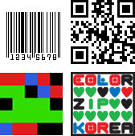
Figure 2-5 – 2D Codes
The proposed Sequential Scalable 2D Codes for PHY system design to enable distance adaptive data rate control on TX Schemes for OCC.
The QR code based Sequential Scalable 2D Code is shown in Figure 2-6.

Figure 2-6 – Sequential Scalable QR Code
The Color Code based Sequential Scalable 2D Code is shown in Figure 2-7.

Figure 2-7 – Sequential Scalable Color Code
15.4.2 Spread Spectrum
The spread spectrum adopted with PHY model design for Display Light Pattern Based Transmitter with Invisible Data Embedding to add built-in adaptation on data recovery in addition to achieve the asynchronous communication with Angle free and distance free communication between transmitter and Receiver. The PHY implementation can use Orthogonal Codes (like Walsh sequences) and Non-Orthogonal Codes (like PN, Gold, and Kasami shift register sequences).
In this PHY model used Gold Sequence based Spreading code for encode data. The Study case of Gold Sequence SS Code Specification is as follows,
- Gold sequence was chosen as a spreading code
- Shifter register length is 5
- Code length is 31 (=2⁵-1)
- 4 family code set was generated via offset 8*n chips of code set 1
- Code Sets
- Code set 1: 0000000010010100100111101010110 (zero offset)
- Code set 2: 1001010010011110101011000000000 (8chip offset)
- Code set 3: 1001111010101100000000010010100 (16chip offset)
- Code set 4: 1010110000000001001010010011110 (24chip offset)
The Figure 2-8 shows the SS Gold Sequence Generator model.
5
4
3
2
1
5
4
3
2
1
Gold-Sequence

Figure 2-8 – Gold Sequence Generator
The Table 2-1 describes the SS Modulation Parameters adopted for simulating proposed PHY Layer design.
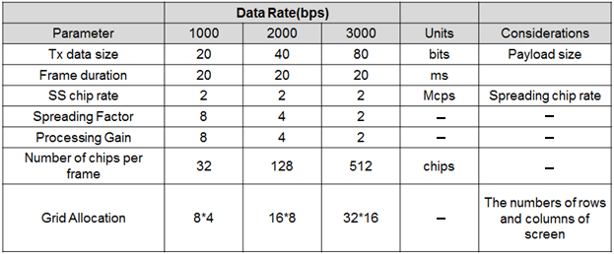
Table 2-1 – SS Modulation Parameters Study Case
15.4.3 Data Encoder
The Invisible Data Embedded Display TX Schemes works with two data embedding method. The supported data embedding principles are Alpha Blending and Watermarking. The rule to embedding data and data rate achievement vary based on the kind of display used to design the Transmitter.

15.4.4 Asynchronous Communication Mode
The PHY for Invisible Data Embedded Display TX Schemes designed with Asynchronous communication mode. The Asynchronous communication achieved when transmitting data, different spreading code is used per video frame. Each code sets repeated for spreading data according to spreading factor and each spreading code set 1, 2, 3, and 4 are assigned for successive 4 frames as shown in Figure 2-9.
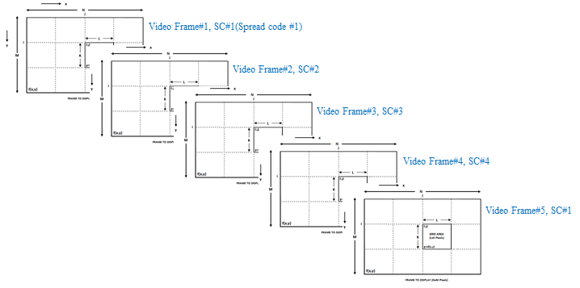
Figure 2-9 – SS Code Assignment
The receiver side spreading code already known with application to synchronize the data automatically. If camera CMOS received same frame, for example #1 video frame receive twice, then receiver will despread video frames using SC#1, SC#2. When processing using SC#2, dominant value will not appear so the video frame will be discarded. The orthogonal spread spectrum sequence is best adopt on PHY design to have easy and fast synchronization
15.4.5 Angle Free Communication
The PHY for Invisible Data Embedded Display TX Schemes designed with Angle Free Communication between Transmitter and Receiver. The Angle free communication is achieved by Warping the ROI of the transmitter to get the original shape alignment and then the decoded data synchronizing with spread code to extract original information transferred on transmitter. The kind automatic synchronization in receiver is time consuming function but the communication is robust.

15.4.6 Scalable Bitrate Controller
The PHY for Invisible Data Embedded Display TX Schemes designed with built-in Scalable bitrate Controller. To achieve robust communication, the scalable data transmission mode is proposed in PHY model design is shown in Figure 2-10. The Screen is divided into Multiple regions and each region has different frame rate controlled data transmission is enabled. This approach adds robustness on system performance for frame rate adaptive communication based on the receiver performance.
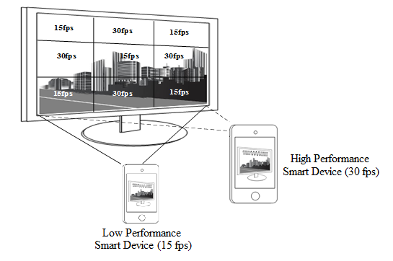
Figure 2-10 – Scalable Bitrate Controller
15.4.7 Distance Adaptive Data Rate Control
The PHY for Invisible Data Embedded Display TX Schemes designed with distance adaptive data rate control. In this case the Transmitter built-in with camera features as shown in Figure 2.11. The Transmitter Camera Estimate the Receivers distance using camera. There are different methods used to estimate the distance to receiver. Some of these methods are active by sending some signals to the object such as laser range finder, ultrasonic range finder, radio waves, microwaves, infrared, etc. Some others are passive that only receive information about the target position. The distance estimation method decision left up to the system designer.
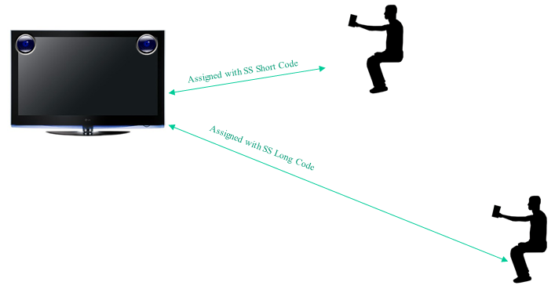
Figure 2-11 – Distance Adaptive Data rate Control
For this conceptual evaluation, Kinect sensor based triangulation method is used for distance estimation. In this approach, the laser source emits a single beam which is split into multiple beams by a diffraction grating to create a constant pattern of speckles projected onto the scene and this pattern is captured by the infrared camera and is correlated against a reference pattern. The reference pattern is obtained by capturing a plane at a known distance from the sensor, and is stored in the memory of the sensor. When a speckle is projected on an object whose distance to the sensor is smaller or larger than that of the reference plane the position of the speckle in the infrared image will be shifted in the direction of the baseline between the laser projector and the perspective center of the infrared camera. These shifts are measured for all speckles by a simple image correlation procedure, which yields a disparity image. For each pixel the distance to the sensor can then be retrieved from the corresponding disparity.
The sequence code length assignment is based the distance of the receiver from transmitter. If the receiver is near then the SF Value is small so Short Sequence Code is assigned otherwise SF values is high so Long Sequence Code is assigned. In this way, PHY model design control the distance adaptive data rate selection.

