IEEE P802.15
Wireless Personal Area Networks

Project | IEEE P802.15 Working Group for Wireless Personal Area Networks (WPANs)
Title | SNUST - Sequential Scalable 2D Code Super Frame Structure and PHY Dimming Specification Revision
Date Submitted | January, 2017
Source | Jaesang Cha, Kim Chan (SNUST), Joonseok Jung (Idolink Co., Ltd), Jongman Kwon/Idolink Co.,Ltd, Vinayagam Mariappan (SNUST) | Voice: [ ]  Fax: [ ]  E-mail: [chajs@seoultech.ac.kr]
Re: | Draft D1 Comment Resolution based Sequential Scalable 2D Code Super Frame Structure and PHY Dimming Specification Revision
Abstract | Details of Resolutions regarding to the submitted Comments on D1 are suggested for Sequential Scalable 2D Code Super Frame Structure and PHY Dimming Specification Revision. The proposed method is designed to operate on the application services like LED ID using Color/QR Code, etc, LBS, Emergency EXIT Signage, LED-IT and Digital Signage with Advertisement Information etc.
Purpose | Draft D1 Comments Resolutions and Editorial Revision.
Notice | This document has been prepared to assist the IEEE P802.15. It is offered as a basis for discussion and is not binding on the contributing individual(s) or organization(s). The material in this document is subject to change in form and content after further study. The contributor(s) reserve(s) the right to add, amend or withdraw material contained herein.
Release | The contributor acknowledges and accepts that this contribution becomes the property of IEEE and may be made publicly available by P802.15.

1. PHY DIMMING FORMART FOR SEQUENTIAL SCALABLE 2D CODE

Sequential Scalable 2D Code Dimming

The Sequential Scalable 2D Code based Display Light Pattern based Transmitter for OCC uses the visibly embedding the data on Video display frame by overlaying patterns on displays visual area.

2. SUPERFRAME STRUCTURE FOR SEQUENTIAL SCALABLE 2D CODE

5.1.2.8 Sequential Scalable 2D Code Superframe Structure

The Display Light Pattern Based Transmitter with Sequential Scalable 2D Code uses the unslotted ALOHA; that is, when the Display Light Pattern Based Transmitter with Sequential Scalable 2D Code uses has a packet to send, it just sends it. This support with beacon and without beacon support and the transmitter does not do a listen before talk channel activity check.
The super frame structure for SS2DC PHY without beacon is shown in Figure 5-1.
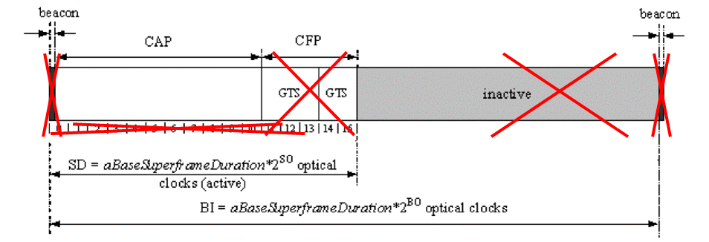
Figure 5-1 – SS2DC PHY Superframe Structure without Beacon

The super frame structure for SS2DC PHY with beacon is shown in Figure 5-2.
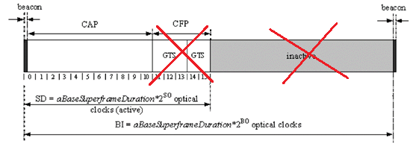
Figure 5-2 – SS2DC PHY Superframe Structure with Beacon

