**IEEE P802.15**

**Wireless Personal Area Networks**

|  |  |  |
| --- | --- | --- |
| Project | IEEE P802.15 Working Group for Wireless Personal Area Networks (WPANs) | |
| Title | **SNUST - Sequential Scalable 2D Code PHY Layer Operating Modes and Specifications Revision** | |
| Date Submitted | January, 2017 | |
| Source | Jaesang Cha (SNUST), Kim Chan (SNUST), Joonseok Jung, Jongman Kwon (Idolink Co.,Ltd), Vinayagam Mariappan (SNUST) | Voice: [ ] Fax: [ ] E-mail: [chajs@seoultech.ac.kr] |
| Re: | Draft D1 Comment Resolution for Sequential Scalable 2D Code PHY Layer Operating Modes and Specifications Revision | |
| Abstract | Details of Resolutions regarding to the submitted Comments on D1 are suggested for Sequential Scalable 2D Code PHY Layer Operating Modes and PHY Specifications. The proposed method is designed to operate on the application services like LED ID using Color/QR Code, etc, LBS, Emergency EXIT Signage, LED-IT and Digital Signage with Advertisement Information etc. | |
| Purpose | D1 Comments Resolutions and Editorial Revision. | |
| Notice | This document has been prepared to assist the IEEE P802.15. It is offered as a basis for discussion and is not binding on the contributing individual(s) or organization(s). The material in this document is subject to change in form and content after further study. The contributor(s) reserve(s) the right to add, amend or withdraw material contained herein. | |
| Release | The contributor acknowledges and accepts that this contribution becomes the property of IEEE and may be made publicly available by P802.15. | |

# **1. PHY LAYER OPERATING MODES FOR SEQUENTIAL SCALABLE 2D CODE**

# **Operating Modes**

The display light pattern based Sequential Scalable 2D Code Transmitter uses the PHY VI – 2 Dimensional / Screen Source.

The PHY VI Operating Modes system specifications are given in Table 81. The additional PHY Operating Modes supported by Sequential Scalable 2D Code is presented the Table 81 – PHY IV Operating Modes (continued).

|  |  |  |  |  |
| --- | --- | --- | --- | --- |
| **PHY Operating Modes** | | | | |
| **Modulation** | **RLL Code** | **Optical Clock Rate** | **FEC** | **Data Rate (Kbps)** |
| SS2DC | None | 2DCodeDecodingRate | RS(64,32)/ RS(160,128)/None | 368 Kbps |
| SS-SS2C | None | 2DCodeDecodingRate | RS(64,32)/ RS(160,128)/None | 184 Kbps |

**Table 120 – PHY VI Operating Modes (continued for Sequential Scalable 2D Code)**

Note : 2DCodeDecodingRate depends on the decoding rate of the 2D Code used.

# **2. PHY SPECIFICATION FOR SEQUENTIAL SCALABLE 2D CODE**

# **Sequential Scalable 2D Code**

The Sequential Scalable 2D code PHY supported data rates and operating conditions are shown in Table 81 – PHY VI Operating Modes. The Display Light Pattern Based Sequential Scalable 2D Code Transmitter works with variable size 2D Code and different type of 2D Codes like QR Code, Color Code, VTASC, etc. The data embedded on visual frame by overlaying visual patterns displays visual area. The PHY system diagram illustrated in Figure 2-1 for 2 Dimensional / Screen Source based transmitter using Sequential Scalable 2D Code.

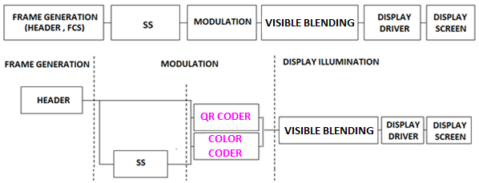

**Figure 2-1 –Display Light Pattern Based Transmitter with Sequential Scalable 2D Code** **PHY System Diagram**

The PHY for Sequential Scalable 2D Code designed with specific key features in consideration to have error free and effective display to camera communication in the real-time usage of end system. The design goals are,

* Angle and Distance Free Communication
* Rx Distance Adaptive Communication by Screen with interactive Camera
* Asynchronous Communication
* Rx Frame Rate independent Transmission
* Multi-Display Model for Transmission

To achieve the above described design goal, the PHY design is proposed with Spread Spectrum based Sequential Scalable 2D Code. The use cases of the modulation scheme and SS Modulation parameter are described in this section.

**15.3.1 Sequential Scalable 2D Code Modulation**

A 2D (Two-Dimensional) Code is a graphical image that stores information both horizontally and vertically for Display based VLC system. In order to improve the distance and angle free with higher bitrate, the new proposed color based modulation scheme called Sequential Scalable 2D Code Modulation is proposed. The Sequential Scalable 2D codes used the QR Code and Color Code to encode the data with visual frame on display. The Sample 2D codes are shown in Figure 2-1.

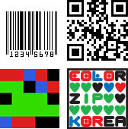

**Figure 2-1 – 2D Codes**

Sequential Scalable 2D Code is one of the promising modulation formats specifically for display based VLC system with improved VLC throughput by increasing the bit per symbol rate, and avoiding the color interference.

The proposed Sequential Scalable 2D Codes for PHY system design to enable distance adaptive data rate control on TX Schemes for OCC. The use case for Sequential Scalable QR code is shown in Figure 2-2.



**Figure 2-2 – Sequential Scalable QR Code**

The use case for Sequential Scalable Color code is shown in Figure 2-3.



**Figure 2-3 – Sequential Scalable Color Code**

The data rate for Sequential Scalable 2D Coded Display TX Schemes calculated using follow mathematical representation,

DataRate = NoOfCodeSequence* (2DCodeDataCapacity * OpticalClockrate * FECRate) / CodeLength)

Where, “CodeLength” is 1 for without SS Coded schemes and respective code length for with SS Coded Schemes

Note this case study designed with 2D Code decoding Rate is 1 for QR. The maximum data capacity for 2D Codes is 2953 bytes.

The Data Rate for 2x2 Sequential Scalable 2D Code without SS Coded Code (CodeLength is 1),

FECRate = 1 (Refer Table 1-2)

DataRate = 4* (2953 * 8)* 1 * 1) / 1) = 94494 Approximated to 92 Kbps

The Table 2-1 describes the data rate supported based on predefined block size.

|  |  |  |  |  |
| --- | --- | --- | --- | --- |
| **Modulation** | **RLL Code** | **Optical Clock Rate** | **FEC** | **Data Rate (Kbps)** |
| 1x1  Sequential Scalable 2D Code | None | 2DCodeDecodingRate | RS(64,32)/ RS(160,128)/None | 23 Kbps |
| 2x2  Sequential Scalable 2D Code | None | 2DCodeDecodingRate | RS(64,32)/ RS(160,128)/None | 92 Kbps |
| 4x4  Sequential Scalable 2D Code | None | 2DCodeDecodingRate | RS(64,32)/ RS(160,128)/None | 368 Kbps |
| 1x1  SS Sequential Scalable 2D Code | None | 2DCodeDecodingRate | None | 12 Kbps |
| 2x2  SS Sequential Scalable 2D Code | None | 2DCodeDecodingRate | None | 46 Kbps |
| 4x4  SS Sequential Scalable 2D Code | None | 2DCodeDecodingRate | None | 184 Kbps |

**Table 2-2 – Sequential Scalable 2D Code Data Rate Table**

**15.3.2 Spread Spectrum**

The spread spectrum adopted with PHY model design for Display Light Pattern Based Transmitter with Sequential Scalable 2D Code to add built-in adaptation on data recovery in addition to achieve the asynchronous communication with Angle free and distance free communication between transmitter and Receiver. The PHY implementation can use Orthogonal Codes (like Walsh sequences) and Non-Orthogonal Codes (like PN, Gold, and Kasami shift register sequences).

In this PHY model used Gold Sequence based Spreading code for encode data. The Study case of Gold Sequence SS Code Specification is as follows,

* Gold sequence was chosen as a spreading code
* Shifter register length is 5
* Code length is 31 (=25-1)
* 4 family code set was generated via offset 8*n chips of code set 1
* Code Sets

1. Code set 1: 0000000010010100100111101010110 (zero offset)
2. Code set 2: 1001010010011110101011000000000 (8chip offset)
3. Code set 3: 1001111010101100000000010010100 (16chip offset)
4. Code set 4: 1010110000000001001010010011110 (24chip offset)

The Figure 2-4 shows the SS Gold Sequence Generator model.

5

4

3

2

1

5

4

3

2

1

Gold-Sequence

**Figure 2-4 – Gold Sequence Generator**

The Table 2-2 describes the SS Modulation Parameters adopted for simulating proposed PHY Layer design.

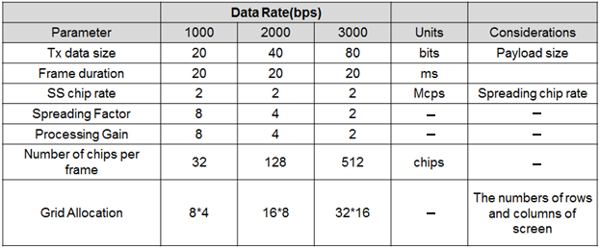

**Table 2-2 – SS Modulation Parameters Study Case**

**15.3.3 Data Encoder**

The Display Light Pattern Based Transmitter with Sequential Scalable 2D Code Schemes works with two data embedding method. The supported data embedding principles are Alpha Blending and Watermarking. The rule to embedding data and data rate achievement vary based on the kind of display used to design the Transmitter.

**15.3.4 Asynchronous Communication Mode**

The PHY for Display Light Pattern Based Transmitter with Sequential Scalable 2D Code designed with Asynchronous communication mode. The Asynchronous communication achieved when transmitting data, different spreading code is used per video frame. Each code sets repeated for spreading data according to spreading factor and each spreading code set 1, 2, 3, and 4 are assigned for successive 4 frames as shown in Figure 2-5.

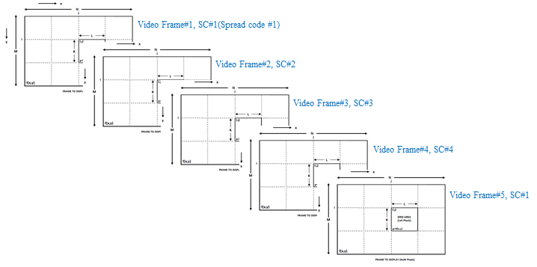

**Figure 2-5 – SS Code Assignment**

The receiver side spreading code already known with application to synchronize the data automatically. If camera CMOS received same frame, for example #1 video frame receive twice, then receiver will despread video frames using SC#1, SC#2. When processing using SC#2, dominant value will not appear so the video frame will be discarded. The orthogonal spread spectrum sequence is best adopt on PHY design to have easy and fast synchronization

**15.3.5 Angle Free Communication**

The PHY for Display Light Pattern Based Transmitter with Sequential Scalable 2D Code designed with Angle Free Communication between Transmitter and Receiver is shown in Figure 2-6. The Angle free communication is achieved by Warping the ROI of the transmitter to get the original shape alignment and then the decoded data synchronizing with spread code to extract original information transferred on transmitter. The kind automatic synchronization in receiver is time consuming function but the communication is robust.

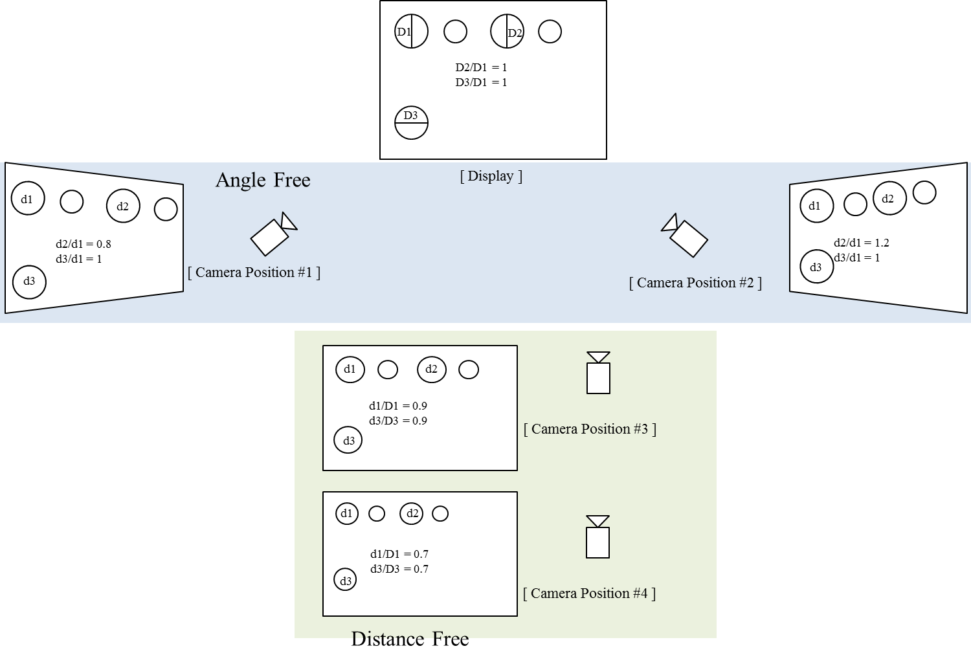

**Figure 2-6 – Angle Free and Distance Adaptive**

**15.3.6 Scalable Bitrate Controller**

The PHY for Display Light Pattern Based Transmitter with Sequential Scalable 2D Code designed with built-in Scalable bitrate Controller. To achieve robust communication, the scalable data transmission mode is proposed in PHY model design is shown in Figure 2-7. The Screen is divided into Multiple regions and each region has different frame rate controlled data transmission is enabled. This approach adds robustness on system performance for frame rate adaptive communication based on the receiver performance.



**Figure 2-7 – Scalable Bitrate Controller**

**15.3.7 Distance Adaptive Data Rate Control**

The PHY for Sequential Scalable 2D Coded Display TX Schemes designed with distance adaptive data rate control. In this case the Transmitter built-in with camera features as shown in Figure 2-8. There are different methods used to estimate the distance to receiver. Some of these methods are active by sending some signals to the object such as laser range finder, ultrasonic range finder, radio waves, microwaves, infrared, etc. Some others are passive that only receive information about the target position. The distance estimation method decision left up to the system designer.

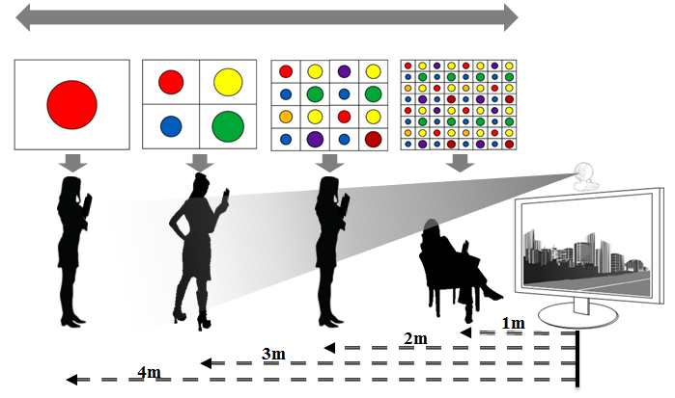

**Figure 2-8 – Distance Adaptive Data rate Control**

For this conceptual evaluation, Kinect sensor based triangulation method is used for distance estimation. In this approach, the laser source emits a single beam which is split into multiple beams by a diffraction grating to create a constant pattern of speckles projected onto the scene and this pattern is captured by the infrared camera and is correlated against a reference pattern. The reference pattern is obtained by capturing a plane at a known distance from the sensor, and is stored in the memory of the sensor. When a speckle is projected on an object whose distance to the sensor is smaller or larger than that of the reference plane the position of the speckle in the infrared image will be shifted in the direction of the baseline between the laser projector and the perspective center of the infrared camera. These shifts are measured for all speckles by a simple image correlation procedure, which yields a disparity image. For each pixel the distance to the sensor can then be retrieved from the corresponding disparity.

The sequence code length assignment is based the distance of the receiver from transmitter. If the receiver is near then the SF Value is small so Short Sequence Code is assigned otherwise SF values is high so Long Sequence Code is assigned. In this way, PHY model design control the distance adaptive data rate selection.