IEEE P802.15
Wireless Personal Area Networks

Project | IEEE P802.15 Working Group for Wireless Personal Area Networks (WPANs)
Title | Suggested Text for Many-to-Many Peering to Resolve Comment CID-37-43
Date Submitted | January 2017
Source | Huan-Bang Li (NICT)  Marco Hernandez (NICT)  Fumihide Kojima (NICT)  Billy Verso (DecaWave)  Myung J. Lee [CUNY]
Re: | TG8 draft text for comment resolution for 802.15.8
Abstract | This is the work in progress text of the MAC component for IEEE 802.15.8 group for PAC.
Purpose | This document provides the details of draft text to IEEE 802.15.8
Notice | This document does not represent the agreed views of the IEEE 802.15 Working Group or IEEE 802.15.8 Task Group. It represents only the views of the participants listed in the “Source(s)” field above. It is offered as a basis for discussion and is not binding on the contributing individual(s) or organization(s). The material in this document is subject to change in form and content after further study. The contributor(s) reserve(s) the right to add, amend or withdraw material contained herein.
Release | The contributor acknowledges and accepts that this contribution becomes the property of IEEE and may be made publicly available by P802.15.
Patent Policy | The contributor is familiar with the IEEE-SA Patent Policy and Procedures:  <http://standards.ieee.org/guides/bylaws/sect6-7.html#6> and  <http://standards.ieee.org/guides/opman/sect6.html#6.3>.  Further information is located at <http://standards.ieee.org/board/pat/pat-material.html> and  <http://standards.ieee.org/board/pat>.

[This is draft text to resolve comment submitted to TG8]

      - Many-to-many peering procedure
Following the discovery procedure for many-to-many group as defined in subclause 6.5.3.4, where the I-PD obtained a list of candidate R-PDs, many-to-many peering procedure forms a many-to-many group. The result of many-to-many peering is that a number of PDs including the I-PD and accepting R-PDs get peered forming a many-to-many group. As illustrated in Figure xxx, many-to-many peering procedure shall contain the following steps.
- The I-PD’s higher layer triggers the many-to-many peering procedure by issuing the MLME-PEERING.request primitive to its MAC sublayer with the selected multicast group address and the list of targeted R-PDs selected from the list of qualified R-PDs obtained during the many-to-many discovery.
- Upon reception of the MLME-PEERING.request primitive, the I-PD’s MAC sublayer broadcasts the Peering Request command frame with content of the PeeringType parameter set to many-to-many, multicast group address, the list of targeted R-PDs, and an empty list of accepted R-PDs.
- Upon reception of Peering Request command frame, the MAC sublayer of an R-PD in the list of targeted R-PDs shall issue the MLME-PEERING.indication primitive to its next higher layer, indicating peering request with the PeeringType parameter set to MANY2MANY, multicast group address, the list of targeted R-PDs, and the list of accepted R-PDs.
- Each R-PD’s next higher layer receiving the MLME-PEERING.indication primitive decides either to accept or reject the request to peer within macPeeringResponseTimeout. The next higher layer of the R-PD shall issue a MLME-PEERING.response primitive to the MAC sublayer. Where the next higher layer is accepting the peering request, it shall add the selected multicast group address to macGroupIdList.
- Upon reception of the MLME-PEERING.response primitive, the R-PD’s MAC sublayer shall send the Peering Response command frame including the multicast group address to the I-PD.
- The I-PD shall wait for either the arrival of Peering Response command frames from all targeted R-PDs or macPeeringResponseTimeout is reached. Then, the I-PD updates the list of targeted R-PDs by moving the R-PDs responding with accept to the accepted R-PD list and discarding R-PDs responding with reject.
- The I-PD broadcasts additional Peering Request command frame with the updated list of targeted R-PDs and the updated list of accepted R-PDs, repeating steps d) to g), until the updated targeted R-PDs list is empty, or reaching the macMaxFrameRetries.
- The I-PD’s MAC sublayer shall issue the MLME-PEERING.confirm to its next higher layer with the final list of accepted R-PDs.
- The next higher layer of I-PD issues a final MLME-PEERING.request primitive to its MAC sublayer with an empty list of targeted R-PDs and the final list of accepted R-PDs.
- Upon reception of the MLME-PEERING.request primitive, the I-PD’s MAC sublayer shall multicast a final many-to-many Peering Request command frame with the final list of accepted R-PDs using the multicast group address selected in step a).
- Upon reception of the final Peering Request command frame, the MAC sublayer of an R-PD shall issue the MLME-PEERING.indication primitive to its next higher layer, indicating a many-to-many group is formed with the final list of R-PDs. Any R-PD not in the final list shall remove the multicast group address from its macGroupIdList.
- The next higher layer of the I-PD and final accepted R-PDs may communicate in many-to-many manner using the selected multicast group address.

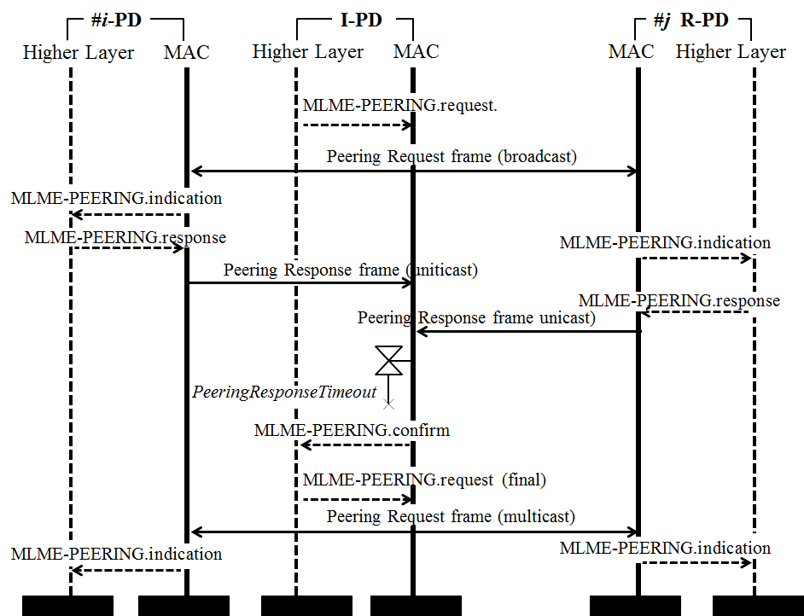
Figure xxx —Many-to-many peering procedure chart

